Reference discharge #20978
One of the discharges after repairing vacuum leak on GOLEM is performed on Friday, March 11, 2016.
Pre set parameters: UBT = 1200 V, UCD = 400 V, PH2 requested 20 mPa - achieved 20.73 mPa, time delay 5 ms (i.e. primary winding is triggered simultaneously with the toroidal magnetic field).
Vessel conditioning prior the discharge has to be clarified: ???????
Result is shown in Fig. 1
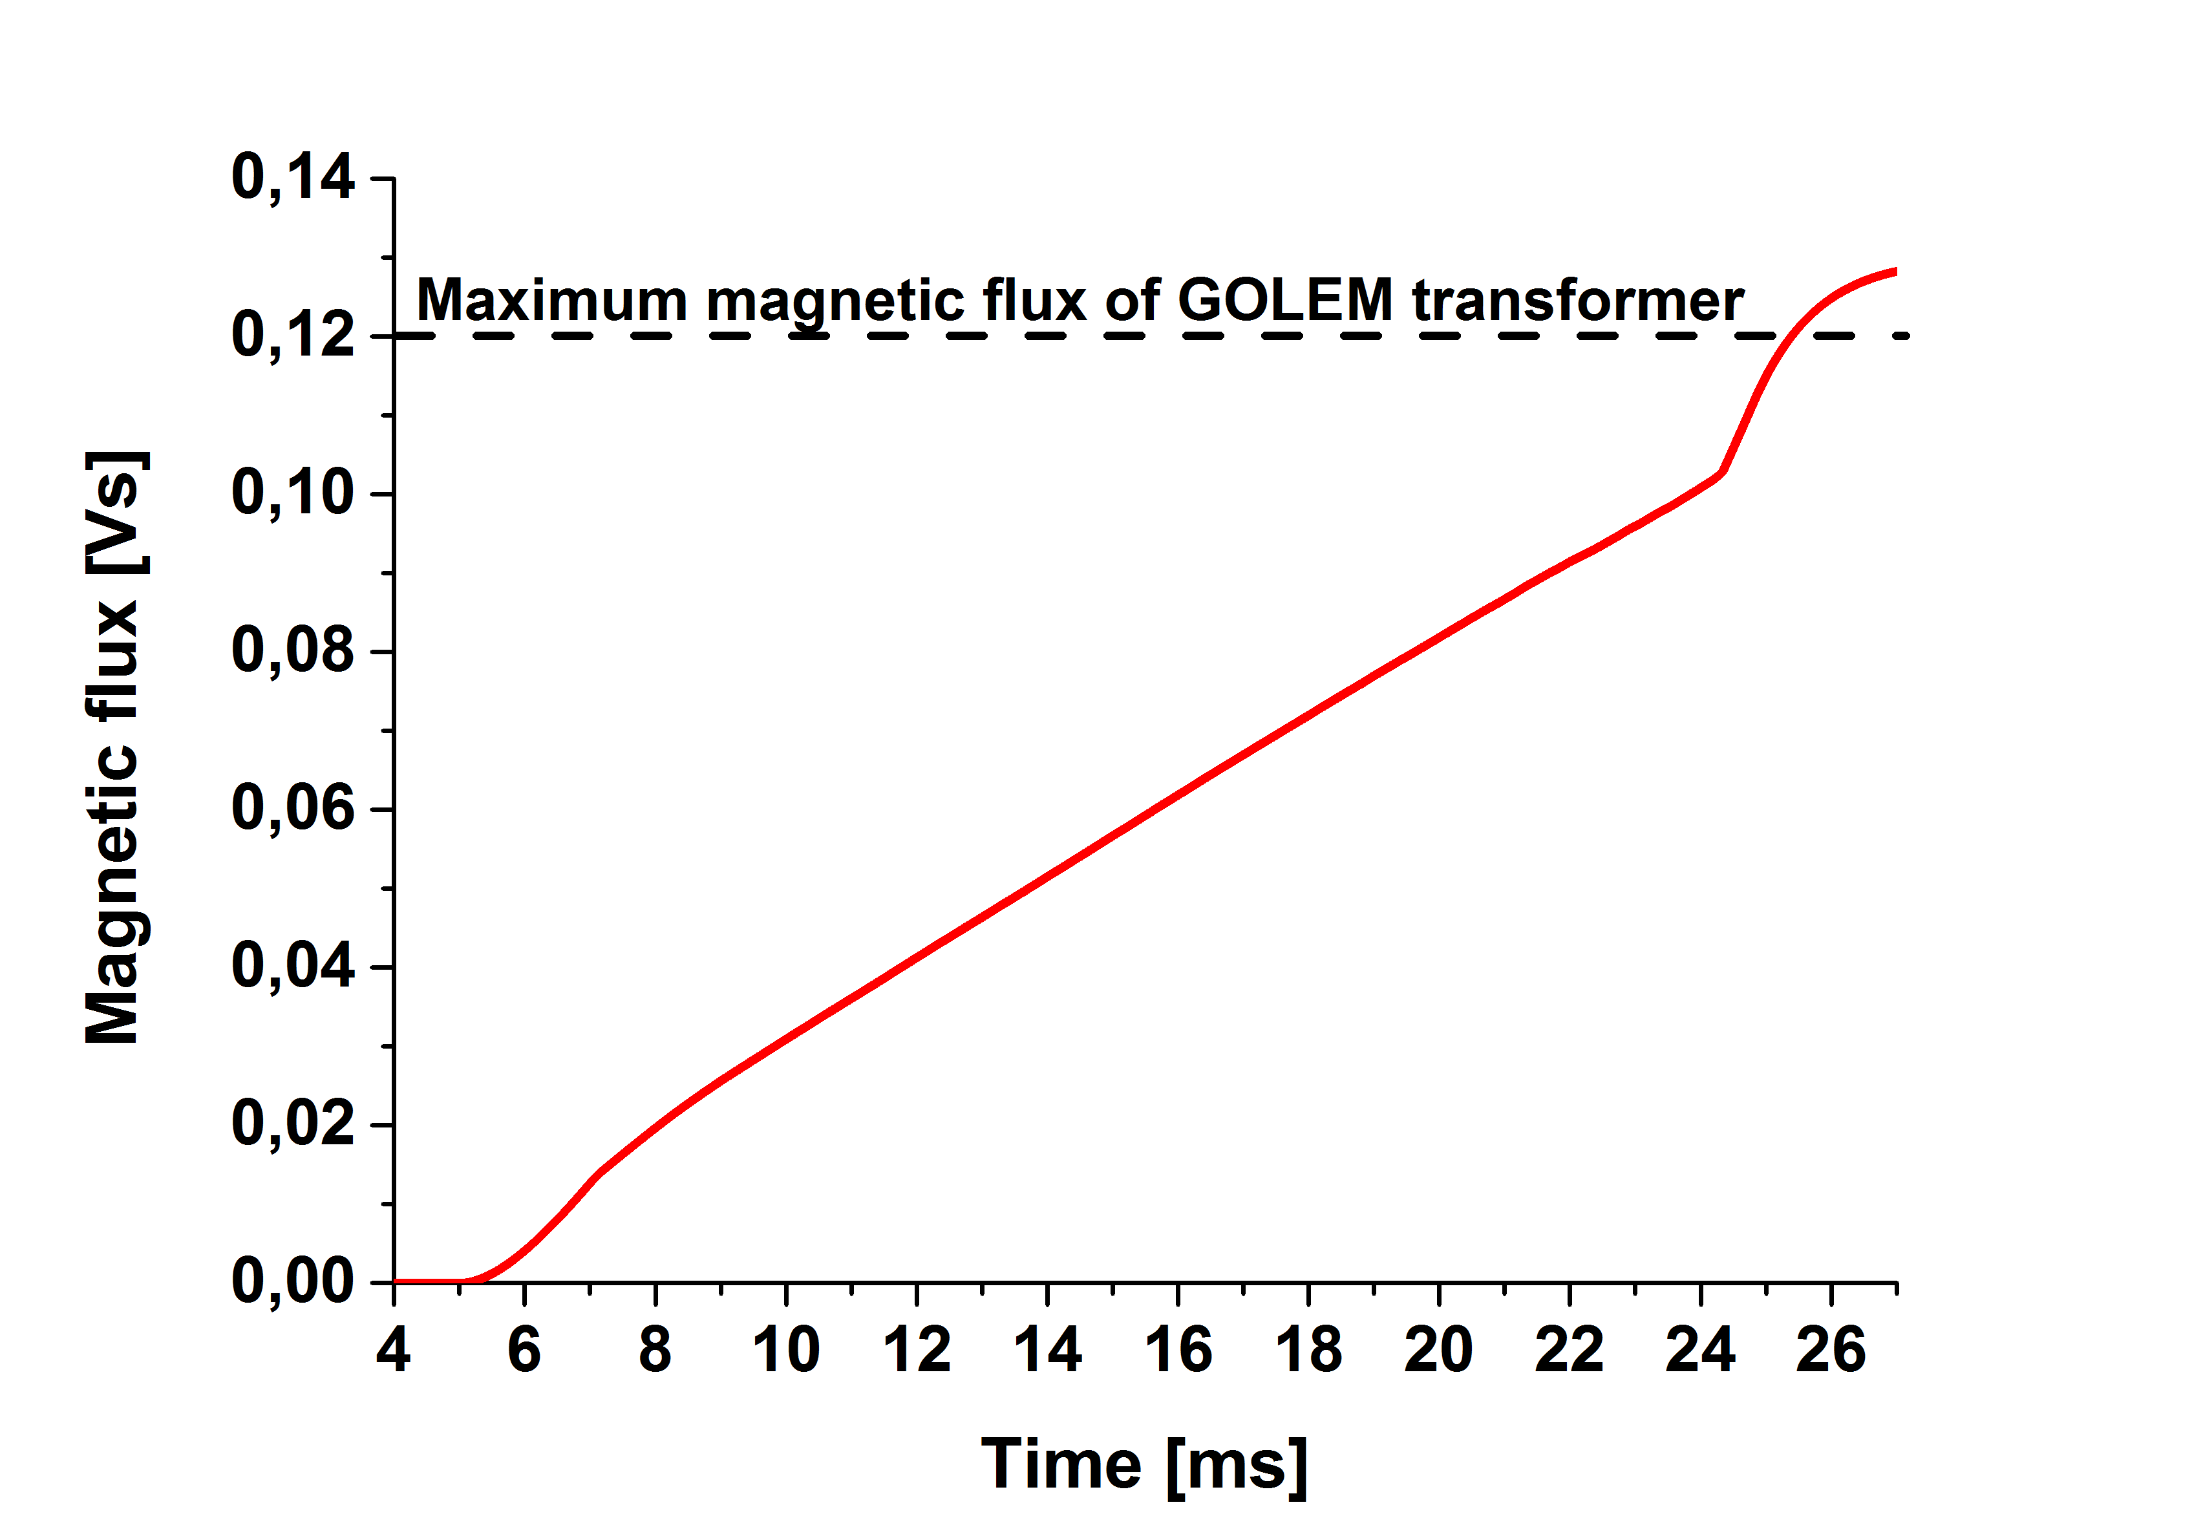
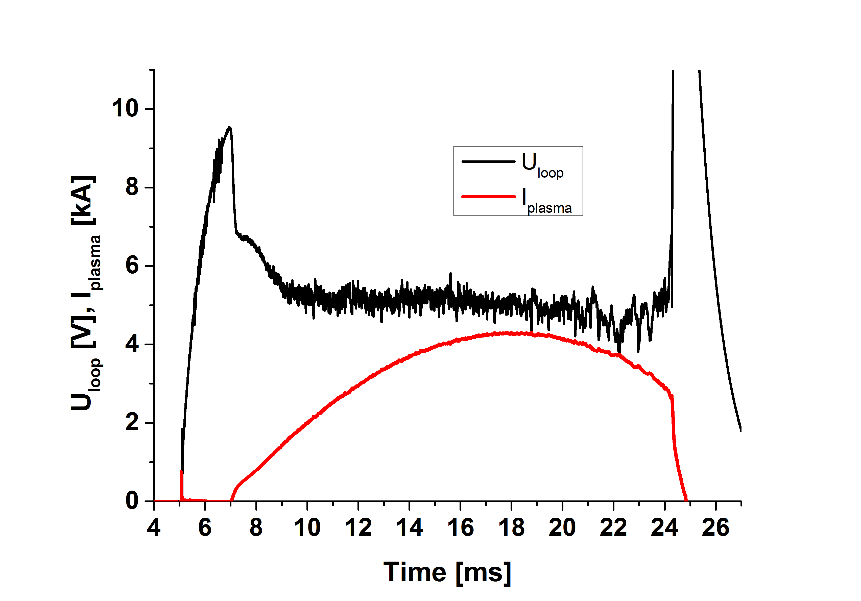
The breakdown voltage is reasonably low – U_{loop}(BD) = 9.5 V at t = 7 ms. The loop voltage is relatively flat, being around 5 V from ~9 to 24 ms. However, whole magnetic flux of the GOLEM transformer which is available (0.12 Vs) is consumed during this shot, as evident in the right panel of Fig. 1. Therefore, the achieved duration of the discharge is almost maximum – the discharge could be longer only by ~2.5 ms!! The only way to prolog the shot is to reduce the loop voltage. Note that just ~10% of magnetic flux is consumed for plasma breakdown – the start-up phase of the discharge is quite optimized. The maximum plasma current is I_{pl} = 4.3 kA-good.
Evolution of the electron density and visible emission is shown in Fig. 2.
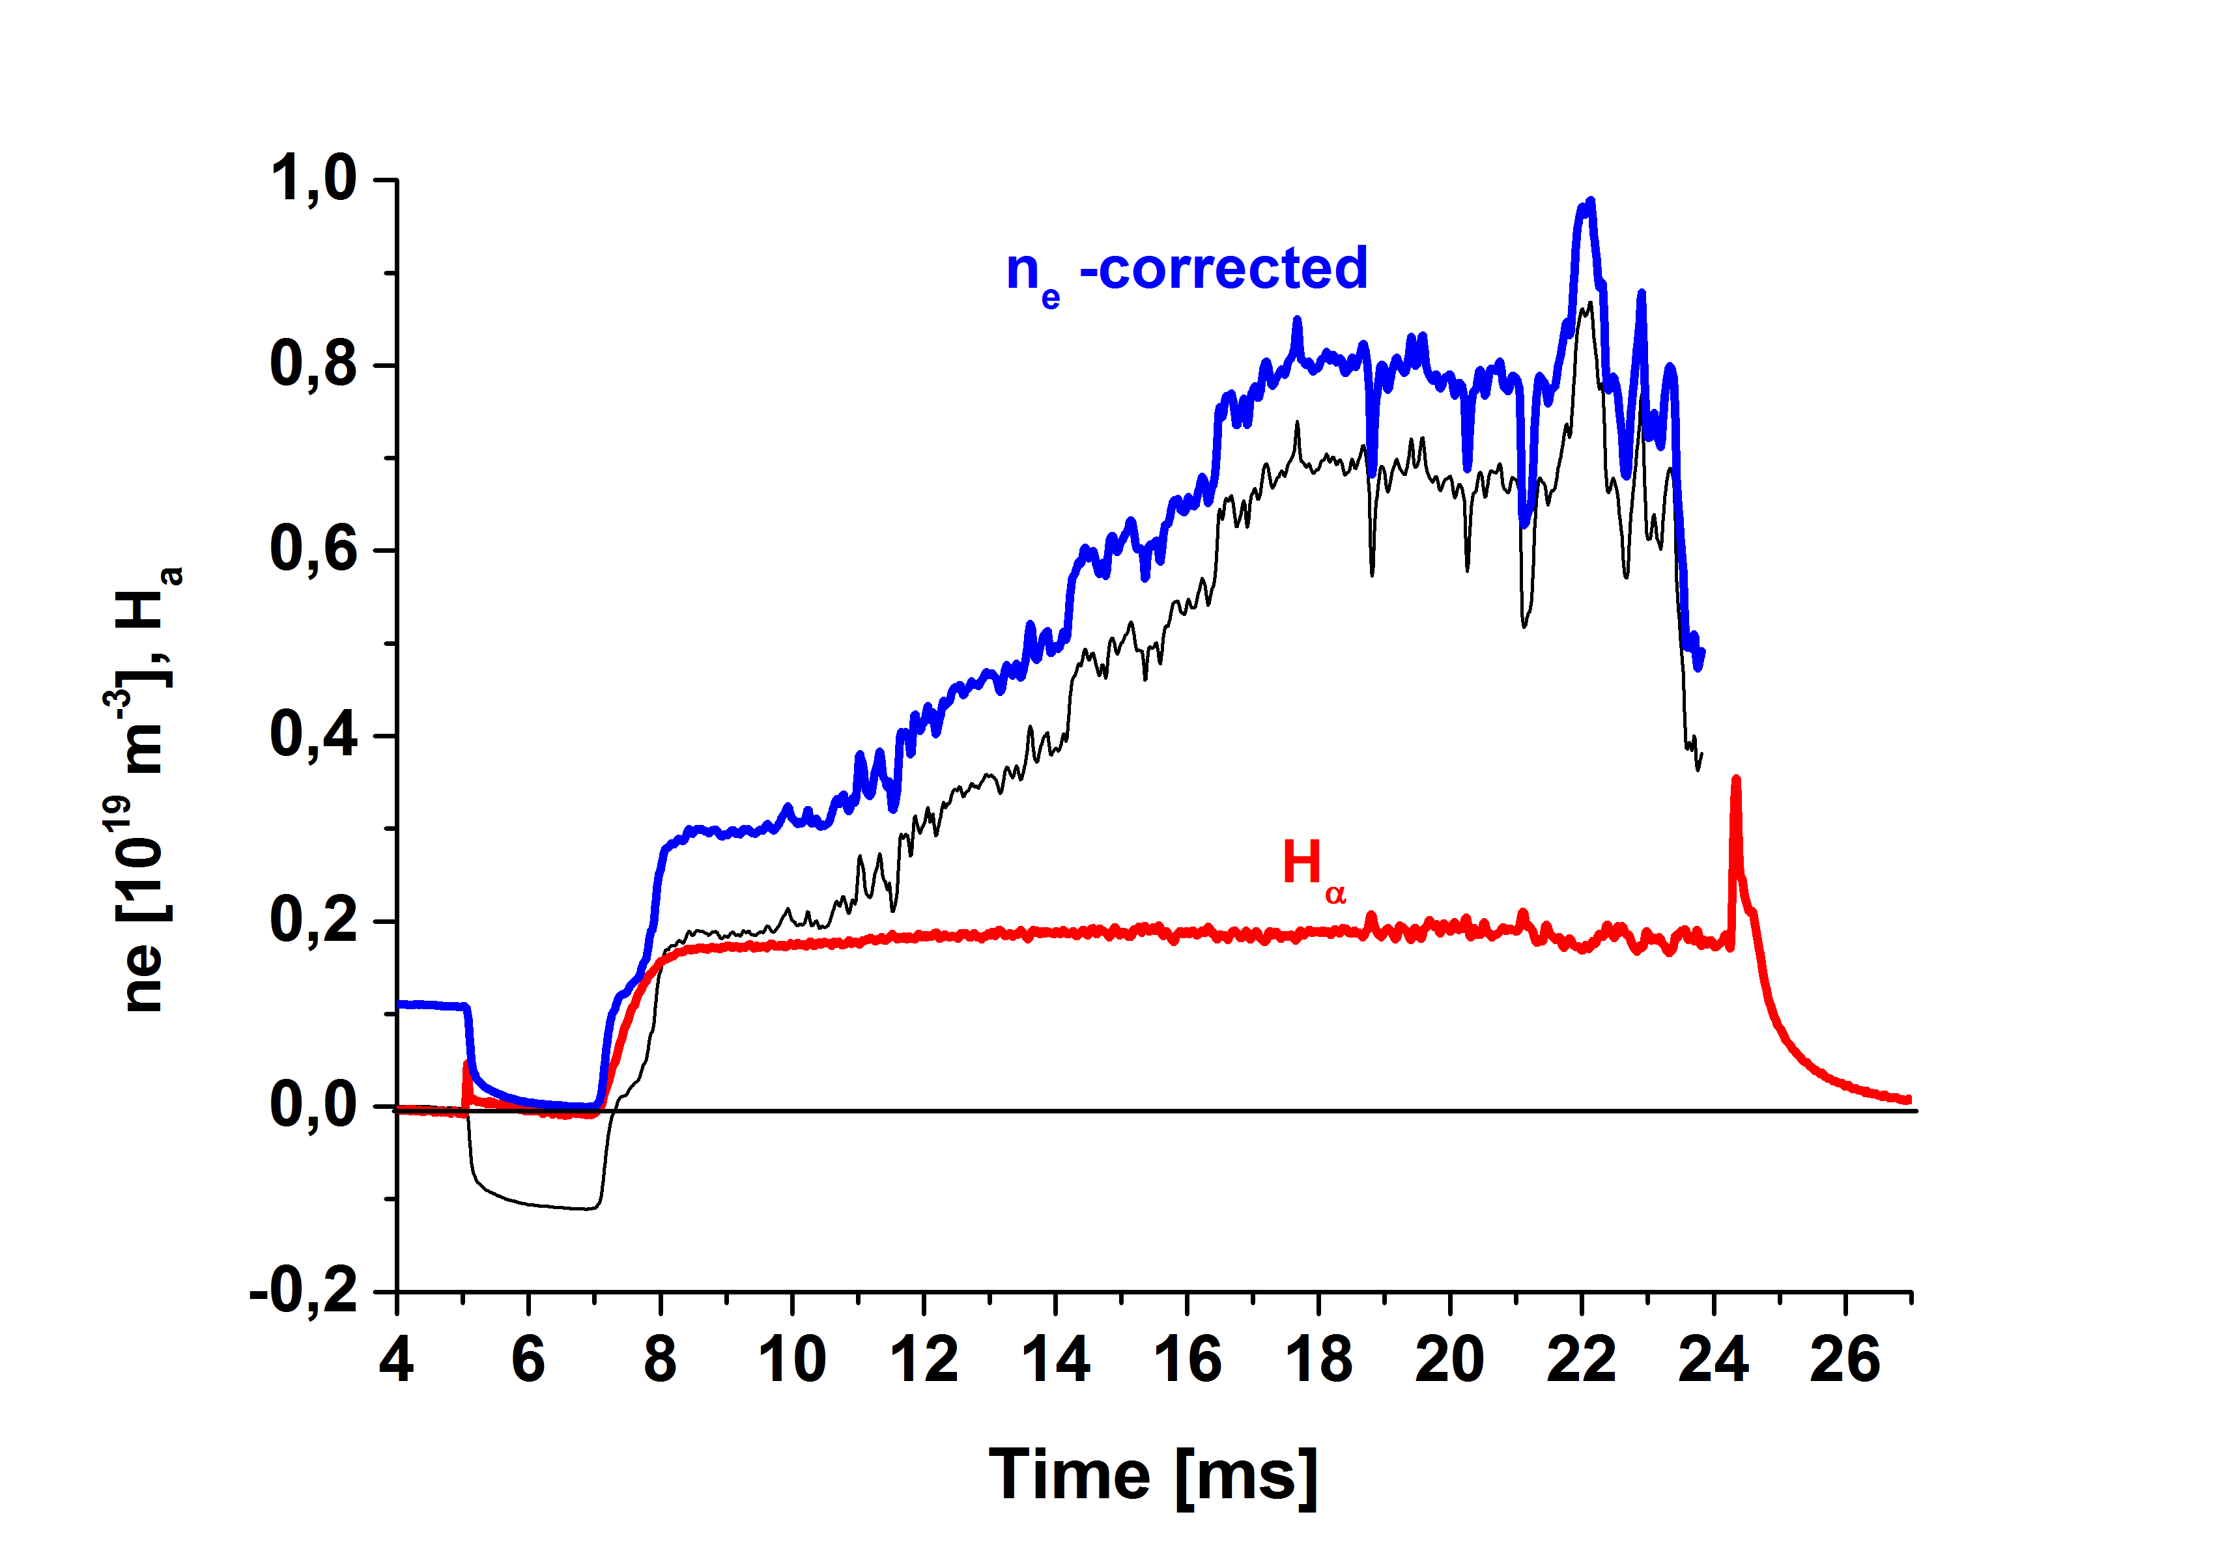
The density increases during the discharge. This is consequence of plasma wall interaction caused by increasing displacement of the plasma column during the discharge. The visible emission is constant for the same reasons. Any burn out is not observed.
Actions: More intensive cleaning of the vessel and plasma position control is required.
11.3.2016, Jan Stockel

