Measurements with the double tunnel probe on the GOLEM tokamak
GOMTRAIC 2019
Jan Stockel
Aim of this experiment is to operate the tunnel probe under discharge conditions on the GOLEM tokamak, ad to analyze experimental data.
Background
A new kind of concave Langmuir probe called the "tunnel probe" has been proposed [1], see Fig.1.
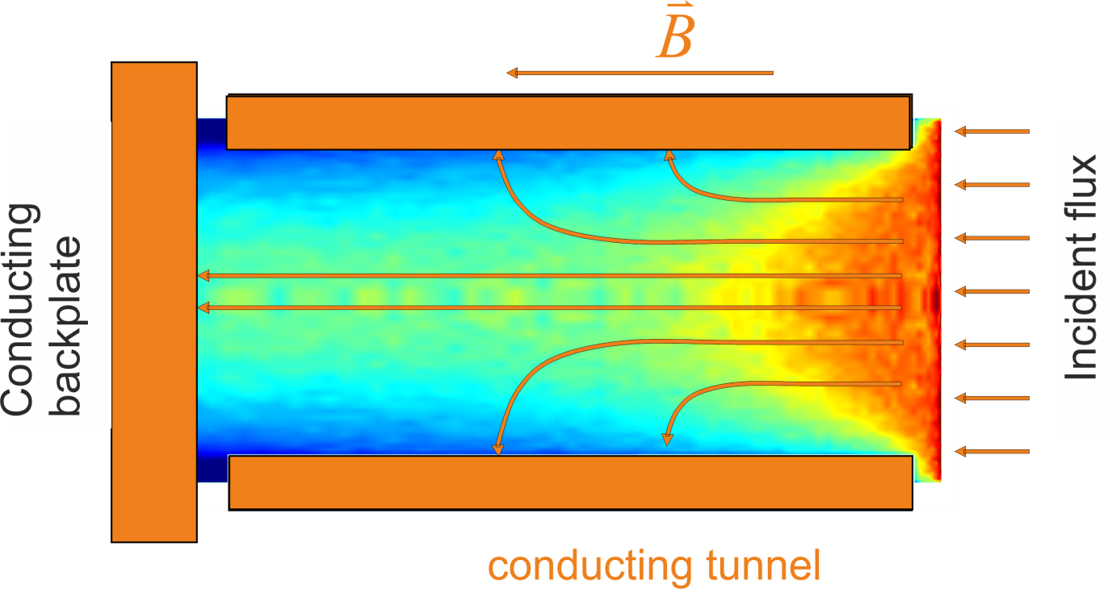

Fig. 1 Scheme of the tunnel probe

The tunnel probe consists of a hollow conducting cylinder, the "tunnel" that is closed at one end by an electrically isolated "backplate". The tunnel axis is parallel to the magnetic field. Plasma flows into the open orifice and the ion flux is distributed between the tunnel and the back plate. A two-dimensional, self-consistent kinetic code called "PICCYL" (Particle-In-Cell code in CYLindrical geometry) was developed in order to model the flow of charges within the cavity of the tunnel probe. Simulations show that despite the strong influence of the electric field on the distribution of ion flux inside the tunnel, it does not penetrate into the plasma. The ion trajectories leading up to the mouth of the tunnel are totally unperturbed. That is, the effective collecting area of a concave Langmuir probe embedded in a nearly planar object is almost exactly equal to the geometrical cross section of its orifice projected along the field lines, which means that such a probe would be absolutely calibrated for the measurement of parallel ion current density, independent of the plasma parameters. Furthermore, the distribution of ion current between the tunnel and backplate depends on the electron temperature. This means that a DC-biased tunnel probe can be used to provide fast, simultaneous measurements of parallel ion current density (the sum of currents to tunnel and backplate) and electron temperature (related the ratio of the currents).
Example of results of numerical simulations of the tunnel probe is shown in Fig.2. The ratio of the ion current I_{T}/(I_{BP} +I_{T}) is plotted versus the ion saturation current density for the toroidal magnetic field B_{TOR} = 1 T. The radius of the tunnel is a =0.25 cm and its length is 0.5 cm.
The ion saturation current density collected by the tunnel probe is calculated as
$J_{sat}=\frac{I_{T}+I_{BP}}{πa^{2}}$ [A/cm2, A, cm]
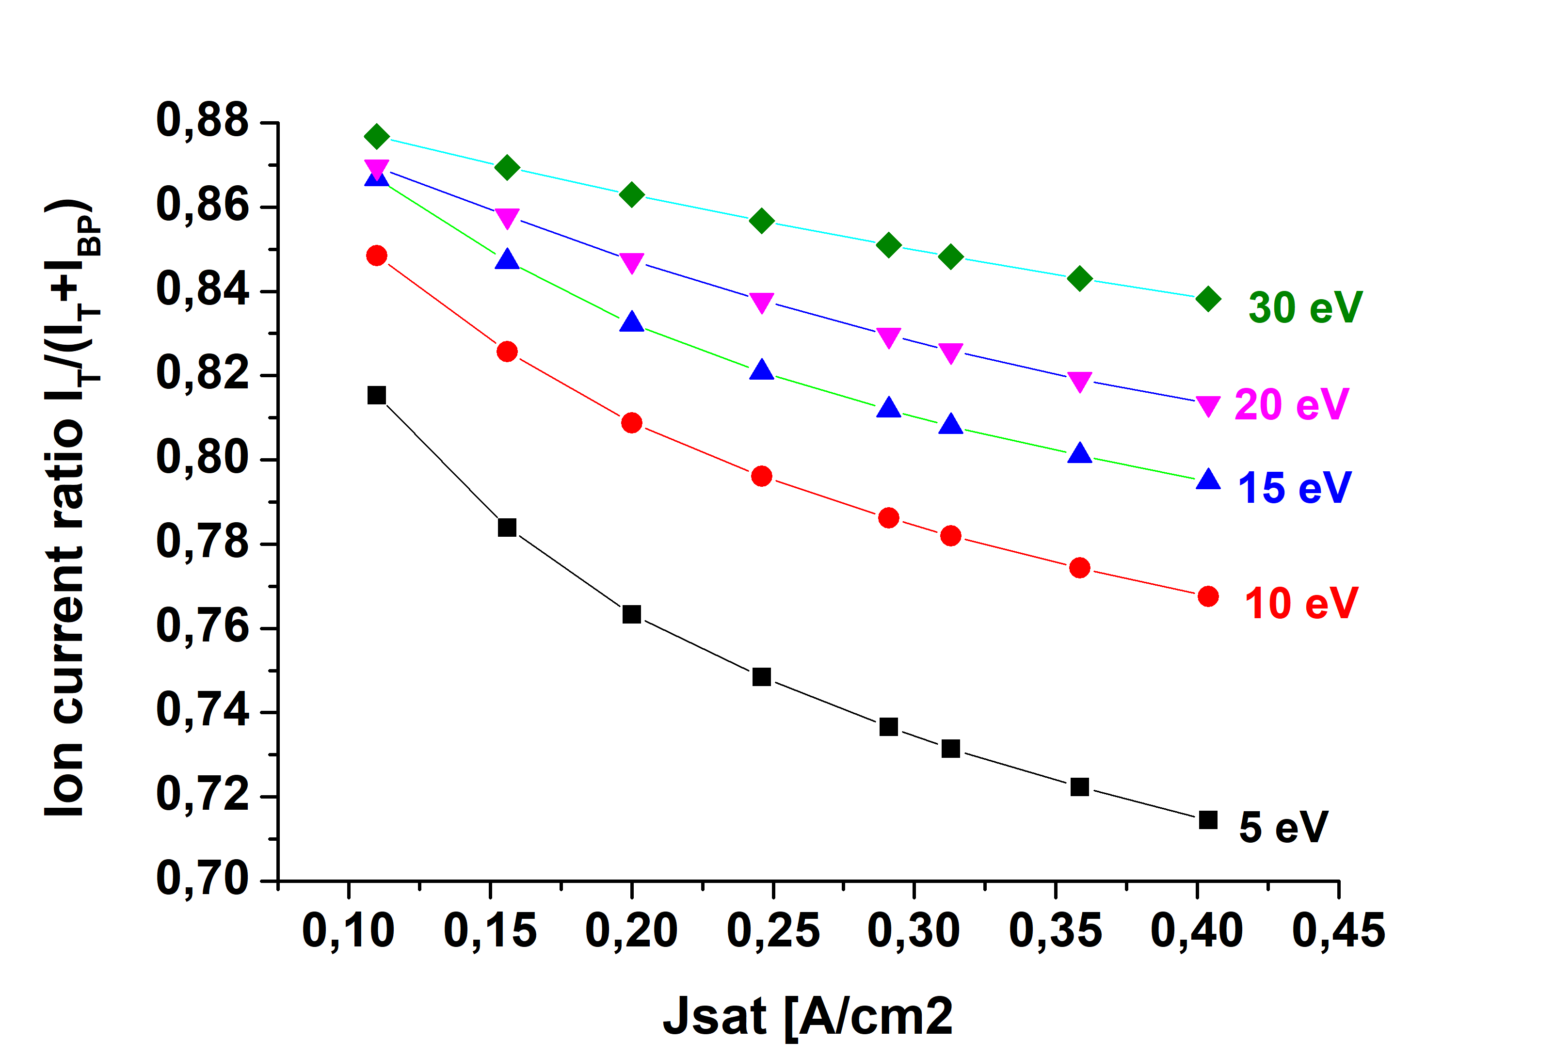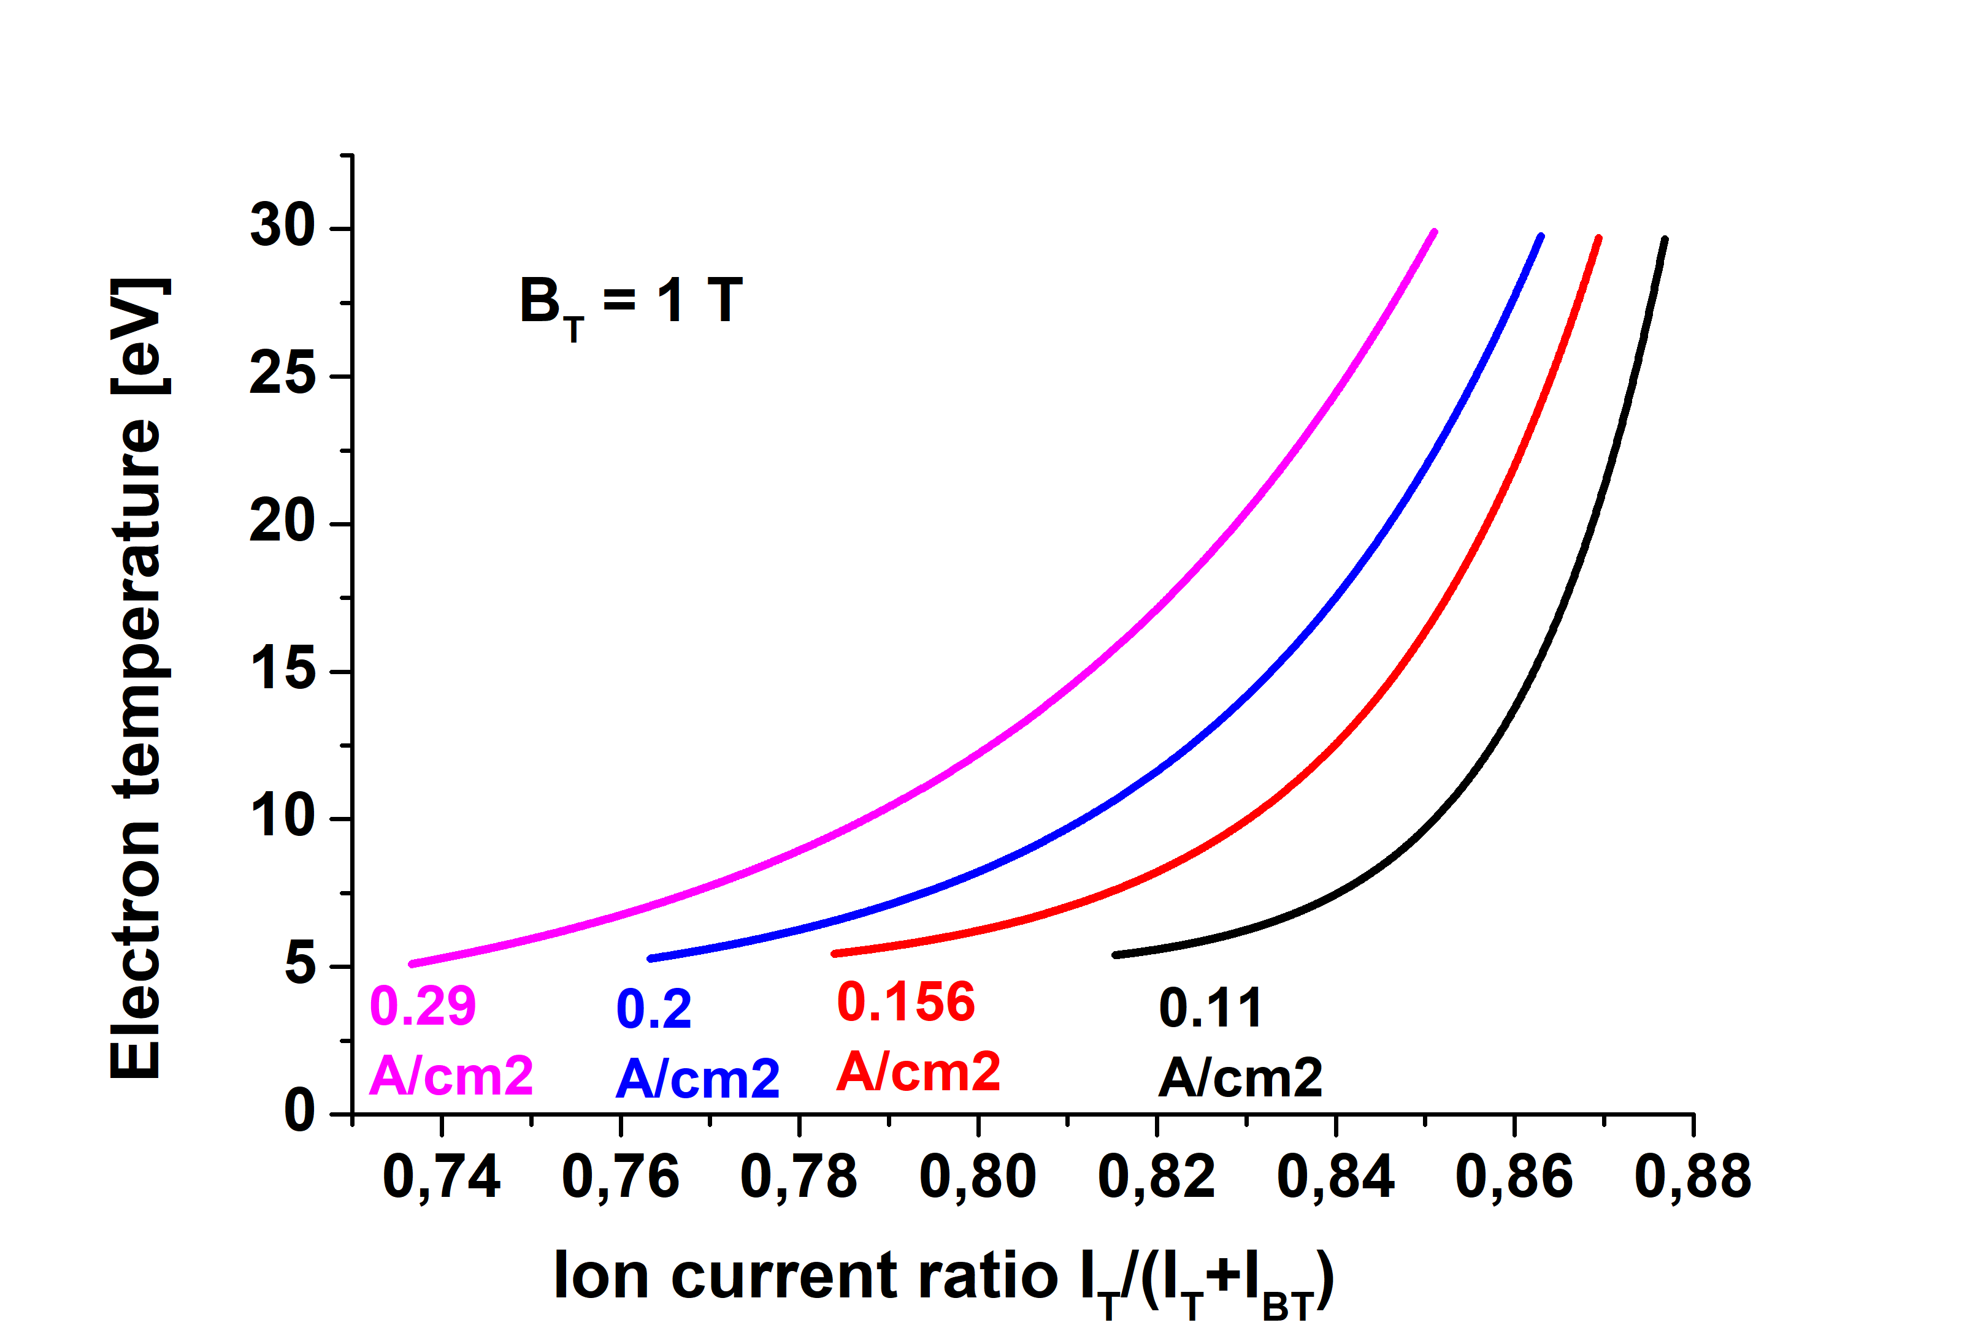
Fig. 2 Numerical calibration of the tunnel probe (B_{tor} = 1 T)

We see that the ratio I_{T}/I_{BP} is a strong function of the electron temperature for a given value of J_{sat}. So, if we measure the ion current ratio and the ion current density, we can determine the electron temperature.

Experimental program for GOMTRAIC
The double tunnel probe, installed currently at GOLEM is depicted in Fig. 3.
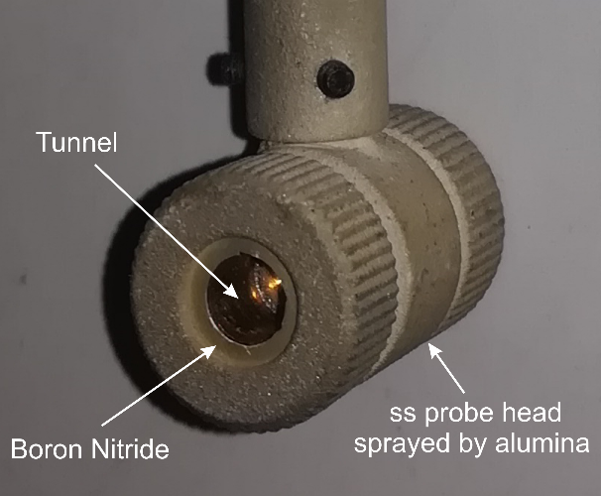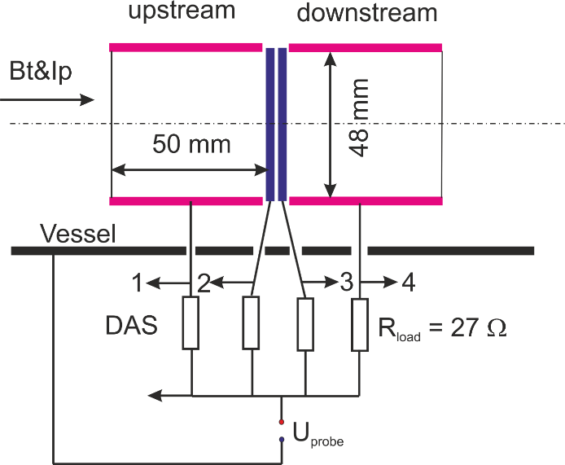
Fig. 3 Picture and the schematic arrangement of the double tunnel probe for GOLEM
The double tunnel probe is installed in the bottom port, 90º toroidally away from the circular limiter (a = 85 mm) and positioned at a distance r from the center of the GOLEM vessel. Positioning of the double tunnel on GOLEM with respect to the orientation of the toroidal magnetic field & plasma current, as well as to the circular limiter is shown in Fig. 4

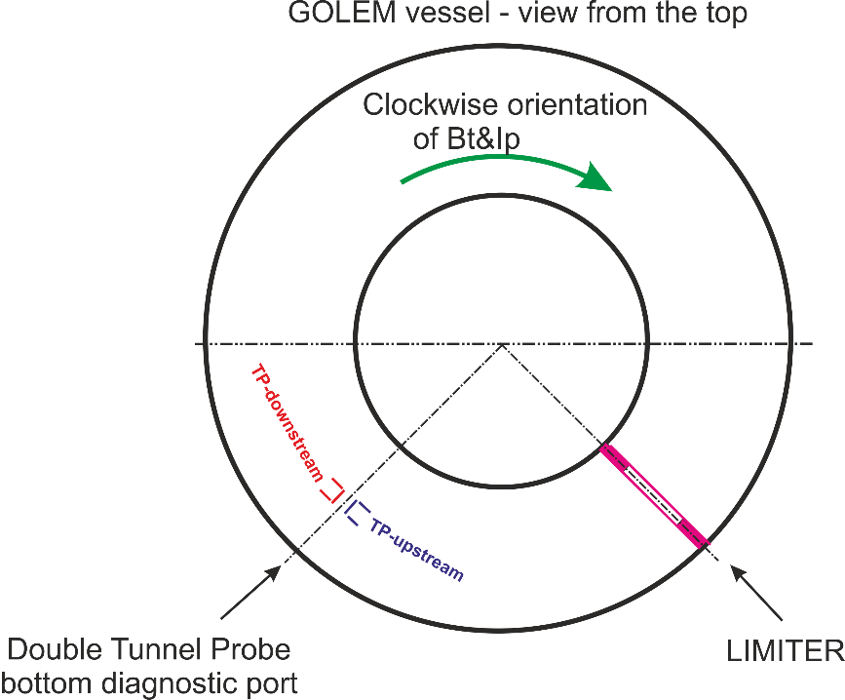
Fig.4. Schematic lay-out of experiment with the double tunnel probe in the case of the clockwise orientation of the plasma current and the toroidal magnetic field.

All electrodes of the double tunnel probe are biased to – 100 V, and consequently measure the ion saturation current. Experimental data are accessible via internet at http://golem.fjfi.cvut.cz/shots/28794//DAS/1011Papouch_St.ON/ in various formats:
Upstream -Tunnel: tp_t_limiter (txt,xls,.), Backplate: tp_bp_limiter (txt,xls,.)
Downstream- Tunnel: tp_t_op_limter (txt,xls,.), Backplate: tp_bp_op_limiter (txt,xls,.)

Experimental program
During GOMTRAIC, we plan to perform a series of reproducible discharges (about 15) with a different position of the double tunnel probe with respect to the center of the tokamak vessel. Experiment will take roughly 2 hours, and should be performed on Tuesday or Wednesday morning. Reference discharge is #29491. The vacuum vessel of GOLEM has to be heated up to ~200º before at least 30 minutes and the standard cleaning glow discharge in He should be applied after that for 20 minutes

Task 1:
Measure the temporal evolution of the parallel Mach number M_{par} calculated according the expression
$M_{par}=0.4∗ln⁡\left(\frac{J_{sat}^{upstream}}{J_{sat}^{downstream}}\right)$ .
If possible, perform measurement in discharges with clockwise and anticlockwise orientation of the toroidal magnetic field and plasma current.
Task 2: Calculate the ion current ratio I_{T}/(I_{BP} +I_{T}) at the same discharge series and try to estimate the electron temperature according PIC calibration, and the plasma density.

