Experimental program on the tunnel probe (GOMTRAIC 2019)
During GOMTRAIC, we plan to perform a series of reproducible discharges (about 15) with a different position of the double tunnel probe with respect to the center of the tokamak vessel. Experiment will take roughly 2 hours, and should be performed on Tuesday or Wednesday morning. Reference discharge is #29491. The vacuum vessel of GOLEM has to be heated up to ~200º before at least 30 minutes and the standard cleaning glow discharge in He should be applied after that for 20 minutes
Task 1:
Measure the temporal evolution of the parallel Mach number M_{par} calculated according the expression
$M_{par}=0.4*ln⁡(\frac{J_{sat}^{upstream}}{J_{sat}^{downstream}})$ .
If possible, perform measurement in discharges with clockwise and anticlockwise orientation of the toroidal magnetic field and plasma current.
Task 2: Calculate the ion current ratio I_{T}/(I_{BP} +I_{T}) at the same discharge series and try to estimate the electron temperature according PIC calibration, and the plasma density.
Manual – how to process experimental data
- Download all DAS channels from the double tunnel probe
- Remove offsets of all signals, because data of some channels do not start and end at zero. This is important, because we should calculate ratio of signals latter on. Example of such offset is shown in fig. 5
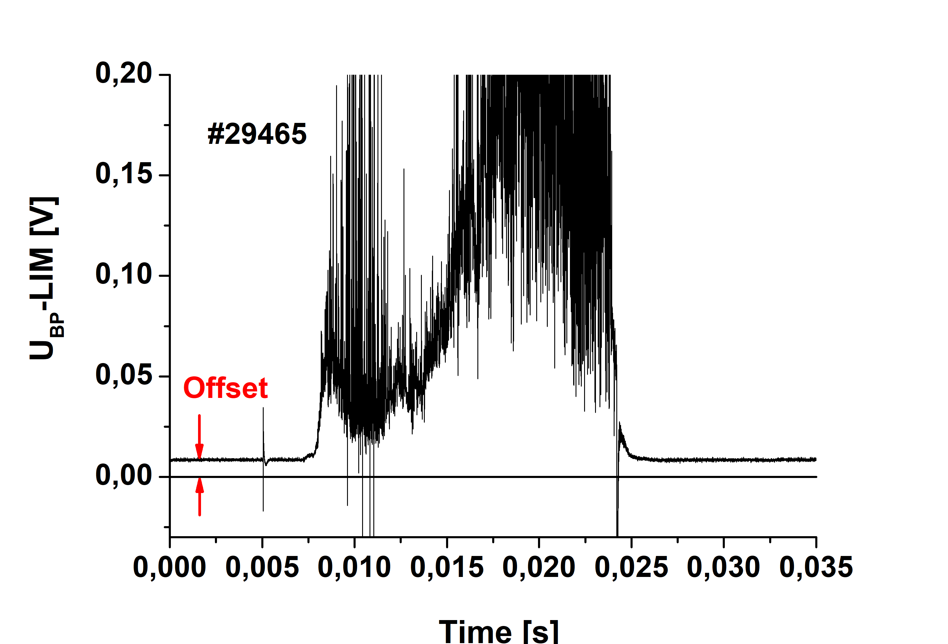
- Sum the tunnel and the backplate signals U_{T}+U_{BP} for both orientation of the tunnel probe.
- Calculate the ion saturation current densities for upstream and downstream TPs as
$J_{sat}=\frac{U_{T}+U_{BP}}{R}\frac{1}{πa^{2}}$ [V, Ω,cm]
Where R =27 Ω is the resistance used for measurement of probe signals, a = 0.25 cm.
Example of the temporal evolution of J_{sat} are shown in fig. 6.
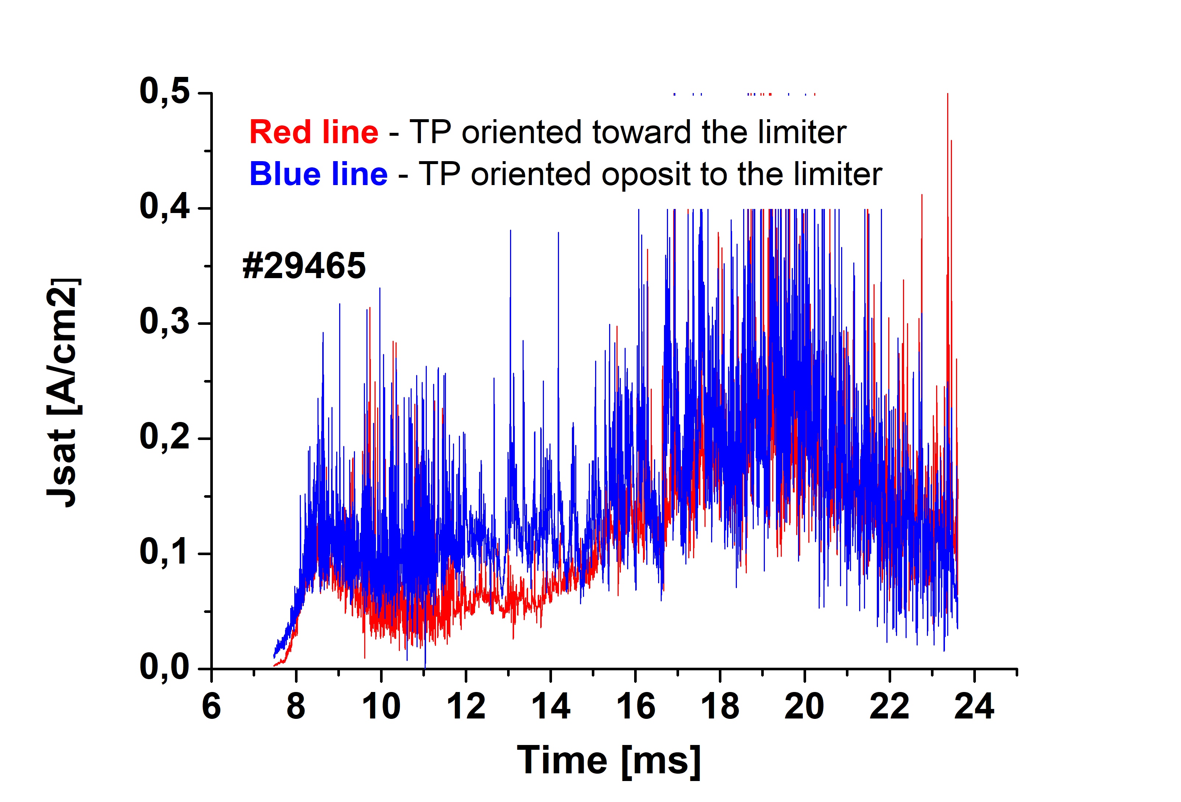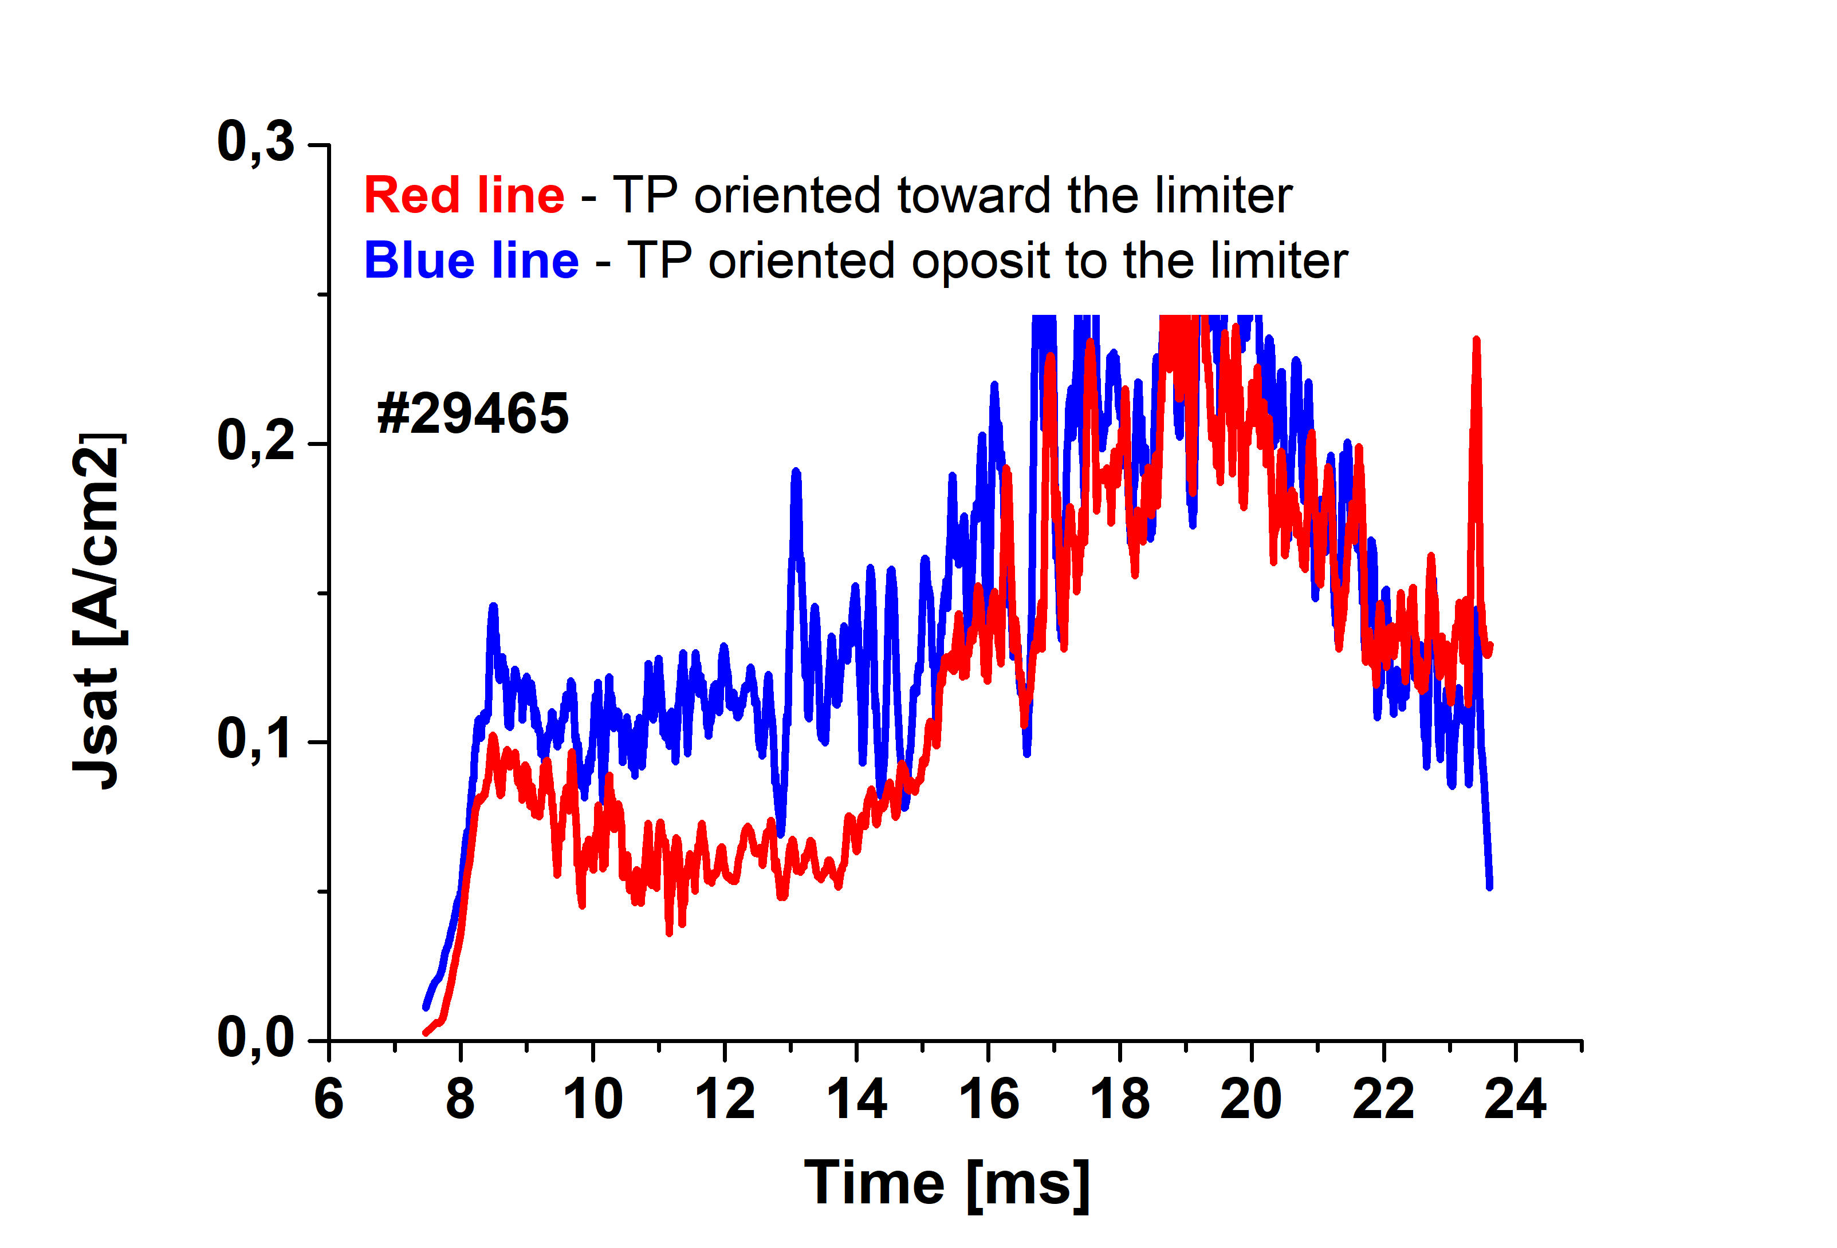
Fig 6. Left – Ion saturation current densities – full data. Right – Jsat smoothed by 200 points (i.e. by 200 μs)
- Calculate temporal evolution of the parallel Mach number
$M_{par}=0.4*ln⁡(\frac{J_{sat}^{lim}}{J_{sat}^{olim}})$
Resulting temporal evolution of M_{par} is shown in the next figure
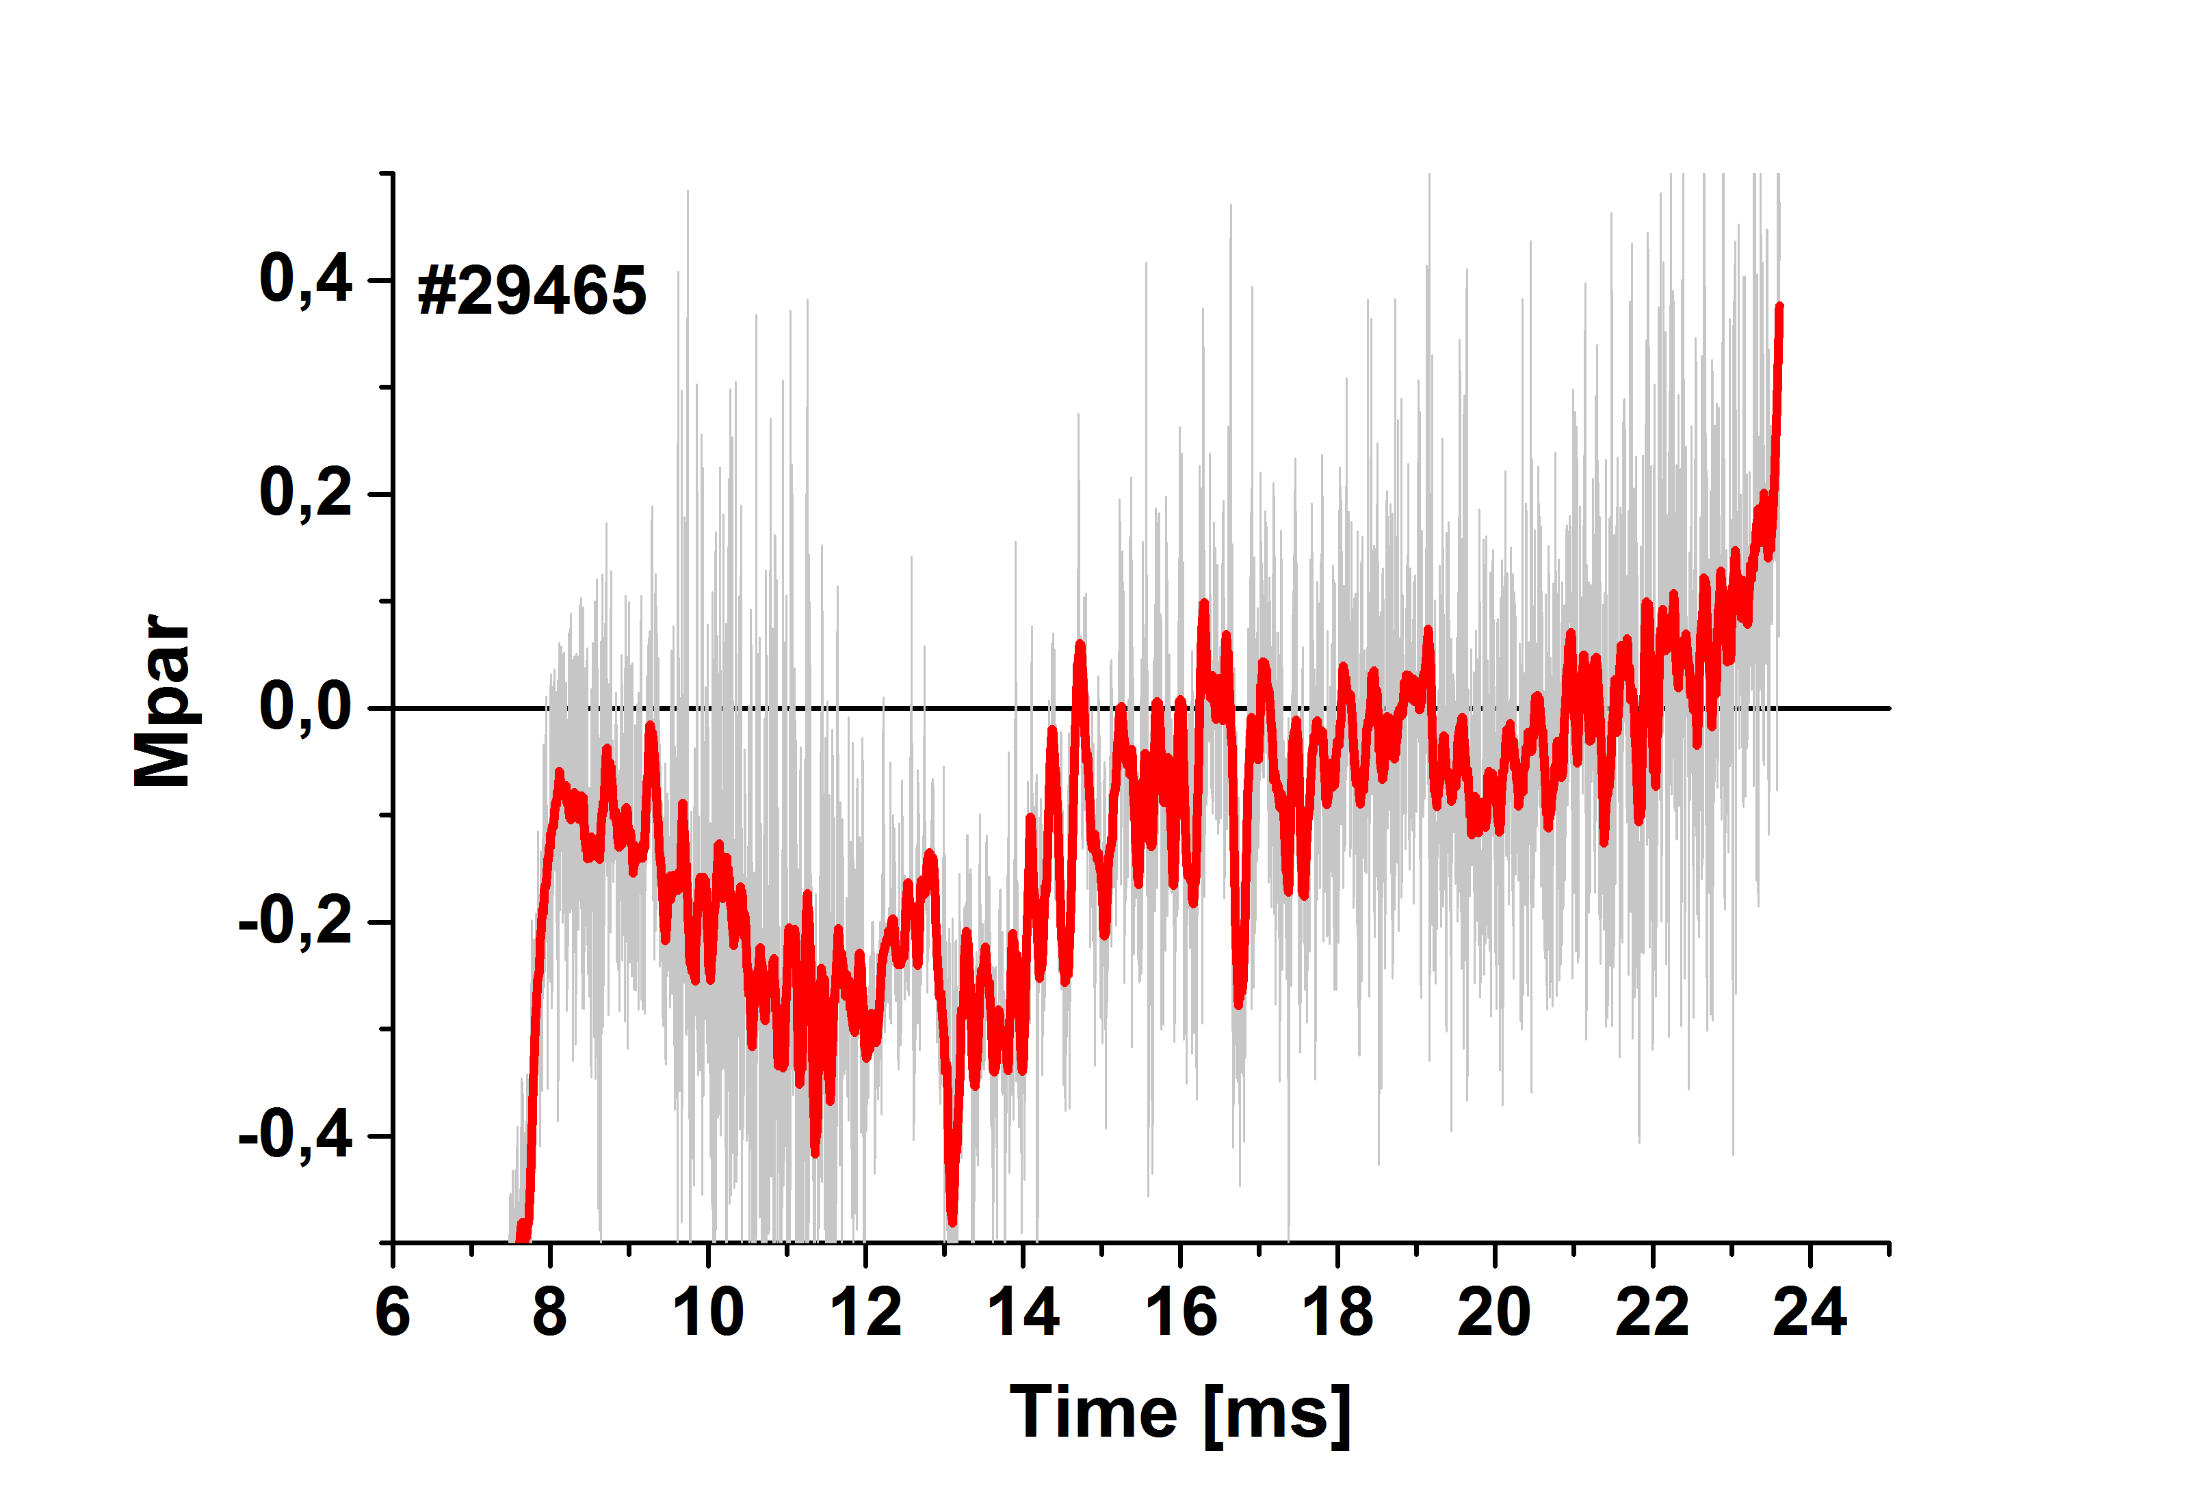
Left Parallel Mach number – full data (gray) and smoothed by 200 points, i.e. by 200 μs (red)
- Calculate the ratio of signals $R=\frac{U_{T}}{U_{T}+U_{BP}}$
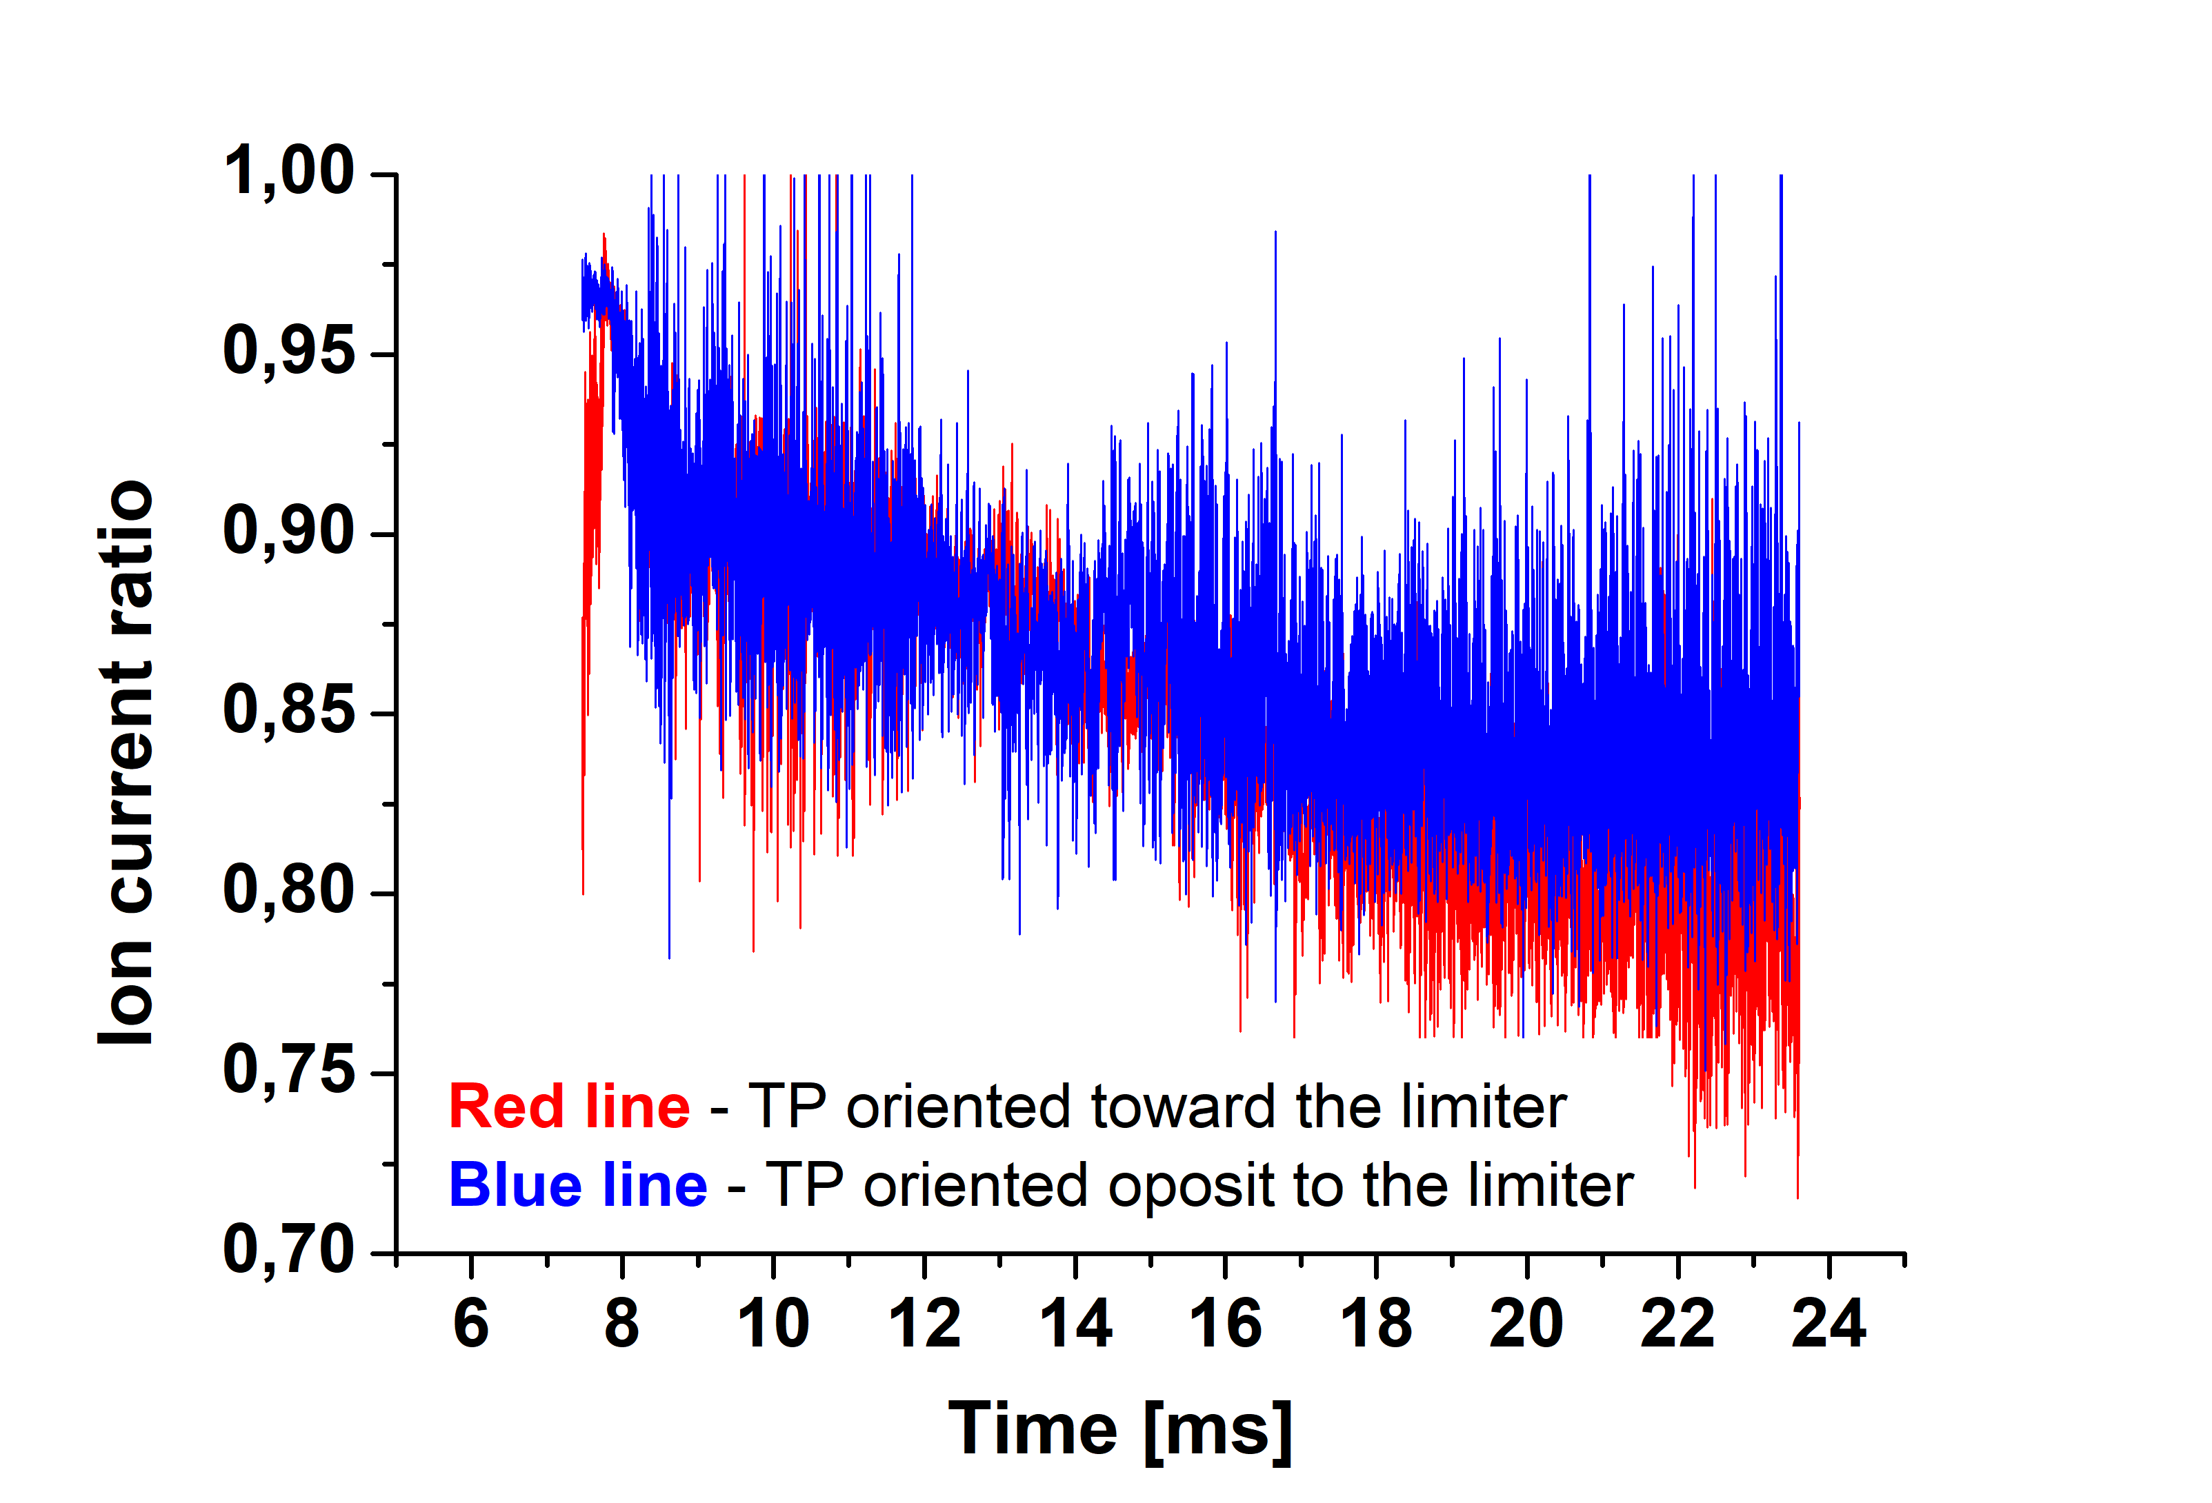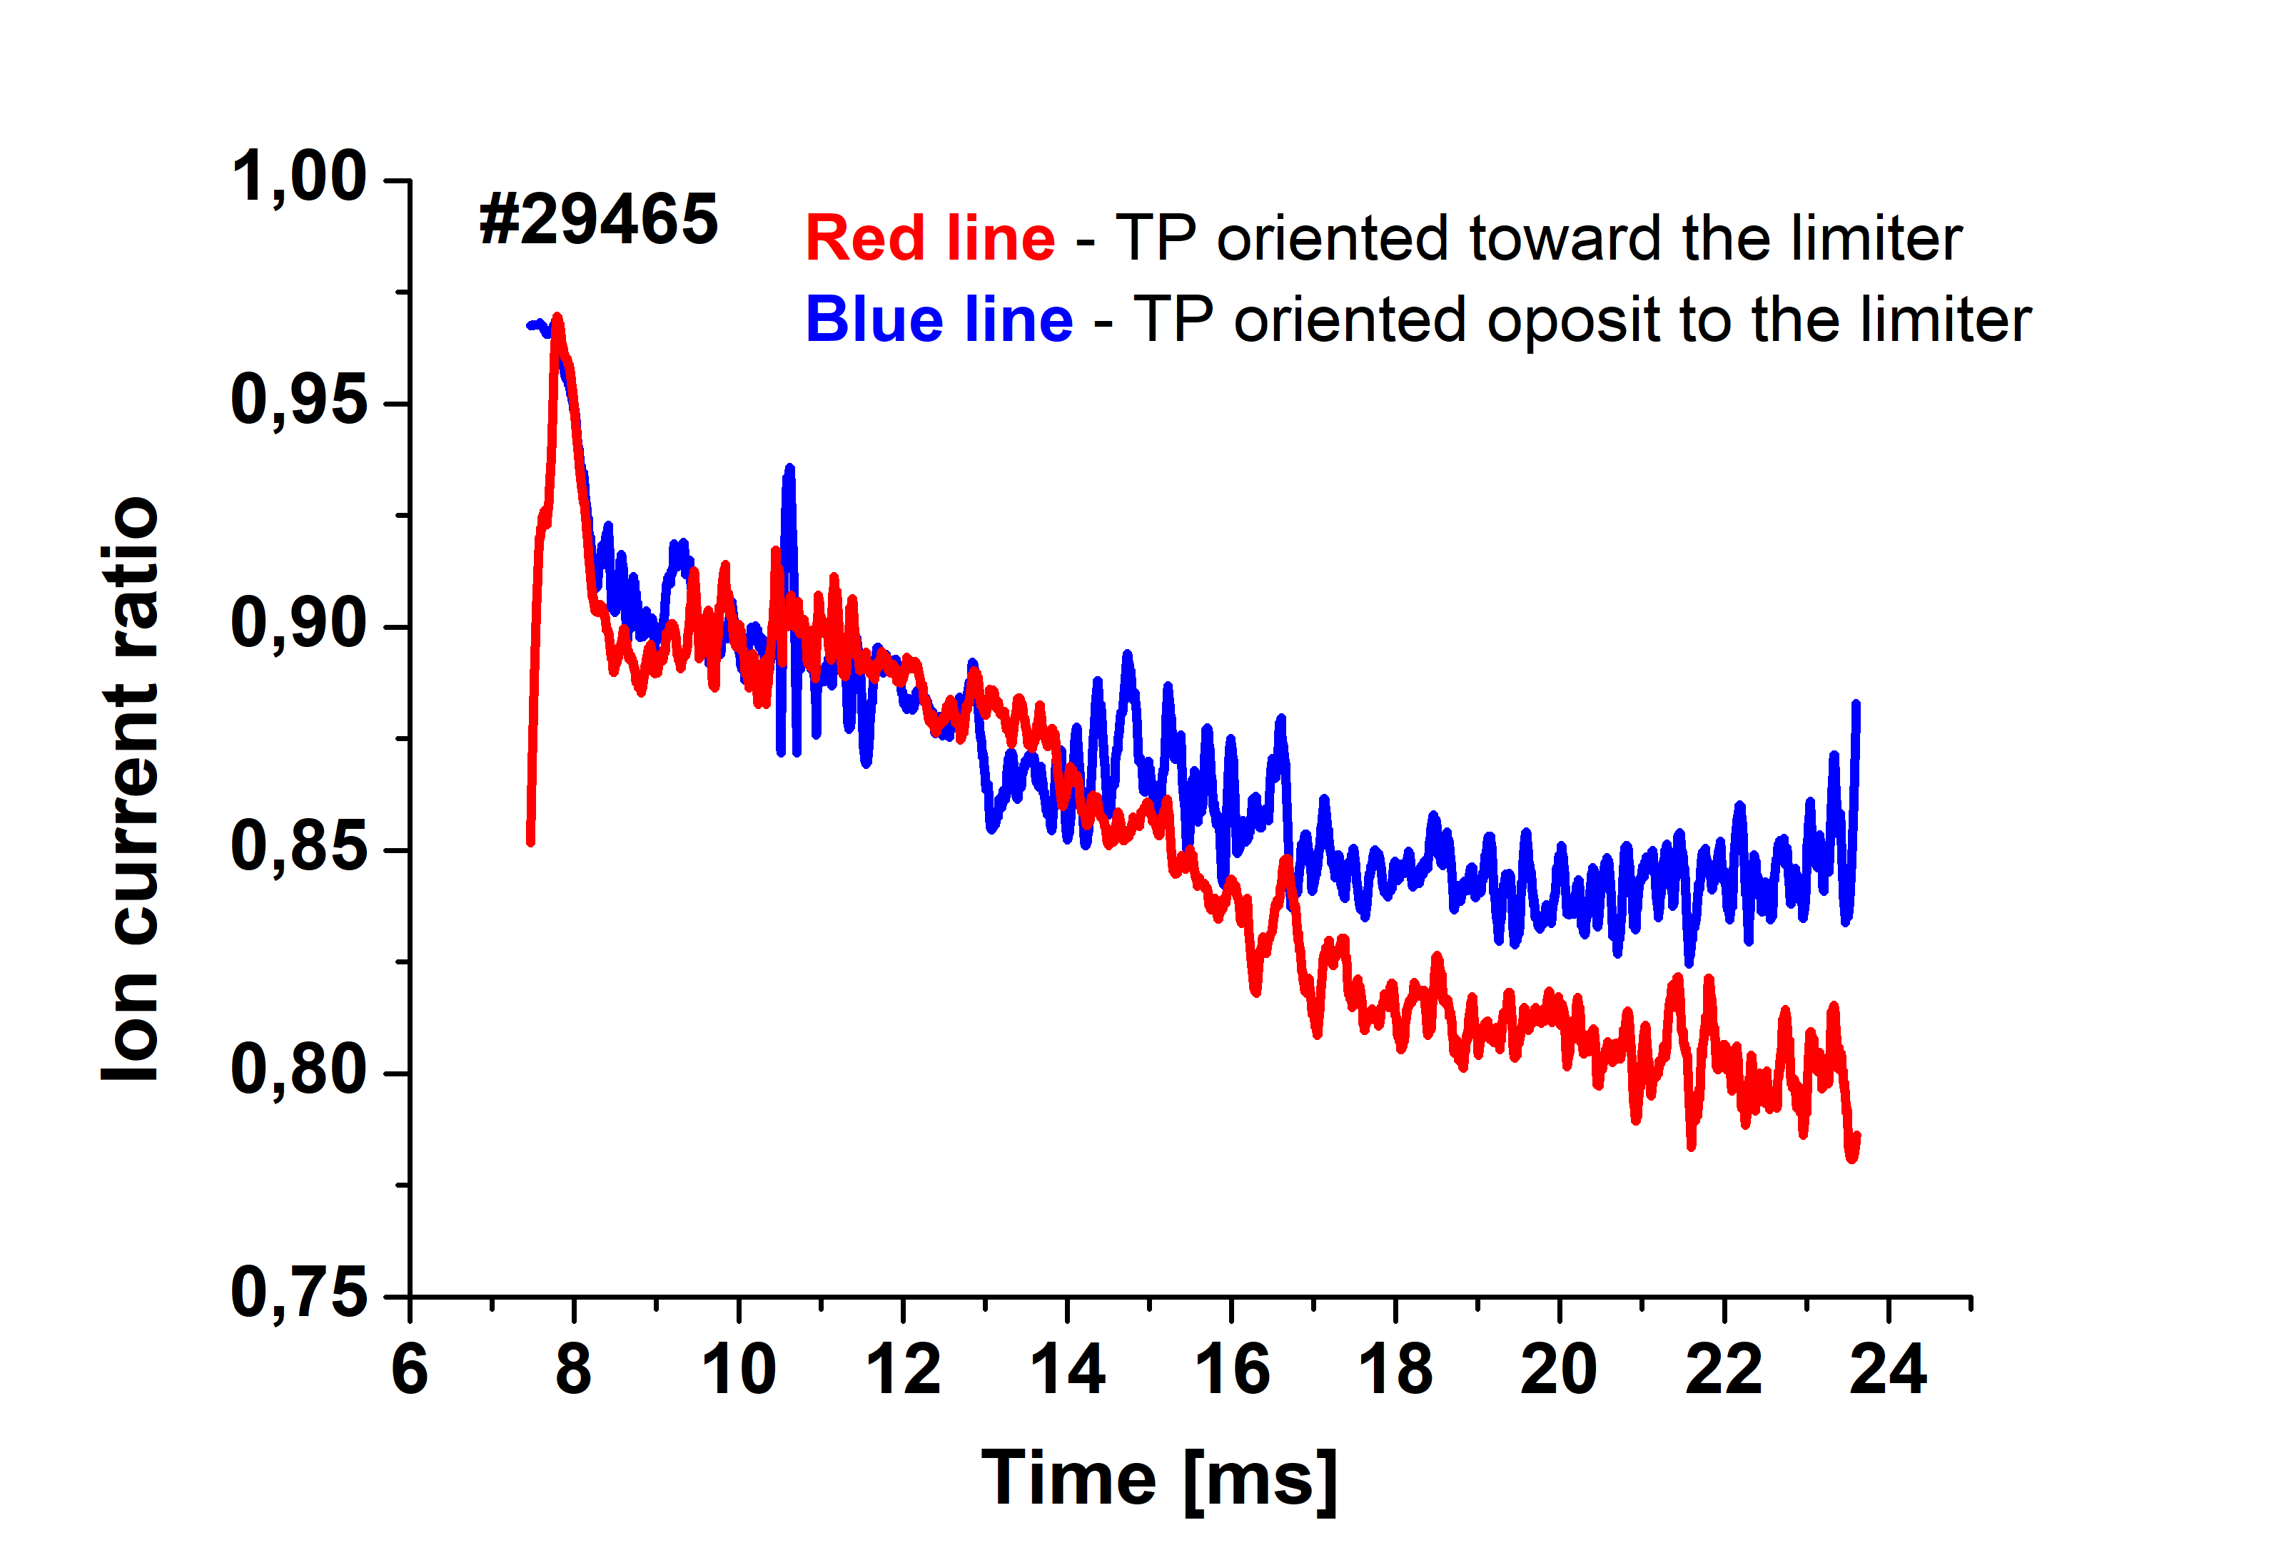
Fig 8. Left – Ion current ratio – full data. Right –smoothed by 200 points (i.e. by 200 μs)
- Plot the temporal evolution of Jsat,
Task 2 – Estimate the electron temperature by using results of the particle in cell simulation of the tunnel probe for both orientation of the tunnel probe.
Performance of the tunnel probe was numerically simulated by PIC code, which results in the following calibration allowing to determine the electron temperature form the probe signals.
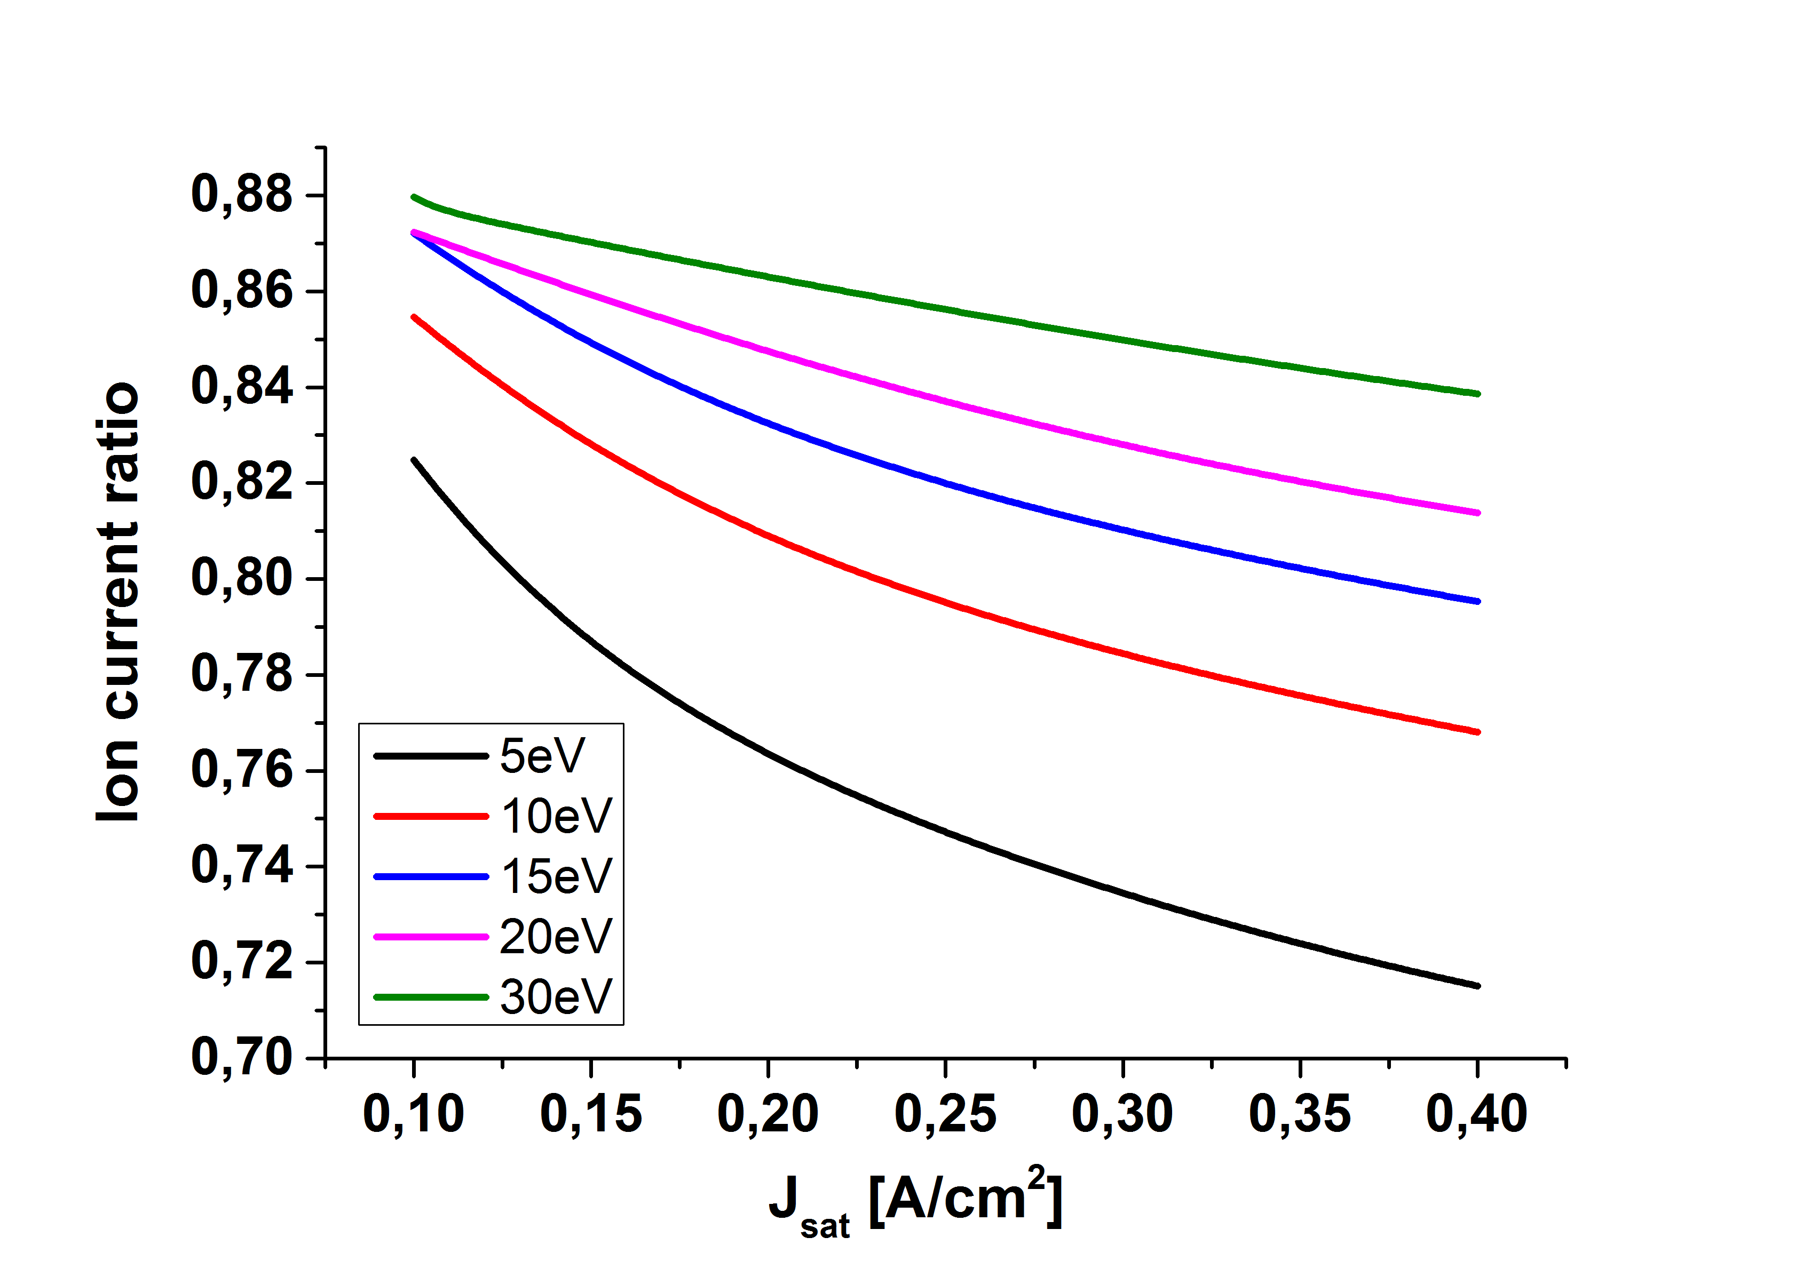
Ratio R = I_{T}/(I_{T}+I_{BP}) versus the ion saturation current density
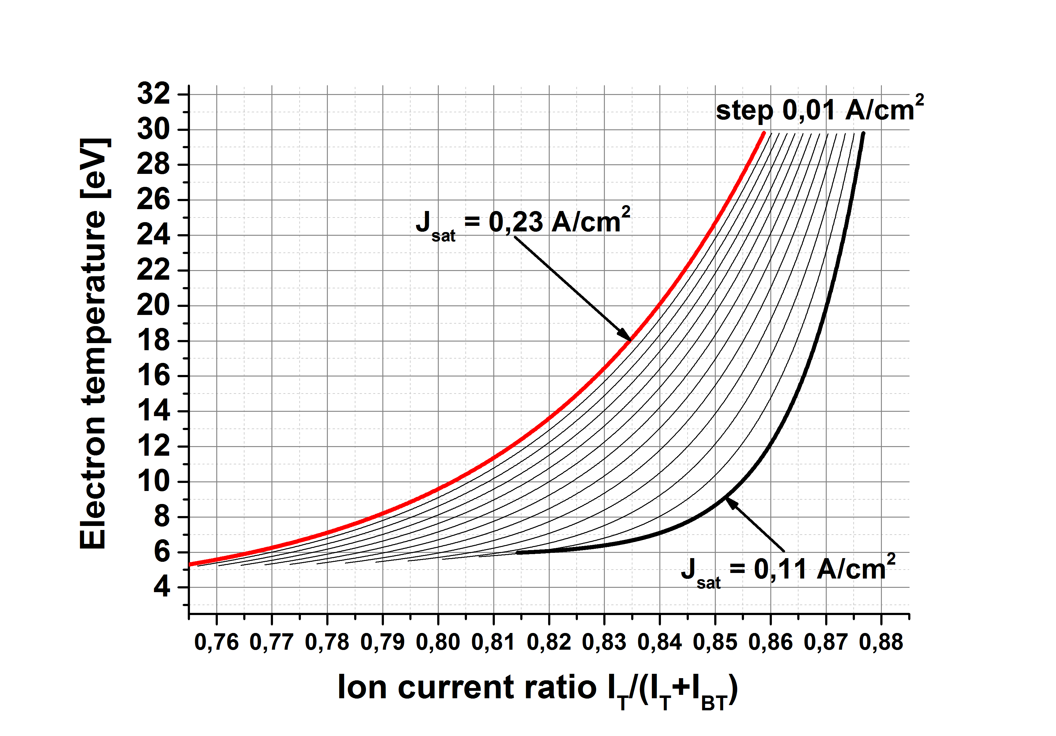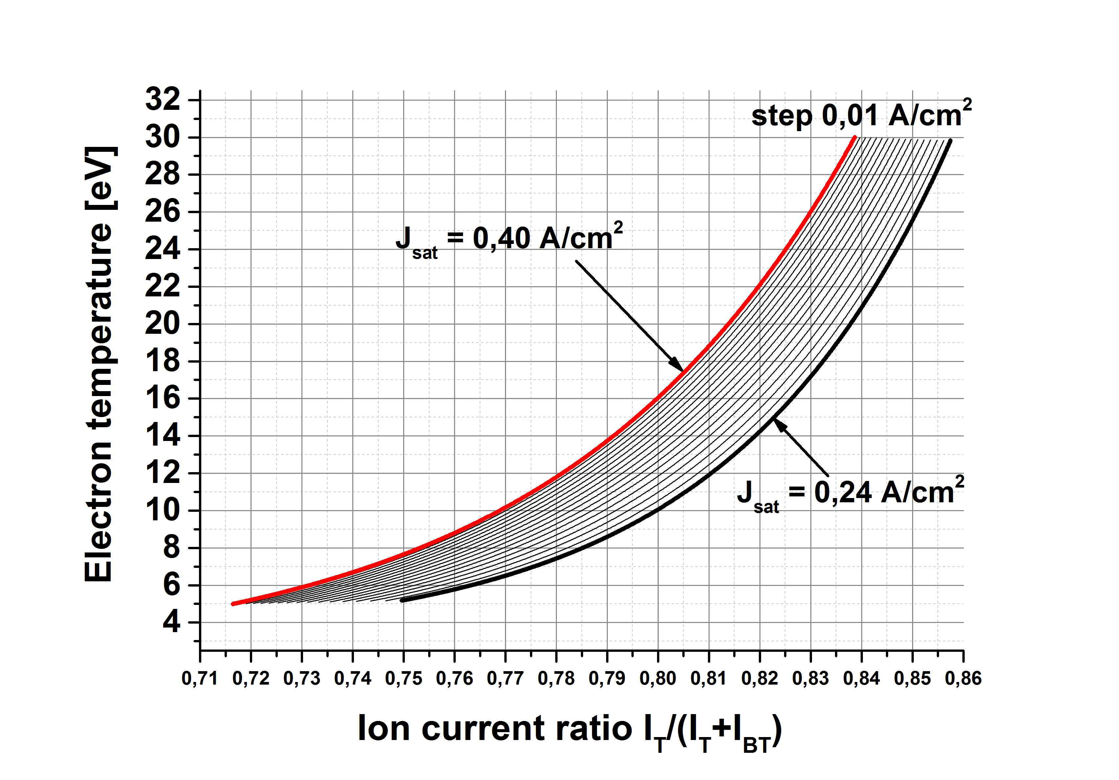
Electron temperature versus the ion saturation current density
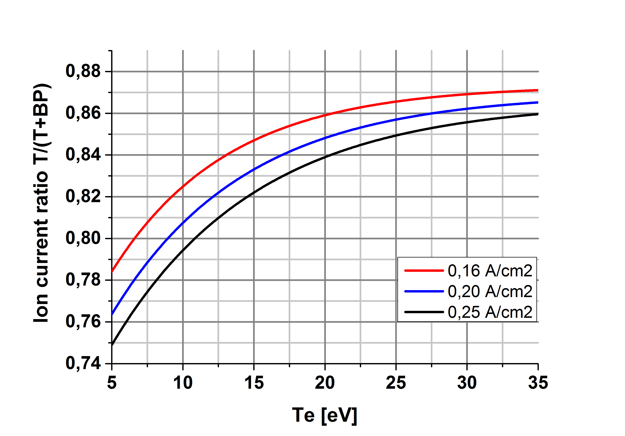
Ratio versus the electron temperature for several values of the ion saturation current density

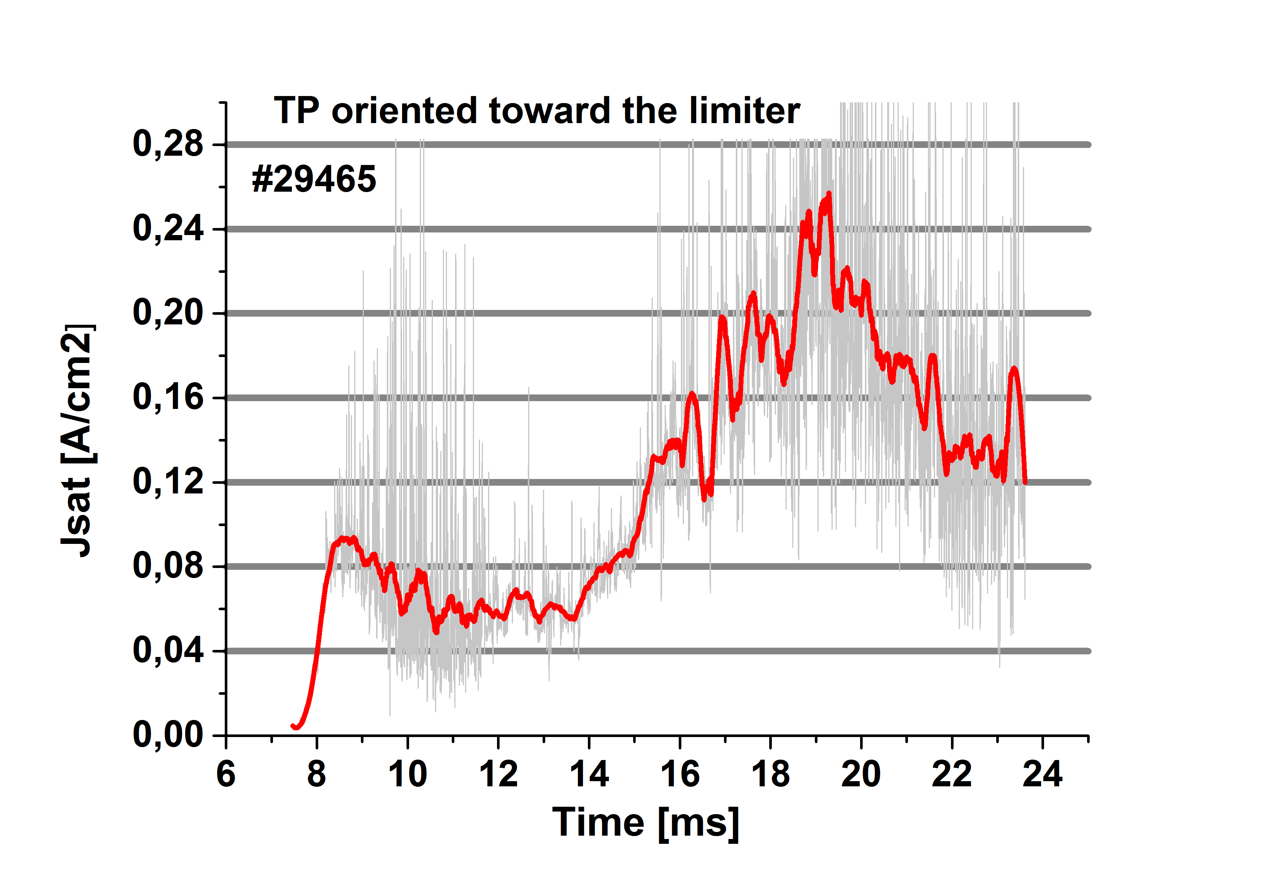
Temporal evolution of the ion saturation current density of the tunnel probe oriented toward the limiter (upstream). Red traceis smoothed by 500 pts
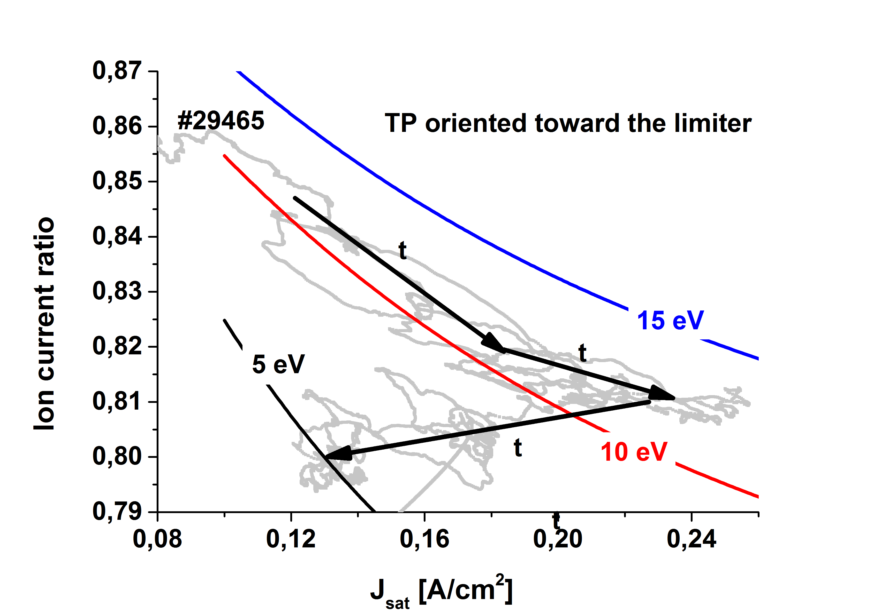
Ion current ratio IT/I(T+IBP) versus the ion saturation current density for t > 15 ms. Signals of R and J_{sat} are smoothed by 500 pts.
Temporal evolution of the ion saturation current density of the tunnel probe oriented opposite to the limiter (downstream).
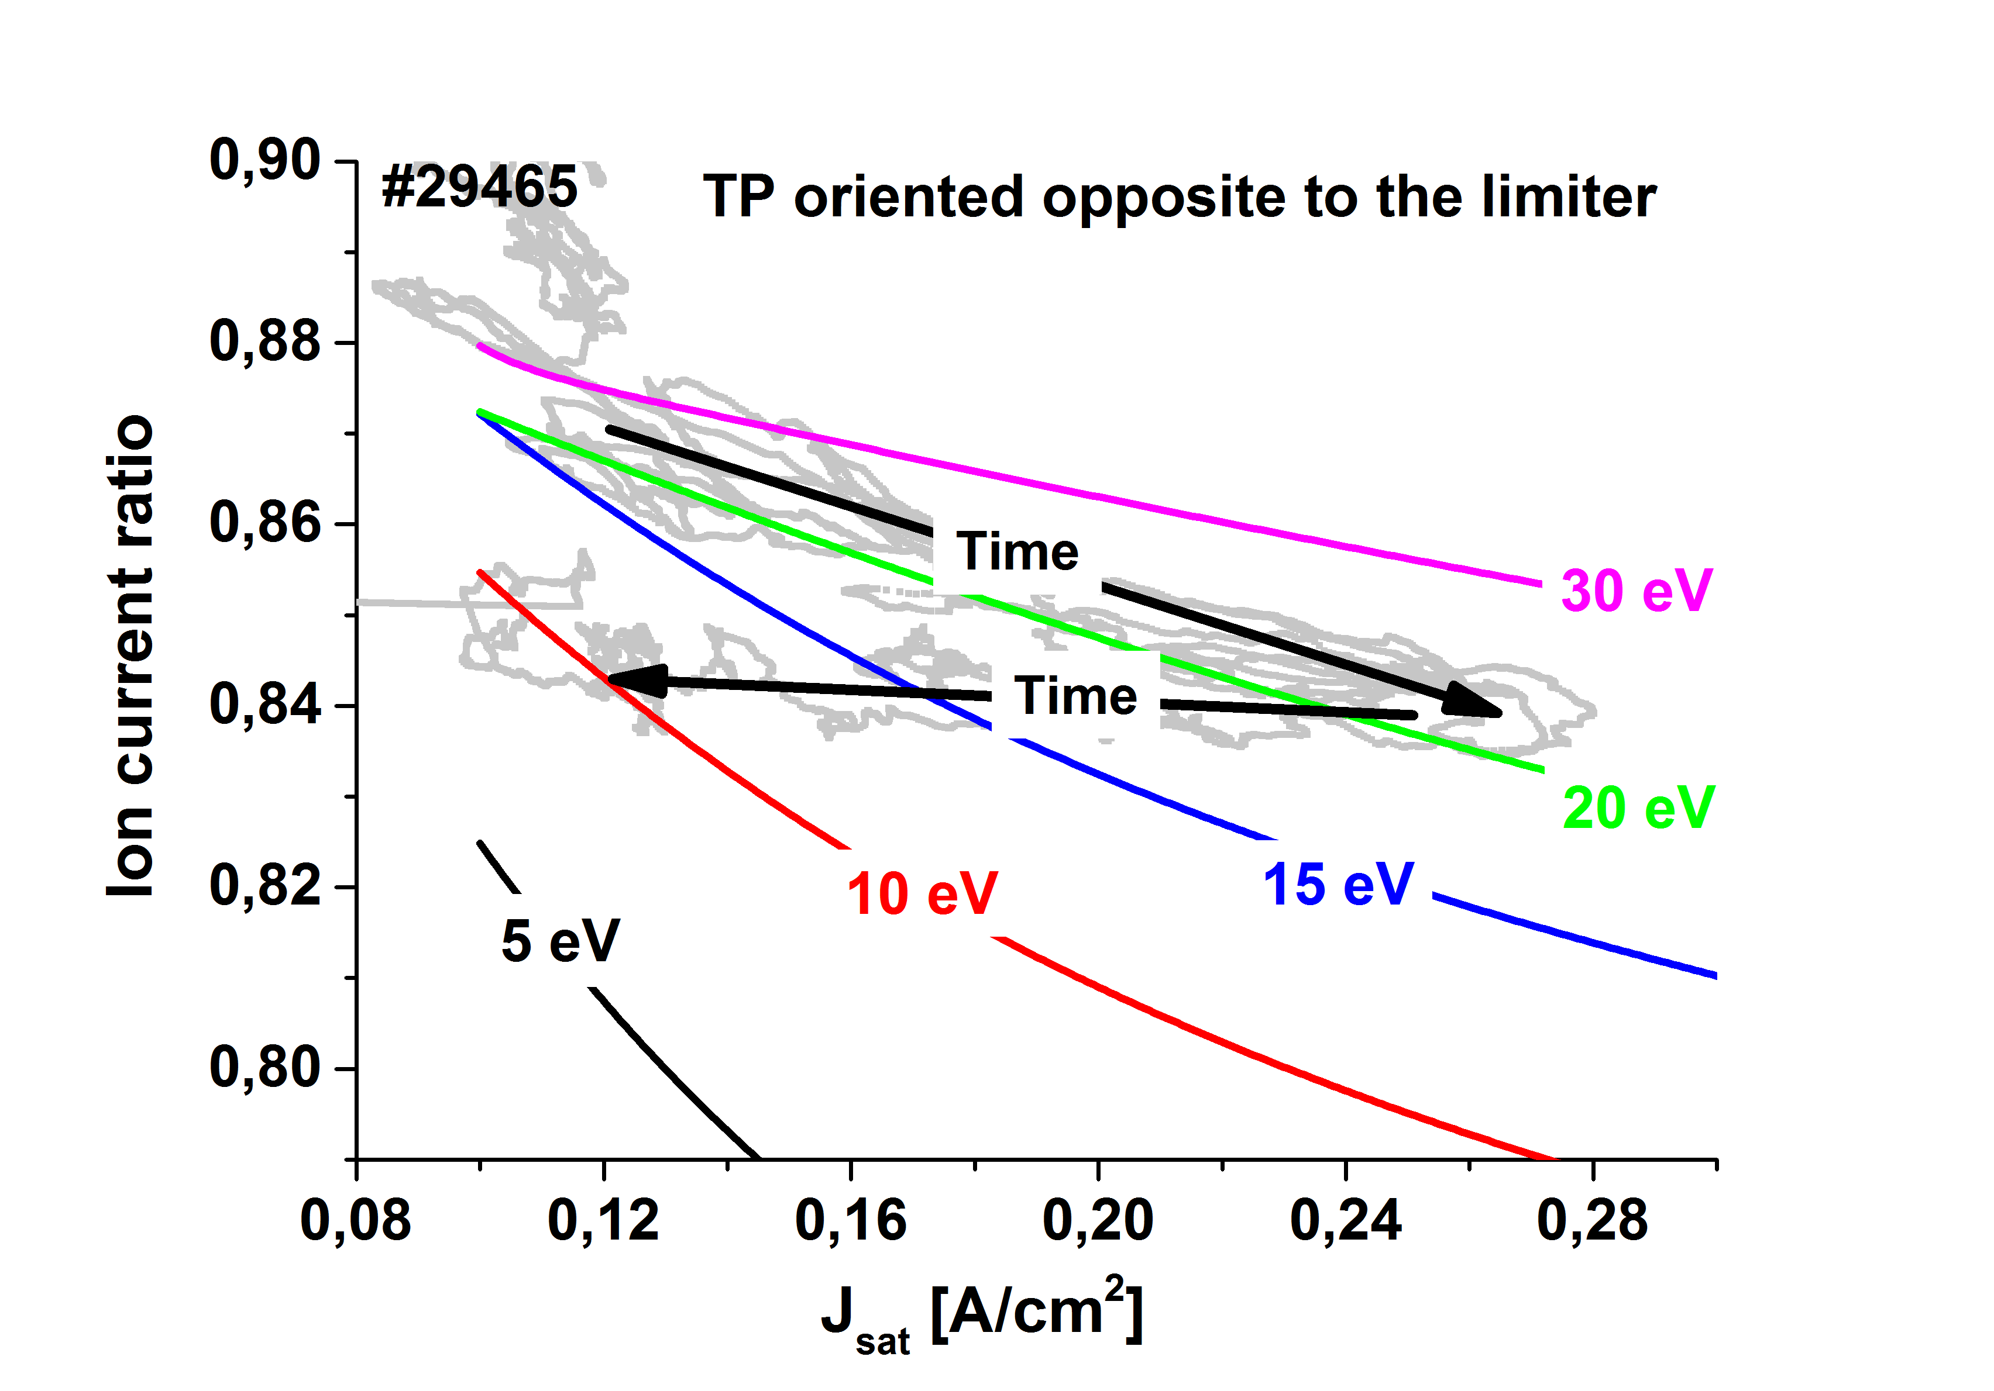
Ion current ratio R = I_{T}/(I_{T}+I_{BP}) versus the ion saturation current density for t > 15 ms. Signals of R and J_{sat} are smoothed by 500 pts.

