Operation of the GOLEM tokamak at the PhD event

Adapted from Belgrade training course October 2015. Special acknowledge to Milos Vlainic, author of the original document.

General Information:

Web of GOLEM: http://golem.fjfi.cvut.cz
Access to GOLEM database: http://golem.fjfi.cvut.cz/shots/0/ (shows the last executed shot)

GOLEM Operation for Dummies:

Step 1: go to the link http://golem.fjfi.cvut.cz/PhDevent, now you get (note the burning GOLEM sign on the top left :D):
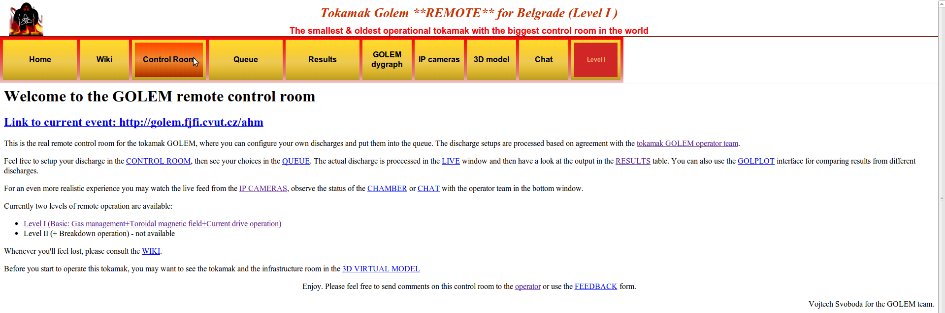
Step 2: going to the 'Control Room', you get:
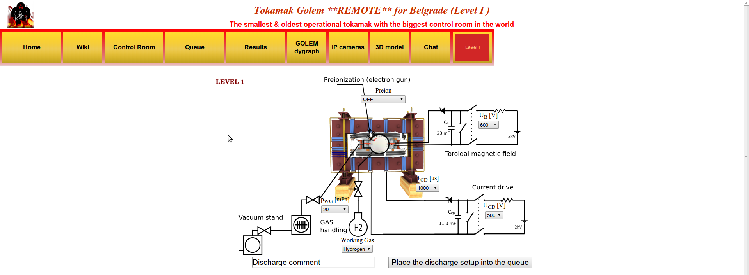

ZOOMED Control Room:
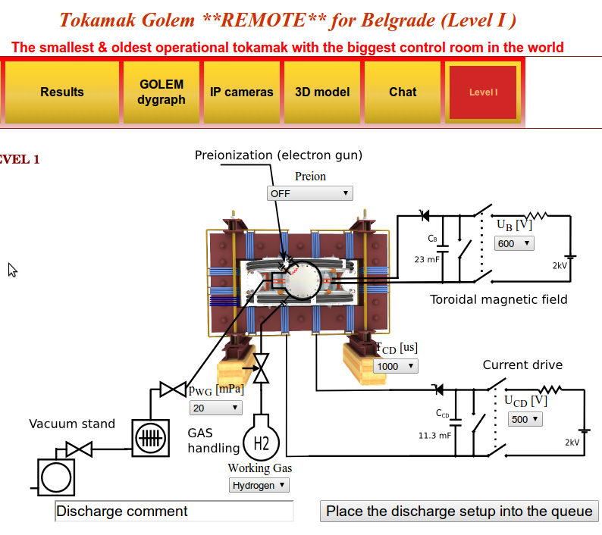
Step 3: WHAT CAN BE MODIFIED (letters are connected with the ones on the figure above)?
a)
b)
c)
d)
e)
f)
g)

a) Preion = Preionization → {OFF (default), Top el. gun, ECRH assisted}:
Choosing type of preionization. Even though Option 'OFF' is a default, use 'Top el. gun', as this one you assure that there will be breakdown to initiate ionization of gas for creating plasma! Option 'ECRH assisted' is not functioning at the moment! While it is possible to create plasma with 'OFF', it is a gambling and could be a waste of discharge – thus time!

b) p_{WG} [mPa] = Pressure in the vacuum vessel before the discharge → {from 1 to 100 with some steps, with 20 as default}:
Even though 20 mPa is default, pressure should be set to lower as possible. Unfortunately, there is some leak in GOLEM vessel those weeks, so there is background pressure of 11 mPa. Hence, putting under this value is nonsense. Anyway, there is plasma even with this relatively high pressure – which is enough for the current purposes! Moreover, real pressure is usually not 20 as requested, but something like 15-16 – thus better than requested ;)

c) Working Gas → {Hydrogen (default), Helium}:
Simply setting the the working gas – both are available, but maybe better to stay with the H due to the leakage...

d) U_{B} [V] = Voltage going trough the capacitor charging the toroidal field (TF) coils → {from 50 to 1100 with step of 50 V, where 600 is default}:
This defines the strength of the toroidal magnetic field B_{tor} – higher U_{B}, higher B_{tor}.

e) U_{CD} [V] = Voltage going trough the capacitor charging the central solenoid → {from 50 to 700 with step of 50 V, where 500 is default}:
This defines the strength of the plasma current I_{p} – higher U_{CD}, higher I_{p}.

f) T_{CD} [μs] = Delay time of the central solenoid charging relative to TF coils charging → {from 500 to 20000 with step of 500, where 1000 is default}:
This defines delay time when the central solenoid will start to be charged relative to the starting time of charging the toroidal field coils (which is always 5 ms!!!). Higher this time, higher is the B_{tor} at the breakdown – to have maximum B_{tor} at the breakdown T_{CD} has to be set on 19000!

g) DISCHARGE COMMENT:
DO NOT FORGET ABOUT THIS ONE!!! It is very very important to write down why or what are you doing in this discharge!!! It is good for making difference after the experiments – so maybe write your name or something funny to make the discharge even more special ;)

Step 4: Give a discharge to a execution waiting list, by pressing the 'Place the discharge setup into the queue', after that you check is your discharge in the 'Queue':
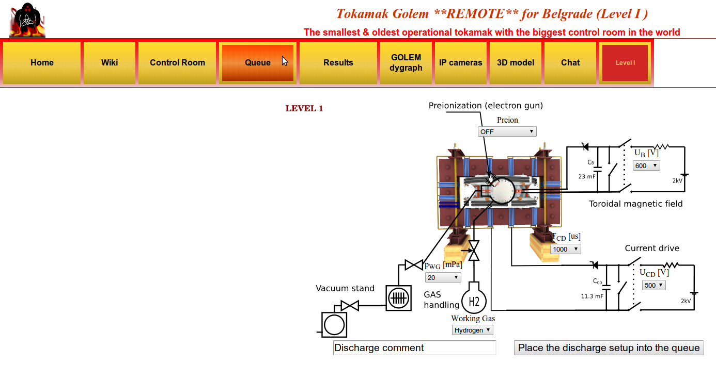

One then gets this:
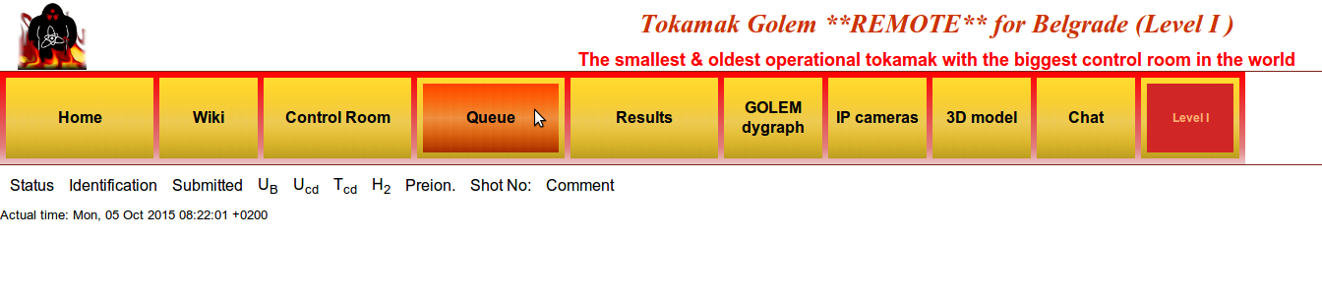
Where you should see all discharges in the queue and there statuses! Note that now there are none, as I did not do this PrintScreen when we really doing the experiments :D
Anyway, once you check that there is a discharge for you – you go to the 'IP cameras', where the live streaming of the GOLEM tokamak hall is shown. There are two screens – one camera shows you the room with tokamak, where first blue rotating beacon light will sign the start of the discharge process and finally red rotating beacon light presents that there is only 10 seconds until the discharge and everybody (if anybody is still in the room) should leave the room immediately; second camera is inside the tokamak and you will see the 'Top electron gun' for preionization (if set ON) and after some time a strong flash is seen – which is the discharge!!!
After some time you can finally go to the 'Results' and check what is there:
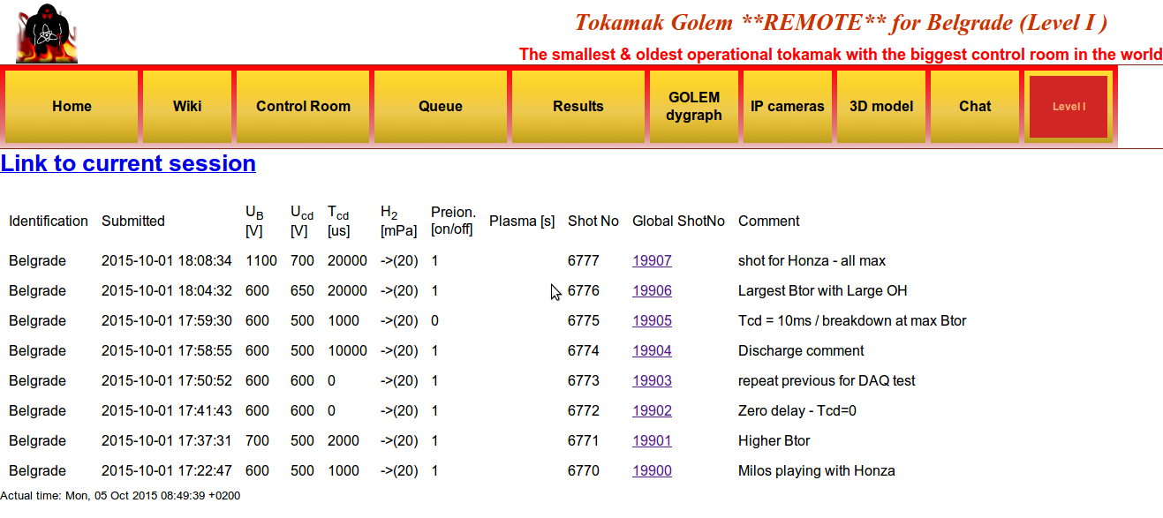
Here you can click on the discharge number ('Global ShotNo') and see the data. You can see here the shots Stockel and Milos did.

After clicking on the discharge number, the new page is open with such graphs on the top (left figure):

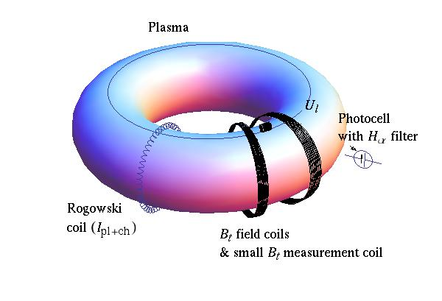
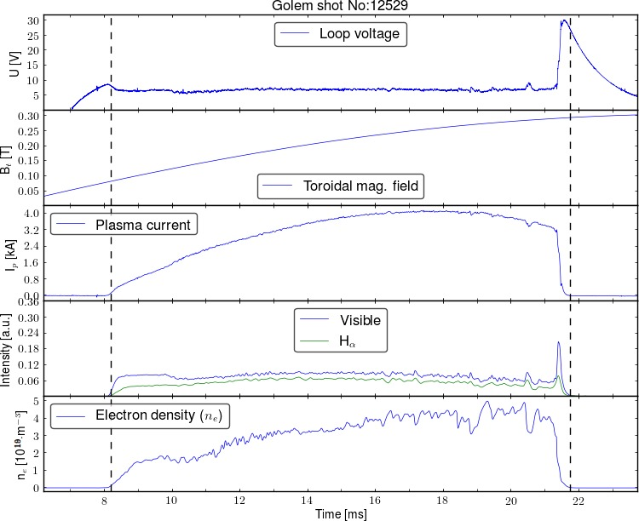
The right figure serves as an illustration of the diagnostics that provides presented data on the left figure!
Now a little bit of physics, just to briefly explain from where does presented data comes from
- Loop voltage U: is practically the toroidal electric field, if U is divided by 2πR (R=0.4m). It introduces the charge separation (thus plasma creation) at the beginning of the discharge. It is measured with the single loop along the tokamak's toroidal direction (Ul in the right figure).
- Toroidal mag. field Bt: keeps plasma in the vessel. It is measured with the pick-up coils near toroidal field coils (small Bt measurment coil in the right figure).
- Plasma current Ip: induced current in plasma, as a secondary winding. It adds an poloidal component of the magnetic field. It is measured with the Rogowski coil (marked in the right figure) – spirally arranged loop in the poloidal direction. N.B. As the Rogowski coil is outside the vessel it measures both, plasma current and current going trough the vessel!!!
- Visible & Hα: radiation detected by the photocells (denoted in the right figure) – one without (Visible) and one with filter around 656nm (Hα).
- Electron density ne: is measured with the interferometer (not in the right figure) – a device that measures phase change of the wave injected in the plasma. N.B. The measurement is integrated along the whole wave path through the plasma!

