Remote operation of the GOLEM tokamak from Beograd

General Information:

Telephone numbers to GOLEM: +420 224 358 361
Mobile to Vojta Svoboda (GOLEM responsible): +420 737 673 903
Gmail chat: tokamakgolam@gmail.com

Web of GOLEM: http://golem.fjfi.cvut.cz
Access to GOLEM database: http://golem.fjfi.cvut.cz/shots/0/ (shows the last executed shot)
Link to the FiSST'15 session: http://golem.fjfi.cvut.cz/belgrade

GOLEM Operation for MEPhI:

Step 1: go to the link http://golem.fjfi.cvut.cz/belgrade, you get:
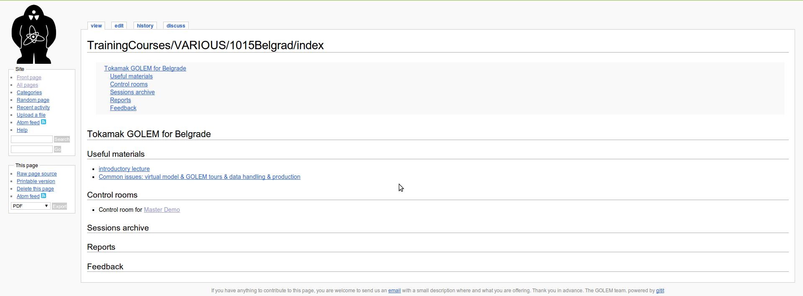

Step 2: click on 'Master Demo', now you get (note the butrning GOLEM sign on the top left :D):
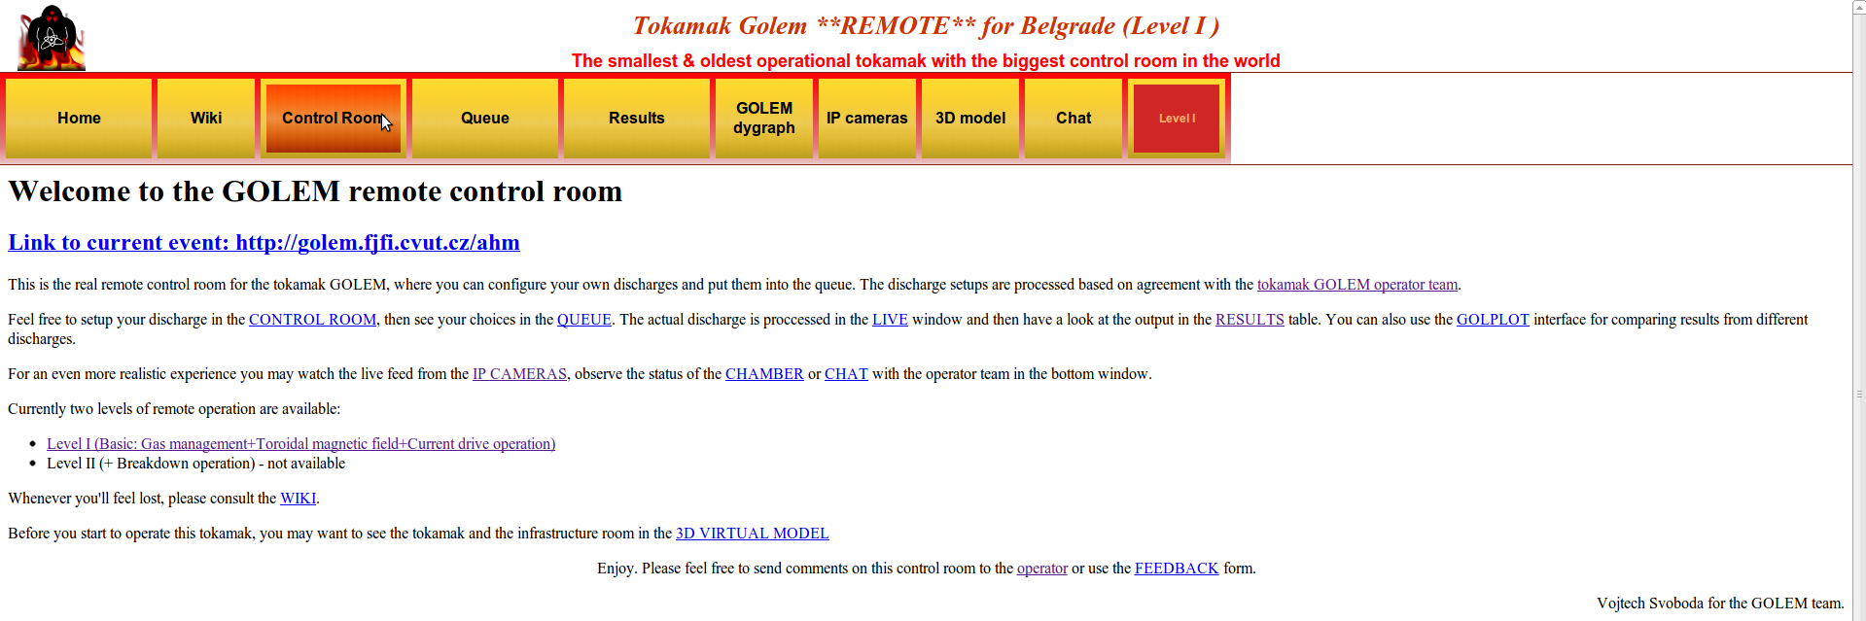

Step 3: finally you got to the 'Control Room', getting:
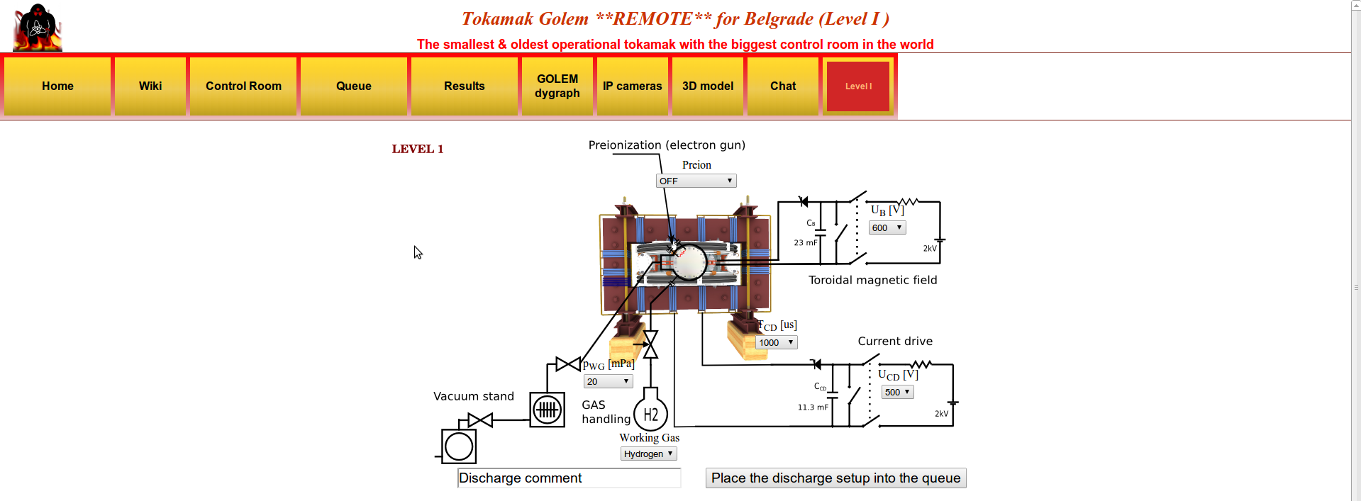
ZOOMED Control Room:
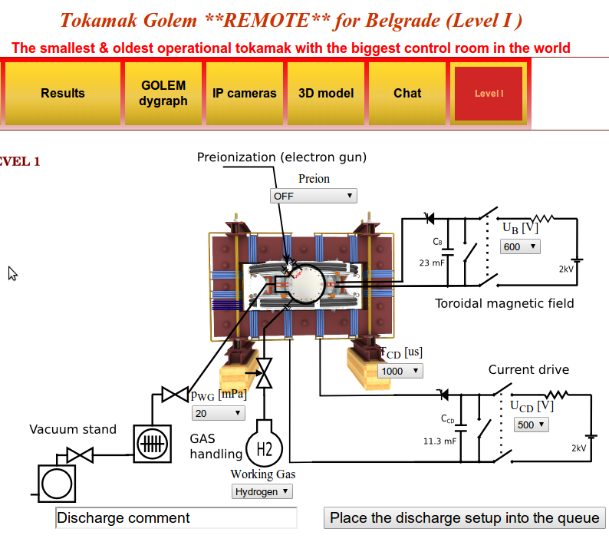
Step 4: WHAT CAN BE MODIFIED (letters are connected with the ones on the figure above)?
a)
b)
c)
d)
e)
f)
g)

a) Preion = Preionization → {OFF (default), Top el. gun, ECRH assisted}:
Choosing type of preionization. Even though Option 'OFF' is a default, use 'Top el. gun', as this one you assure that there will be breakdown to initiate ionization of gas for creating plasma!!! Option 'ECRH assisted' is not functioning at the moment! While you can create plasma with 'OFF' (Stockel and me succeeded accidentally last week from the first attempt at #19905), but it could be waste of discharge – thus time! ;)

b) p_{WG} [mPa] = Pressure in the vacuum vessel before the discharge → {from 1 to 100 with some steps, with 20 as default}:
Even though 20 mPa is default, pressure should be set to lower as possible. Unfortunately, there is some leak in GOLEM vessel does weeks, so there is background pressure of 11 mPa. Hence, putting under this value is nonsense. Anyway, Stockel and me were setting pressure to 20 and there was plasma – which is enough for our purposes! Moreover, real pressure was not 20 as requested, but something like 15-16 – thus better than requested ;)

c) Working Gas → {Hydrogen (default), Helium- not available today}:
Simply setting the the working gas – both are available, but maybe Vojta would need to set something for the change, as Stockel is not sure is this part automatic :D

d) U_{B} [V] = Voltage going trough the capacitor charging the toroidal field (TF) coils → {from 50 to 1100 with step of 50 V, where 600 is default}:
This defines the strength of the toroidal magnetic field B_{tor} – higher U_{B}, higher B_{tor} :)

e) U_{CD} [V] = Voltage going trough the capacitor charging the central solenoid → {from 50 to 700 with step of 50 V, where 500 is default}:
This defines the strength of the plasma current I_{p} – higher U_{CD}, higher I_{p} :)

f) T_{CD} [μs] = Delay time of the central solenoid charging relative to TF coils → {from 500 to 20000 with step of 500, where 1000 is default}:
This defines delay time when the central solenoid will start to be charged relative to the starting time of charging the toroidal field coils (which is always 5 ms!!!). Higher this time, higher is the B_{tor} at the breakdown – to have maximum B_{tor} at the breakdown T_{CD} has to be set on 19000!!!

g) DISCHARGE COMMENT:
DO NOT FORGET ABOUT THIS ONE!!! It is very very important to write down why or what are you doing in this discharge!!! It is good for making difference after the experiments – so maybe every group would have first to write: “Group 1: BlaBlaBla: or instead of Group 1 you can invent some funny/cool name for the group :D

Note: GLOW DISCHARGE is done by Vojta!!! So it is no remote...

Step 5: Give a discharge to a execution waiting list, by pressing the 'Place the discharge setup into the queue', after you check is your discharge in the 'Queue':
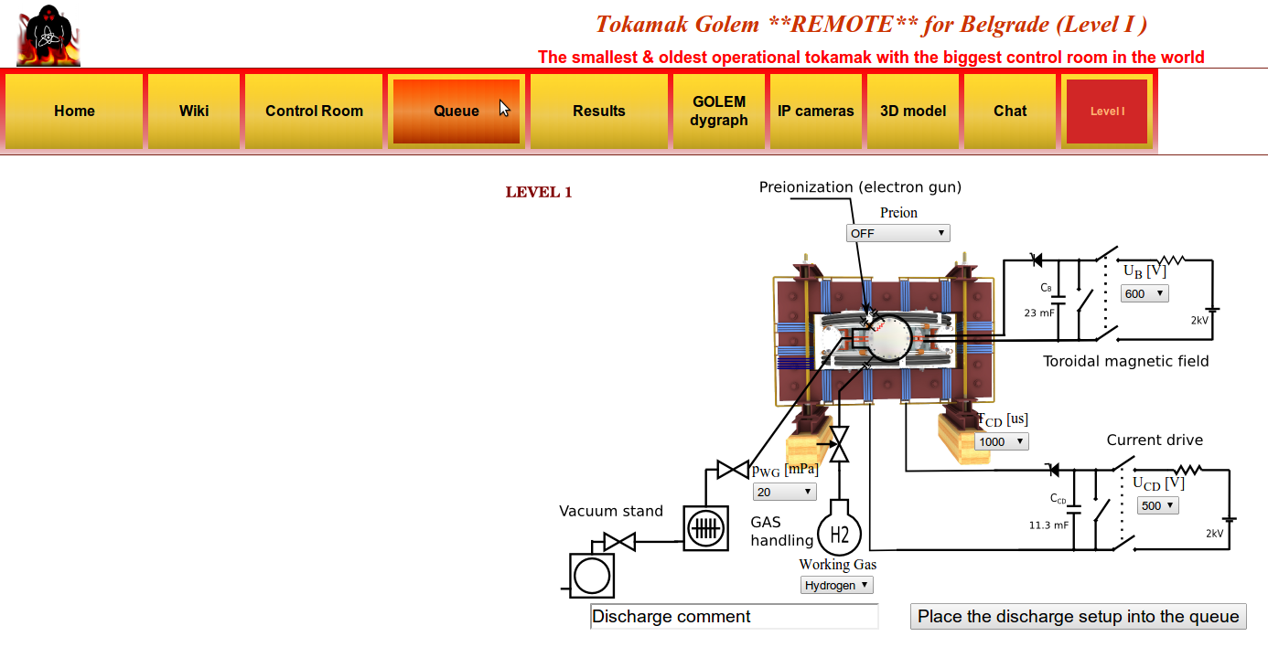

One then gets this:
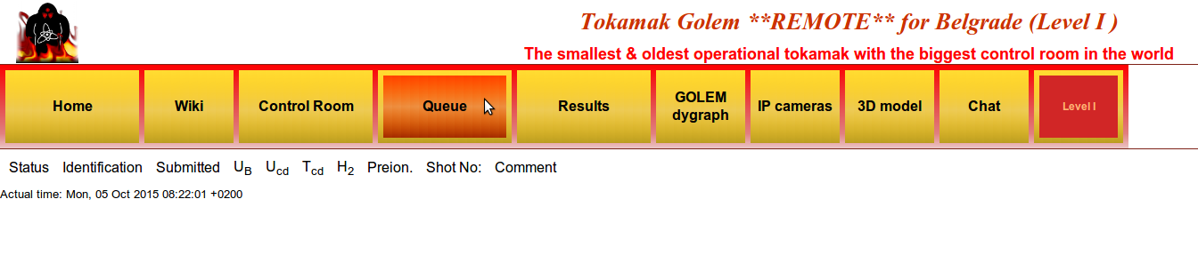
Where you should see all discharges in the queue and there statuses! Note that now there are none, as I did not do this PrintScreen when we really doing the experiments :D

Anyway, once you check that there is a discharge for you – you go to the 'IP cameras', where the live streaming of the GOLEM tokamak hall is shown. There are two screens – one camera shows you the room with tokamak, where first blue rotating beacon light will sign the start of the discharge process and finally red rotating beacon light presents that there is only 10 s until the discharge and everybody (if anybody is still in the room) should leave the room immediately; second camera is inside the tokamak and you will see the 'Top electron gun' for preionization (if set ON) and after some time a strong flash – which is the discharge!!!
After some time you can finally go to the 'Results' and check what is there:
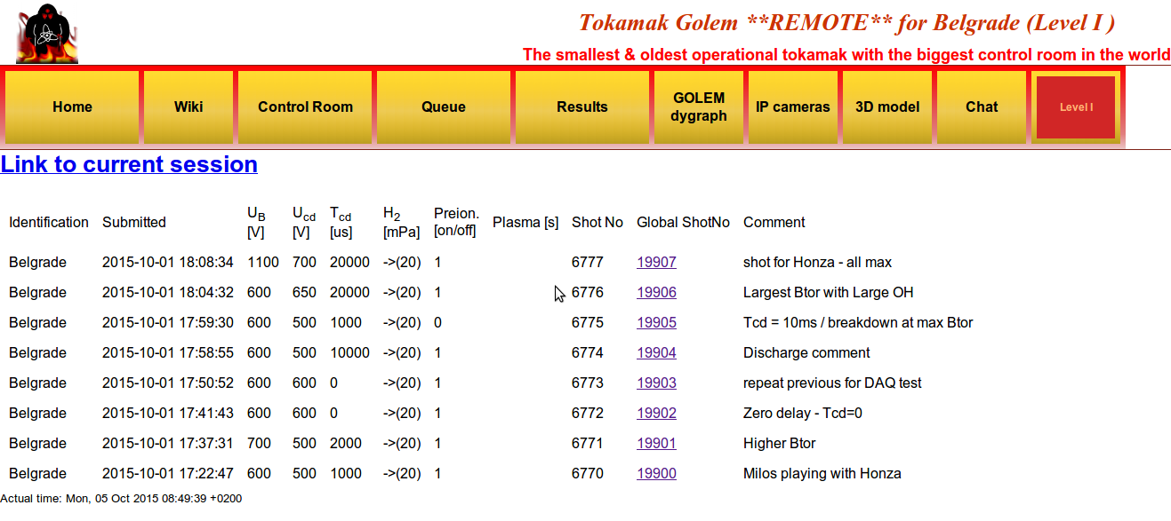
Here you can click on the discharge number ('Global ShotNo') and see the data!!! You all can check now the shots Stockel and me did last week ;)

Tasks:

Note: If enybody has additional idea for his topic, feel free to propose! Then I will see with Jan and Vojtech... Addining an additional data analysis task for Wendsday is very welcome ;)

1) ??? – Temperature measurement from plasma resistivity:
Using $U_{\text{loop}}=I_{p}R_{p}+L_{p}\frac{{\text{dI}}_{p}}{\text{dt}}$one calculates the plasma resistivity, and then from Spitzer formula temperature is estimated. Lp is know, Ip and Uloop are measured! Two things are possible – time evolution of the temperature using above formula & finding the maximum value at the maximum current (current derivative = 0) and than trying from discharge to discharge to get higher and higher temperature!!! Calculations from shot to shot needed!

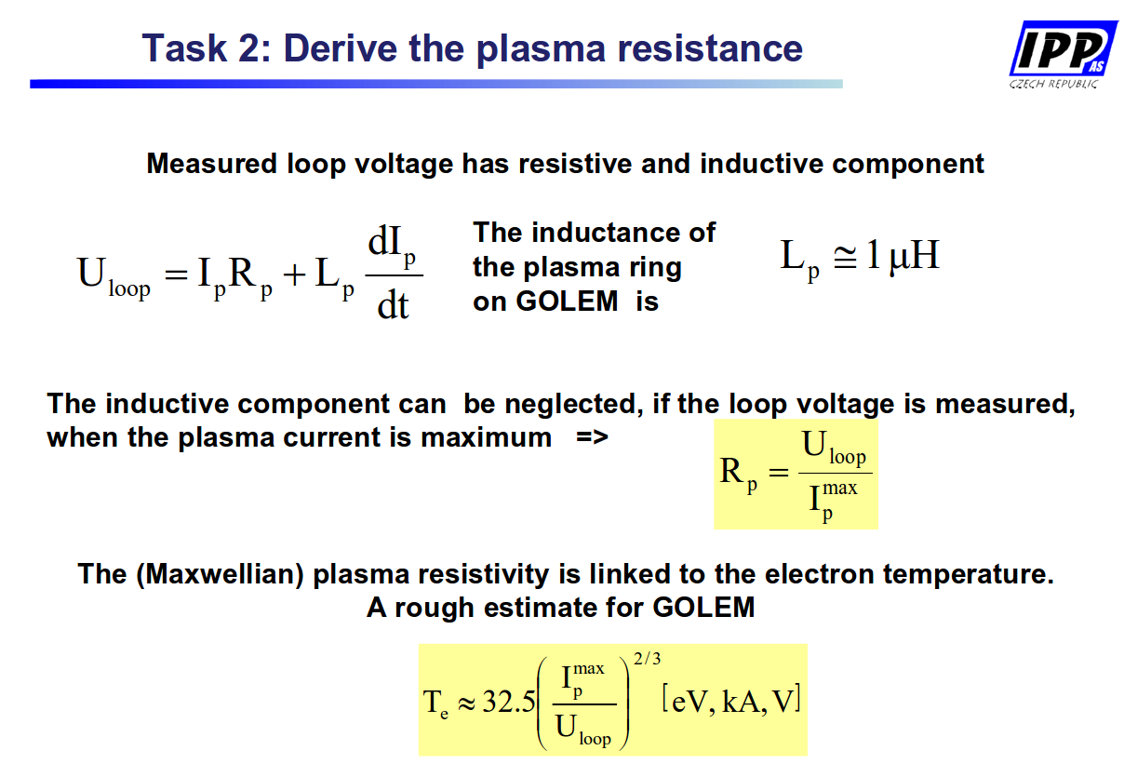
My ideas:
- After the calculations are done, students can compare there results with the ones that can be found in the database :)

My planning proposal:
- first shot some 'standard shot' and then as influence of Ucd is obvious (higher Ucd → higher Te) investigate role of other two
- second shot change Tcd up (or down), then third down (or up) relative to the first shot
- forth shot go with the Ub up (or down), then fifth down (or up) relative to the first shot
- finally (2-3 shots) to try by the previous observations (and increasing the Ucd) to get as larger as possible Te :)
2) ??? – Search discharges with the lowest loop voltage at the breakdown (Ubd):
Here one has a circuit of primary winding (central solenoid) on one side and parallel connection of plasma and vessel resistivity. Vessel and primary resistance are know!!!
Playing with Ucd (directly larger Ip), with Tcd (larger Btor at breakdown) and maybe Ub (steepness of the Btor could make some influance)... Ubd can be directly observed from the basic data!!!
Benefits of lower Ubd: 1) longer discharge (as there is more volt-seconds in the central solenoid); 2) less runaway electrons (Zana!)

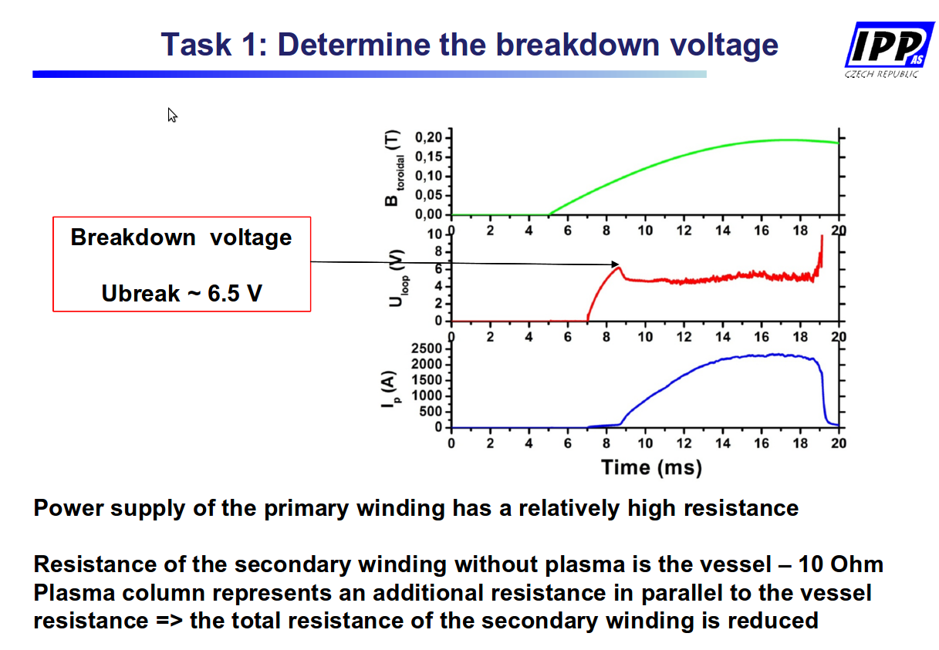
My planning proposal:
- first shot some 'standard shot' and then as influence of Ucd is obvious (lower Ucd → lower Ubd) investigate role of other two
- second shot change Tcd up (or down), then third down (or up) relative to the first shot
- forth shot go with the Ub up (or down), then fifth down (or up) relative to the first shot
- finally (2-3 shots) to try by the previous observations (and reducing the Ucd) to get as smaller as possible Ubd :)

3) ??? – Search discharges with highest safaty factor at the edge q(a):
From formula $q(a)=\frac{{2πa}^{2}}{μ_{0}R}\frac{B_{\text{tor}}}{I_{p}}$you see how one needs to play with Ucd, Ub and Tcd to get the maximum q(a) – calculations from shot to shot needed!!!

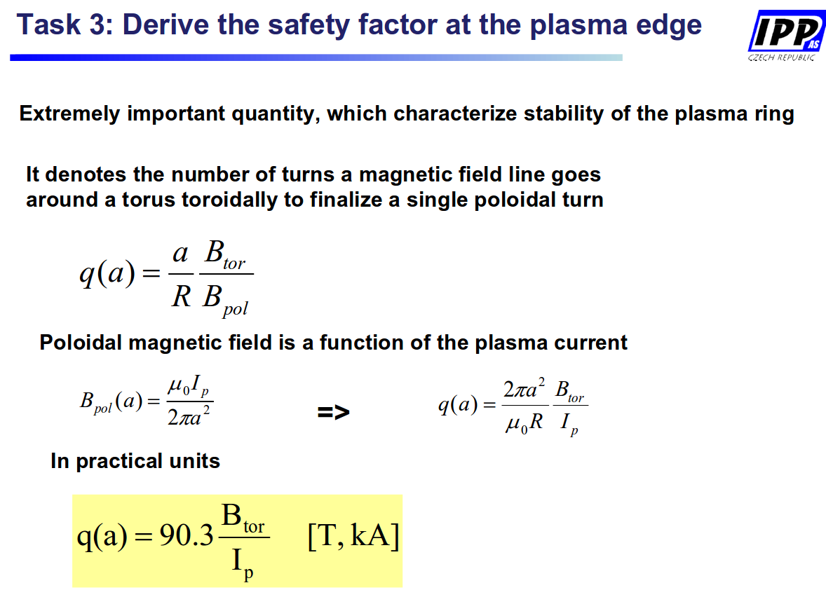
My additional ideas:
- students could also after look at the q(0)? :)
- they could after compare there own results with the database...

My planning proposal:
- first shot some 'standard shot' and then as influence of Ub is the obvious (higher Ub → higher q(a)) investigate role of other two
- second shot change Tcd up (or down), then third down (or up) relative to the first shot
- forth shot go with the Ucd up (or down), then fifth down (or up) relative to the first shot
- finally (2-3 shots) to try by the previous observations (and increasing the Ub) to get as larger as possible q(a) :)
4) ???? – Impact of Glow Discharge (GD) cleaning on plasma parameters:
Looking at the changes of plasma parameters after the GD: First three shots after GD, then again 2 shots after new GD and finally one more shots after GD (so that every student does a shot!) - the outcome should be that all three first discharges after GD are similar, while Ip should get lower as we go further away from GD... Maybe to change the time of shot after GD? Maybe not to do discharges in a row, but every second? :)
Stockel: Do one before GD and one after!!!

5) ???? – Measurements with the rake of Langmuir probes:
I know only that they have 16 (not sure) probes, and I guess students could do many cool stuff with this one – so it is up to you Jordan (but do not over do it, keep it simple) ;)
- Honza sent me an article from GOLEM, maybe you can find something even there – here is his comment: “I would suggest to operate the rake probe in the U_fl regime, which is much easy. If the probes are in I_sat, some arking may appear an complicate interpretation of experiment.
We did some experiments with Renaud from Kiten and results are interesting - see attachment.”
My comment – as much I understood there is some colleration measurement! I would not go that far, maybe just estimation of any plasma parameter possible with U-fl and comparing it with some other diagnostics? The colleration could be left for Friday or Extra work :)

6) ????? – HXR measurements – calibration with Cs, spectrum of HXR photons in plasma discharge:
If calibration is done (Ondra say it is already done!) – student could make PDF of the signal and then measure the the energy distribution function of the runaway electrons. It could be interesting to try to get the most possible energetic RE playing with Ucd (higher Ip and Uloop), Tcd (higher Btor), Ub (higher Btor) and pWG (lower pressure, lower density)... Maybe calculation between the shots needed to see what was the largest energy, but if not – playing with the parameters and then see after :)
Note: By increasing breakdown voltage, you will reduce discharge length so maybe RE would not have enough time to accelerate...

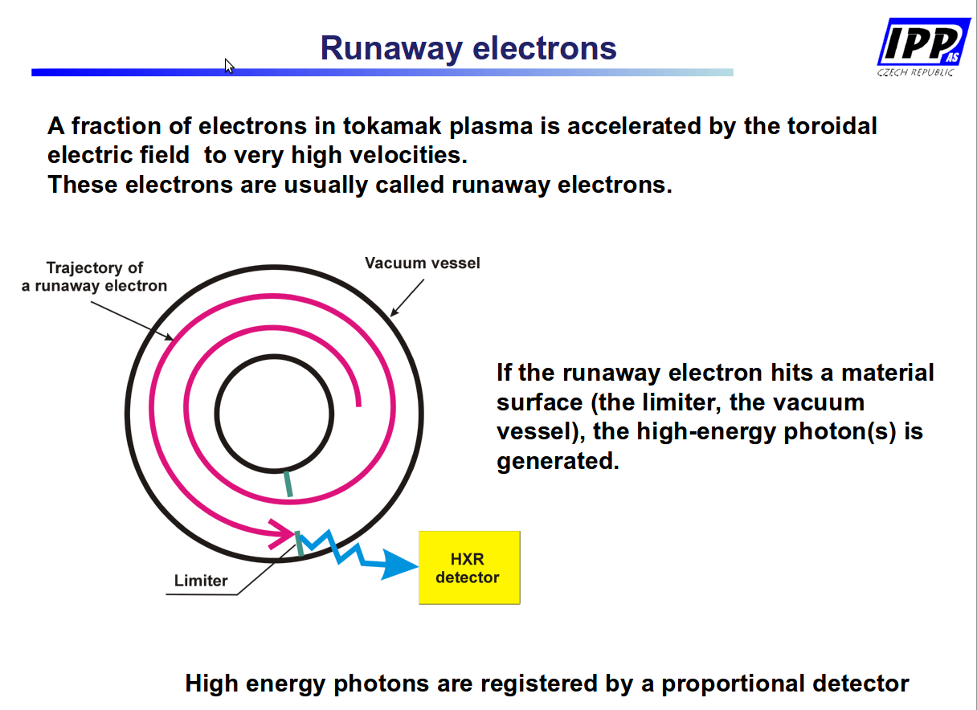
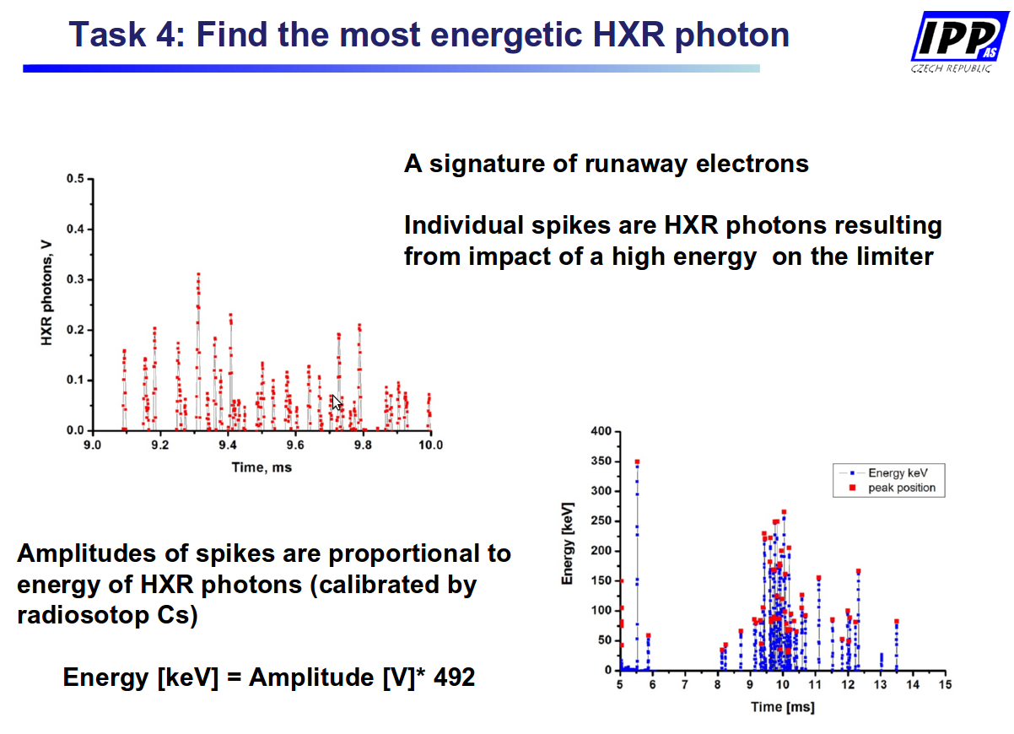
Stockel's additional idea:
- Vladica's group will try to get smallest breakdown voltage, as you will try to get as larger as possible – you can also look at Vladica's data and fill the other part of the graph :)

