Summary of the remote operation of GOLEM performed on June 4, 2021
Remote operation of GOLEM in the TGI Friday meetings was performed on June 4, 2021 by six remote operators: David, Emilio, Guido, Jamie, Jordan and Marketa. Around 18 discharges (#39936 - #3994) were executed, 3 attempts per operator.
Details are seen at http://golem.fjfi.cvut.cz/shots/39936/, 14 discharges were successfully preprogrammed, and only 4 shots were without breakdown of three working gas.
Mail goal was to preprogram hardware parameters of GOLEM to achieve the longest discharge. The absolute winner of the competition was Marketa Fuchs as demonstrated in Fig.1. Congratulations Marketa!!
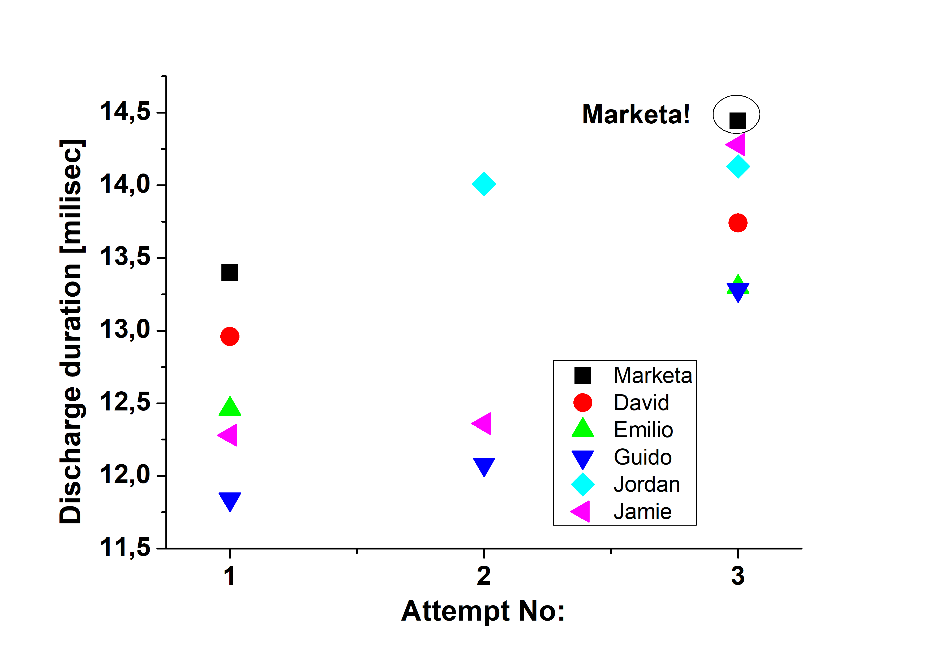
Fig. 1 Discharge duration versus the attempts for all participants.
However, it is evident that all participants have converged to quite reasonable values 13.5 -14.5 milliseconds. To reach longer discharges, more vessel conditioning would be required.
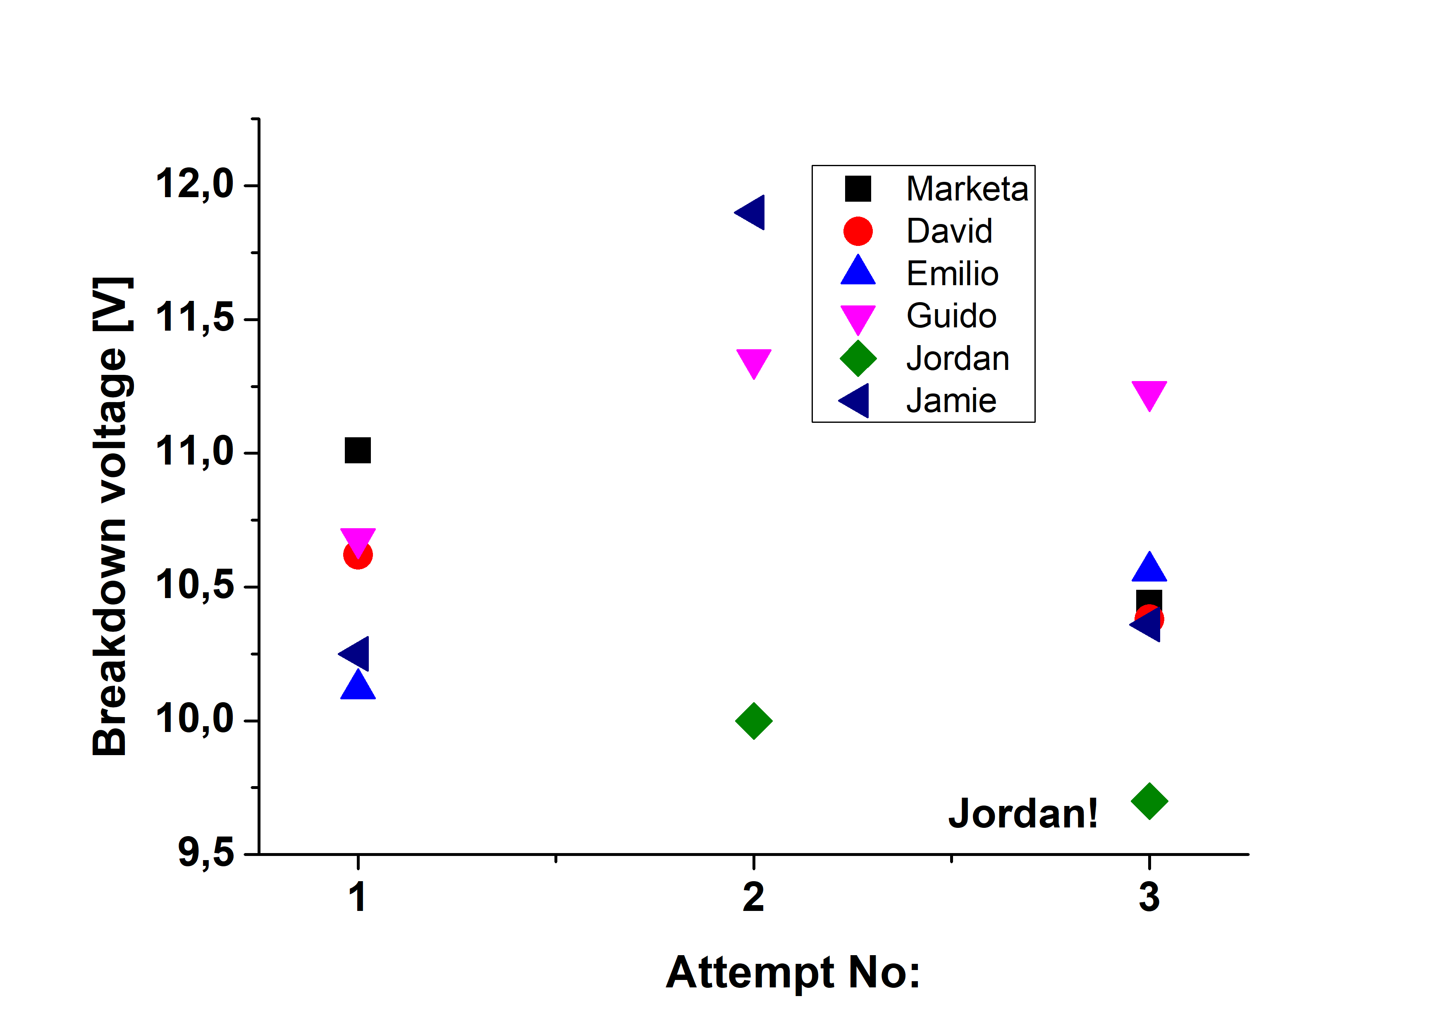
However, sometimes, optimization other discharge parameters are required for executing a research program on GOLEM. Figure 2 displays results for two of them, maximum plasma current and the breakdown voltage, during TGI operation.
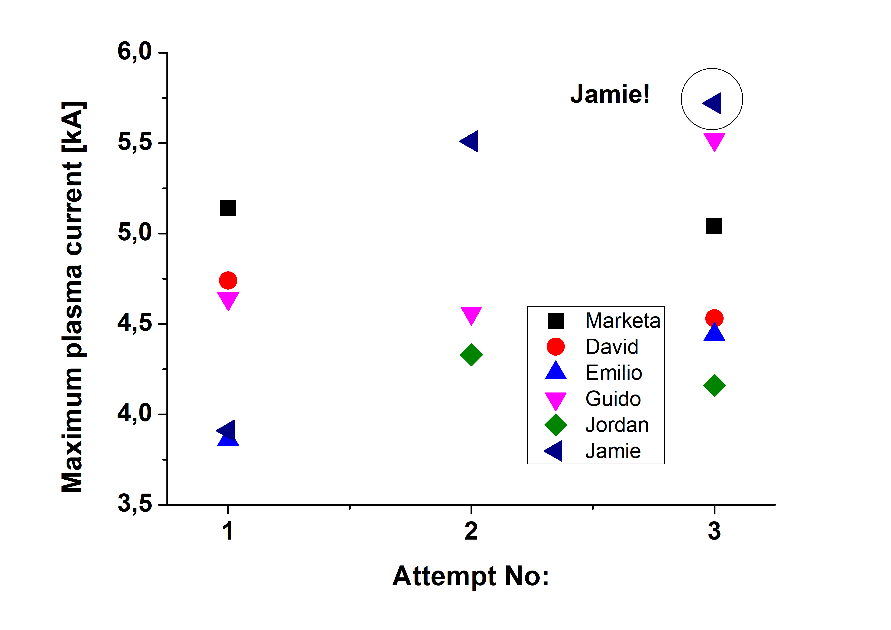
Fig. 2 Maximum plasma current and the breakdown voltage versus the attempts for all participants.
We see that maximum plasma current, around 5.7 kiloAmps, was reached by Jamie. And the minimum voltage required for breakdown of working gas (<10 V) was found by Jordan. Jamie and Jordan congratulations!!
Finally, a stable discharge is necessary for physical studies (probe measurements, ….). Guido was the most successful in this respect. Congratulations Guido!
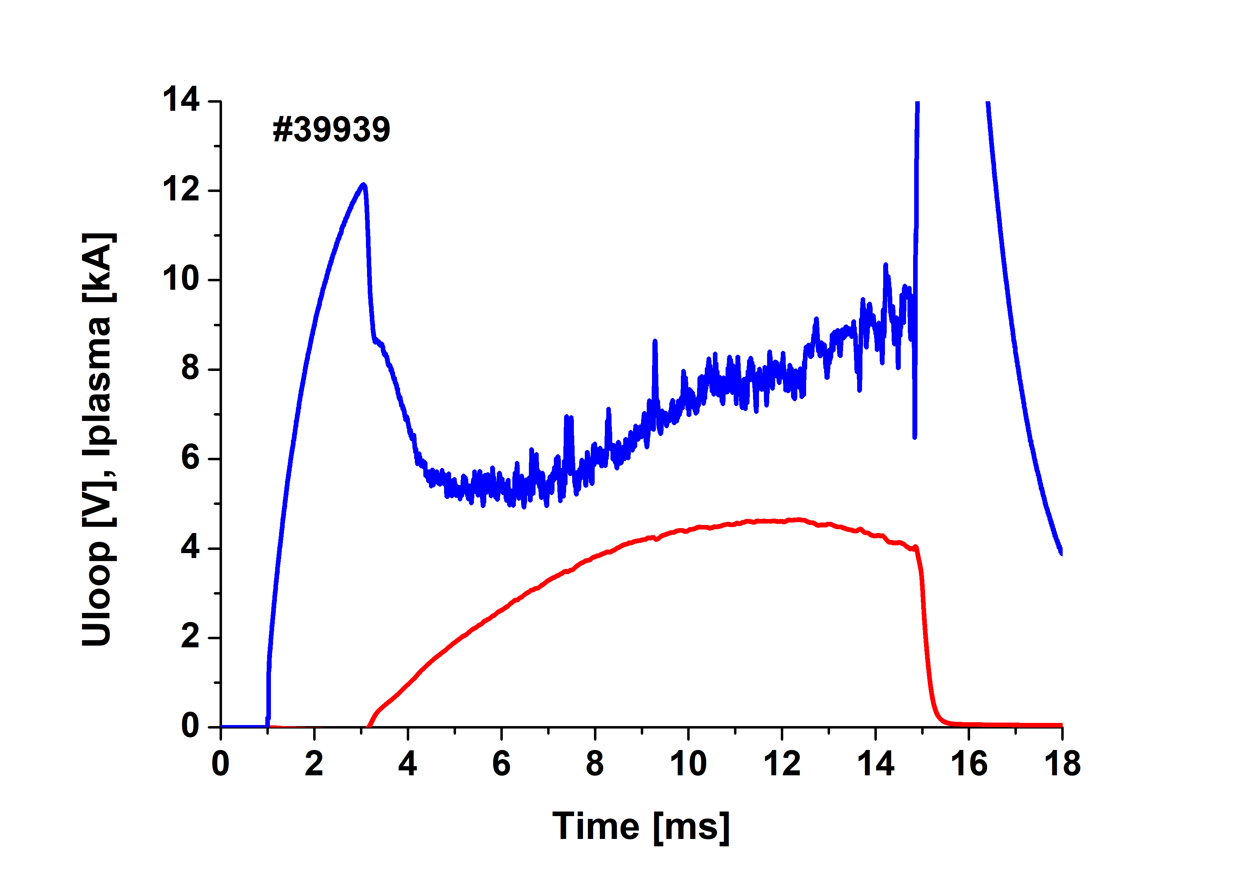
Fig. 3 Temporal evolution of plasma current and the loop voltage.

We like to thank GOLEM chief, Vojta Svoboda, for opportunity to touch OLEM, at least remotely.
6/6/2021

