Direct observation of the Anomalous Doppler instability by the Ball Pen Probe. Low density discharges (n_{e} ~ 10¹⁸ m⁻³) on the GOLEM tokamak usually exhibit an instability, which is manifested by spikes of the loop voltage. These spikes are signature of the Anomalous Doppler Instability (ADI) [1], which occurs when a sufficient amount of runaway electrons is generated. An example of a typical runaway discharge is shown in Fig, 1.
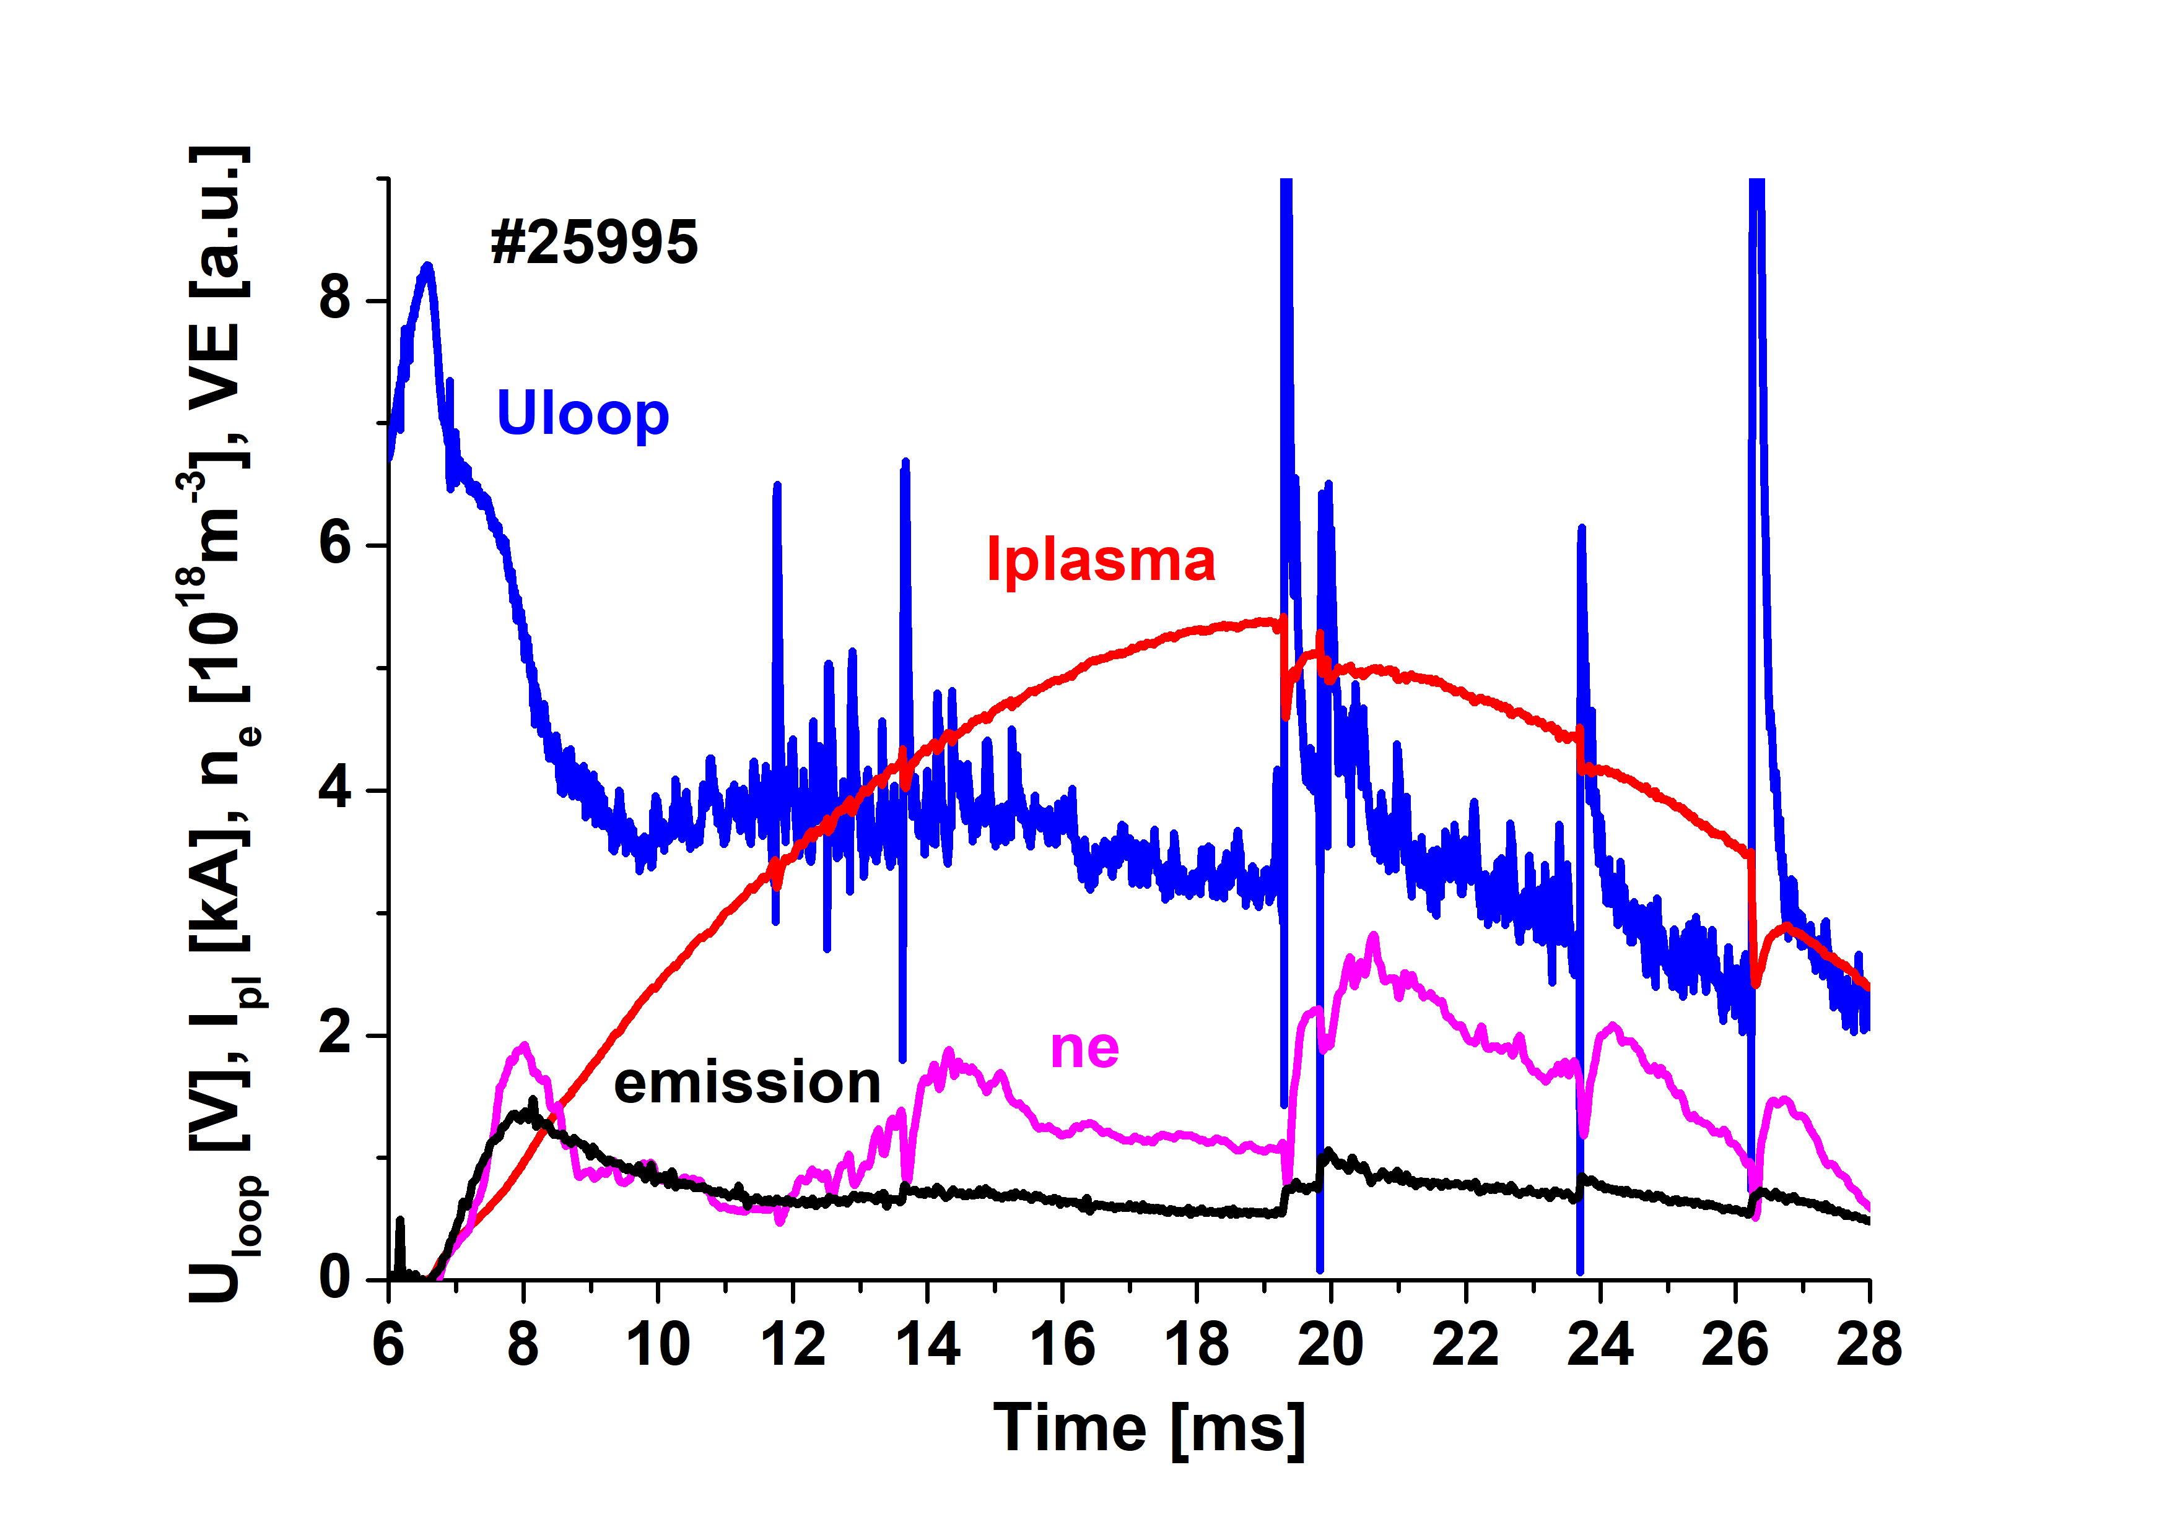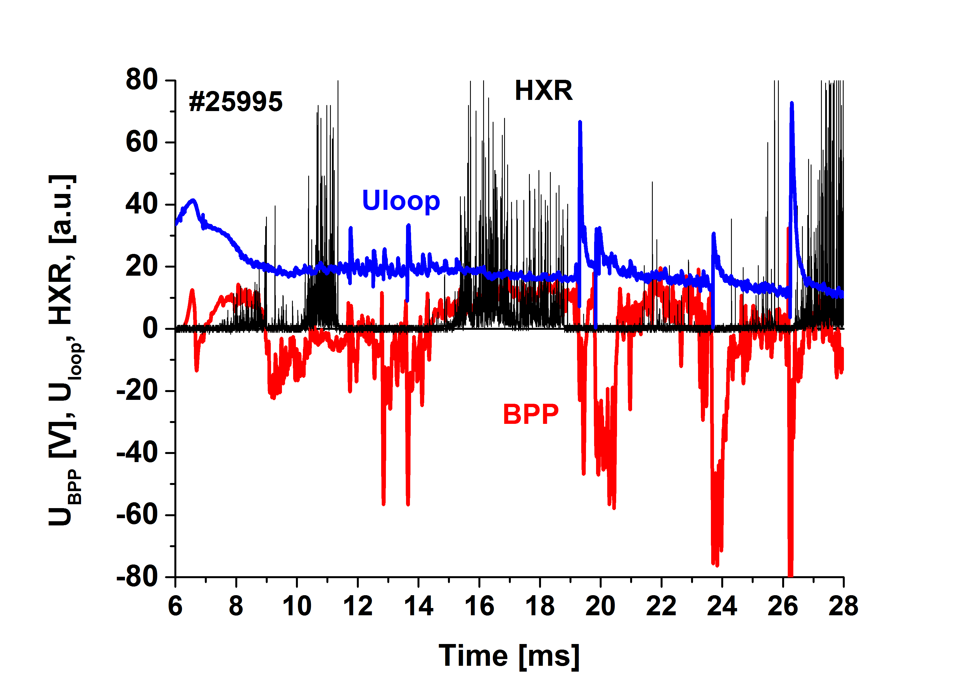
Fig. 1. Left: Temporal evolution of a low density hydrogen discharge (#25995). Right: Temporal evolution of plasma potential at r = 70 mm and of the HXR emission. The loop voltage is plotted for reference.
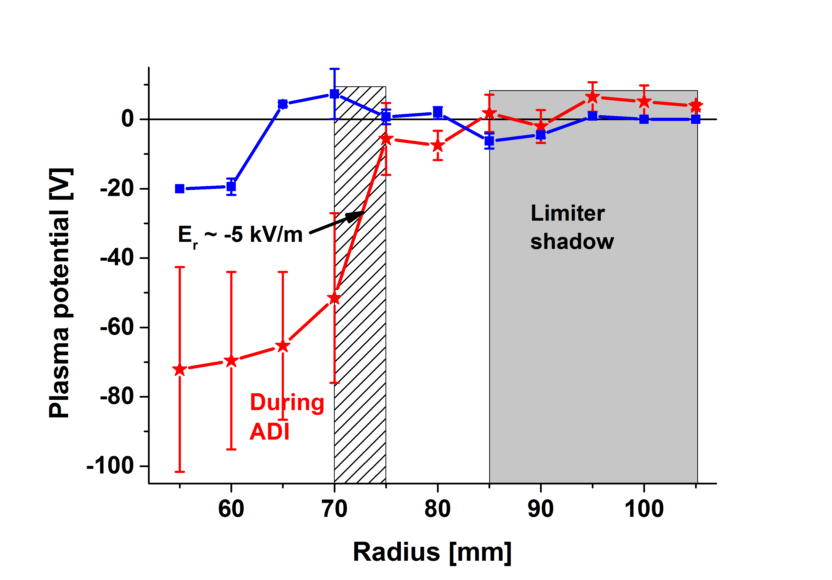
We observe three huge positive spikes in the loop voltage, which are accompanied with a prompt increase of visible plasma emission followed by an increase of the line average density. This is a signature of an enhanced plasma wall interaction at ADI. The edge plasma are studied by the Ball Pen Probe (BPP), which measures directly the plasma potential Φ [2]. The right panel compares the signal of BPP with the signal of a HXR sensor. We observe a strong HXR activity, which corresponds to interaction of runaway electrons with the first wall. The HXR signal disappears before ADI, which is interpreted as conversion of parallel velocity of runaways to the perpendicular one (according theory [1]). At the same time, a significant negative peaks of the plasma potential are observed by BPP located at r = 70 mm. However, this negative plasma potential occurs only at several radii of the plasma column during ADI, as follows from its radial profile obtained on shot to shot basis is plotted in Fig.2.
The plasma potential Φ is elevated only inside the last closed magnetic surface (defined by the poloidal limiter with a = 85 mm). This implies formation of a quite strong negative radial electric field E_{r} =--d Φ/dr ~ -5 kV/m in a narrow region (Δr ~ 5 mm) at the plasma edge, which is not attached to the limiter. This should lead to a transient poloidal rotation due to E_{r}xB_{tor} drift in this region.
Fig. 2. Radial profiles of the plasma potential during
appearance of the Anomalous Doppler Instability.
[1] V.V. Parail, O.P. Pogutse, Nuclear Fusion, 18, 3(1978)
[2] J Adamek et al, Czech J. Phys., 54 (2004), C95, J Adamek et al, CONTRIBUTIONS TO PLASMA PHYSICS 2013,54, 3, p. 279

