Description of the ST25 Tokamak

The ST25 tokamak situated at Milton Park, Oxfordshire, UK has major/minor radii of 0.25/0.125m and features toroidal and poloidal magnet coils wound from copper cable, with a central solenoid made of enamelled wire potted in resin. Three features combine to produce discharges of up to ~20s (RF driven), longer than usually obtained in such a small device: namely the multi-turn TF winding giving high inductance, the use of high-capacity ultracapacitors for the TF and PF supplies, and the adaptation of IGBT switching to provide controlled waveforms for these coils from a single central capacitor bank.
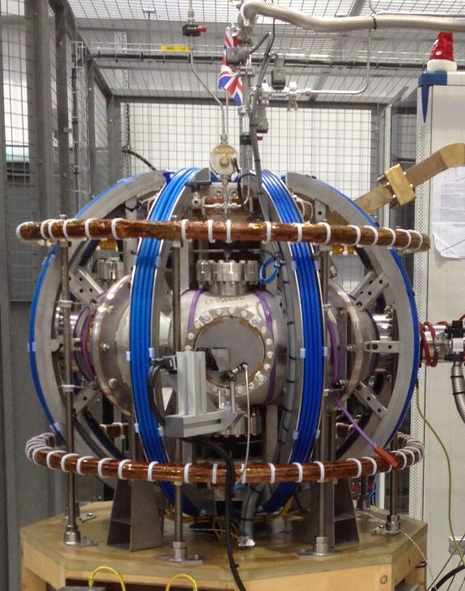
Main parameters of the ST25:
R/a = 0.25/0.125 m, B_{t} = 0.1 - 0.5 T, I_{pl} = 10 - 20 kA, pulse duration up to 27 s achieved or continues in the AC mode; plasma density = 10¹⁸ - 2 x 10¹⁹m⁻³; plasma temperature = 100 – 300 eV, working gas: H, He, Ag; current drive: inductive or RF; heating and current drive power: P_{RF}= 3 - 20 kW, RF frequency 2.45 – 18 GHz. Operation costs are non-significant (electricity, cooling water, H₂ and He₂ gas) and it is currently operated by two engineers and a PhD student in a 20 m² room including the tokamak and all power supplies (capacitor banks and Super-capacitors). It requires 20 – 50 kW of electricity during a few second pulses with repetition rate up to 10 pulses per hour. The tokamak is equipped with basic diagnostics, which can be upgraded and extended.
Plasma currents can be initiated either by induction from the central solenoid, or by injection of 2.45GHz and 5.8GHz microwaves, for which the toroidal field at major radius 25cm is ~0.1T or 0.2T respectively. For these relatively long plasma discharges special screened, balanced and temperature controlled data integrators have been developed to almost completely eliminate pick-up from the RF noise, and arrays of field sensors based on 3D Hall probes are used in place of the more usual Rogowski coils (which are liable to exhibit substantial drift).
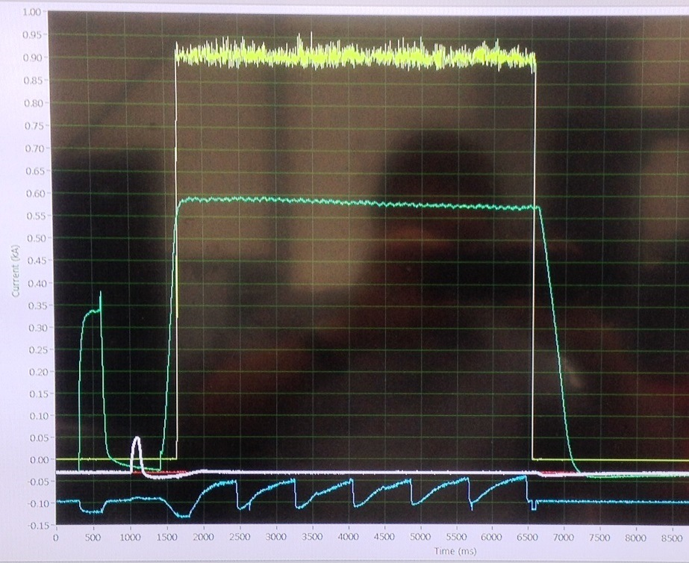
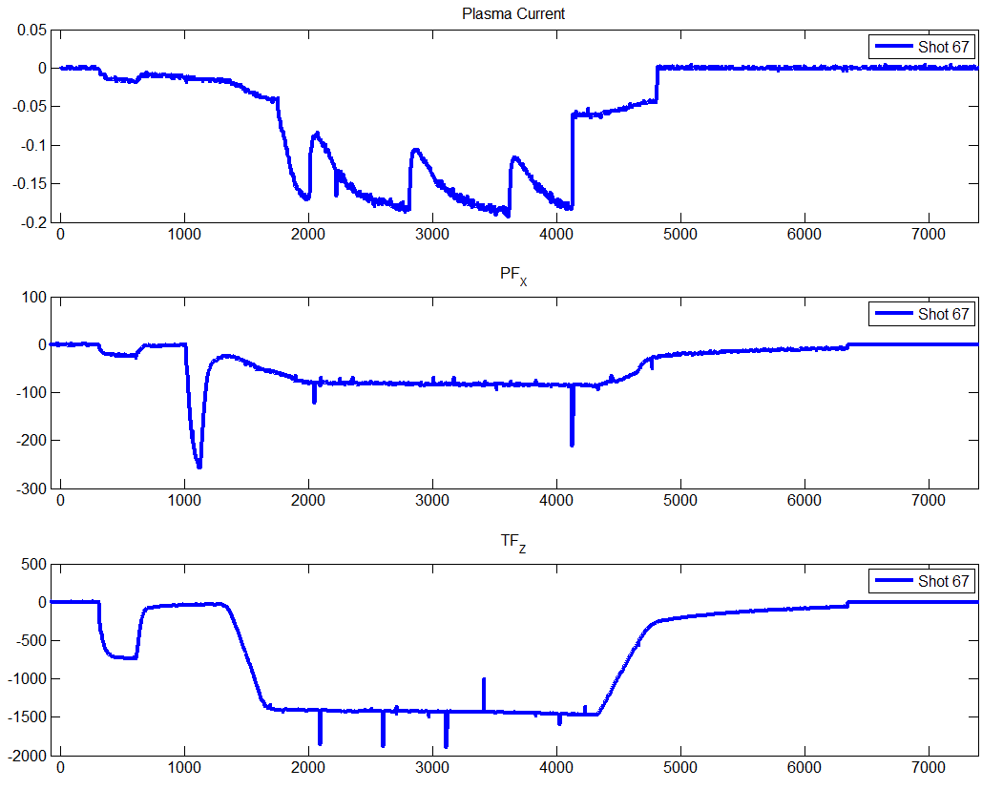

Hall probe traces of Bv and TF currents, showing pre-pulses for calibration. Both are produced from the same cap bank
RF power (yellow), TF trace,(with initial calibration pulse (green); vertical field (white); plasma current (blue). Plasma current reduces at each gas puff

The main objectives of ST25 are to establish techniques appropriate for long pulse operation in the High-Temperature-Superconducting ST25(HTS) tokamak recently constructed in collaboration with Oxford Instruments; in particular to study RF methods of plasma initiation and current drive using inside-launch Electron Bernstein Wave, and low-field-side injection using a 2D tilting bellows which can provide a combination of both tilt and skew injection angles. However the facility is ideally suited to basic plasma operation studies, lithium conditioning, development of diagnostics, etc.
The control system is LabView based (and has won a UK award for Innovation) with data analysis based on Matlab. The safety system is PLC controlled using compressed air operated switches, dumps and earths. Maximum power consumption is approx 30kA of 3-phase 415V standard lab supplies, the major demands being the capacitor bank charging and to power the microwave supplies (presently two 3kW units). The microwave uses closed system compact water cooling.
Plasma conditioning is ensured by passing high-purity hydrogen through a LN trap, and by employing a cold head in the turbo stack to aid the pumping of water impurity. Argon and Helium plasmas (and Helium Glow Discharge Cleaning) are available. Diagnostics are under development, including interferometry; a high-grade ‘Rocoil’ Rogowski is used to measure plasma current, and a spectrometer and high speed colour video camera record plasma information. A Lithium injection system is under test off-line, using laser ablation of lithium foil.
2.45GHz , 3kW microwave
Autotuner
Waveguide for HFS launch
Pumping stack
RGA
LN trap
Cold head
Turbo pump
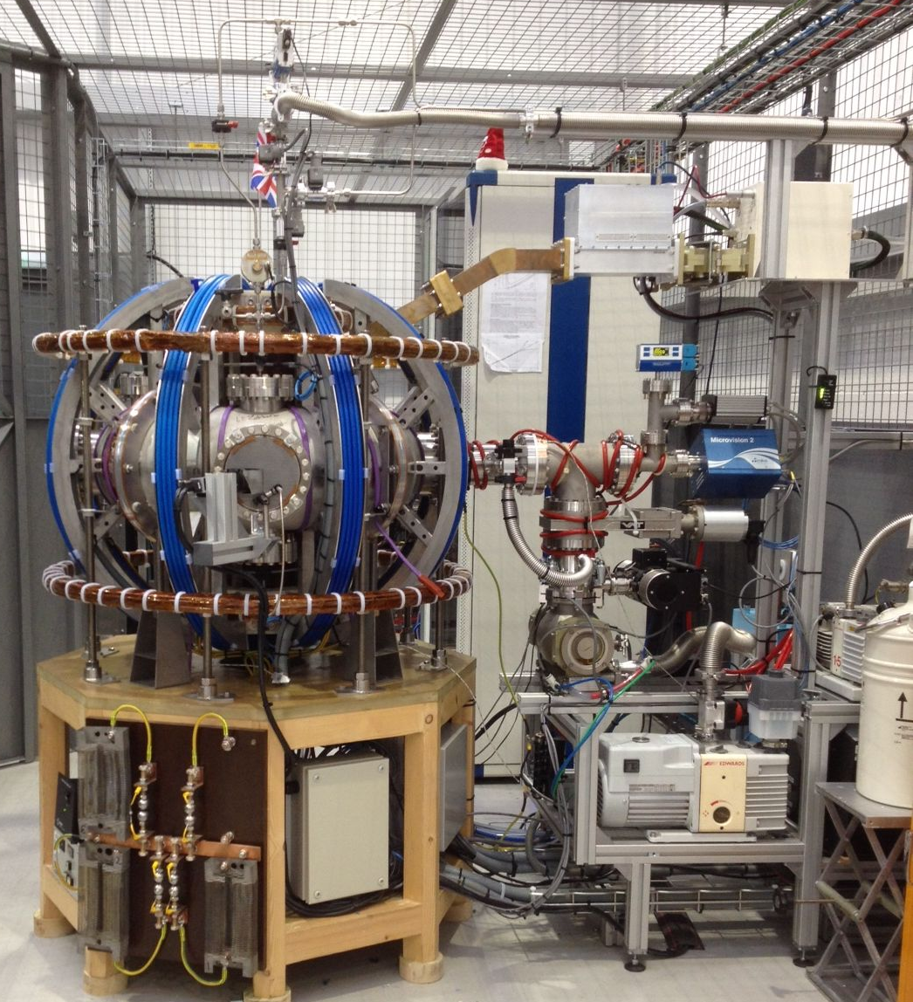
Gas feed
Piezo valve
Bv coil
TF coil

High-Speed video
Spectrometer head

Power Supplies
A major innovation is the use of Maxwell Transport Modules. These are 125V, 63F units used in buses, etc and are very robust. At present ST25 is powered by 3 modules: in series they can provide TF of ~0.25T, in parallel they can provide resonance for the 2.45GHz microwave for a full 20s. This bank is of 1.5megajoules, and can deliver over 1MW of power. Using IGBT controlled switching, fully variable waveforms can be produced independently for both TF and PF coils from this single central resource.
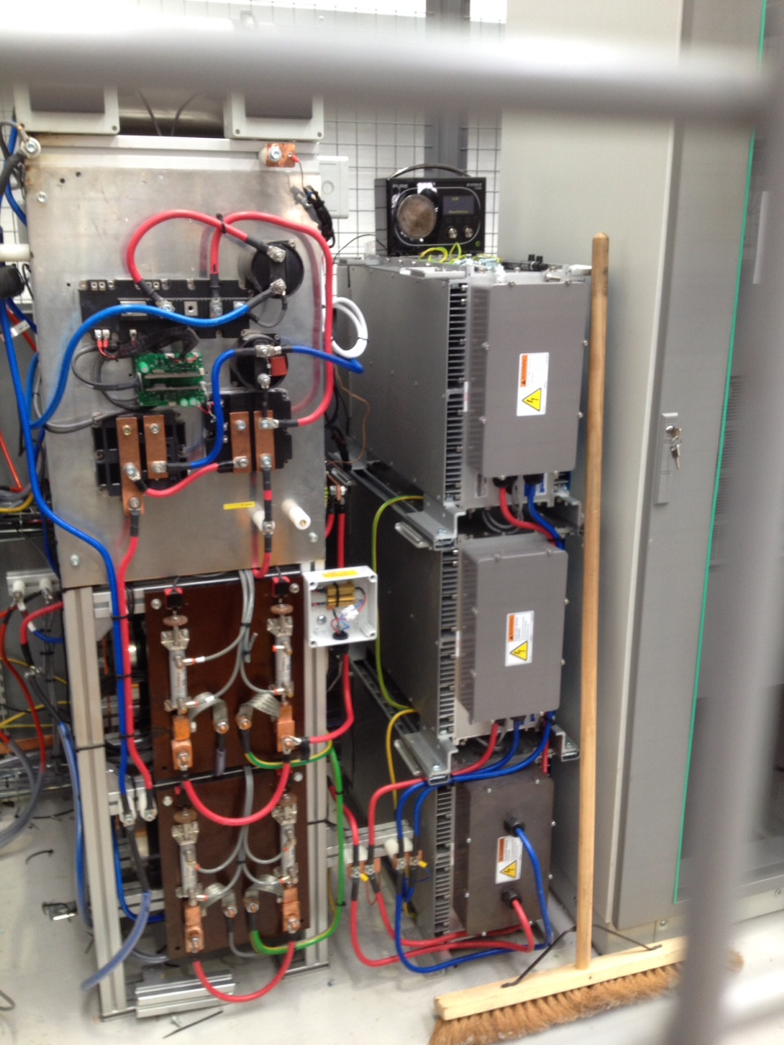

Development in progress
- Improvements to LFS and HFS RF antennae to improve coupling
- Installation of lithium equipment (laser ablation of Li foil)
- Testing of waveform control for new central solenoid (previous hand-wound solenoid produced discharges of ~6kA for a few ms)

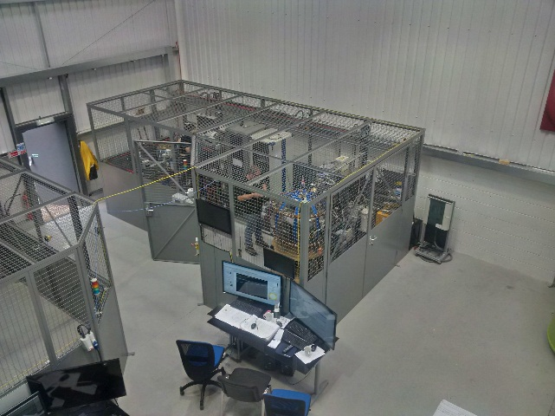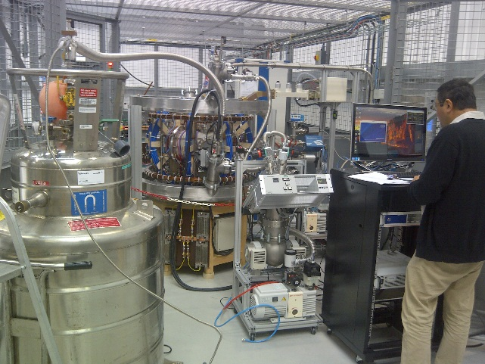
ST25 assembly. ST25 used as a test bed for HTS PF coils
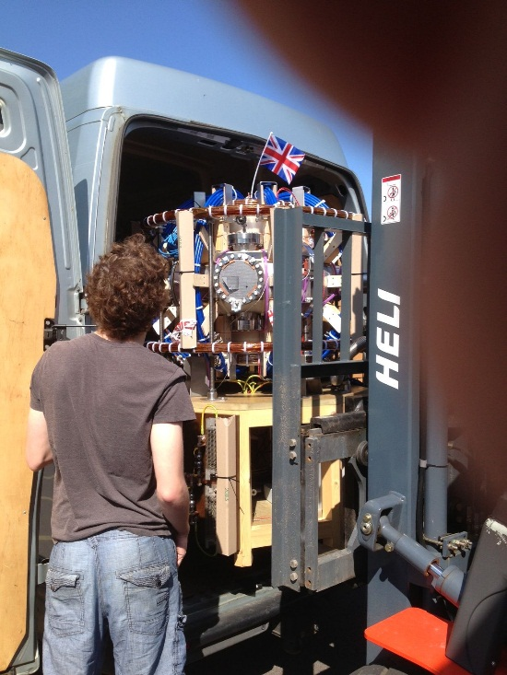
Transportation of ST25 – fits in a small van.

Longer term improvement: replacement of pipe-bend vac vessel with ‘D’ shape vessel

