PROGRAMME OF COORDINATED RESEARCH ACTIVITIES
Webpage: www.iaea.org/services/coordinated-research-activities

Final Report for Contracts
Please send the Progress Report to research.contracts@iaea.org
CRP code: F13019 | CRP title: Network of Small and Medium Size Magnetic Confinement Fusion Devices for Fusion Research
Contract Number: 22782 | Contract title: Scientific and education activities on the GOLEM tokamak in the framework of the IAEA CRP
Institute Name: Czech Technical University
CSI: Vojtěch SVOBODA | Alternate CSI:
Progress Report for year: 1-4  (year 1, 2, 3…) | Period covered:  (2018-06-20 – 2022-12-31)

- Detailed programme of work, as planned at the beginning of the period, taking into account the recommendations given during Research Coordination Meetings (RCMs) and/or through communication with the Project Officer:

2.2.14.1. Main research activities proposed
The scientific activities focus on the field of plasma edge studies using advanced probe techniques and developing diagnostics for runaway studies.

2.2.14.3. Education activities
In the CRP context there are two planned education activities: GOMTRAIC, a week of hands-on experiments at the GOLEM tokamak, and a set of remote participation training courses.

- Results achieved in comparison with the planned programme of work.

Introduction

Research activities

* plasma edge studies using advanced probe techniques

I:
Operational domains
=================

Operational domain in hydrogen plasmas on the GOLEM tokamak
Helium plasmas operation domain studies on the GOLEM tokamak
Hydrogen and Helium Plasmas in the GOLEM Tokamak

Advanced electrostatic probes … using
===================
Self-induced transport barrier in the helium plasma on the tokamak GOLEM
Fast measurements of electron temperature on the GOLEM tokamak by means of Tunnel Probe
Electron temperature measurements using rail probe on the tokamak GOLEM
Ion and electron temperature study in the edge plasma of the tokamak device
Impact of swept edge plasma potential biasing on turbulence in tokamaks

Magnetohydrodynamic studies:
=====================
Magnetic turbulence and long-range correlation studies in the GOLEM tokamak

Magnetohydrodynamic Mode Identification for Golem Mirnov Coil Signals Using Singular Value Decomposition and Multichannel Variational Mode Decomposition Method for Analyzing Time–
Frequency

* developing diagnostics for runaway studies.

Diagnostics
========
Design and Development of Probe for the Measurements of Runaway Electrons Inside the GOLEM Tokamak Plasma Edge
Runaway electron diagnostics using silicon strip detector
Runaway electron study at the COMPASS tokamak using the Timepix3-based silicon pixel detector with SPIDR 10 GBps readout.

Physics
======
Study of Runaway Electrons in GOLEM Tokamak
The Runaway Electrons Production Dynamics Dependence on the Breakdown Phase of the Tokamak Plasma

How does this support affect your outputs

List of publications related to the grant.

Educational activities

GOleM TRAIning Course (GOMTRAIC 2019)
GOleM TRAIning Course (GOMTRAIC2019) was held at the faculty of Nuclear Sciences and Physical Engineering in the Czech Technical University in Prague, Czech Republic during March 04-08, 2019. Sixteen students (from undergraduate to doctoral level and ten countries) participated in the course to have hands-on experience of tokamak operation and perform experiments on the GOLEM tokamak.

Online experimentation at the GOLEM tokamak
The GOLEM tokamak offers students and other interested parties the opportunity to gain “hands-on” experience through online experimentation in the field of plasma physics and controlled thermonuclear fusion in tokamaks. A typical online experiment scenario is outlined. The new web application facilitating safe, easy and efficient online experimentation, including a live, real-time view of the experiment is described in detail. Simple access to the open and extensive database of experimental results is demonstrated. Finally, the wide range of possible experimental topics from past -and applicable to future- online experimentation sessions is reported. More info at [GSS19a, GSS19b]

Education and training of students
* Experiments related to CRP project triggered approx 10 bachelor and master thesis at the Czech Technical University
* Hands-on/ on site tokamak GOLEM projects
* Approx 6 projects for extremely skilled high school students was completed.
* More then 30 training courses of students has also been performed remotely, exploiting a unique feature of the GOLEM tokamak, which can be operated via Internet.

One figure that you think summarizes the advances made with the help of the IAEA grant.

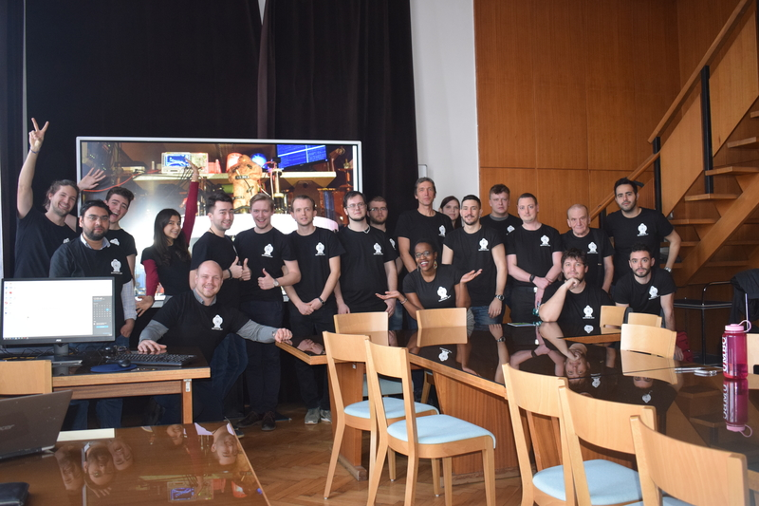

- Papers published and dissemination at national and international conferences on work performed under this Project (please enter a web-link or attach copies to this progress report):

I:
[Lin+18] V. Linhart et al. “First Measurement of X-rays Generated by Runaway Electrons in Tokamaks Using a TimePix3
Device with 1 mm thick Silicon Sensor”. In: 2018 IEEE Nuclear Science Symposium and Medical Imaging Conference
Proceedings (NSS/MIC). 2018, pp. 1–9. doi: 10.1109/NSSMIC.2018.8824534.

[Dhy+19] P. Dhyani et al. “Study of Runaway Electrons in GOLEM Tokamak”. In: Journal of Instrumentation 14.09 (2019),
pp. C09029–C09029. doi: 10.1088/1748-0221/14/09/c09029. url: https://doi.org/10.1088%2F1748-0221%2F14%
2F09%2Fc09029.

[Dhy19] Svoboda V. Istokskaia V. Mlynář J. Čeřovský J. Ficker O. Linhart V. Dhyani P. “Design and development of probe for the
measurements of runaway electrons inside the golem tokamak plasma edge”. In: vol. 2019-July. Europhysics conference
abstracts. 2019, P1.1016. isbn: 979-10-96389-11-7. url: http://ocs.ciemat.es/EPS2019PAP/pdf/P1.1016.pdf.

[GSS19a] O. Grover, V. Svoboda, and J. Stockel. “Online experimentation at the GOLEM tokamak”. In: 2019 5th Experiment International Conference (exp.at’19). 2019, pp. 220–225. doi: 10 . 1109 / EXPAT . 2019 . 8876482. url: https :
//ieeexplore.ieee.org/document/8876482.

[GSS19b] O. Grover, V. Svoboda, and J. Stockel. “Remote demonstration of the GOLEM tokamak”. In: 2019 5th Experiment International Conference (exp.at’19). 2019, pp. 239–240. doi: 10 . 1109 / EXPAT . 2019 . 8876584. url: https :
//ieeexplore.ieee.org/document/8876584.

[Kul19] Mácha P. Istokskkaia V. Kropáčková D. Papoušek F. Adámek J. Čeřovský J. Ficker O. Grover O. Jiráková K. Stöckel J.
Svoboda V. Kulkov S. “Tokamak GOLEM for fusion education - chapter 10”. In: vol. 2019-July. Europhysics conference
abstracts. 2019, P1.1068. isbn: 979-10-96389-11-7. url: http://ocs.ciemat.es/EPS2019PAP/pdf/P1.1068.pdf.

[Svo+19] Vojtech Svoboda et al. “Operational Domain in Hydrogen Plasmas on the GOLEM Tokamak”. In: Journal of Fusion
Energy (2019). issn: 1572-9591. doi: https://doi.org/10.1007/s10894-019-00215-7.

II:
[Nov+20]
L. Novotny et al. “Runaway electron diagnostics using silicon strip detector”. In: Journal of Instrumentation 15.07
(2020), pp. C07015–C07015. doi: 10.1088/1748-0221/15/07/c07015. url: https://doi.org/10.1088%2F17480221%2F15%2F07%2Fc07015.

III:
[Sius+21]
Siusko, Y., Svoboda, V., Stockel, J., Garkusha, I., Solyakov, D., Girka, I., . . . Shchibrya, A. . Breakdown phase in the golem tokamak and its impact on plasma performance. Ukrainian Journal of Physics, 66(3), 231-239 (2021). doi:10.15407/ujpe66.3.231

[Kul21] Kulkov, S., Marcisovsky, M., Svihra, P., Ficker, O., Cerovsky, J., Macusova, E., Weinzettl, V., Beuzekom, M., Fransen, M. , Bren, D. , Linhart, V., , Svoboda, V., Tunkl, M. “Runaway electron study at the COMPASS tokamak using the Timepix3-based silicon pixel detector with SPIDR 10 GBps readout”. In: vol. 2021-July. Europhysics conference abstracts. 2021, P3.1006. isbn: 979-10-96389-13-1. url: http://ocs.ciemat.es/EPS2021PAP/pdf/P3.1006.pdf.

[Mac21] Macha,P.,Hromasova, K., Kropackova,D., Lauerova, M., Socha, A., Malinak, J., Cipciar, D., Cecrdle, J., Svoboda, V., Stockel, J., Adamek, J., Papousek, F., Lobko, L. “Tokamak GOLEM for fusion education - chapter 12”. In: vol. 2021-July. Europhysics conference abstracts. 2021, P4.1028. isbn: 979-10-96389-13-1. url: http://ocs.ciemat. es/EPS2021PAP/pdf/P4.1028.pdf.

[Jirch] Jiri Malinak. “Electron temperature measurements using rail probe on the tokamak GOLEM.” Bachelor project at the CTU Prague, 2021. url: http://golem.fjfi.cvut.cz/wiki/Presentations/Students/BachelorProjects/21MalinakJiri.pdf

[Darst] Dario Cipciar. “Ion and electron temperature study in the edge plasma of the tokamak device”. Master thesis at the CTU Prague, 2021. url: http://golem.fjfi.cvut.cz/wiki/Presentations/Students/MasterThesis/21DarioCipciar.pdf

[Saranch+21]
George Sarancha, Alexey Drozd, Stanislav Ganin, Daniela Kropachkova, Ivan Kudashev, Vladimir Kulagin, Martina Lauerova, Alexander Melnikov, Nikita Sergeev, Oleg Krokhalev, Jan Stockel and Vojtech Svoboda. Hydrogen and Helium Plasmas in the GOLEM Tokamak. Prepared for publication in Questions of Atomic Science and Technique.

IV:

Articles:
[Cer+22] J. Cerovsky et al. “Progress in HXR diagnostics at GOLEM and COMPASS tokamaks”. In: Journal of Instrumentation. 17.01 (2022), p. C01033. doi: 10 . 1088 / 1748 - 0221 / 17 / 01 / c01033.

[Kul+22] S. Kulkov et al. “Detection of runaway electrons at the COMPASS tokamak using a Timepix3-based semiconductor. detector”. In: Journal of Instrumentation 17.02 (2022), P02030. doi: 10 . 1088 / 1748 - 0221 / 17 / 02 / p02030.

Conferences:
[Mac22a] Macha, P., M. Pokorny, D. Kropackova, M.Humpolec, J. Chlum, K. Wen, M. Tunkl, M. Lauerova, J. Brotankova, J.
Stockel, V. Svoboda, S. Kulkov, A. PodolnikJ. Caloud, S. Malec. “Tokamak GOLEM for fusion education – chapter 13”. In: vol. 2022-July. Europhysics conference abstracts. 2022.

[Mac22b] Macha,P., Svoboda, V., Stockel, J., Adamek, J., Seidl, J. “Self-induced transport barrier in the helium plasma on the tokamak GOLEM”. In: vol. 2022-July. Europhysics conference abstracts. 2022.

[Sar+21a] G Sarancha et al. “Magnetic turbulence and long-range correlation studies in the GOLEM tokamak” . In: Journal of Physics: Conference Series 2055.1 (2021), p. 012003. doi: 10.1088/1742- 6596/2055/1/012003.

Others:
[Jakch] Jakub Chlum. “Implementation of tomographic inversion on the GOLEM tokamak.” Bachelor project 2022. url:
http://golem.fjfi.cvut.cz/wiki/Presentations/Students/BachelorProjects/22ChlumJakub.pdf.

[CJ22] Jayakumar Chandrasekaran and Sangeetha Jayaraman. “Magnetohydrodynamic Mode Identification for Golem Mirnov Coil Signals Using Singular Value Decomposition and Multichannel Variational Mode Decomposition Method for Analyzing Time-Frequency”. English. In: JOURNAL OF FUSION ENERGY 41.2 (2022). issn: 0164-0313. doi: 10.1007/s10894-022-00329-5.

- Activities included in the programme of work which were planned, but were not implemented. Please state reason (i.e.: delays, issues encountered):

- Detailed programme of work for the coming year, taking into account the recommendations given during RCMs and/or through communication with the Project Officer (to be used as reference for the next Progress Report):

-

CSI Name and signature: Date: 18.9.2022
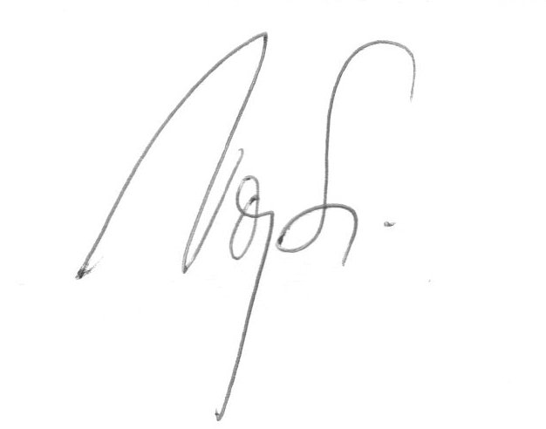
Vojtěch Svoboda

