PROGRAMME OF COORDINATED RESEARCH ACTIVITIES
Webpage: www.iaea.org/services/coordinated-research-activities

Annual Progress Report for Contracts
Please send the Progress Report to research.contracts@iaea.org
CRP code: F13019 | CRP title: Network of Small and Medium Size Magnetic Confinement Fusion Devices for Fusion Research
Contract Number: 22782 | Contract title: Scientific and education activities on the GOLEM tokamak in the framework of the IAEA CRP
Institute Name: Czech Technical University
CSI: Vojtěch SVOBODA | Alternate CSI:
Progress Report for year: 2  (year 1, 2, 3…) | Period covered:  (2019-06-28 – 2020-08-31)

- Detailed programme of work, as planned at the beginning of the period, taking into account the recommendations given during Research Coordination Meetings (RCMs) and/or through communication with the Project Officer:

2.2.14.1. Main research activities proposed
The scientific activities focus on the field of plasma edge studies using advanced probe techniques and developing diagnostics for runaway studies.

2.2.14.3. Education activities
In the CRP context there are two planned education activities: GOMTRAIC, a week of hands-on experiments at the GOLEM tokamak, and a set of remote participation training courses.

- Results achieved in comparison with the planned programme of work.

* plasma edge studies using advanced probe techniques

Helium plasmas operation domain studies on the GOLEM tokamak
The issue of helium plasma confinement in modern tokamaks remains an important area of research. This work is dedicated to the study of helium plasma initiation and its control in a small-scale machine GOLEM. The comparison between helium and hydrogen plasma discharges are done. Main plasma parameters evolution for both types of gas is presented here during start-up and burn-through phase of the discharge. Optimum operational conditions for the start-up of helium plasma are found experimentally. Helium and hydrogen plasma operational regimes are discussed, and the extension of the operation domain is proposed for further research. More info in the article under preparation for publication:“Helium plasmas operation domain studies on the GOLEM tokamak.pdf”.

* developing diagnostics for runaway studies.

Runaway electron diagnostics using silicon strip detector
We present a proof-of-principle measurement of runaway electrons in a small tokamak
using a silicon strip detector. The detector was placed inside the diagnostic port of the tokamak vessel and detected the runaway electron signal directly. The measured signal was compared to the signal provided by other tokamak diagnostics, especially the hard X-ray scintillation detector, which detects secondary photons created by interaction of accelerated electrons with tokamak walls (indirect detection of runaway electrons). The preliminary results show that when not saturated, direct detection with a segmented silicon strip detector provides promising new diagnostic information including spatial and temporal distribution of the runaway electron beam, and the measurement results are in good agreement with hard X-ray measurements with a scintillation detector. More info in the article [Nov+20].

* educational activities

Foressen GOleM TRAIning Course (GOMTRAIC 2020)
GOleM TRAIning Course (GOMTRAIC2020) was not organized due to pandemic situation.

Education and training of students
Experiments related to CRP project triggered bachelor and master thesis at the CTU:
Bachelor projects:
• Vojtech Fiser: Real time tokamak GOLEM operation.
Research projects:
• Filip Papousek: Impact of swept edge plasma potential biasing on turbulence in tokamaks
Master thesis:
• Petr Mácha: Fast measurements of electron temperature on the GOLEM tokamak by means of Tunnel Probe (defended 2020)
Hands-on/ on site tokamak GOLEM projects
• For Students (bachelor level) of the FNSPE CTU in the frame of the Basic experimental laboratory. This year remotely due to pandemic situation.
• September 2019: Night of Scientists for broad public.
• Two projects for extremely skilled high school students: Martina Lauerova (Plasma edge studies via electrostatic probes) and Daniela Kropackova (Plasma stabilization studies)
Training of students has also been performed remotely, exploiting a unique feature of the GOLEM tokamak, which can be operated via Internet. Several on-site as well as remote courses were organized in the period 2019 – 2020, among these, major events were:
• Remote practice for Budapest University of Economics and technology, Hungary, offline data mining version due to Tokamak GOLEM control system reconstruction.

• Remote practice for Eindhoven University, Netherlands 14th, January 2020
• Remote practice for Torino University, Italy 15th, January 2020
• Remote workshop for the 6th ASEAN School on Plasma and Nuclear Fusion, 30th, January 2020, Thailand,
• Remote practice for Moscow University, Russia 27th, May 2020

* Overall tokamak GOLEM contribution the the IAEA CRP project
Contribution of joint experiments on small tokamaks in the framework of IAEA coordinated research projects to mainstream fusion research
Joint experiments (JEs) on small tokamaks have been regularly performed between 2005 and 2015 under the framework of the International Atomic Energy Agency (IAEA) coordinated research projects (CRPs). This paper describes the background and the rationale for these experiments, how they were organized and executed, main areas of research covered during these experiments, main results, contributions to mainstream fusion research, and discusses lessons learned and outcomes from these activities. We underline several of the most important scientific outputs and also specific outputs in the education of young scientists and scientists from developing countries and their importance. More info in the article [GRY+20].

- Papers published and dissemination at national and international conferences on work performed under this Project (please enter a web-link or attach copies to this progress report):

[GRY+20]
M GRYAZNEVICH et al. “Contribution of joint experiments on small tokamaks in the framework of IAEA coordinated
research projects to mainstream fusion research”. In: Plasma Science and Technology 22.5 (2020), p. 055102. doi:
10.1088/2058-6272/ab6d4d. url: https://doi.org/10.1088%2F2058-6272%2Fab6d4d.

[Nov+20]
L. Novotny et al. “Runaway electron diagnostics using silicon strip detector”. In: Journal of Instrumentation 15.07
(2020), pp. C07015–C07015. doi: 10.1088/1748-0221/15/07/c07015. url: https://doi.org/10.1088%2F17480221%2F15%2F07%2Fc07015.
- Activities included in the programme of work which were planned, but were not implemented. Please state reason (i.e.: delays, issues encountered):
- Tokamak GOLEM control system reconstruction (autumn 2019) and pandemic situation (spring 2020).

- Detailed programme of work for the coming year, taking into account the recommendations given during RCMs and/or through communication with the Project Officer (to be used as reference for the next Progress Report):

Main research activities proposed:
The scientific activities continues to focus on the field of plasma edge studies using advanced probe techniques and developing diagnostics for runaway studies.

Education activities proposed:
In the CRP context there are again two planned education activities based on first year experience: GOMTRAIC #2, a week of hands-on experiments at the GOLEM tokamak, and a set of remote participation training courses.

CSI Name and signature: Date: 14.9.2020
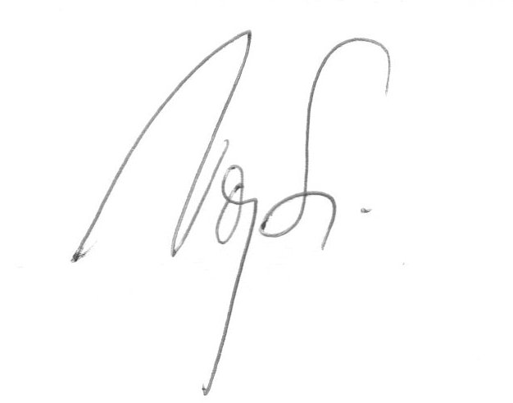
Vojtěch Svoboda

