PROGRAMME OF COORDINATED RESEARCH ACTIVITIES
Webpage: www.iaea.org/services/coordinated-research-activities

Final Report for Contracts
Please send the Final Report to research.contracts@iaea.org
CRP code: F13019 | CRP title: Network of Small and Medium Size Magnetic Confinement Fusion Devices for Fusion Research
Contract Number: 22782 | Contract title: Scientific and education activities on the GOLEM tokamak in the framework of the IAEA CRP
Institute Name: Czech Technical University
CSI: Vojtěch SVOBODA | Alternate CSI:
Period covered: 2018-06-20 – 2022-12-31
(yyyy-mm-dd – yyyy-mm-dd)

- Overall programme of work, as stated in the Contract, taking into account the recommendations given during Research Coordination Meetings (RCMs) and/or through communication with the Project Officer:
2.2.14.1. Main research activities proposed
The scientific activities focus on the field of plasma edge studies using advanced probe techniques and developing diagnostics for runaway studies.

2.2.14.3. Education activities
In the CRP context there are two planned education activities: GOMTRAIC, a week of hands-on experiments at the GOLEM tokamak, and a set of remote participation training courses.

- Summary which describes in brief form the experimental method, the results and conclusions drawn:
Research activities
I. physics and diagnostics of the plasma edge
A wide spectrum of advanced electrostatic probes (Tunnel , Rail, Ball pen, Mach, Double rake ) were tested in various tokamak regimes including swept edge plasma potential biasing, and used for fast measurements of ion and electron temperature. [Macch], [Jirch] ,[Darst] and [Papch].
Particular focus was applied to the isotopic studies of operational domains in hydrogen and helium plasmas and self-induced transport barrier in the Helium plasma, see [Svo+19], [Saranch+21] and [Mac22b].
Secondly studies dedicated to Magnetic turbulence and long-range correlation together with Magnetohydrodynamic Mode Identification Using Singular Value Decomposition and Multichannel Variational Mode Decomposition Method were performed with two sets of Mirnov coils surrounding poloidally plasma column at two different toroidal positions, see[Sar+21a], [CJ22].

II. physics and diagnostics of runaway electrons.
In the Diagnostics branch we focused on Design and Development of various Probes for the Measurements of X-rays Generated by Runaway Electrons using silicon strip detector, Timepix3-based silicon pixel detector with SPIDR 10 GBps readout., TimePix3 Device with 1 mm thick Silicon Sensor and a set of scintillation probes with various crystals (NaI(Tl), YAP, CeBr and LYSO), see [Lin+18], [Dhy19] , [Nov+20], [Kul21] and [Kul+22]. Based on these novel diagnostics we performed a set of sessions dedicated to general behaviour of Runaway Electrons in GOLEM Tokamak with focus on their Production Dynamics Dependence on the Breakdown Phase of the Tokamak Plasma [Dhy+19] and [Siu+21].

III. Pioneering studies in connection with the application of the high temperature superconductors (HTS) magnets.
In the framework of the IAEA coordinated research projects experiments on the tokamak GOLEM were dedicated to many: HTS DC and AC tests, HTS switch tests, plasma optimization with HTS coils and required modifications to the discharge scenario to reduce AC losses in HTS coils during current ramp-up, and also characterization of a quench in the HTS coil. [GRY+20].

Educational activities

I. GOleM TRAIning Course (GOMTRAIC 2019)
.. was held at the faculty of Nuclear Sciences and Physical Engineering in the Czech Technical University in Prague, Czech Republic during March 04-08, 2019. Sixteen students (from undergraduate to doctoral level and from ten countries) participated in the course to have hands-on experience of tokamak operation and perform experiments on the GOLEM tokamak. See the final report in attached file.
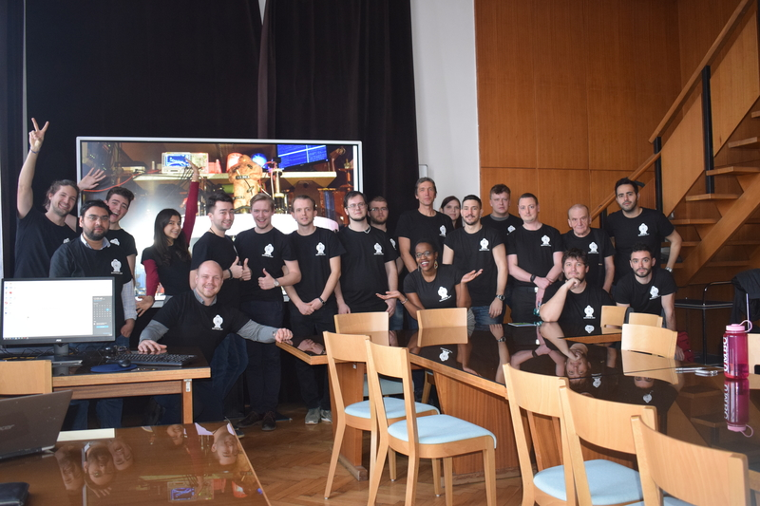

GOMTRAIC students after successful presentations, the final day of the course

II. EPSs:
Each year, a summary of all student activities from bachelor to doctoral level on the Golem tokamak is summarized in a paper for the European Physical Society (EPS) conference on Plasma Physics:
- 2019: Tokamak GOLEM for fusion education - chapter 10 [Kul19]
- (Skipped due to covid)
- 2021: Tokamak GOLEM for fusion education - chapter 12[Mac21]
- 2022: Tokamak GOLEM for fusion education - chapter 13[Mac22a]

III. Online experimentation at the GOLEM tokamak
The GOLEM tokamak offers students and other interested parties the opportunity to gain “hands-on” experience through online experimentation in the field of plasma physics and controlled thermonuclear fusion in tokamaks. More info at [GSS19a, GSS19b]

IV. Education and training of students
* Experiments related to CRP project triggered 4 bachelor projects and 3 master thesis at the Czech Technical University
* Every year 3-5 hands-on/ on site tokamak GOLEM projects are produced for CTU Prague university students.
* Approx 6 projects for extremely skilled high school students were completed.
* More then 30 training courses of students has also been performed remotely, exploiting a unique feature of the GOLEM tokamak, which can be operated remotely via Internet.

- Detailed results achieved in comparison with the planned programme of work, including quantitative data if applicable (please attach appropriate technical documents if needed):
For detailed results, see attached journal and conference contributions.

- Papers published and dissemination at national and international conferences on the Project or parts thereof performed under this Contract (please enter a web-link or attach copies to this final report):
See attached file “GOLEM_biblio_IAEA.pdf”

- PhD and Master’s theses that include data from the Project under this contract:
See attached file “GOLEM_biblio_IAEA.pdf”

- Activities included in the programme of work which were planned, but were not implemented. Please state reason (i.e.: delays, issues encountered):
We planned to organize at least one more “GOleM TRAIning Course“, but we had to cancelled it twice due to COVID pandemic situation.

- Please provide a short financial overview on how the IAEA contribution to this Project was used and if other contributions, either from a technical cooperation project, or other sources of funding, were used for the implementation of the project:
The funds were used to cover the cost of diagnostic and data acquisition systems, services associated with the production of specialized instruments, laboratory material, remuneration for trainers and supervisors of student works, conference fee and travel expenses, IT support and shot database management, SW licenses, and repairs of special equipments.

- Please describe the impact and relevance of this Project, as well as any recommended follow-up actions :
It is said that education is the key to success in the greatest human projects. From this point of view, the contribution of the GOLEM tokamak (mainly various local and remote training courses for students of universities and various seminars from all over the world) with the support of the IAEA CRP is a very important contribution to solving such a challenging vision as mastering thermonuclear fusion in terrestrial conditions. On the other hand, education does not have unconditional financial support and it is necessary to apply for support in smaller amounts to all possible institutions, and so these IAEA funds significantly helped the production of an infinite number of small procedural steps in solving various experimental and technological problems related to student activities at this facility. As the leader of this experiment, I am very grateful for this support, and at least similar support for the following years would greatly help my work.

CSI Name and signature: Date: 2.12.2022
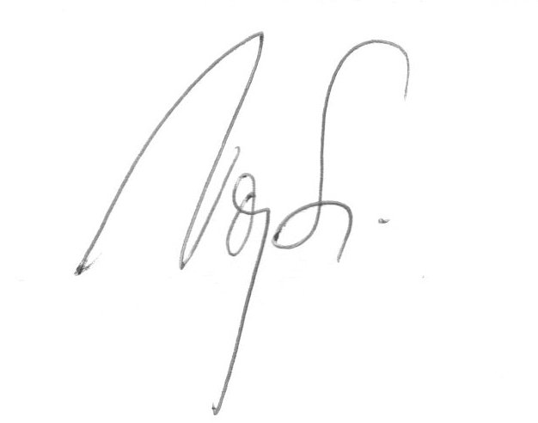
Vojtěch Svoboda

