Initial analysis of BPP+LP experiment
Analysis is performed using tables of Vojta for shots #23191, 93, 95 and 98 - Btor scan.
Color plots of the floating potential (from fit of IV characteristics) left, and plasma potential measured directly by BPP - right
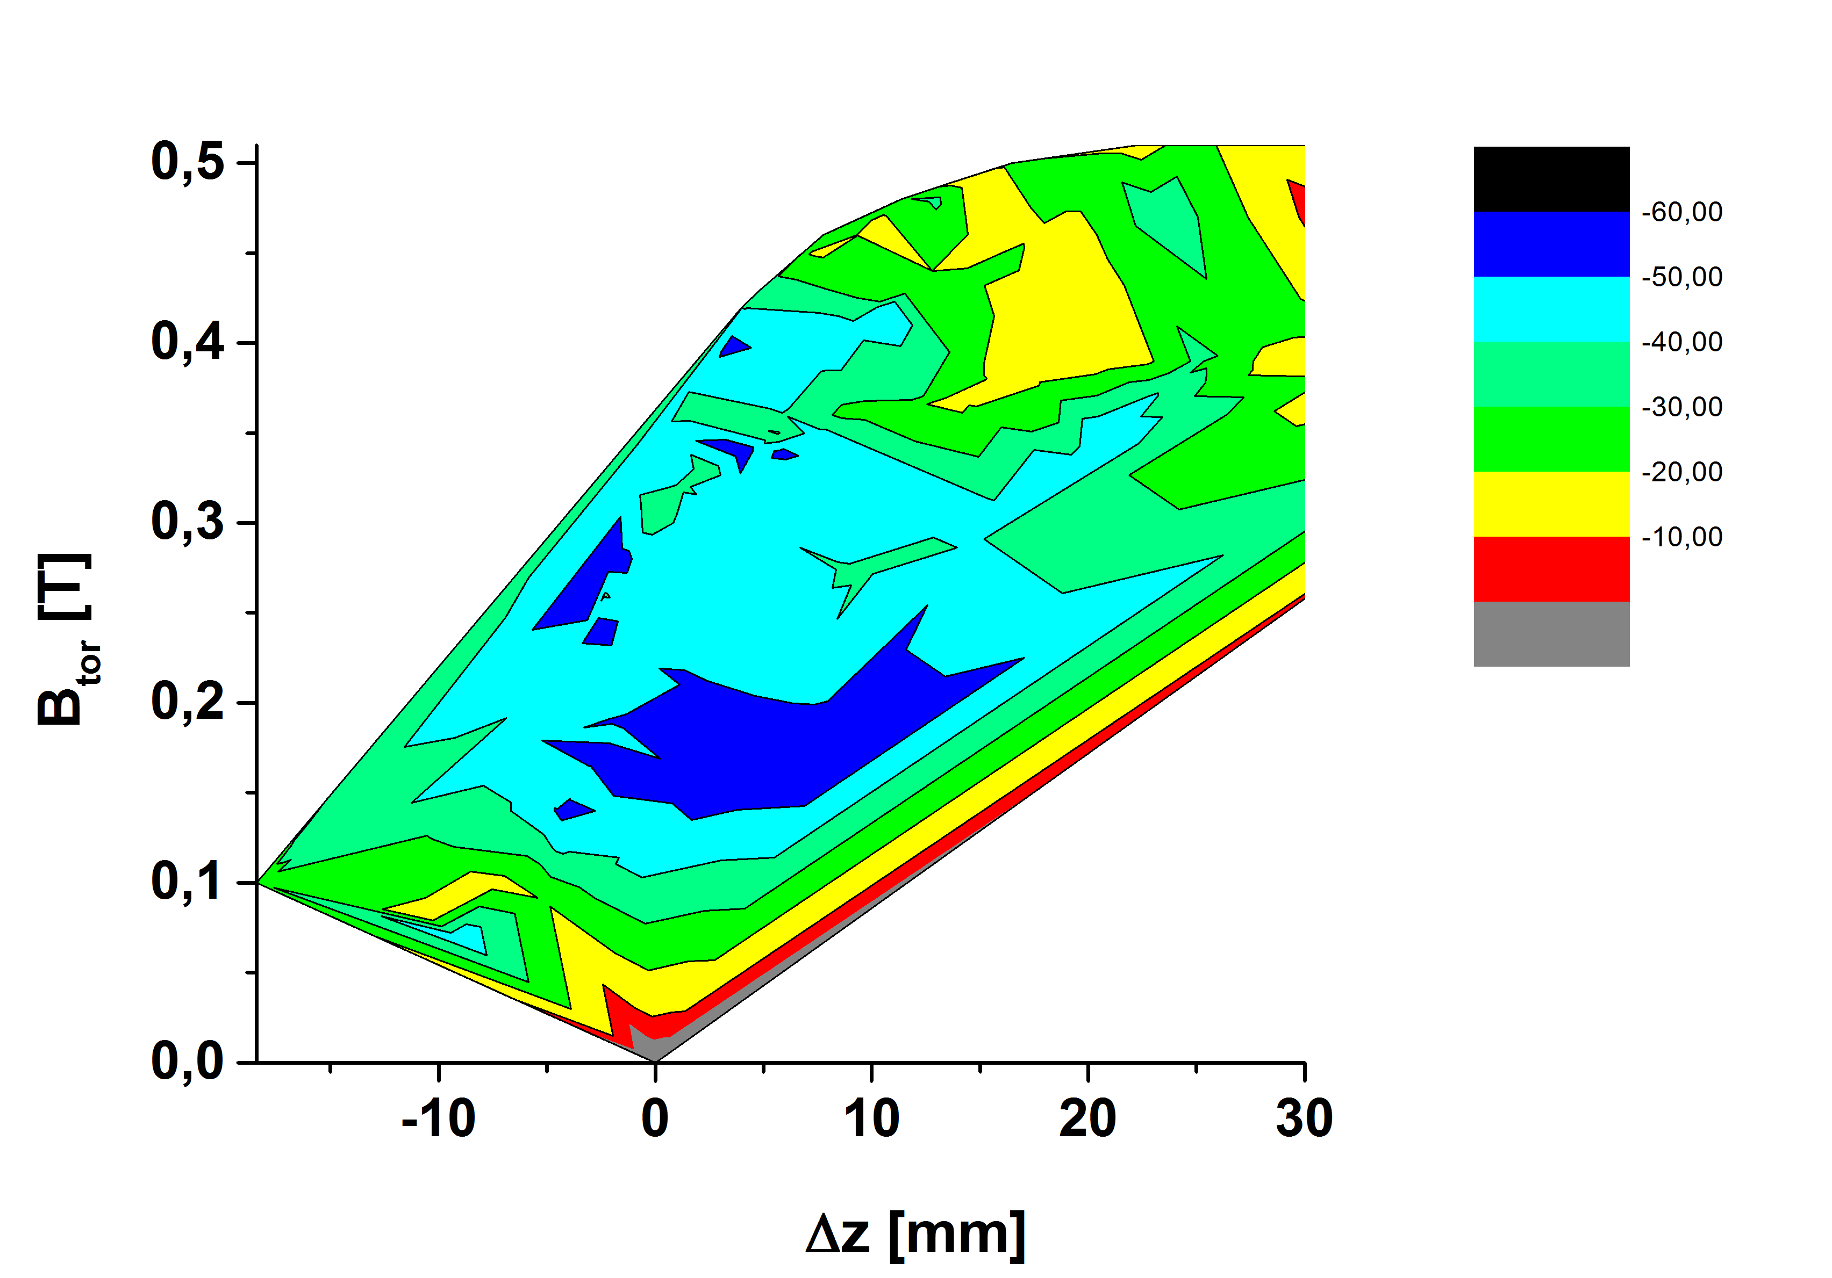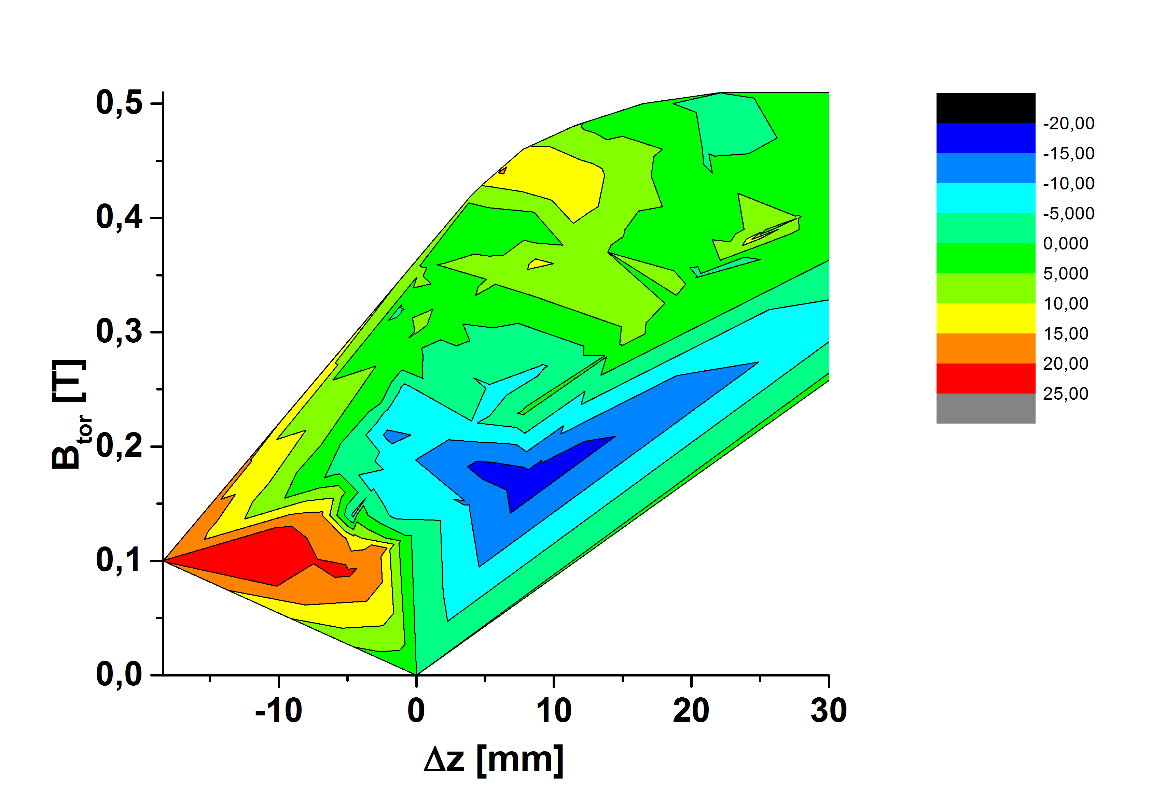
Nice result! – minimum of both quantities occurs at the vertical displacement 0 – 10 mm and Btor ~ 0.18 T.
Color plots of Isat (left) and the ratio of electron and ion saturation current from fitting of IV characteristics (Azooz fitting).
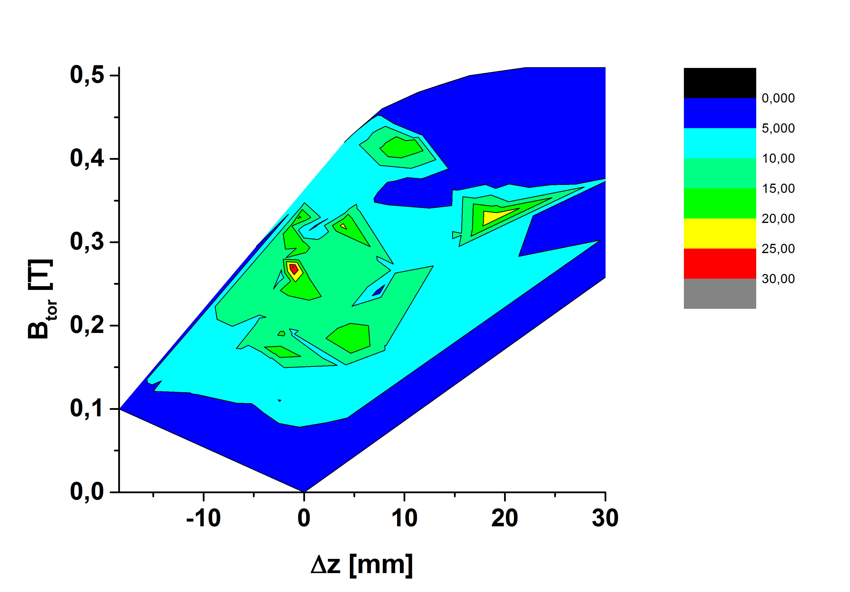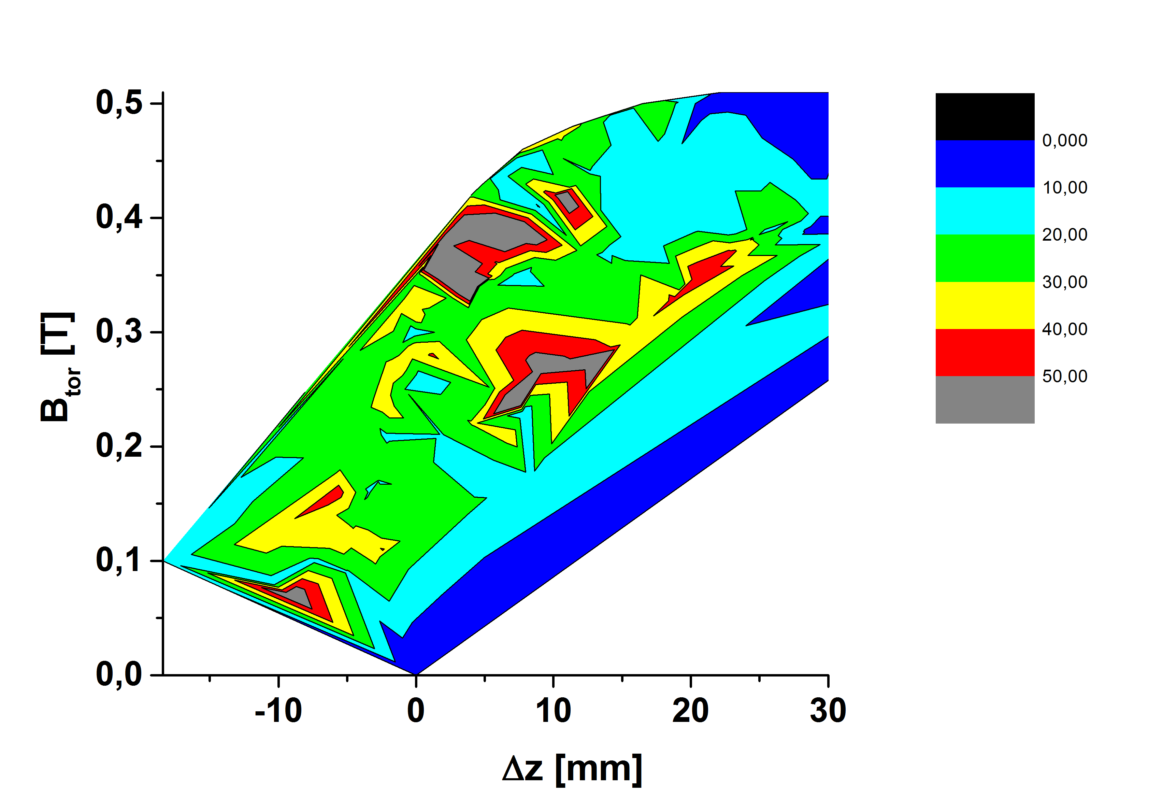

Ion saturation current plot looks reasonable – maximum at zero displacement and at a relatively low value of Btor. Ratio of electron and ion saturation current is more scattered – Azooz fit has to be analyzed in more detail.

Electron temperature from standard fir of IV characteristics – rather scattered not any .
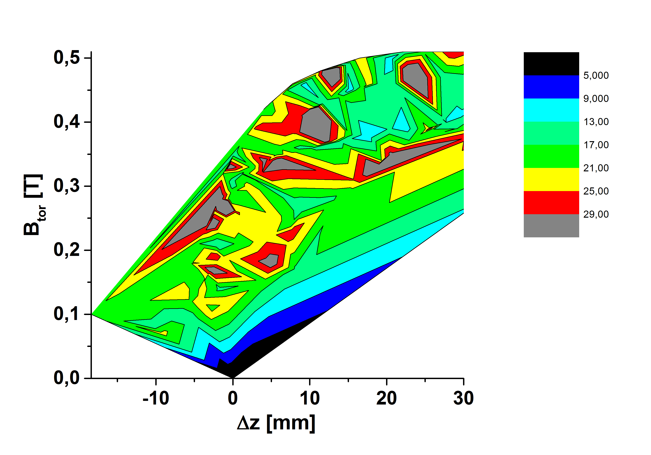
Rather scattered not any apparent dependency. Fitting has to be checked. Data from Megi will help.

The most important picture for theory of BPP is shown in the next figure, where the ratio
Alpha = (Plasma potential-Floating potential)/electron temperature is plotted
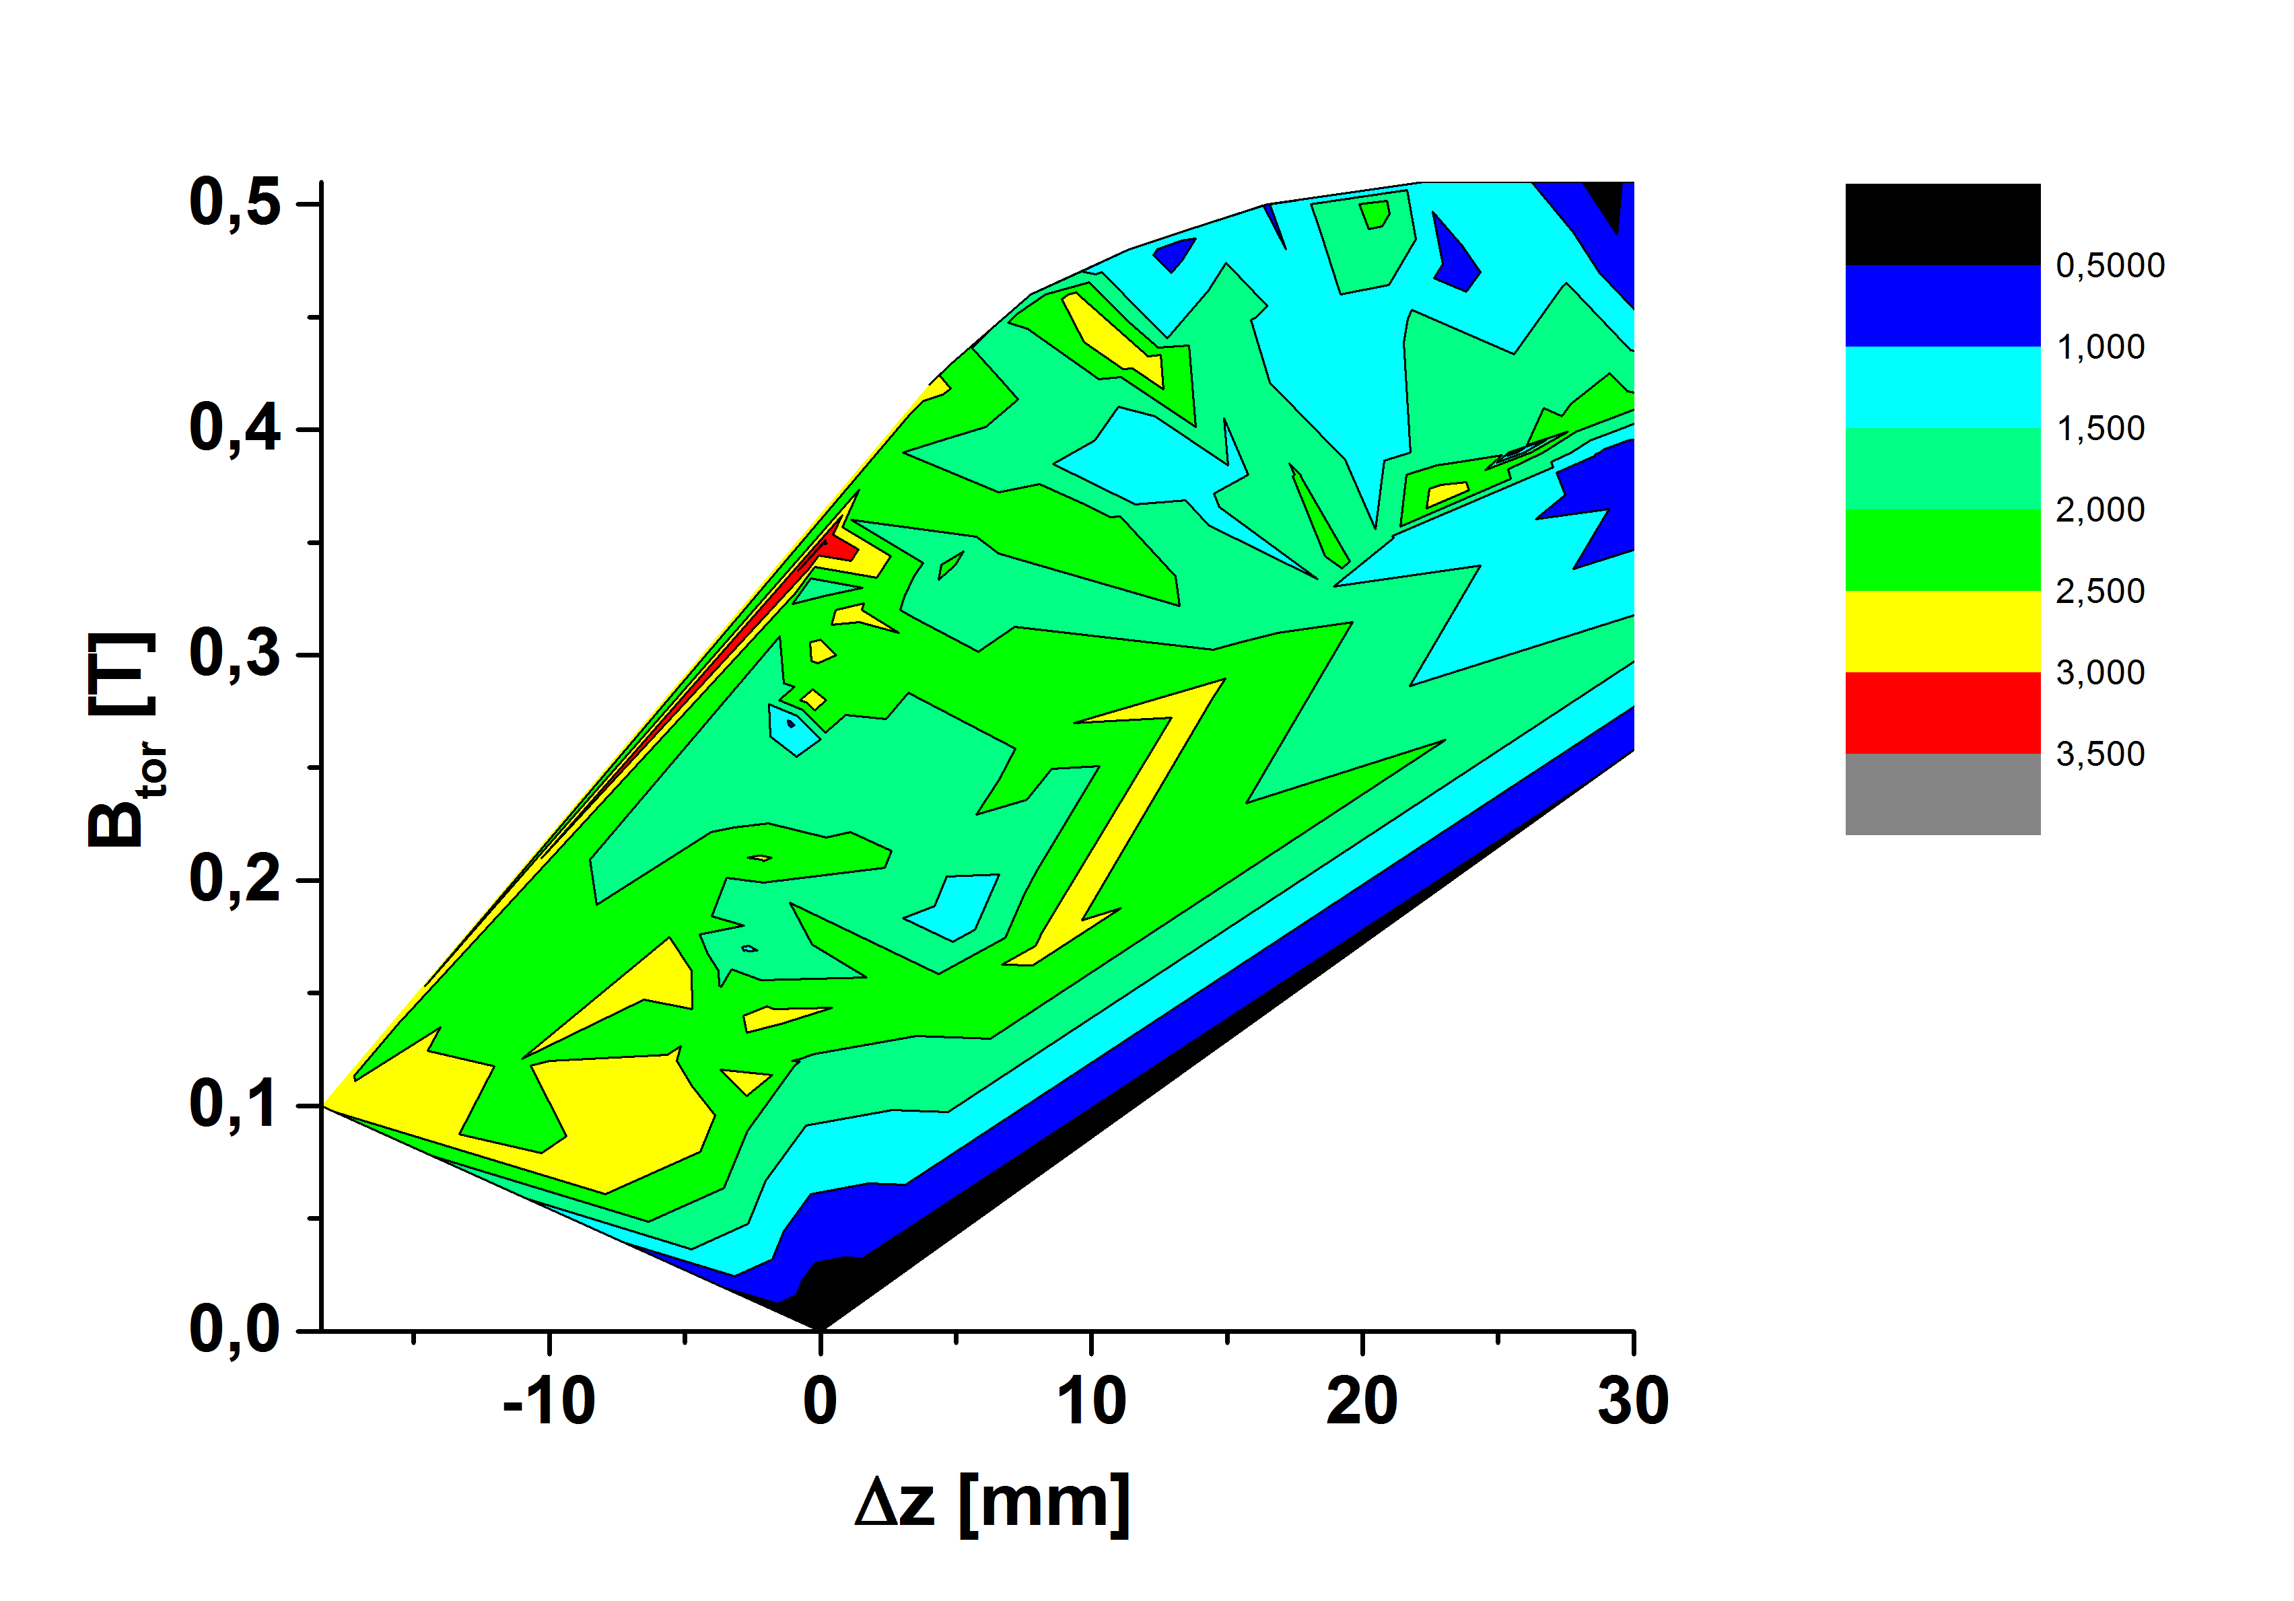
Majority of data are between alpha = 1.5- 2.5. Better estimate of Te is necessary

15.2.2017

