IV characteristics of the Ball Pen Probe
A very good discharge, #23034, is analyzed - see the left panel. Raw probe data (r_{BPP} =80 mm) are shown in the right panel. The probe voltahe is swept between ~-95 V and + 78 V.
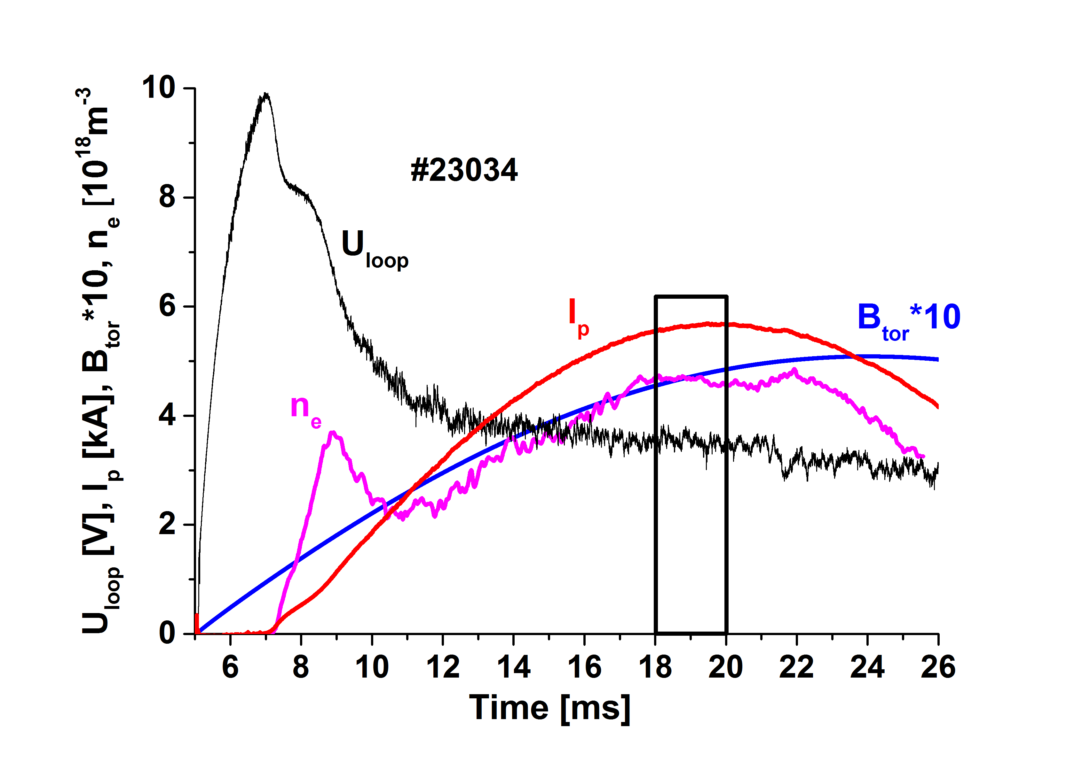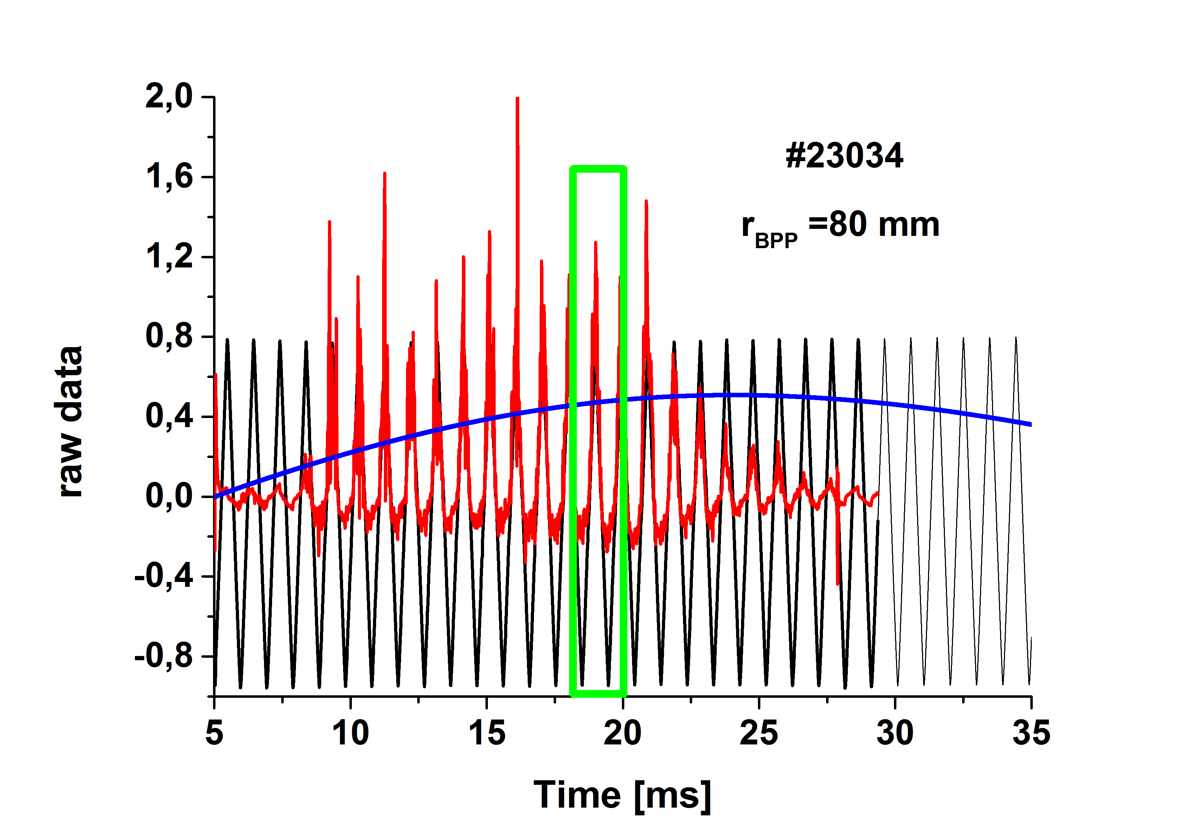
We selected period between 18th and 20th ms, where main plasma parameters are almost constant, in the range of:
I_{p} = 5.6 kA, B_{t} = 0. 47 T, n_{e} = 4.7 10¹⁸ m⁻³, U_{loop} = 3.45 V.
The selected time interval contains two IV characteristic at the ramp-up probe voltage and two IV characteristics with ramp-down voltage. Note, the capacitive pick-up current was not removed, so the raw data are plotted in the next figures.
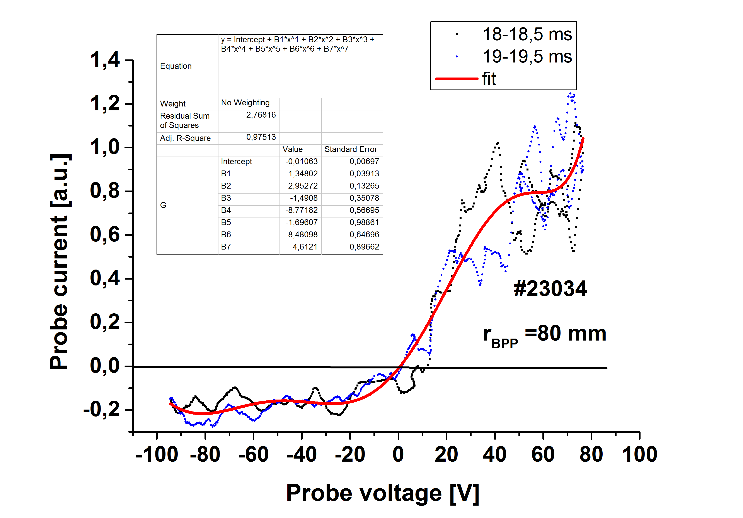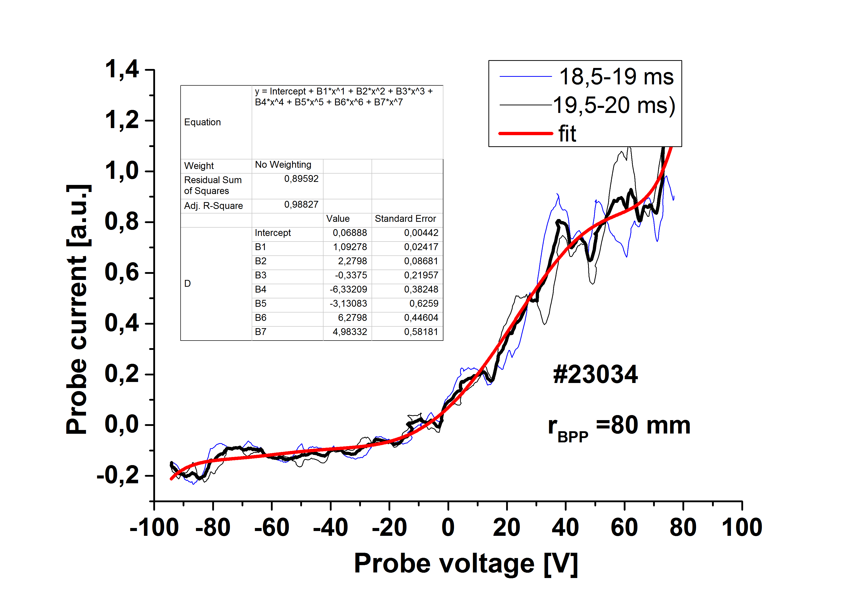
We observe:
- A clear ion saturation current.
- An indication of saturation the electron current above U_{probe} > 40-50 V.

Average IV characteristic during the ramp up and ramp down phase of the voltage sweeping are compared in the next figure.
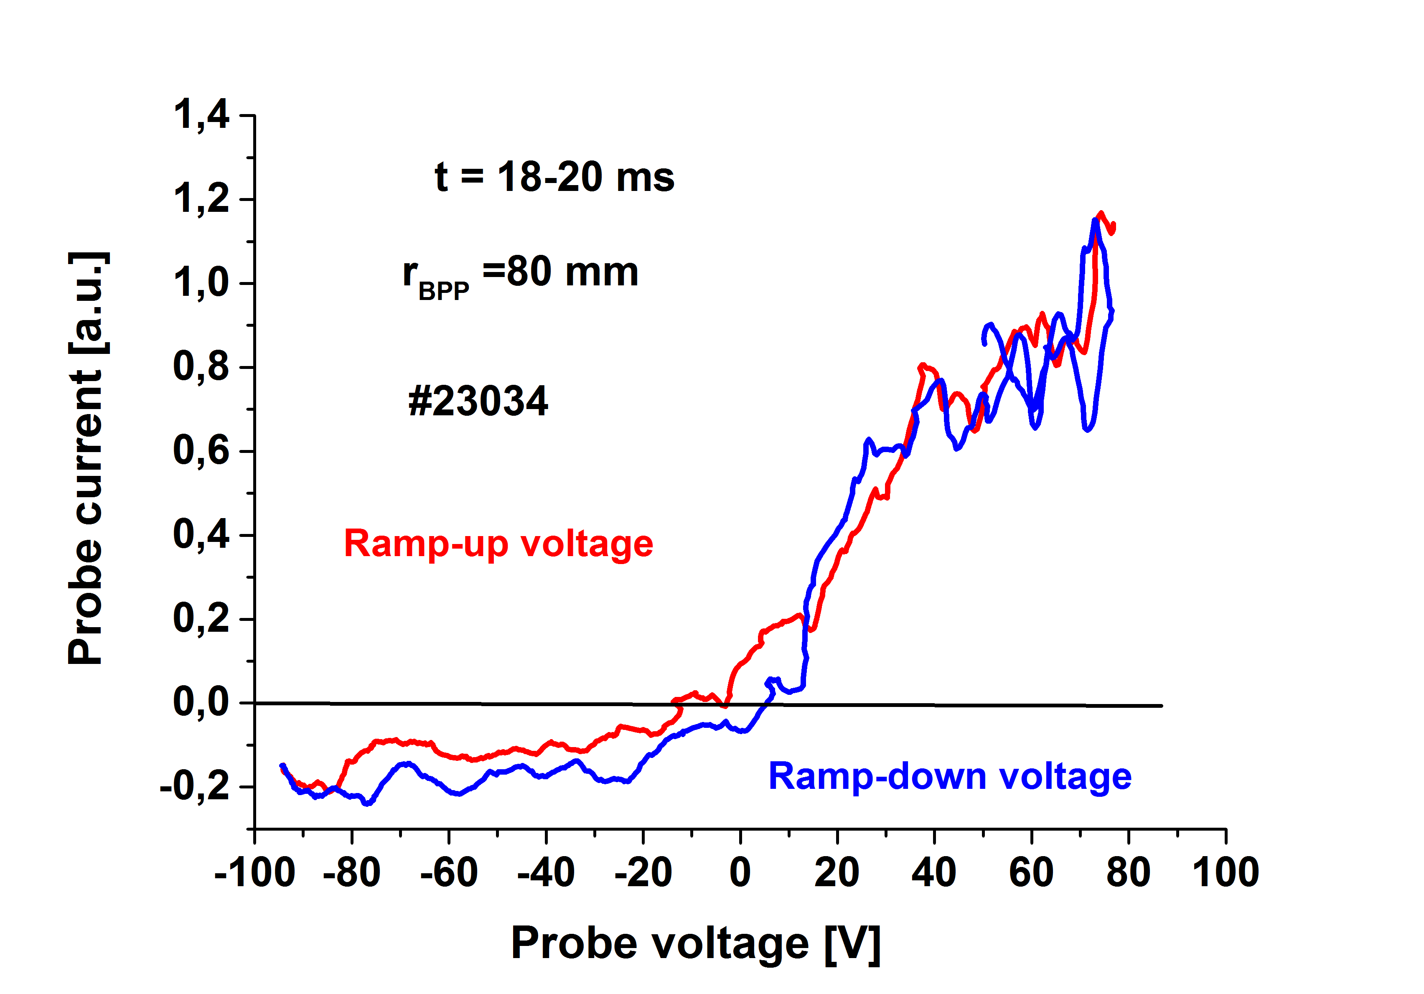
A difference in the ion saturation currents is due to neglecting capacitive pick-ups.
Conclusions:
- Saturation of the electron and ion current is seen (as expected)
- The ion saturation is around 0.15 V, the electron saturation around 0.8 V. So, the ratio Ie_{sat}/I^{ion}_{sat} is in the range of 5.3. for B_{tor} = 0.47 T.
- More detail analysis of IV characteristics must be performed for other time intervals and for more probe positions at this series of discharges.
- We did good job!

Vojta Svoboda, Jirka Adamek, Alexis Devitre, Jindra Kocman, Maxim ????, Jan Stockel
GOLEM, 19.1.2017

