Rotatable Mach probe

Signal from the Mach probe, located at the midplane of GOLEM are collected in series of discharges. The inclination angle of the Mach probe is changed on the shot-to shot basis, the angular step is 30º. These shots are not quite reproducible as seen from signals of the loop voltage.
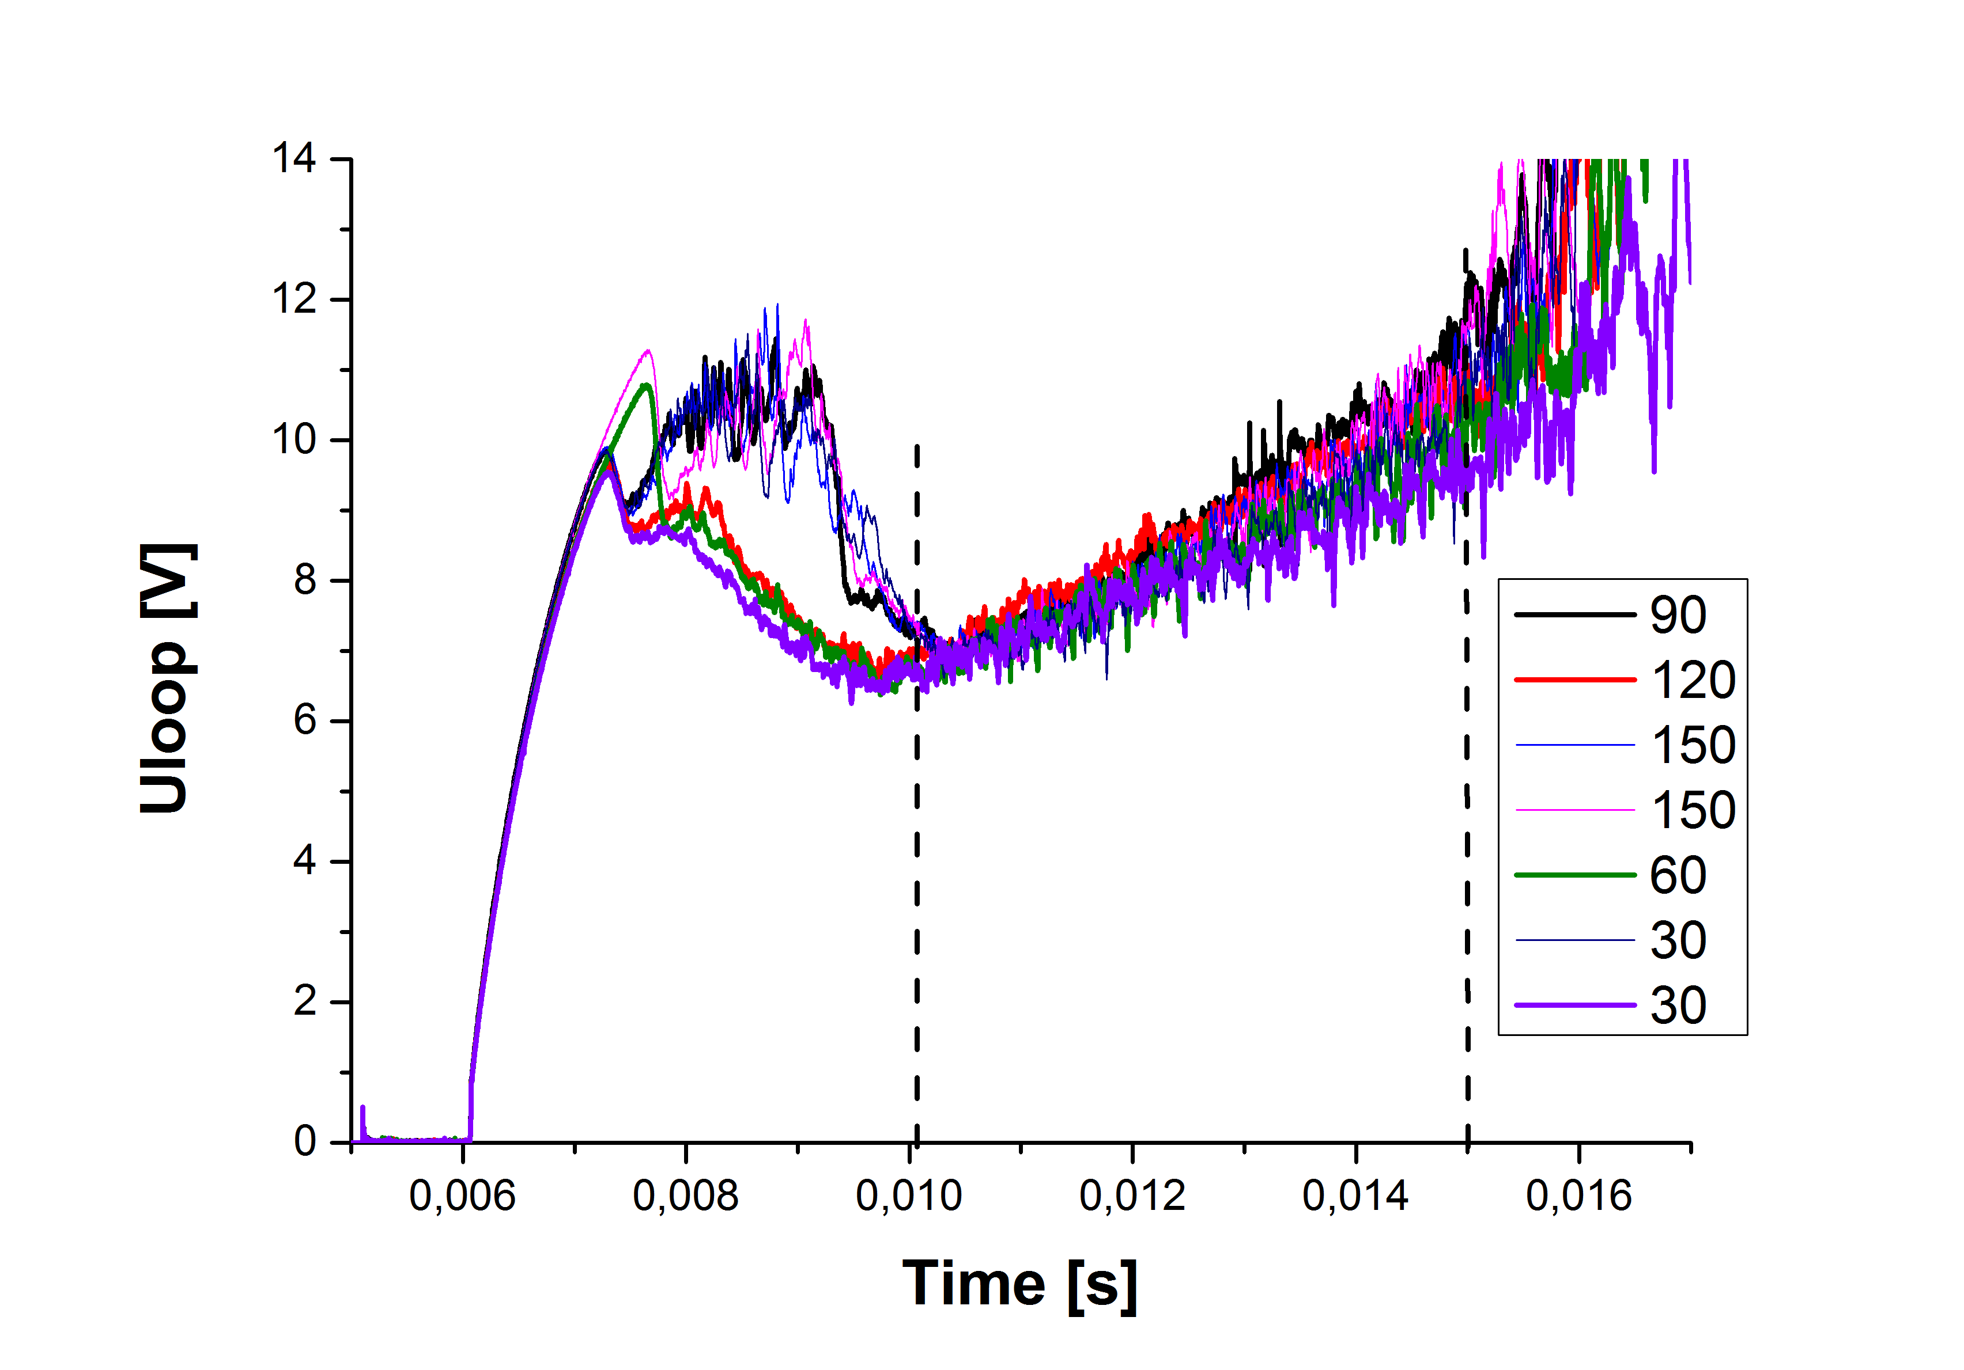
The only period still reasonable (but not perfect) is between 10 and 15 ms.
The Mach prove signals are processed in the following way. Raw data are smoothed over 1000 samples and the ratio of signals from upstream and downstream probe is calculated, see next figure.
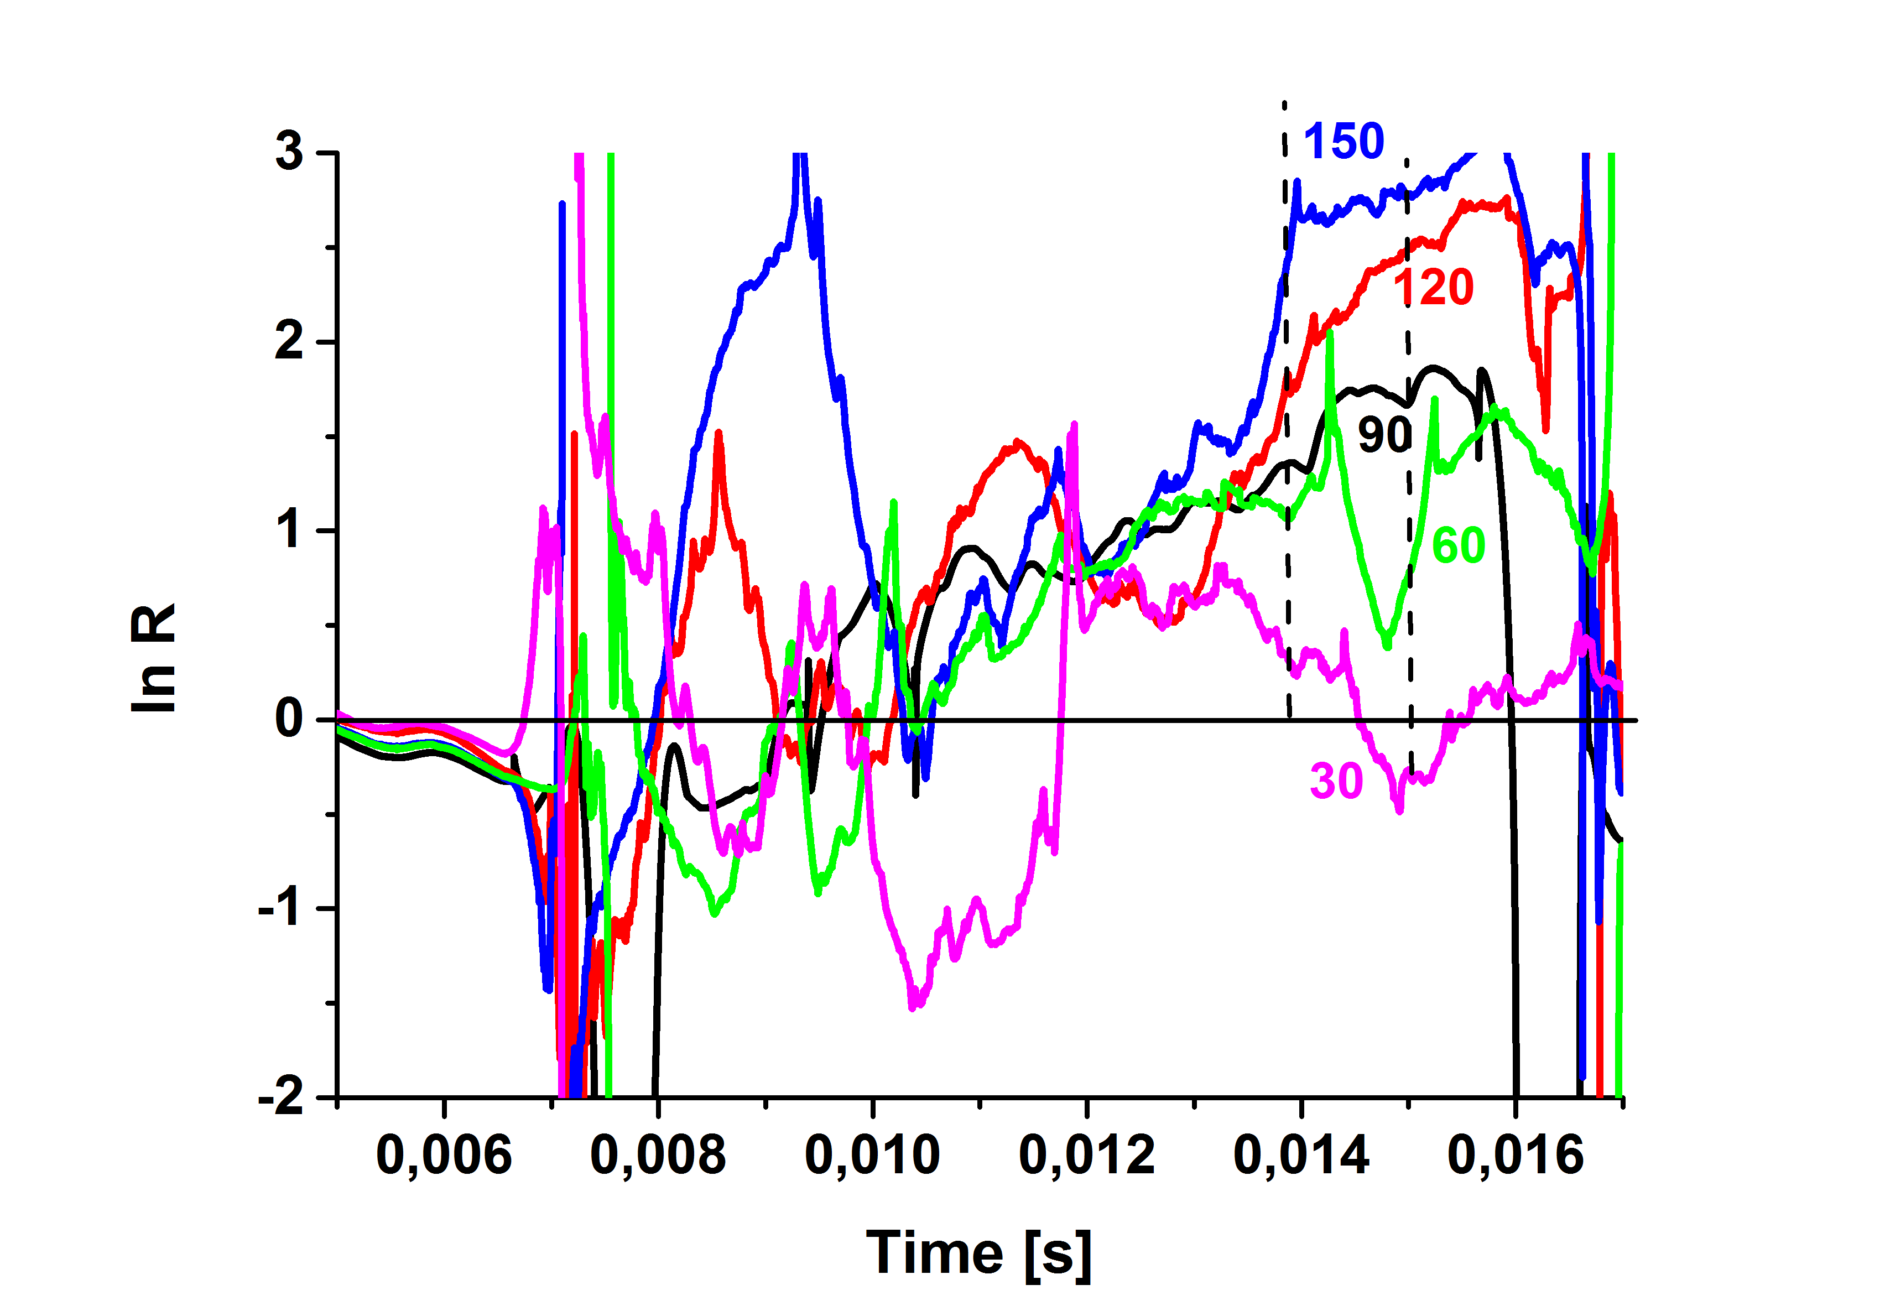
It is evident that the function ln(R) doesn look nice even in the period 10-15 ms. This implies dramatic changes in M_{par} and, in particular M_{perp} during this period.
As a starting step of the data analysis, we calculate at first the temporal evolution of M_{par} from data recorded at 90º using expression
$$M_{par}=lnR/2.4$$
The result is seen in the next figure.
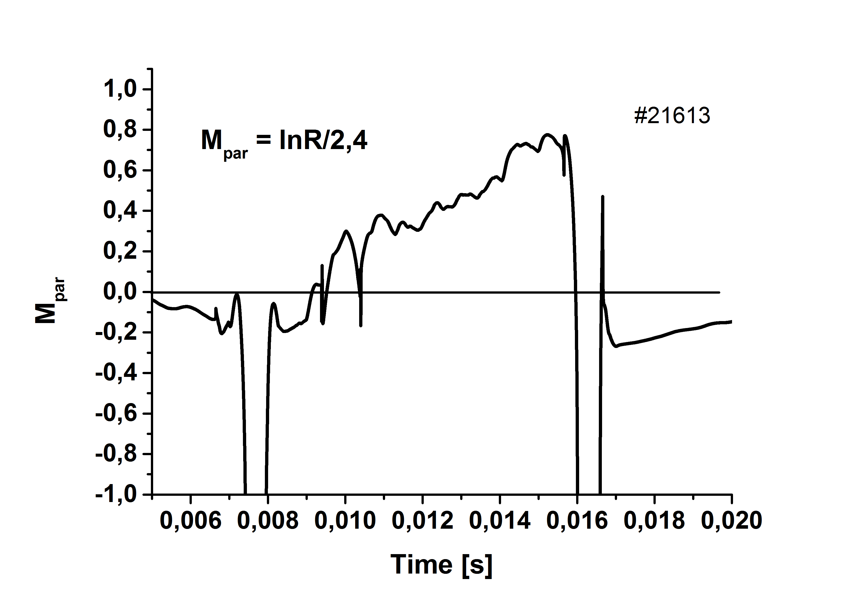
We see trend of increasing M_{par} between 8-15.5 ms. There isn’t any explanation for the negative Mach numbers >-1 before and after this interval.
We exploit the expression derived by Van Goubergen o determine both M_{par} and M_{perp}, at t = 14 ms and t= 15 ms.
$lnR=2.4(M_{par}-M_{perp}/tgθ$ (2)
The result is shown in the next figure.
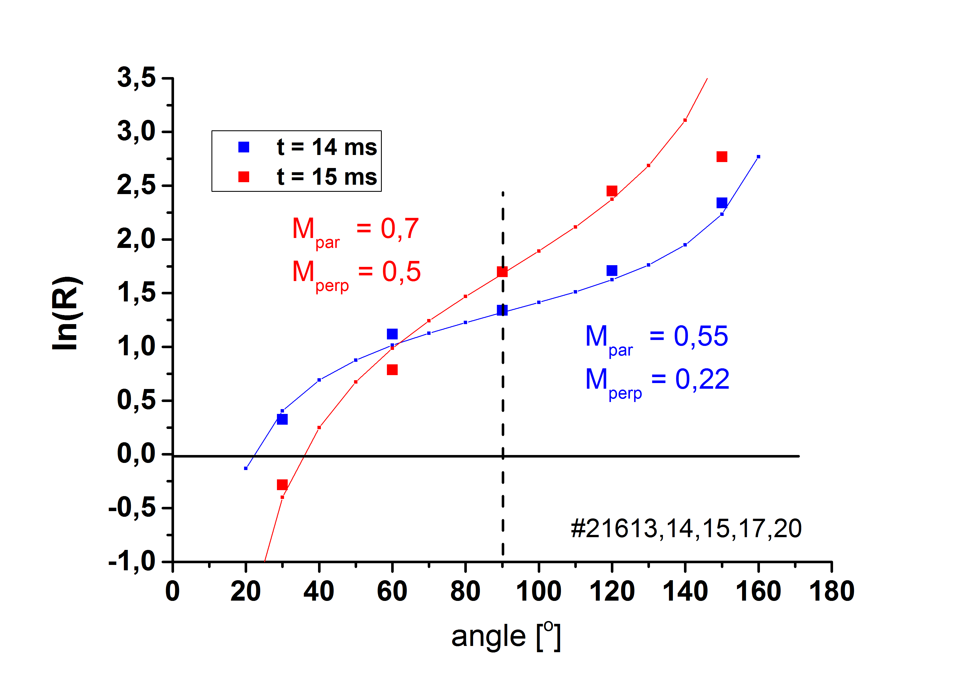
We see excellent agreement between the model and experiment for t =14 ms for inclination angles between 30º-150º. Consequently, the Mach number are determined with a sufficient precision. A good agreement is also find for t = 15 ms, excluding data measured at the angle 150º.

Suggestions for the next experiments:
- Use only measurements at three angles 40, 90 and 135º. This would be sufficient to determine both M_{par} and M_{perp} by comparison experimental data with the modified expression (2).
45º $lnR({45}^{o})=2.4(M_{par}-M_{perp})$
90º $lnR({90}^{o})=2.4M_{par}$
135º $lnR({135}^{0})=2.4(M_{par}+M_{perp})$
Then, the M_{perp} can be derived in a quite straightforward way as
$$M_{perp}=(lnR({135}^{0})-lnR({45}^{0}))/4.8$$
- Perform at least two shots of each angle and calculate average value.
Select better discharge parameters: U_{BT} > 800 V, U_{CD} ~ 400 V to get better plasma performance (more stable plasma).
Baking + glow discharge would be beneficial
Measurements of the radial profile of the floating potential by the rake probe and subsequent determination of the radial electric field at the position of the Mach probe would be worthwhile (in collaboration with Katka). Note however that the rake probe measures at the bottom of the vessel, but the Mach probe at the midplane. We must be careful with interpretation!

Results of such experiment could be a nice part of the EPS 2016 contribution, if properly discussed.

