Progress in probe data analysis on GOLEM for discharges #23191, 93, 95 and 98.
Fitting of IV characteristics of LP are performed in two ways
3 parameter fit:
$$I_{p}=-I_{sat}\left[1-exp\frac{V_{p}-V_{fl}}{T_{e}}\right]$$
4 parameter fit:
$$I_{p}=-I_{sat}\left(1-C(V_{p}-V_{fl}\right)\left[1-exp\frac{V_{p}-V_{fl}}{T_{e}}\right]$$
The following data are removed:
- Evidently wrong fits of IV characteristics of LP
- Data at plasma position δz > 20 mm
- Data with the electron temperature > 30 eV, and with the ratio of electron/ion saturation current R >30
Results are summarized in following figures.
Ion saturation current of LP
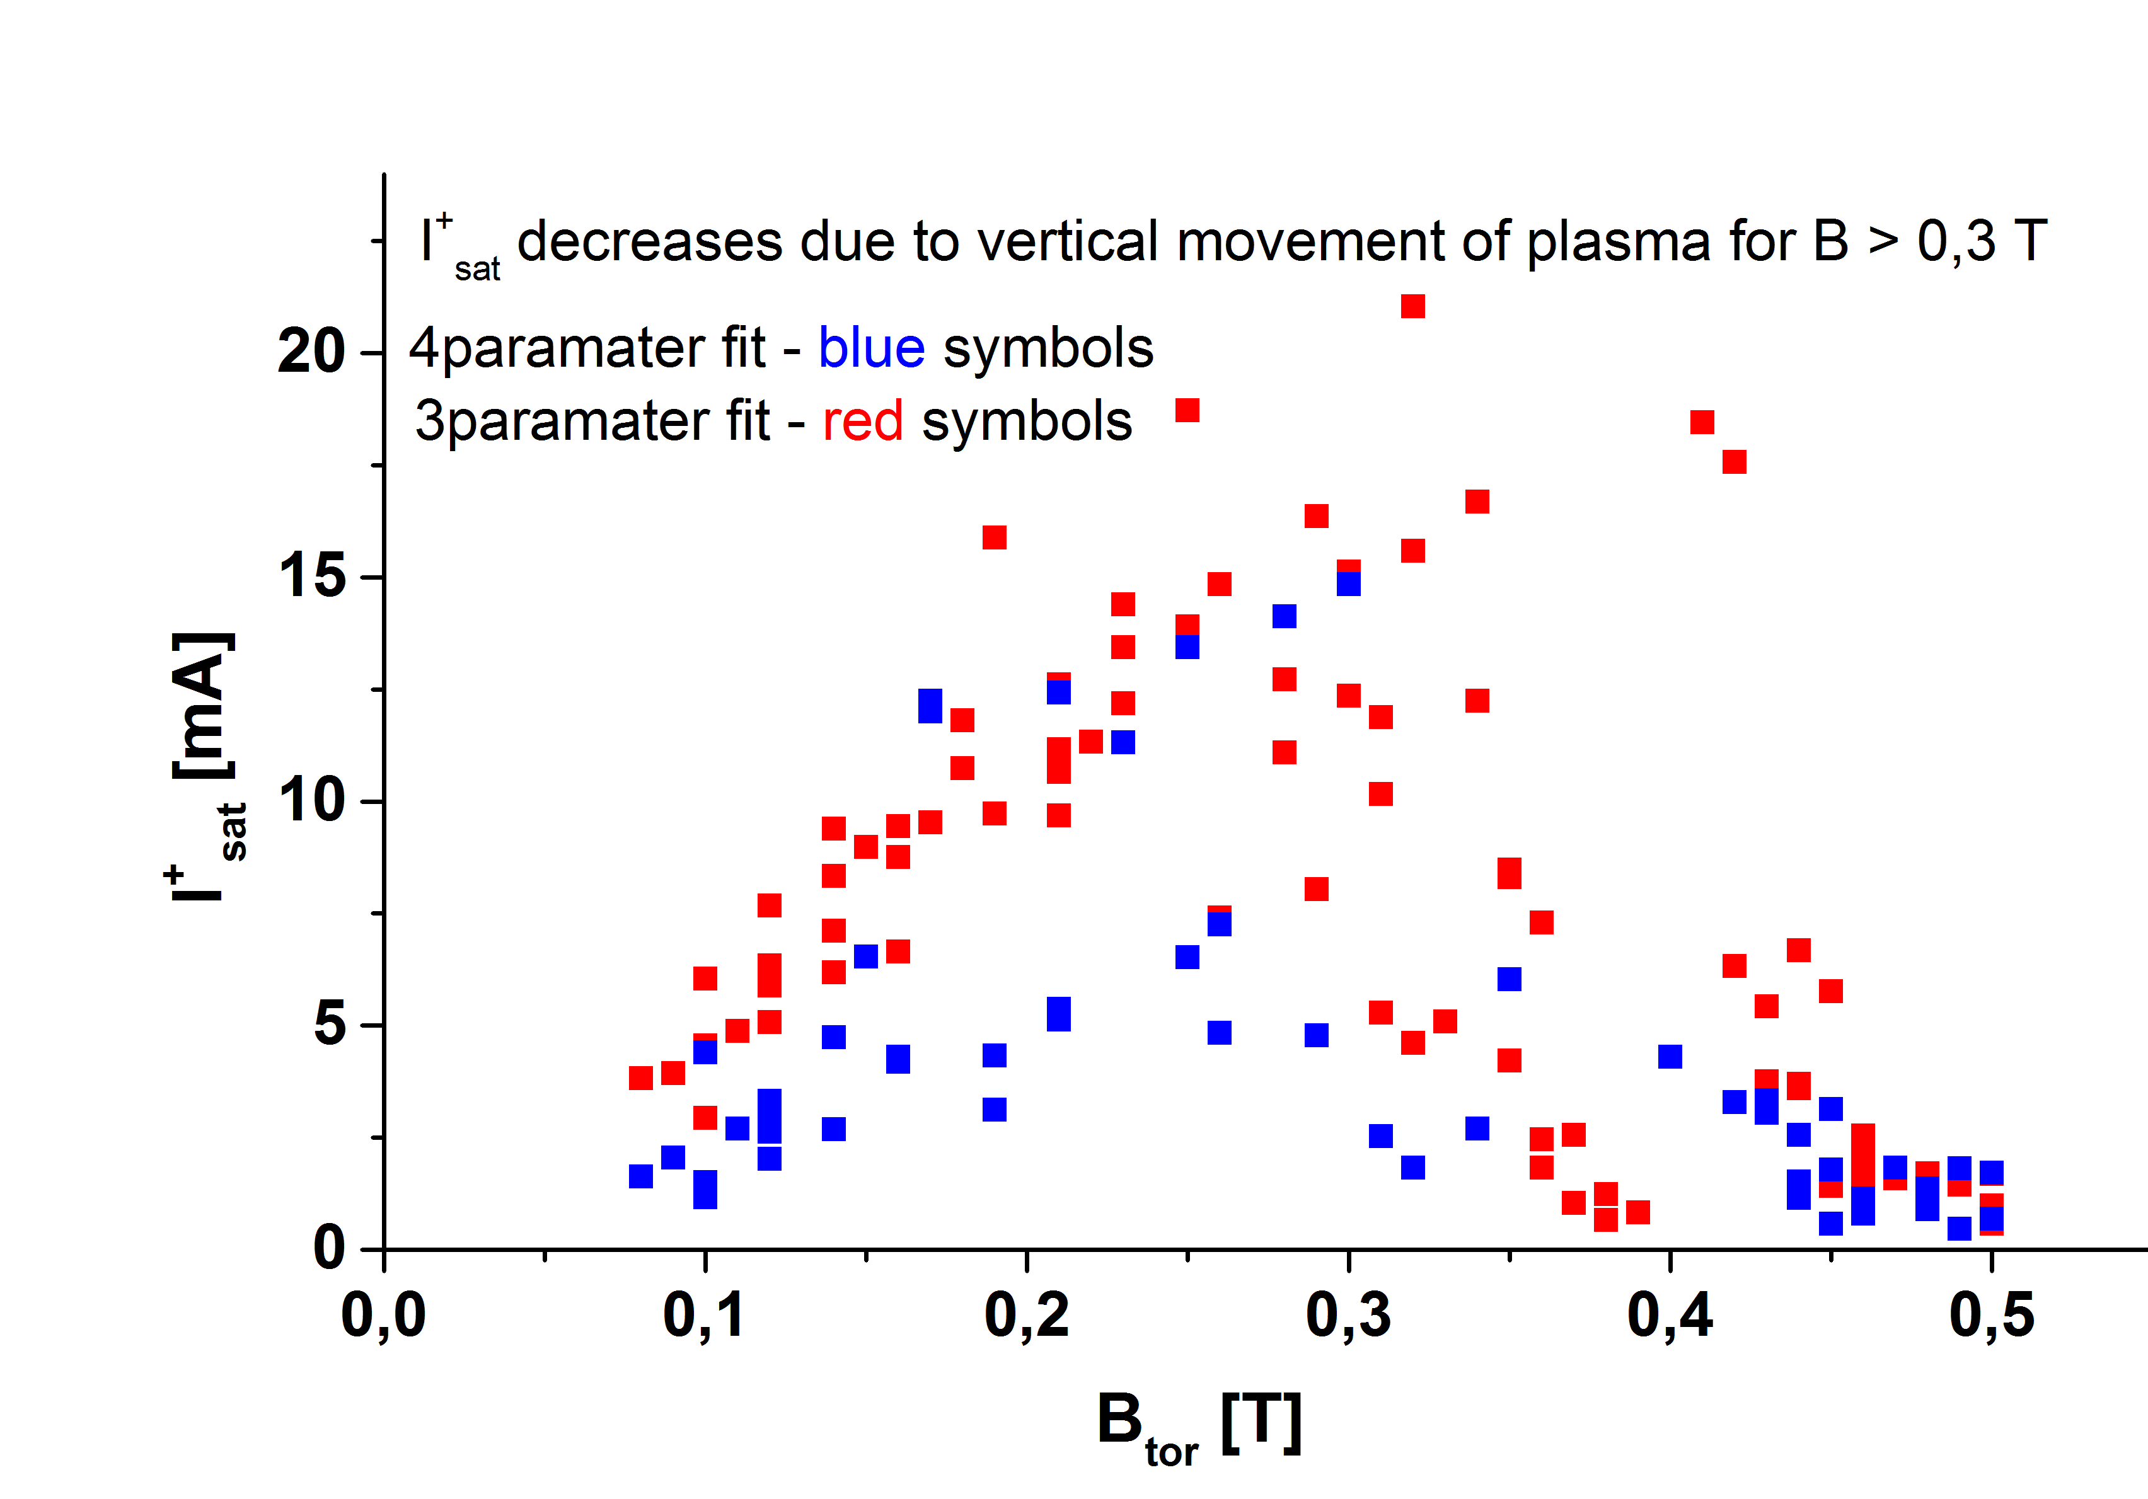
The higher vertical displacement appears at high Btor, which means that the probe is deeper in SOL (i.e. at lower plasma densities). 4 parameter fit yields lower Ion saturation current – expected.

Electron temperature
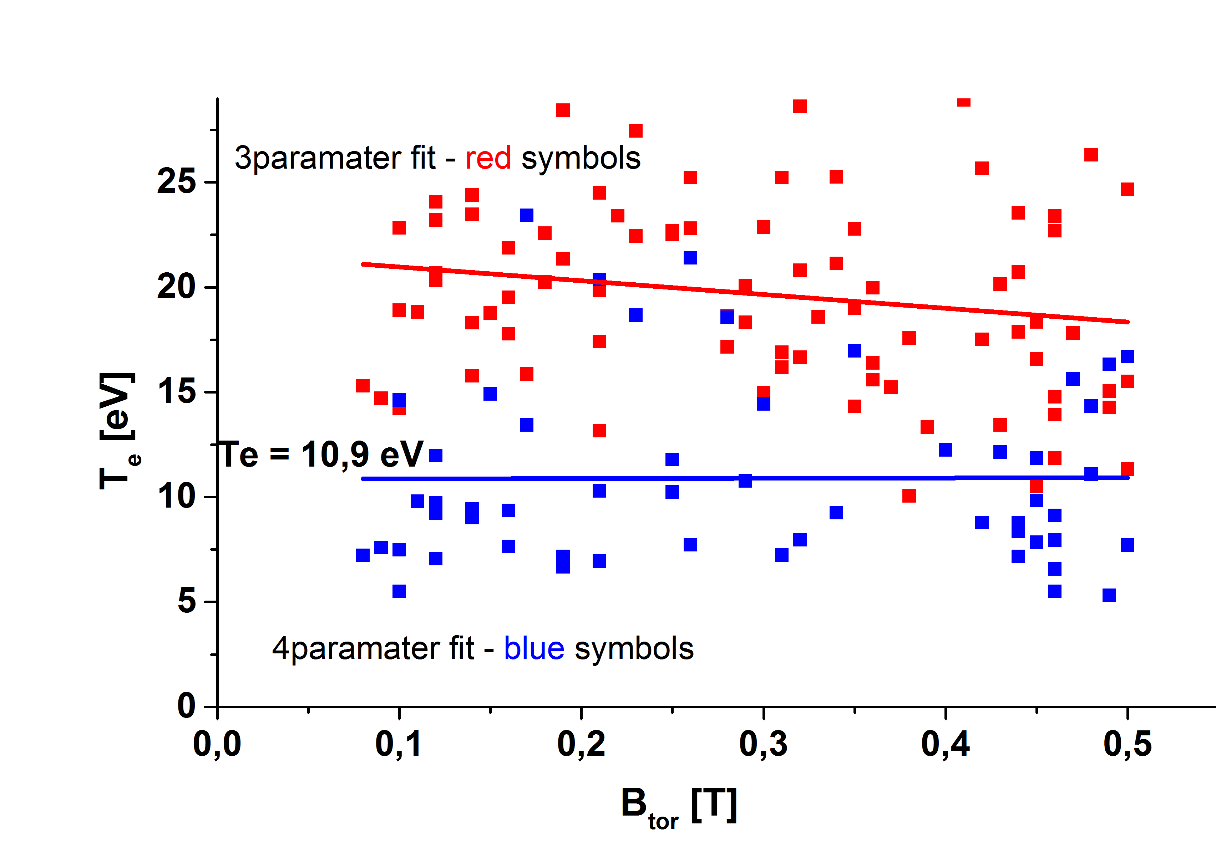
The electron temperature is almost independent on Bt – scattering of data is due to non-precise fitting of IV characteristics. A direct influence of plasma displacement is not evident. The 4 parameter fit yields significantly lower temperatures - expected
Floating potential of LP and plasma potential of BPP
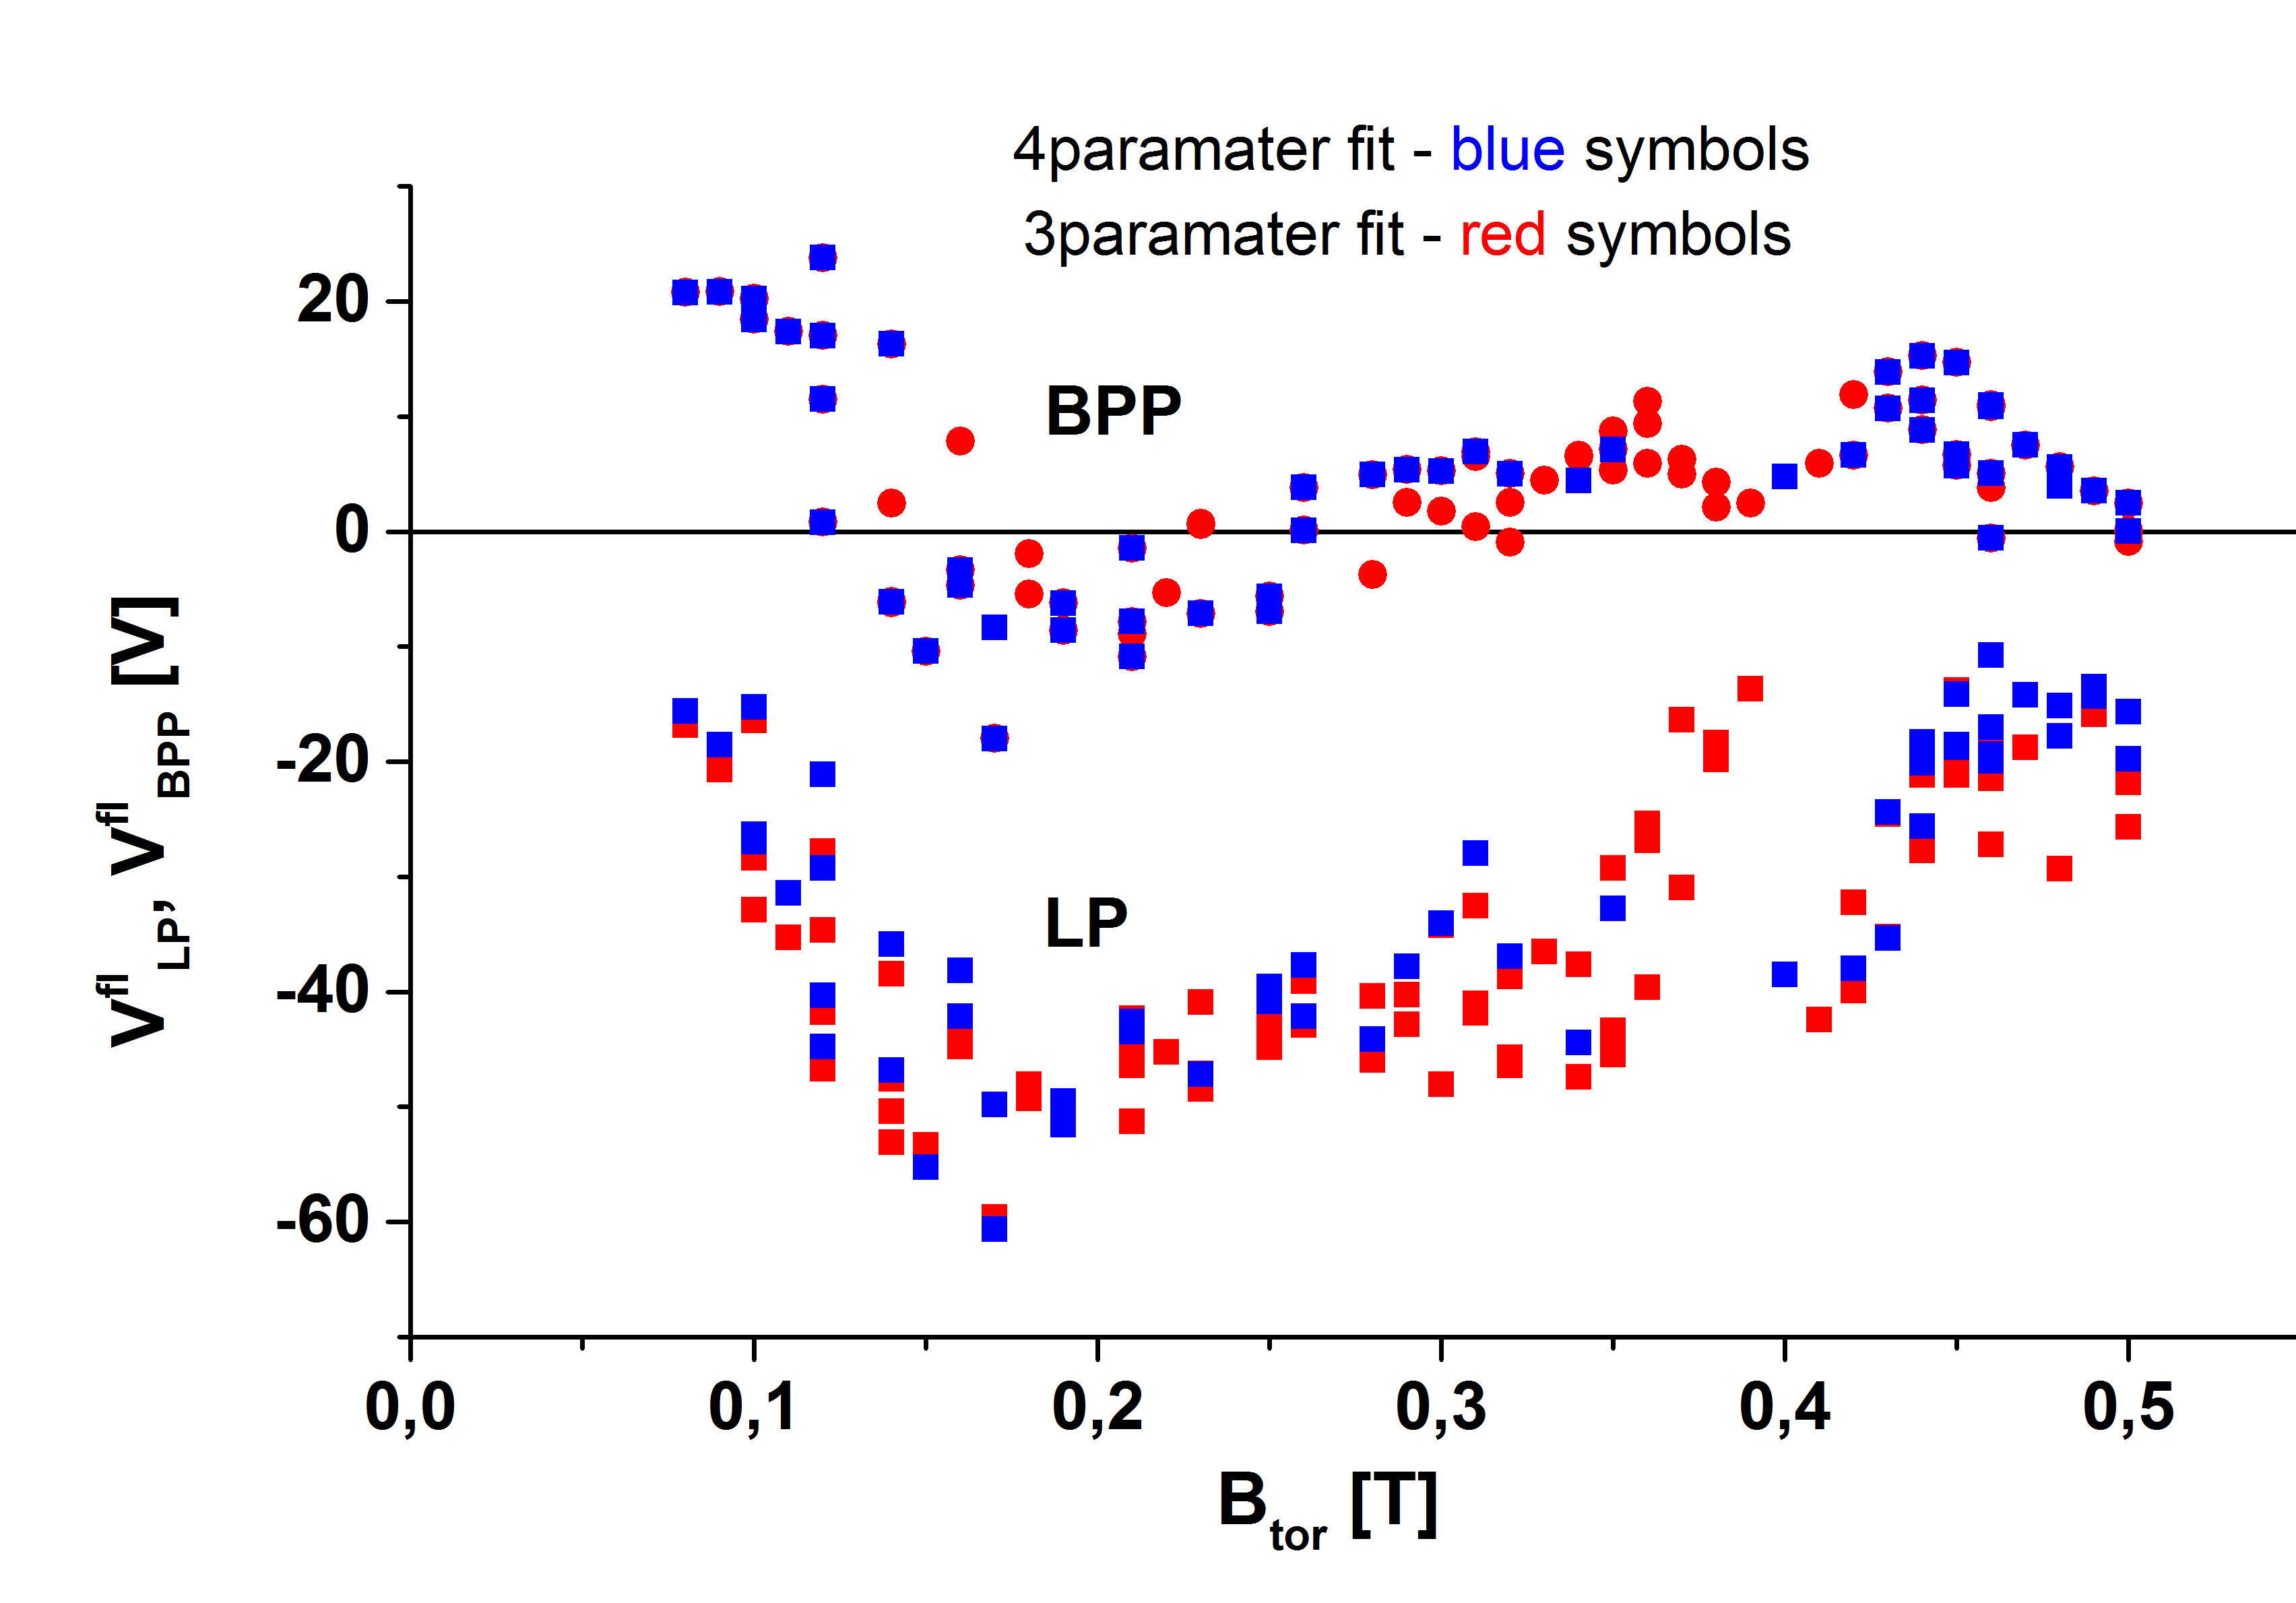
Dependences of floating potentials on Btor are mainly due to the plasma displacement, Both fitting yield very similar values of Vfl of LP

The most interesting dependences are for the ratio R and for the factor α.
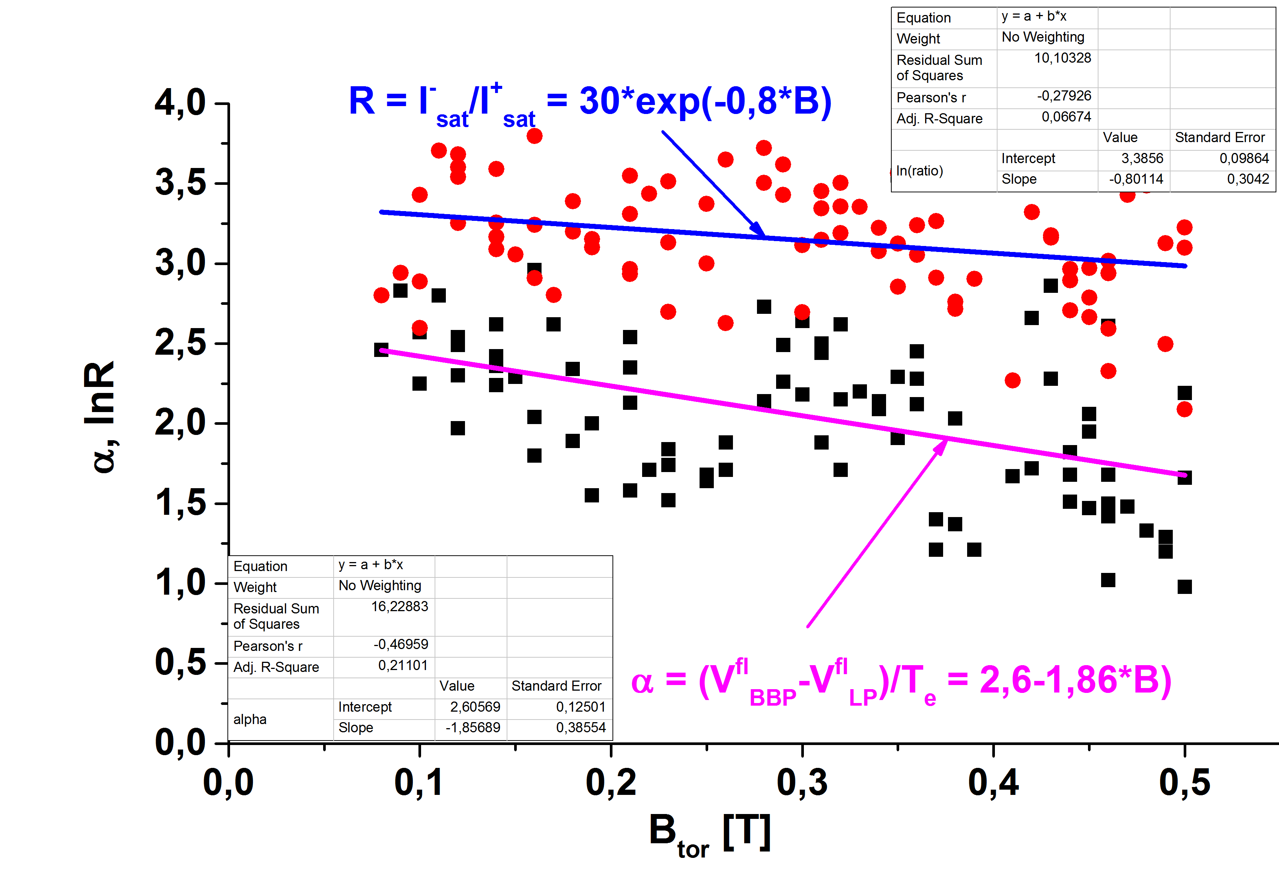
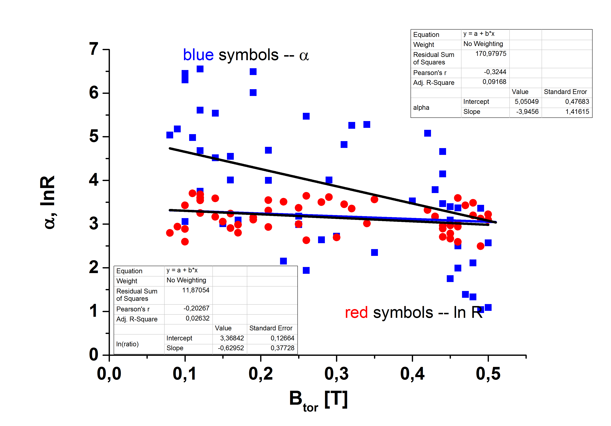
The ratio R decreases exponentially with Btor, and seems to be independent on plasma position and plasma density. The factor α should be the same as lnR. However, it is lower, most probably by overestimation of the electron temperature from IV fits.
To be done:
- )
- Add data from Megi’s analysis
- Stabilize plasma position during GOLEM discharges
- Perform shots with a lower value of Btor
20.2. 2017

