Ratio of electron and ion saturation currents of Langmuir and Ball Pen Probes
13.7.2017
Probe measurements are performed at the following discharge conditions:
• Gas pressure p_{ch}:0.36->19.93
• Working gas: H
• Preionization: Upper el. gun
• Chamber temperature: 34.70 C
• C_{Bt} capacitors charged to: 1300 V, triggered 5.0 ms
• C_{CD} capacitors charged to: 400 V, triggered 5.0 ms

Combined probe head, equipped by the Langmuir Probe (LP) (diameter = ?, length = ?) and the Ball Pen Probe (BPP) (diameter = ?, depth = ?), is located from the bottom of the vessel at the radius 70 mm from the centre.
IV characteristics are measured on the shot to shot basis by using power supply based on 6x12V battery. The shot series started from #24411 @ Up = 0 V via #24417 @ +77 V, and #24419 @ -77 V to #24426 @ Up = 0 V.
Load resistance: BPP @ 200 Ω and LP @ 23 Ω . Signals are recorded simultaneously with the Tektronix oscilloscope.
Figure 1 compares the ion saturation currents of LP and BPP at U = -77 V.
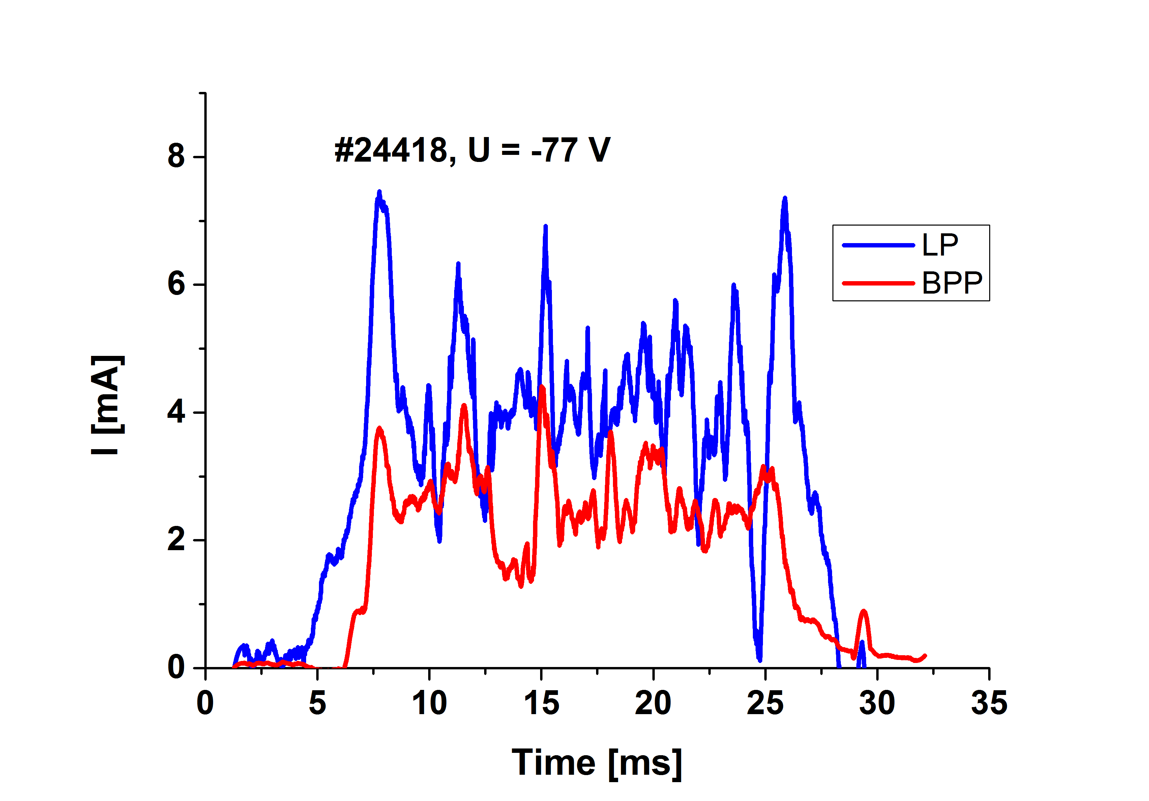
We see that signals are quite comparable being 2-5 mA. It means that dimensions of both probe were selected properly (by chance).
Figure 2 compares electron and ion saturation currents of LP and BPP.
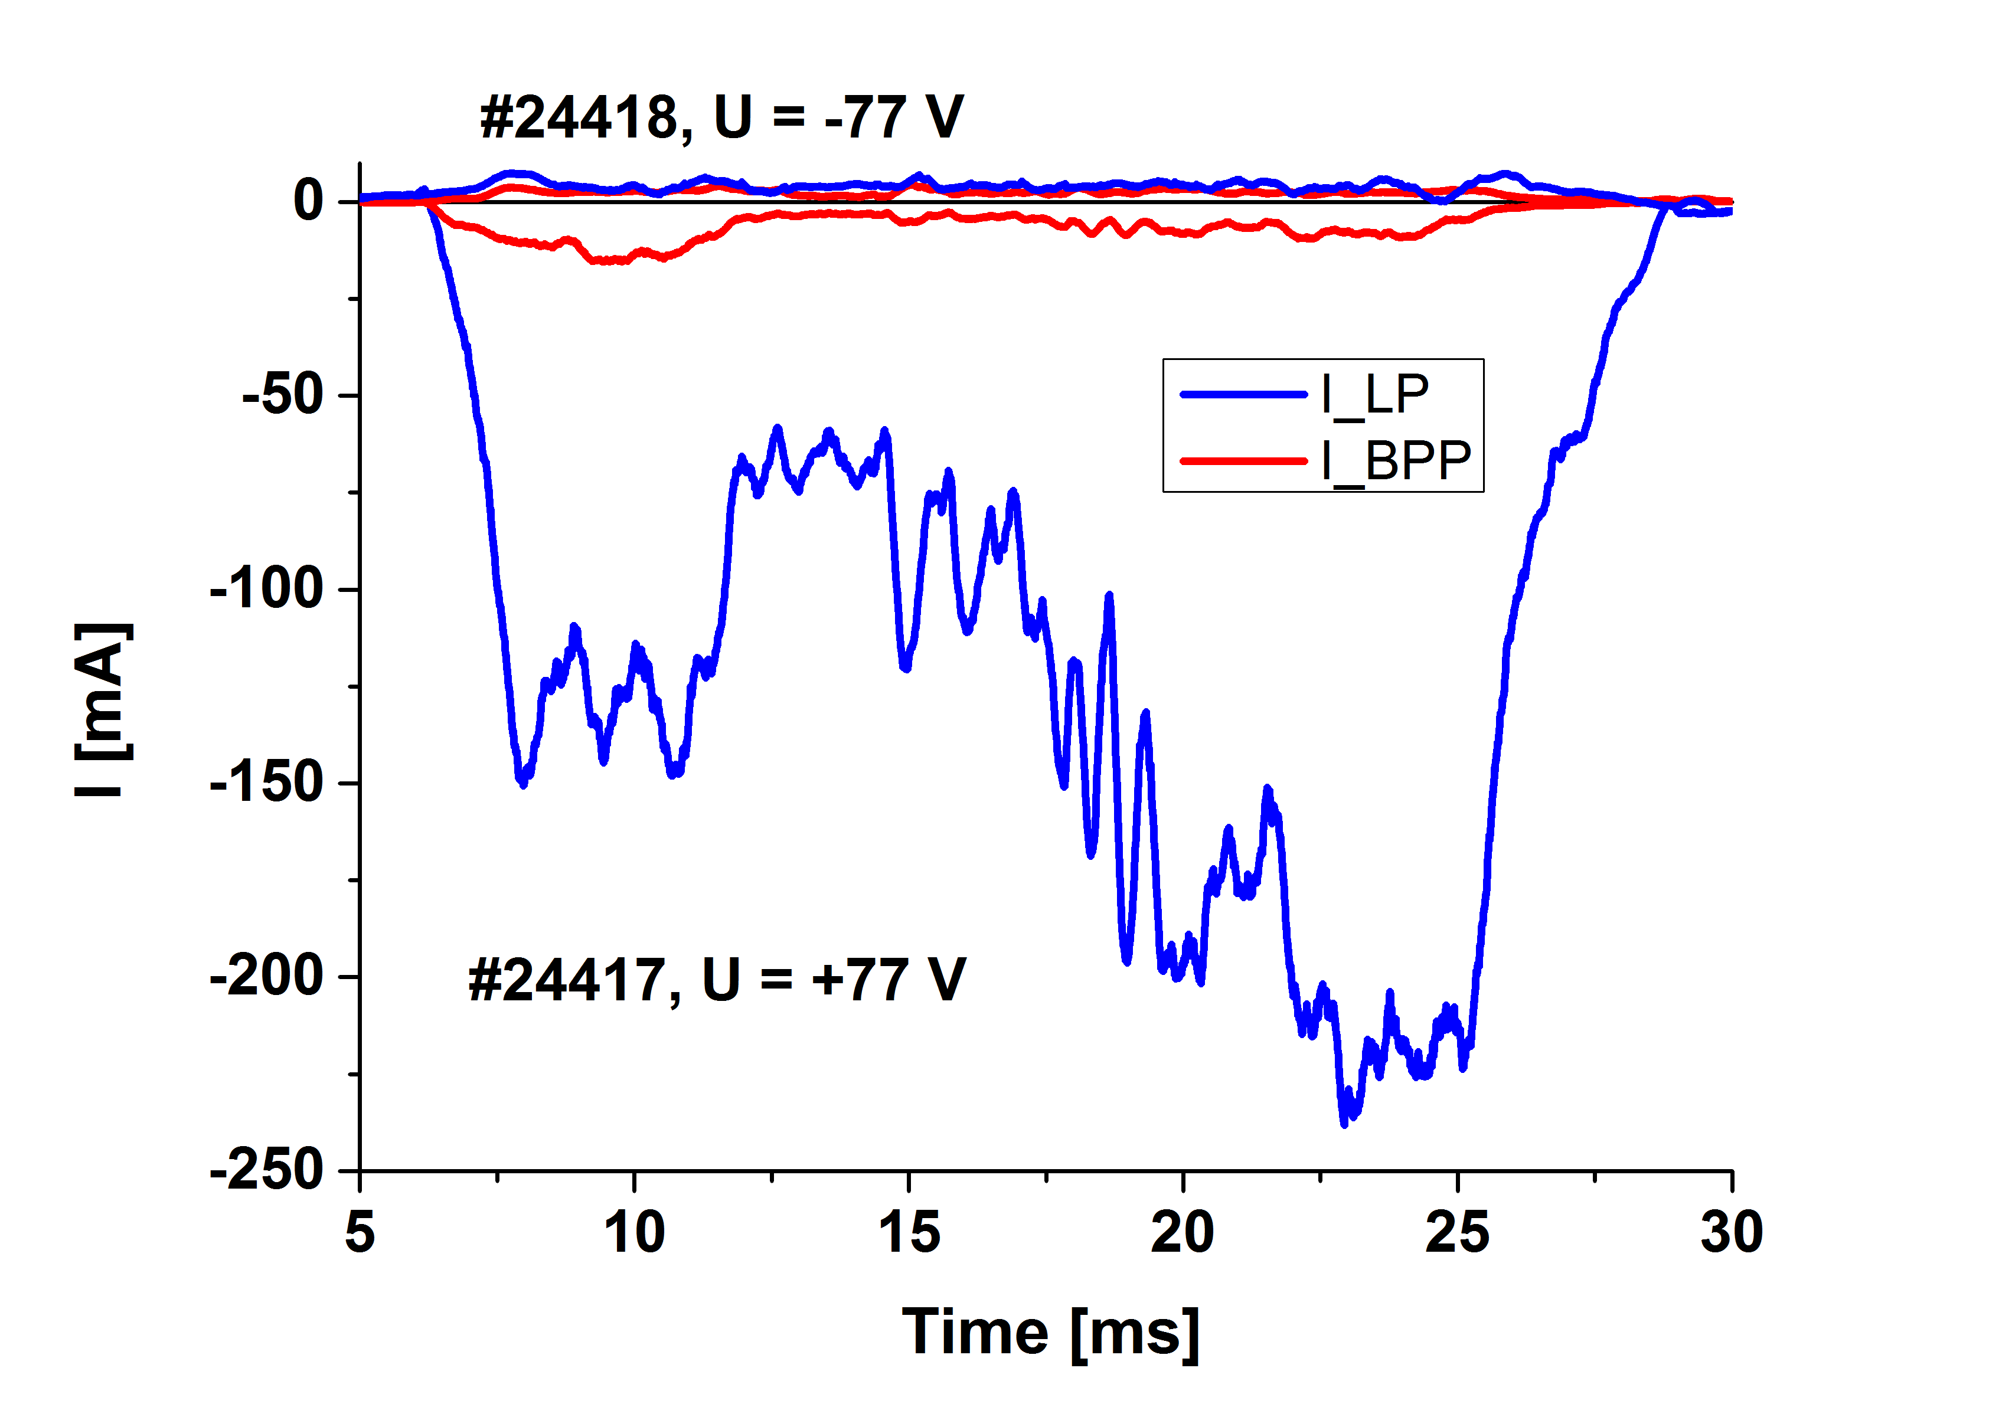
Reduction of the electron branch of IV characteristics of BPP is evident.
The temporal evolution of the ratio of electron and ion saturation current of LP measured in two subsequent discharges with Up = +77 V and Up = -77 V is seen in Figure 3.
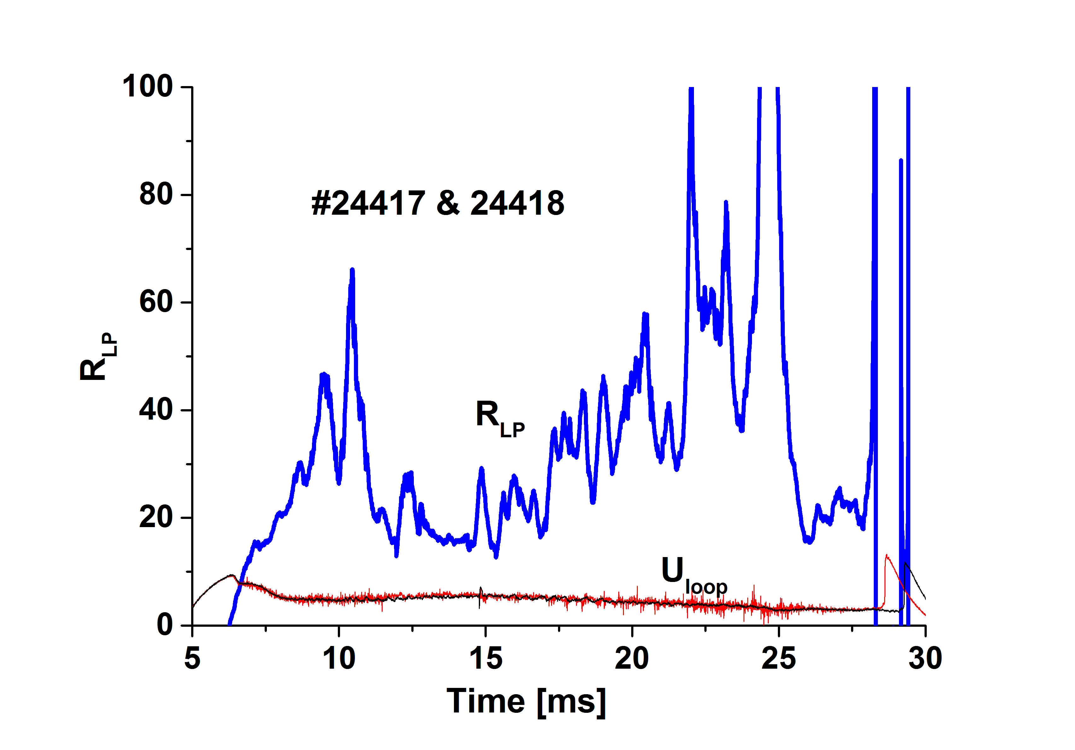
The ratio is between 20-40 during stationary phase of the discharges (12-22 ms), as could be expected. However, the ratio increases when the toroidal magnetic field increases. The opposite trend would be expected, i.e. the ratio of I_{e,sat}/I_{i,sat} should decrease when magnetic field increases. However, it is true only if plasma parameters remain constant during the discharge. The signals of the loop voltage for both discharges are over-plotted, and they are basically the same. But, the discharge is not quasistationary, because the loop voltage decreases in time. This feature is better seen in Figure 4, where temporal evolution of ratio of electron and ion saturation current is plotted for BPP.
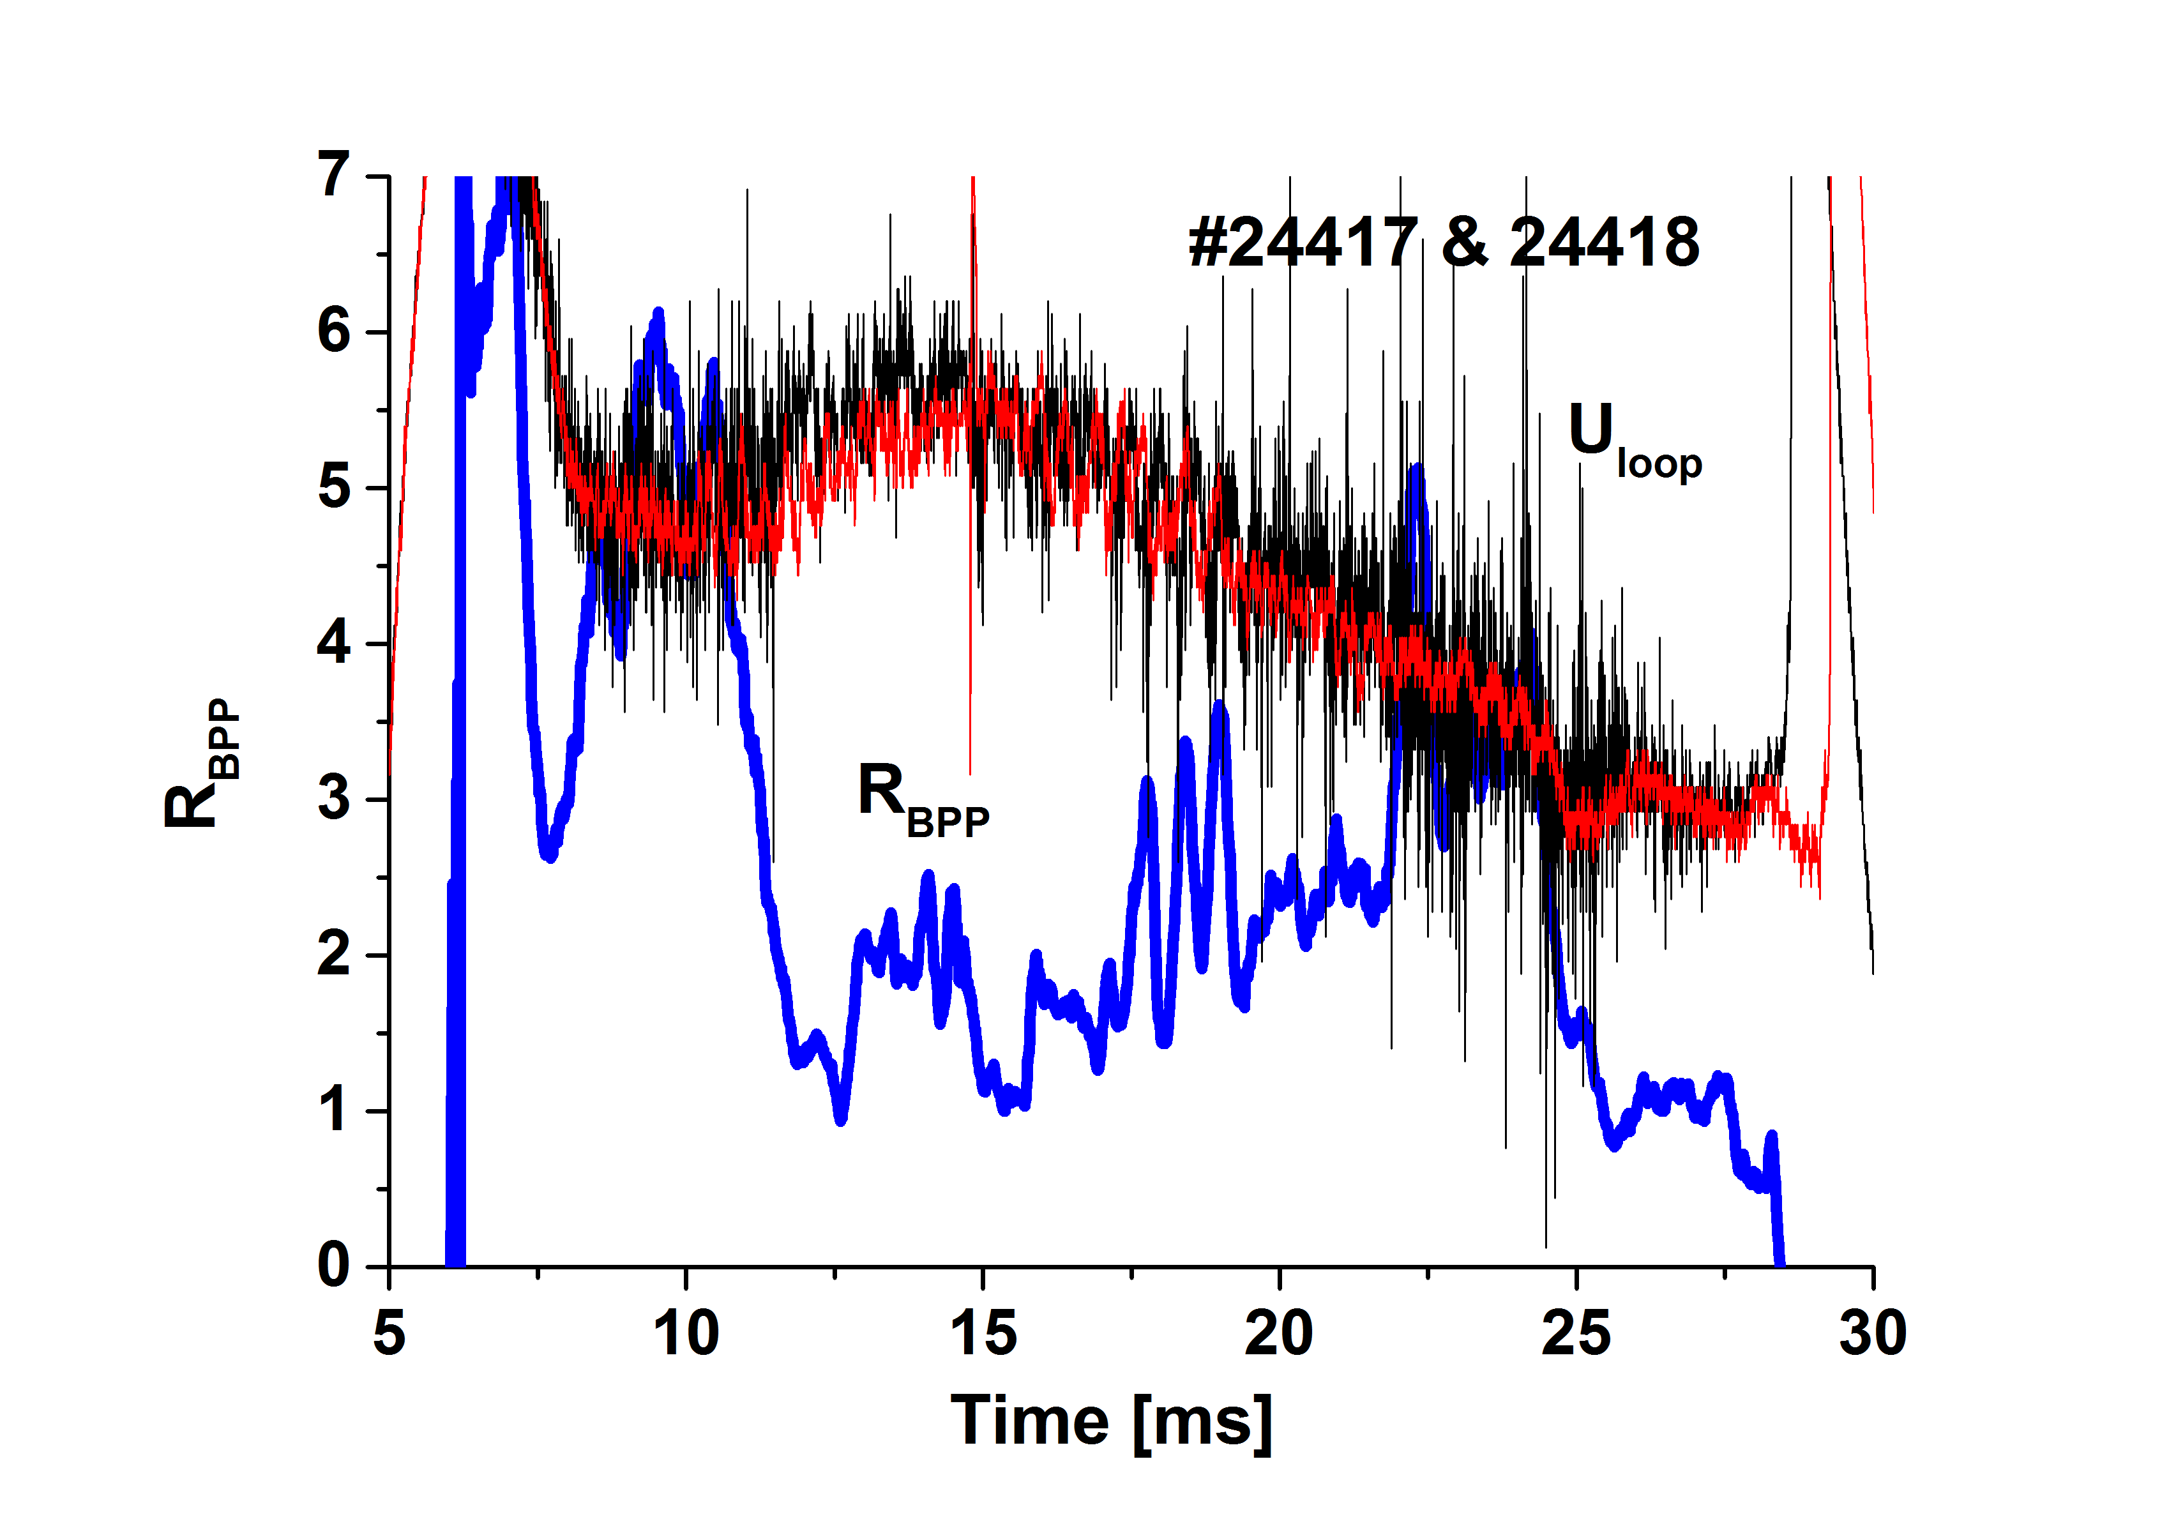
We see the ratio of R_{BPP} between 1.5 and 2.5 in the time interval 12 – 22 ms. Jirka Adamek is happy! However, the ration again increase with B_{tor}. Signals of the loop voltage are similar, but differ in details. More noisy signal in #24418 is observed and also some differences in instabilities.
TBD: do the same for shots 24419 and 24417.
The IV characteristics of BPP and LP recorded at t = 10-11 ms are compared in Figure 4.
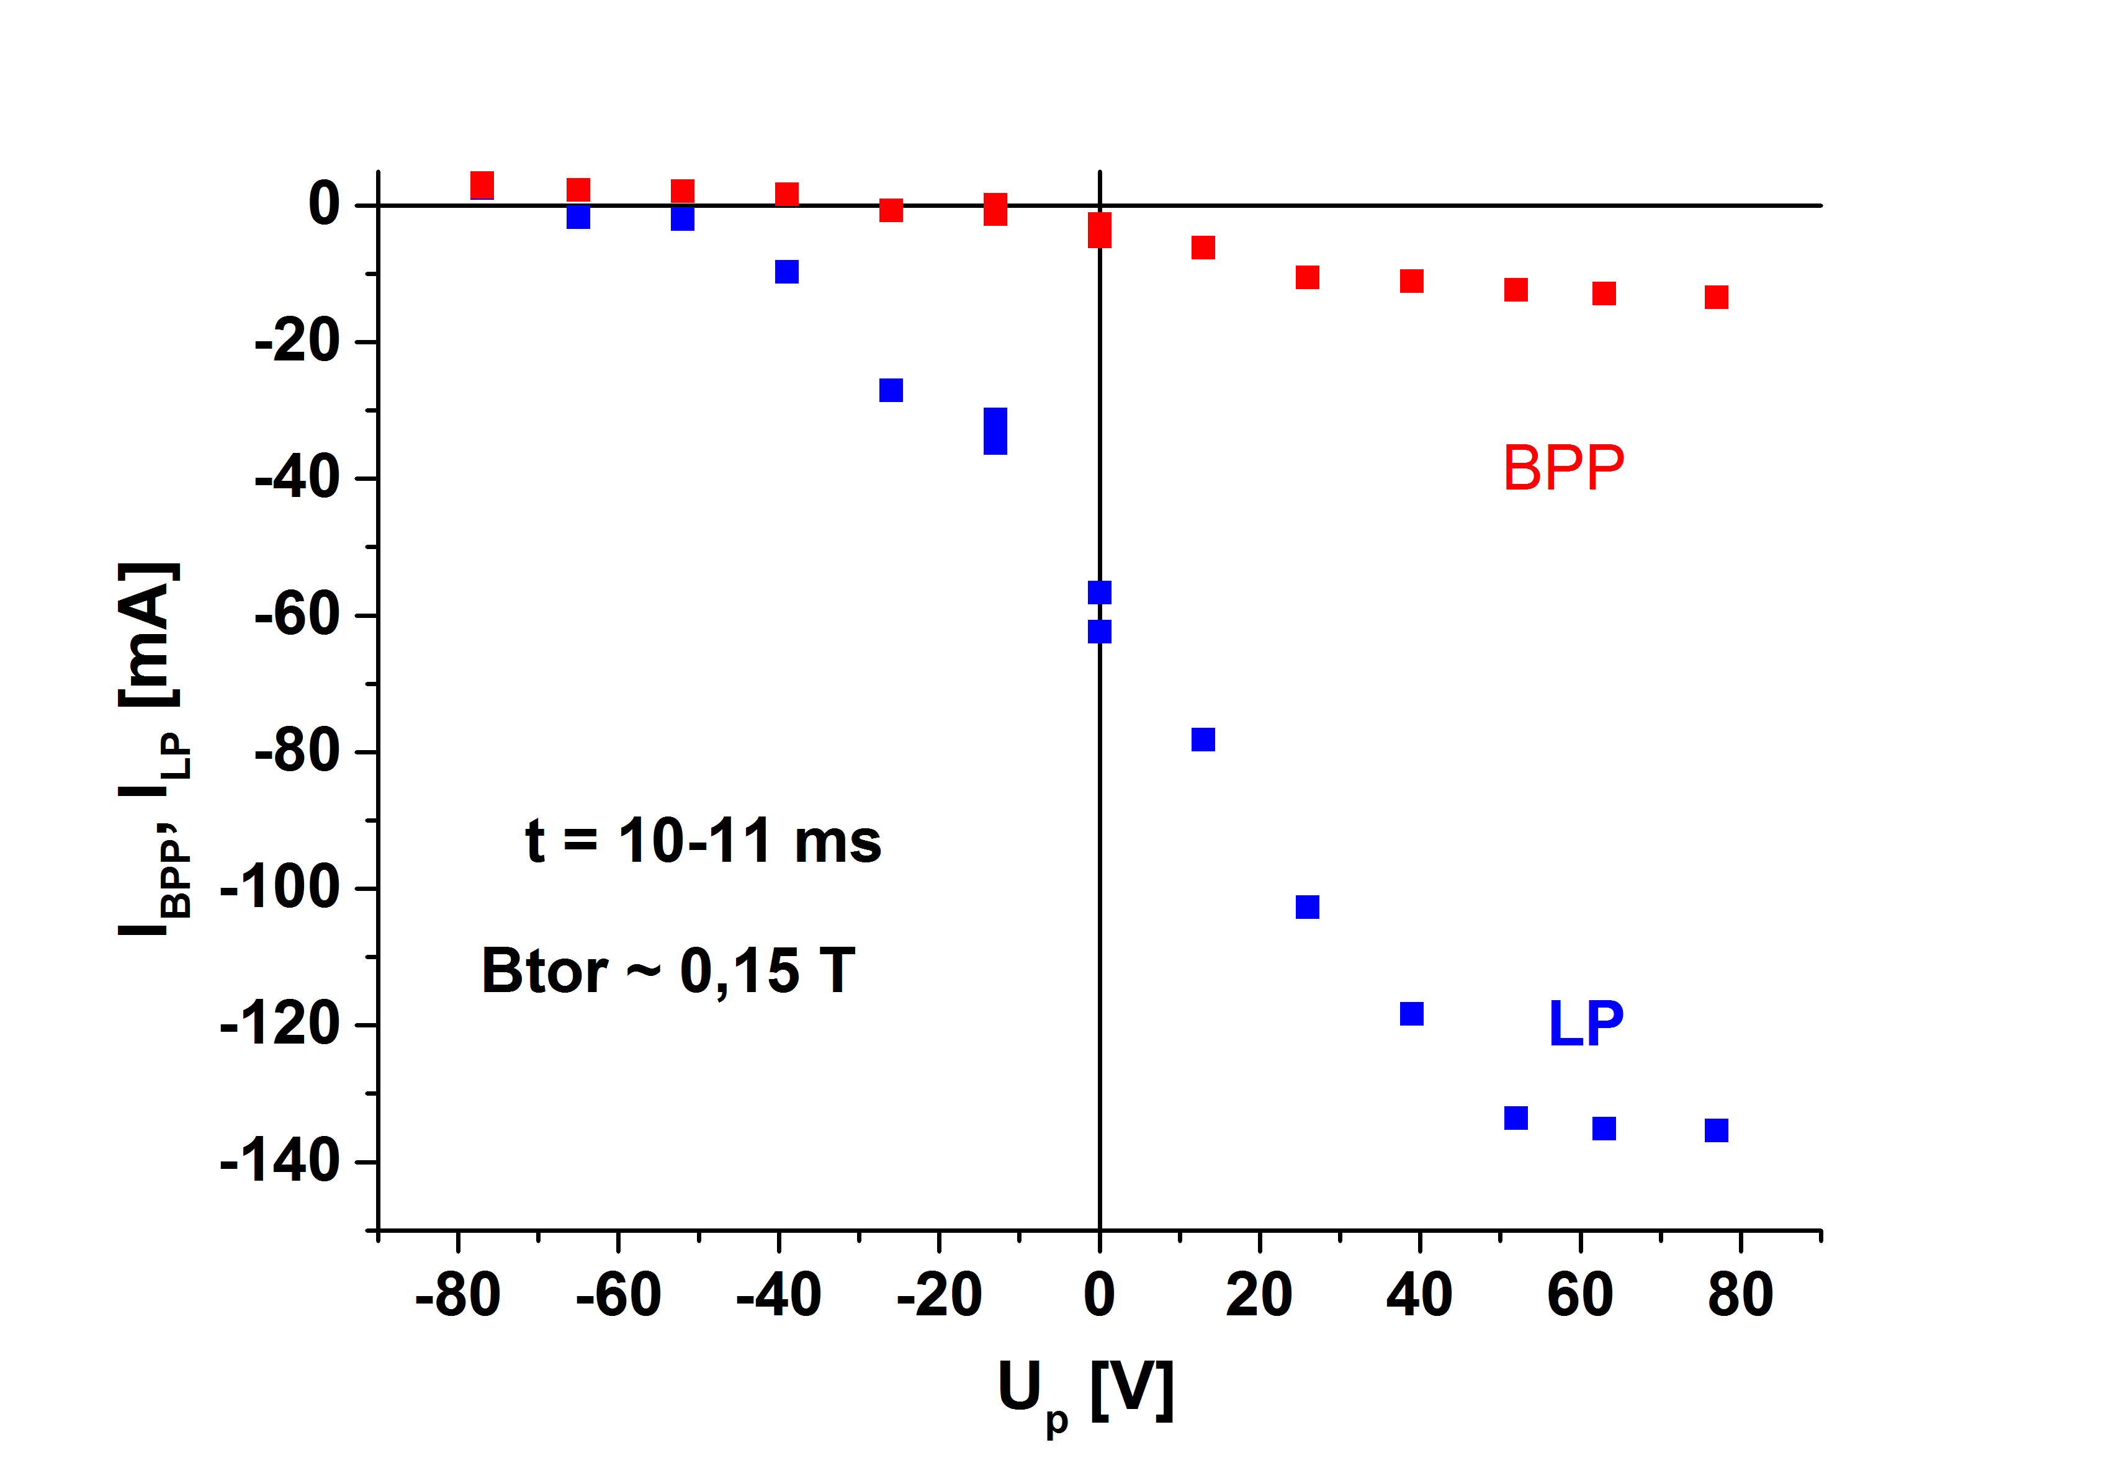
Figure 5 shows IV characteristics of BP probe at different values of the toroidal magnetic field normalized at Up = -77 V.
