A description...

**Professor Responsible (CTU)**: Dr. Vojtech Svoboda

**Professor Responsible (CICATA)**: Dr. Martín de Jesús Nieto Pérez

**Proponent Student**: Daniel Hernández Arriaga

**Experimental study on the rotation of magnetic islands in the GOLEM Tokamak.**

**Background.**

One of the major limitations on the performance of fusion devices is the presence of plasma instabilities, which often take form of magnetic islands. These change the overall magnetic field topology of nested poloidal flux surfaces, and degrade the plasma confinement. A suppression technique for these structures that has lately drawn considerable interest is active mitigation of neoclassical tearing modes (NTM). Tearing modes in general take form of magnetic islands situated on low order, rational value safety factor *q* surfaces within plasma. By application of local electron cyclotron resonance heating on surface where island has emerged, it is possible to mitigate its amplitude.

Magnetic islands rotate in fusion devices in kHz range of frequencies together with plasma and in such state pose no serious threat for plasma confinement. However, their interaction with tokamak wall of finite conductivity eventually leads to mode locking as they cease to rotate. Under these circumstances magnitude of islands start to grow, as stabilizing effect of plasma rotation velocity shear is no longer present, which eventually leads to disruption. In tokamaks, additional rotation to their intrinsic one may be provided by the external momentum input from neutral beam injection (NBI). In the case of studied tokamak in question, rotation is fully intrinsic (spontaneous), without any external momentum input.

Magnetic islands create distinct perturbations in the magnetic field, with each type of island (2/1, 3/2, 3/1, etc.) possessing its own signature, which can be recognized by set of sensors of local magnetic field, often referred to as Mirnov coils. These collect spatial and temporal information of all the MHD perturbations that are present within plasma at the time, since MHD instabilities in tokamaks may simultaneously exist on different *q* rational surfaces.

The present work proposal considers the use of two Mirnov coil arrays on the GOLEM tokamak as a diagnostic to study the behavior of magnetic island rotation by measuring their structure at two different toroidal positions separated by 180°, as is shown in figure 1. Toroidal phase correlation provided by two arrays of Mirnov coils rings will undoubtedly provide better insight into structure of magnetic islands on studied device, which has until now been observed only by poloidal phase correlation and temporal frequency analysis using single Mirnov array. The two poloidal arrays will have 16 coils each, although due to limitations in the number of channels available in the data acquisition system one of them will only use 8 coils.

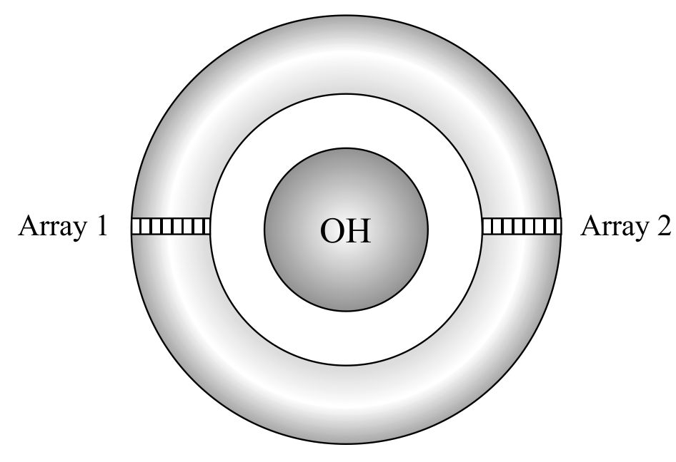 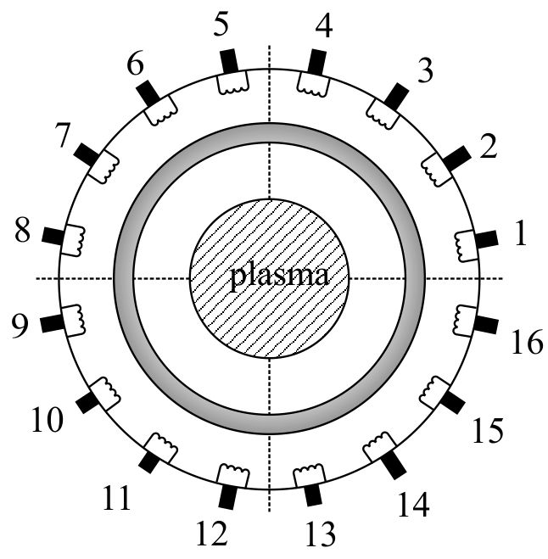

**Figure1. Mirnov coil arrays proposed for GOLEM Tokamak**

During experiments, the plan calls for multiple shots with different safety factor values in order to observe different islands using both coil arrays. Temporal change of phase observed on both diagnostic sets as indicator of toroidal rotation allows for the estimation of toroidal angular speed. This quantity should be proportional to poloidal angular speed through structure of MHD island modes. Proposed experimental arrangement will allow measurement of poloidal and toroidal angular velocity, as well as mode numbers of islands. A critical step towards an adequate and accurate interpretation of the output signals from both diagnostics is to choose the proper data processing techniques. Fourier transform is considered the universal method for time to frequency domain conversion and will play crucial role in island detection and determination of its poloidal angular frequency. Cross-correlation technique will provide information on island mode numbers (i.e. its structure) as well as on toroidal angular frequency. Should there be more islands present in plasma at time, singular value decomposition (SVD) algorithms can be used for deconvolution of the coil array signals that containing multiple harmonic signals from islands into a thread of tempo-spatial harmonic bases and enable to distinguish islands from each other.

In fig. 2 there is provided an example of Fourier transform and cross-correlation analysis of (3/1) magnetic island, using single array of Mirnov coils. Experiment took place within GOMTRAIC course and plots represent part of the output of magnetic diagnostics team:

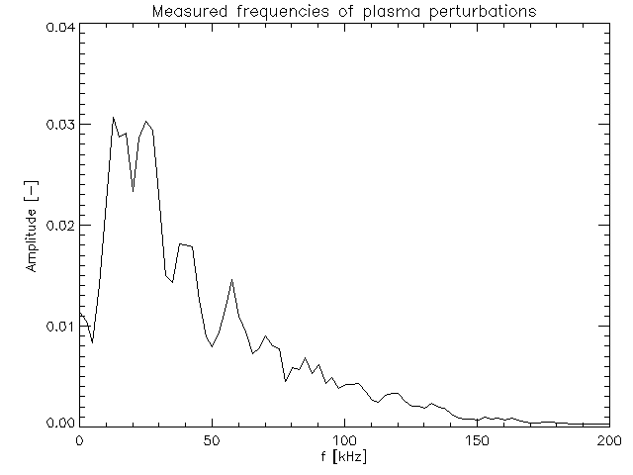

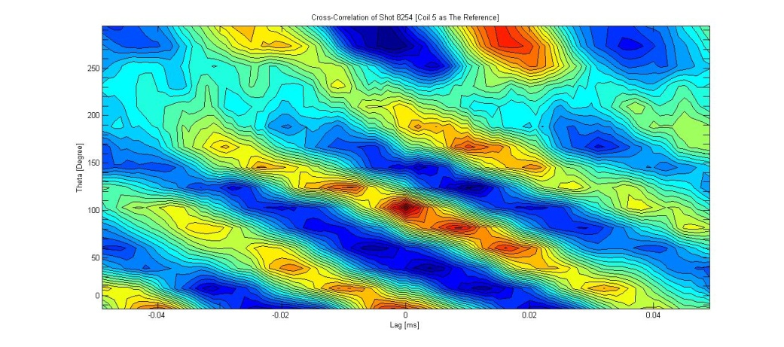

**Figure 2. Reconstruction of Magnetic islands in GOLEM Tokamak.**

**Overall Goal.**

Perform experiments on the GOLEM Tokamak aimed to detect and measure plasma rotation and magnetic islands by use of two full poloidal arrays of Mirnov coils located at two different toroidal positions.

**Specific Goals.**

* Become familiar with the experimental environment in GOLEM.
* Design, construction and installation of the new Mirnov coil diagnostic for GOLEM.
* Perform experiments on GOLEM to identify MHD structures and measure their properties as a function of safety factor for different shots.

**Specific Activities.**

* Training on the GOLEM tokamak operation and safety (2 weeks)
* Finishing assembly and construction of the second Mirnov ring (2 weeks)
* Installation of the diagnostic in the GOLEM tokamak (1 week)
* Perform experiments dedicated to measure rotation (3 weeks)
* Analysis of data from first experiments (2 weeks)
* Second round of experiments in GOLEM (3 weeks)
* Analysis of data from second round of experiments (2 weeks)
* Documentation and reporting of the internship (1 week)

***Calendar – Activities*** March 9 – June 28, 2013

|  |  |  |  |  |  |  |  |  |  |  |  |  |  |  |  |  |
| --- | --- | --- | --- | --- | --- | --- | --- | --- | --- | --- | --- | --- | --- | --- | --- | --- |
| **Activity** | **March** | | | | **April** | | | | **May** | | | | **June** | | | |
| Training on the GOLEM tokamak operation and safety |  |  |  |  |  |  |  |  |  |  |  |  |  |  |  |  |
| Finishing assembly and construction of the second Mirnov ring |  |  |  |  |  |  |  |  |  |  |  |  |  |  |  |  |
| Installation of the diagnostic in the GOLEM tokamak |  |  |  |  |  |  |  |  |  |  |  |  |  |  |  |  |
| Perform experiments dedicated to measure rotation |  |  |  |  |  |  |  |  |  |  |  |  |  |  |  |  |
| Analysis of data from first experiments |  |  |  |  |  |  |  |  |  |  |  |  |  |  |  |  |
| Second round of experiments in GOLEM |  |  |  |  |  |  |  |  |  |  |  |  |  |  |  |  |
| Analysis of data from second round of experiments |  |  |  |  |  |  |  |  |  |  |  |  |  |  |  |  |
| Documentation and reporting of the internship |  |  |  |  |  |  |  |  |  |  |  |  |  |  |  |  |

**Approval Signatures**

___________________________ __________________________

Martin Nieto Perez, Ph.D. Vojtech Svoboda, Ph.D.

Local Supervisor Foreign SupervisorCICATA Queretaro – IPN Czech Technical University - Prague