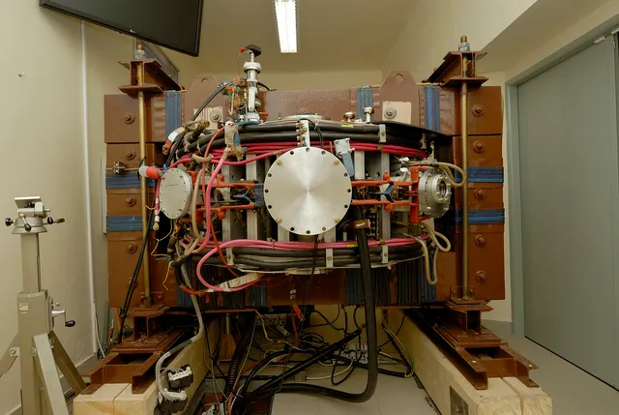 | Next to GOLEM:  Mr Svoboda: Hello and welcome…  Martina: Hello, my name is Martina and I will be your guide in this series.
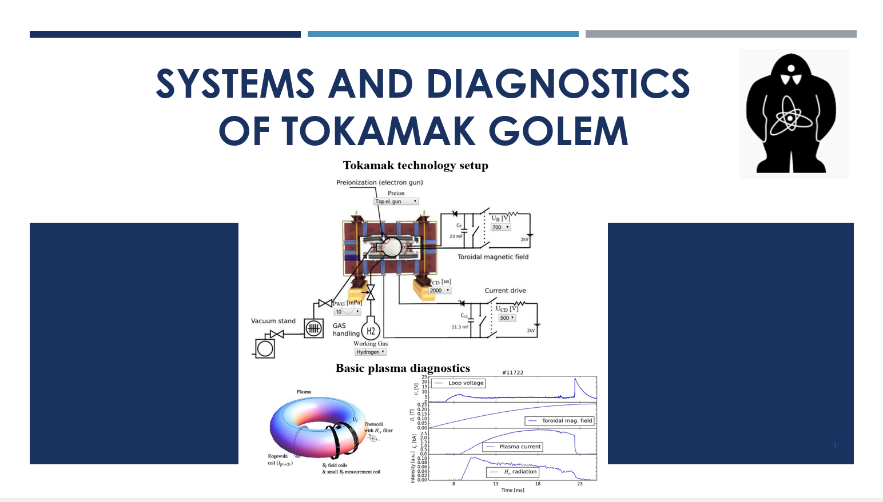 | In this video series we will talk about the systems and diagnostics of tokamak GOLEM.
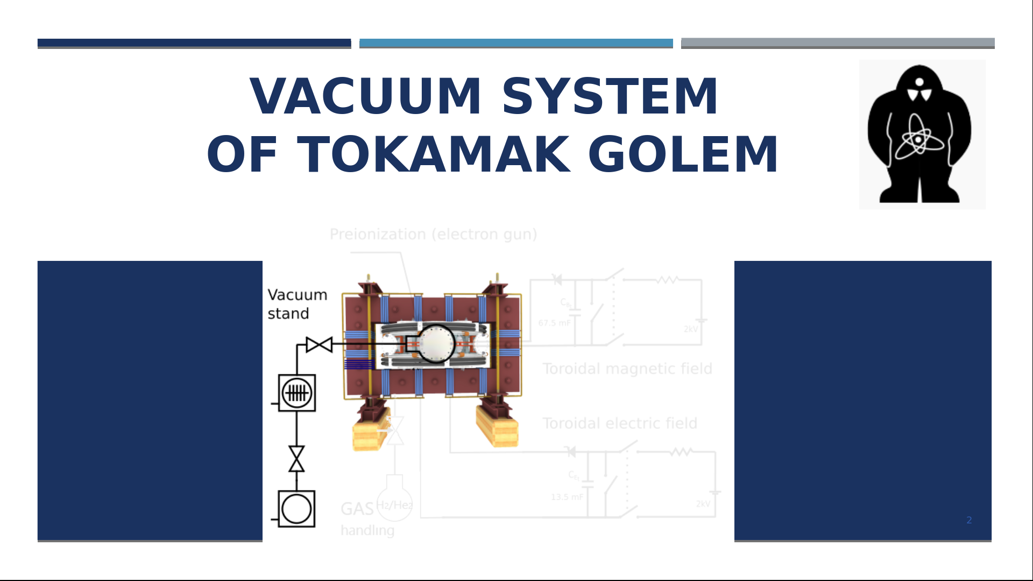 | In this presentation, we will look more closely at the vacuum system of tokamak GOLEM
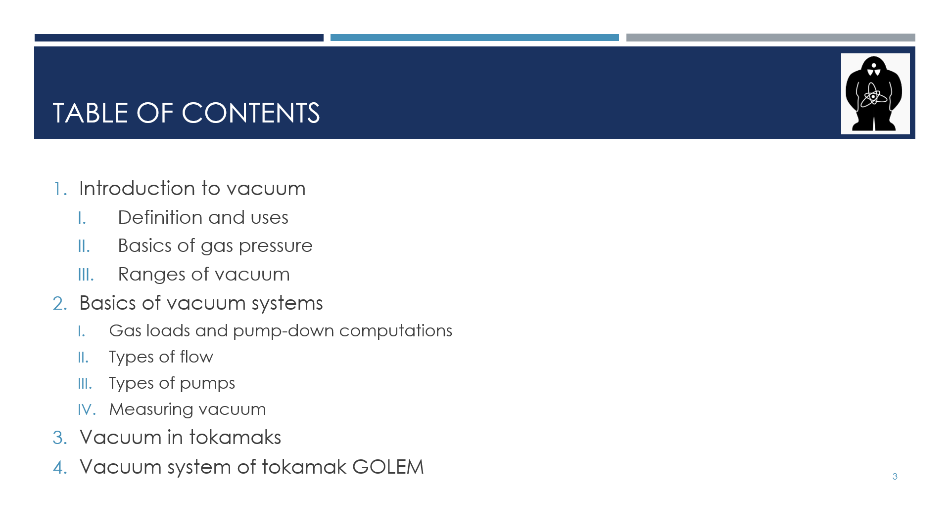 | Those are the topics we will cover.  Firstly, we will take a look at what exactly vacuum is and where we can find it.  Then, we will talk about the basics of vacuum systems, the components and how do they work.  After that, we will move to tokamaks generally and finally, to the specifics of tokamak GOLEM.
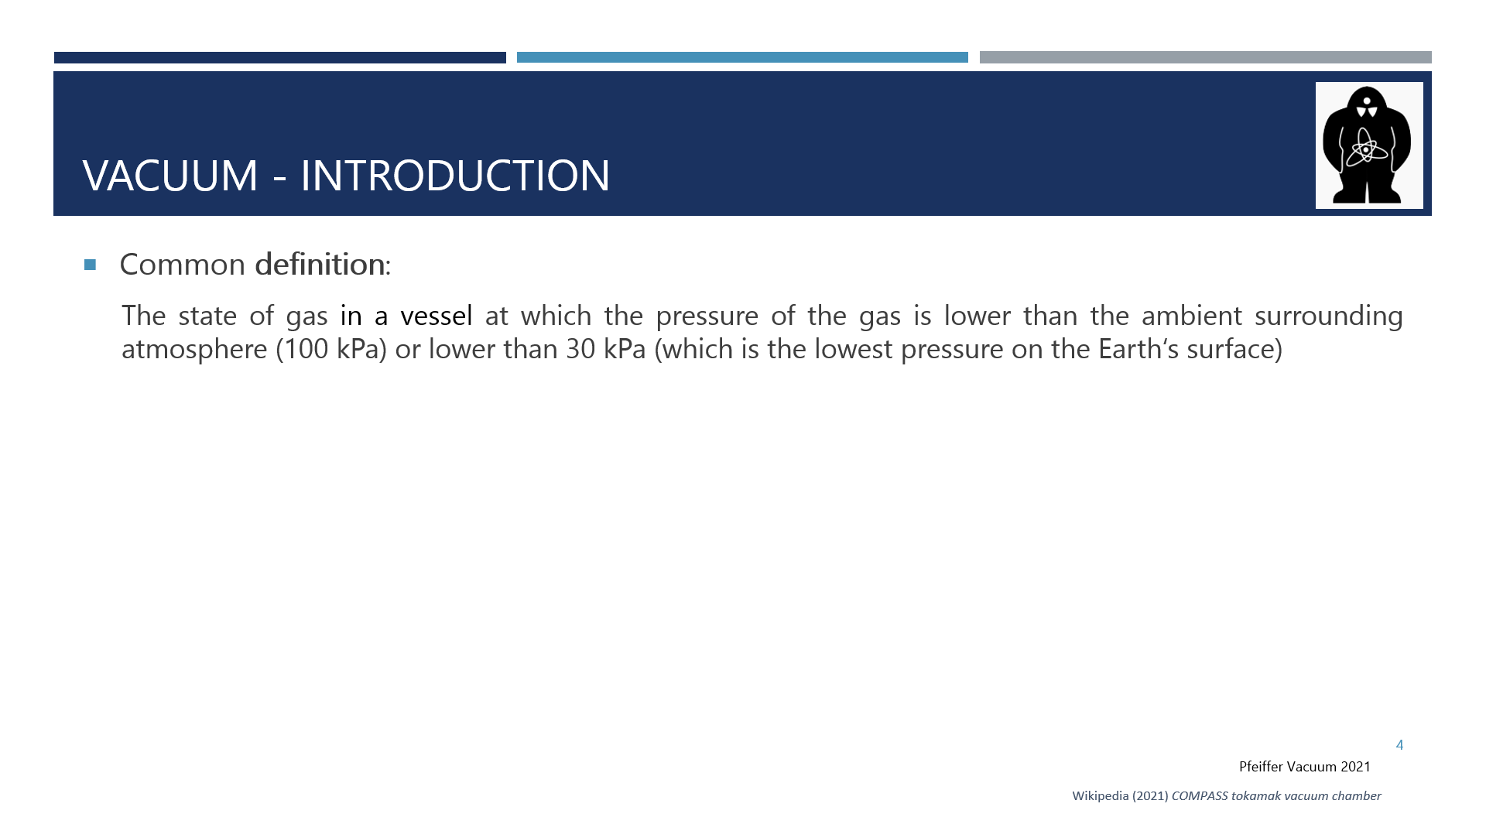 | There are several definitions of vacuum. Most commonly, vacuum is referred to as a state of a system containing gas or vapours at lower pressure than the atmospheric pressure i.e. 100 kPa.  And where can we encounter vacuum?
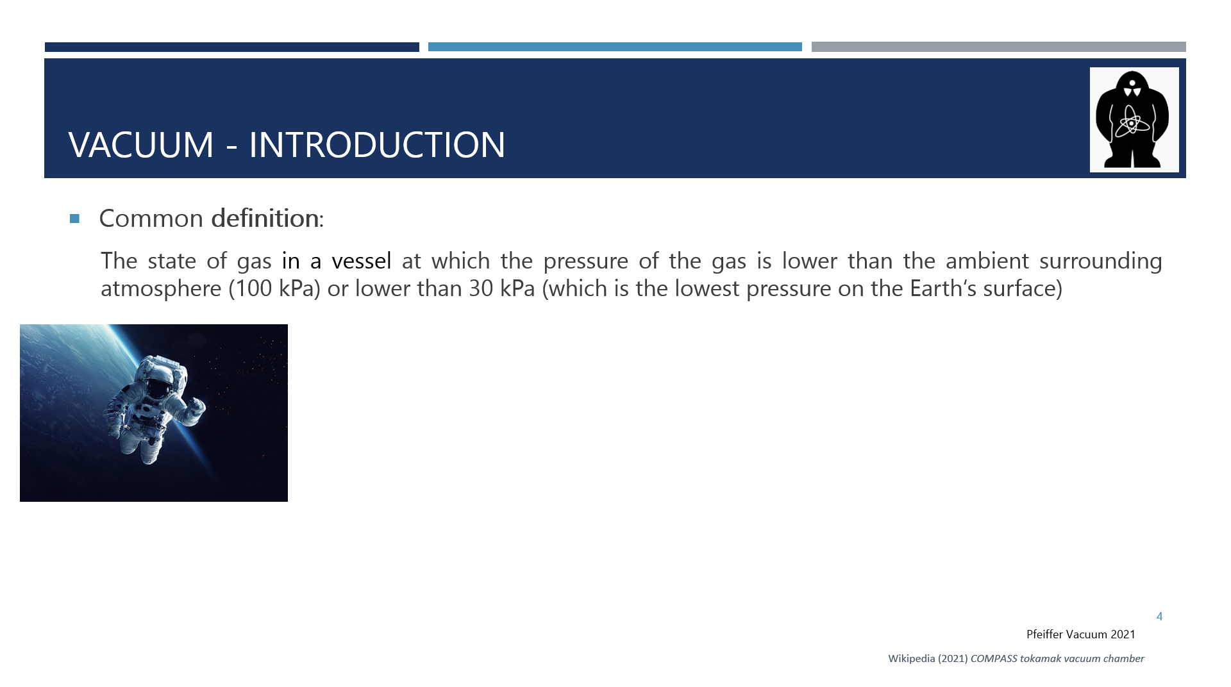 | Animation Free space is a prime example, one which would come to a mind of many of you at the first place.
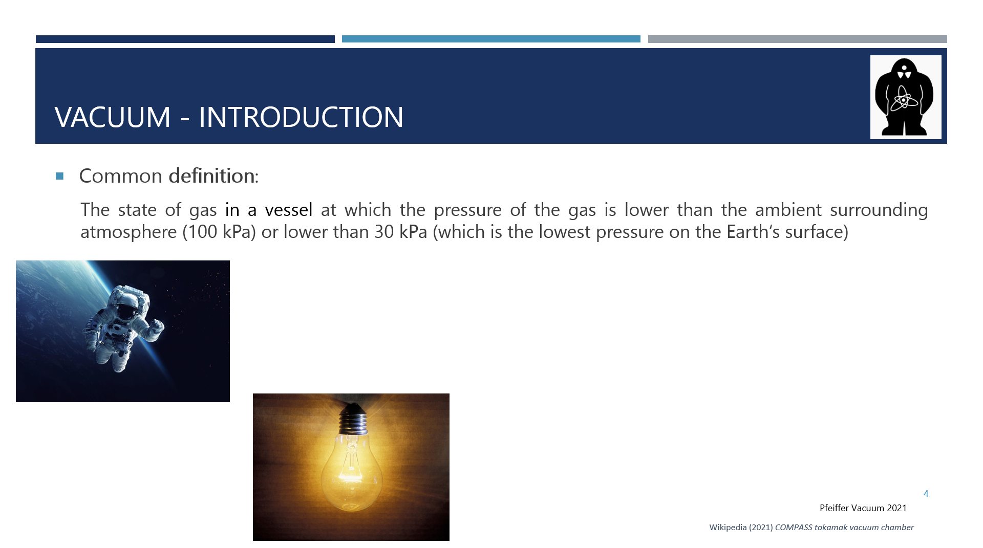 | Also, vacuum is used as a protection layers. In a light bulb Animation there is a metal wire heated by the passing current. The vacuum inside the bulb protects it from an oxidation and a disintegration.
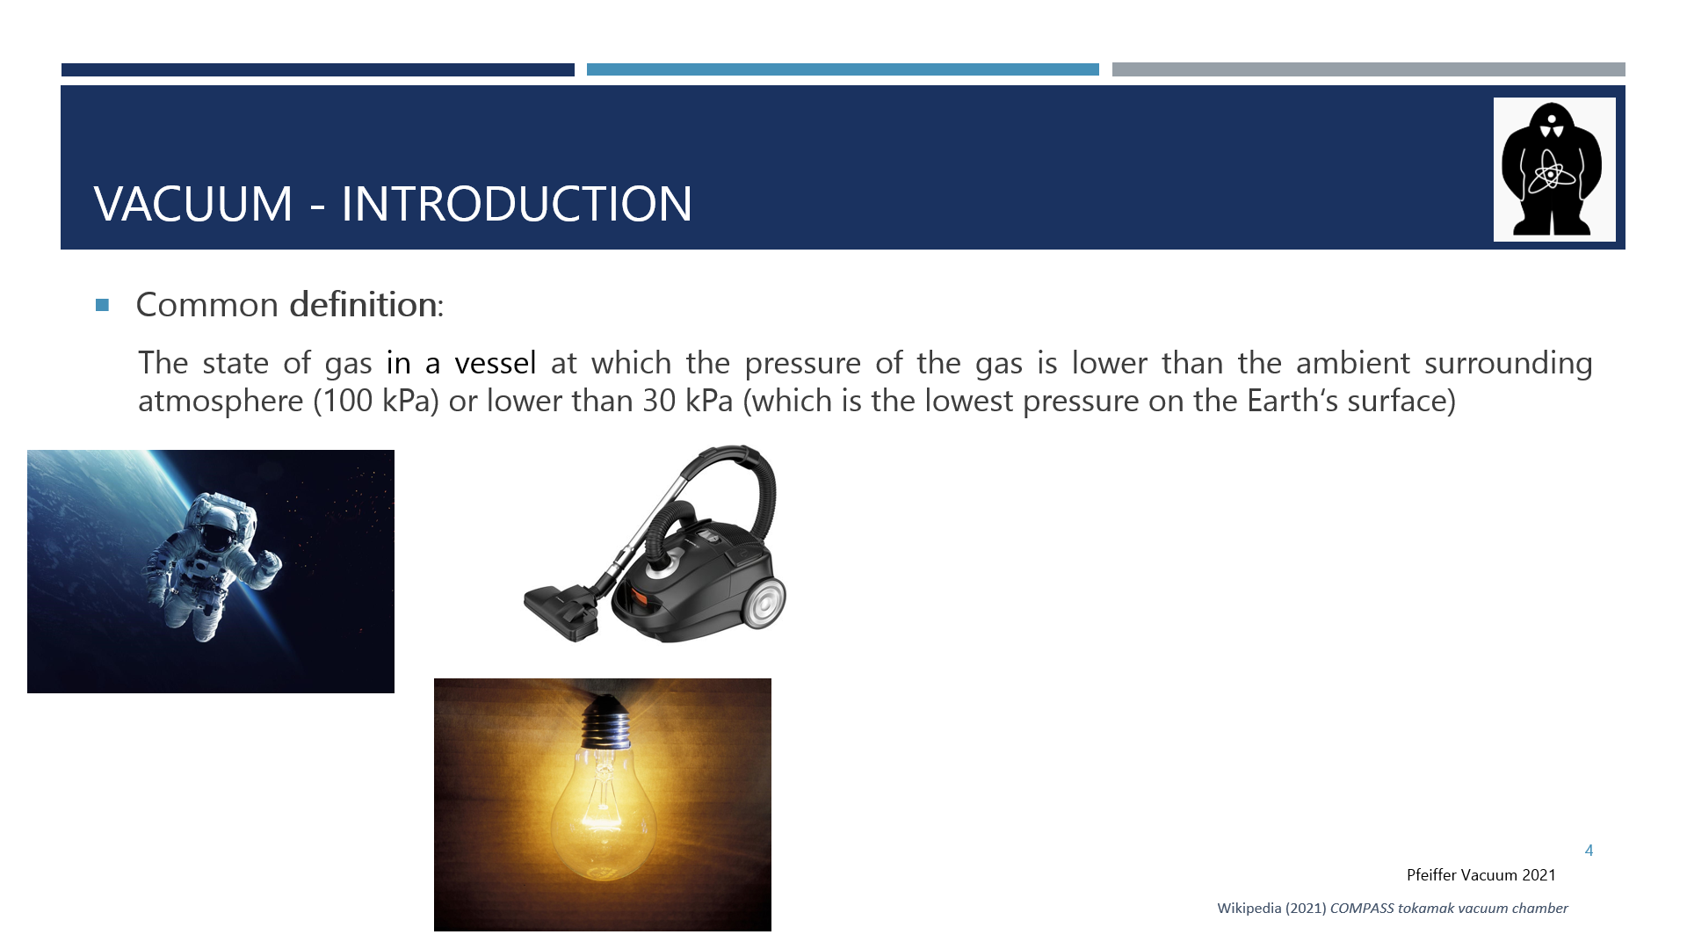 | And of course, a vacuum can be used for a suction. Probably most of you have a machine using this principle at home, Animation a vacuum cleaner. Another example of using the system of creating vacuum is a straw you put into your drink to be able to get the fluid or some types of wells work by decreasing pressure to pump the liquid.
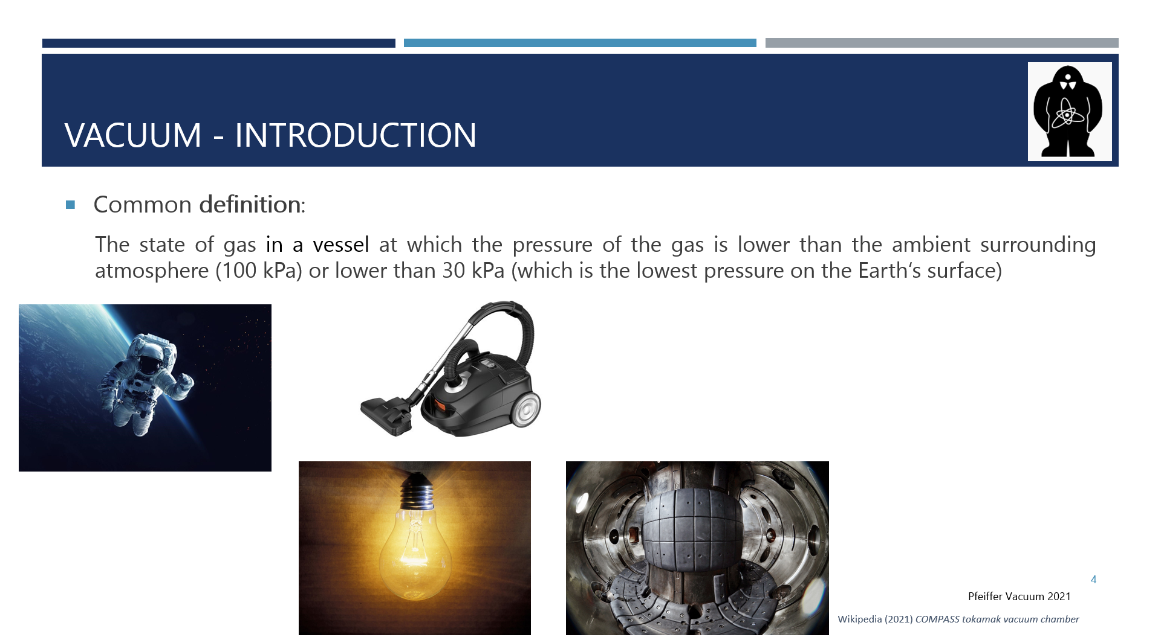 | Since this is a presentation about tokamaks, it is no surprise that tokamaks also use vacuum Animation, let me tell you more about that later. But also other scientific machines rely on vacuum (free space), such as particle accelerators. You can encounter evacuated tubes even in a school laboratory, for example, tubes used to show cathode rays.
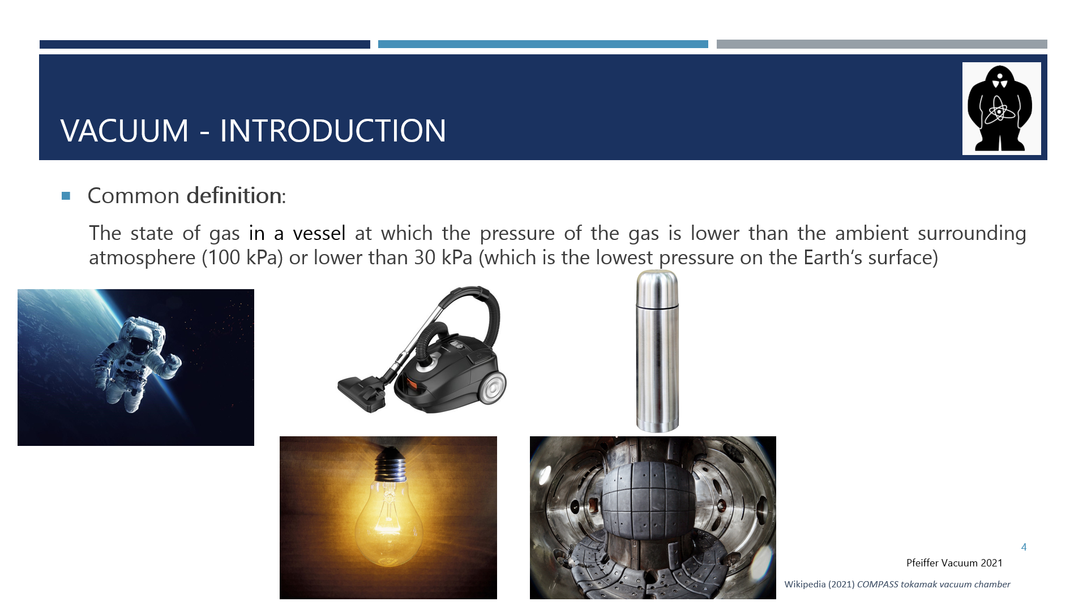 | Another example from everyday life Animation is a thermos flask or, more generally, insulation.
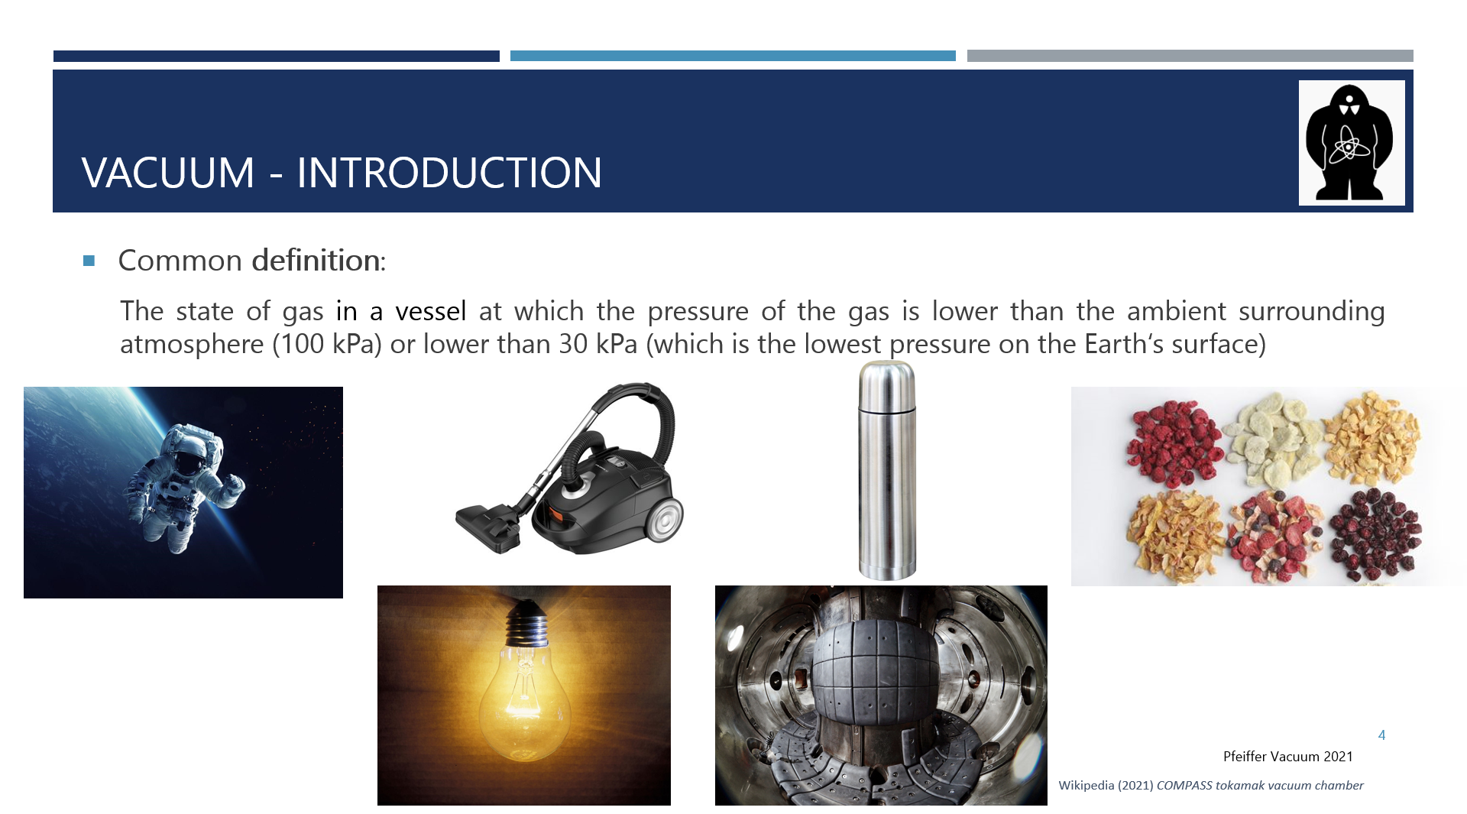 | And finally, Animation vacuum is widely used in the food industry for dry-freezing or persevering the food.  Vacuum has a lot more uses but they are not the focus of this presentation, so let's move on.
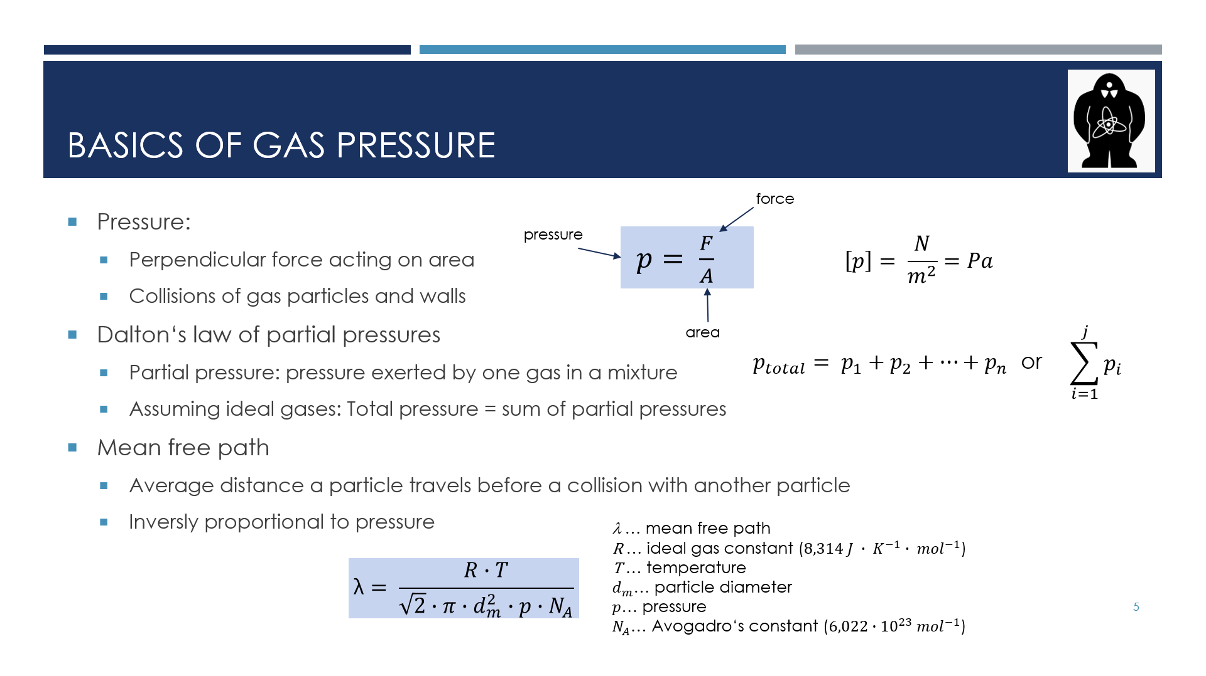 | Here I’ll review the basics of gas pressure. The pressure is defined as a force applied perpendicularly to an area. It is expressed as newtons per metre squared or more commonly in pascals. In gases the pressure is created through collisions of gas particles with the walls of the gas container.  Often we work with more than one gas. In such systems we use the Dalton’s law of partial pressures, which states that the overall pressure in a system is the sum of pressures exerted by individual gases or partial pressures.  Finally, I would like to mention quantity called mean free path as we will use it later. Mean free path delta is the average distance a particle travels before collision with another particle. As you can see in the formula below, it is inversely proportional to pressure because when there are more particles in volume, collisions are more common, hence, individual particle travels shorter distance before a collision.
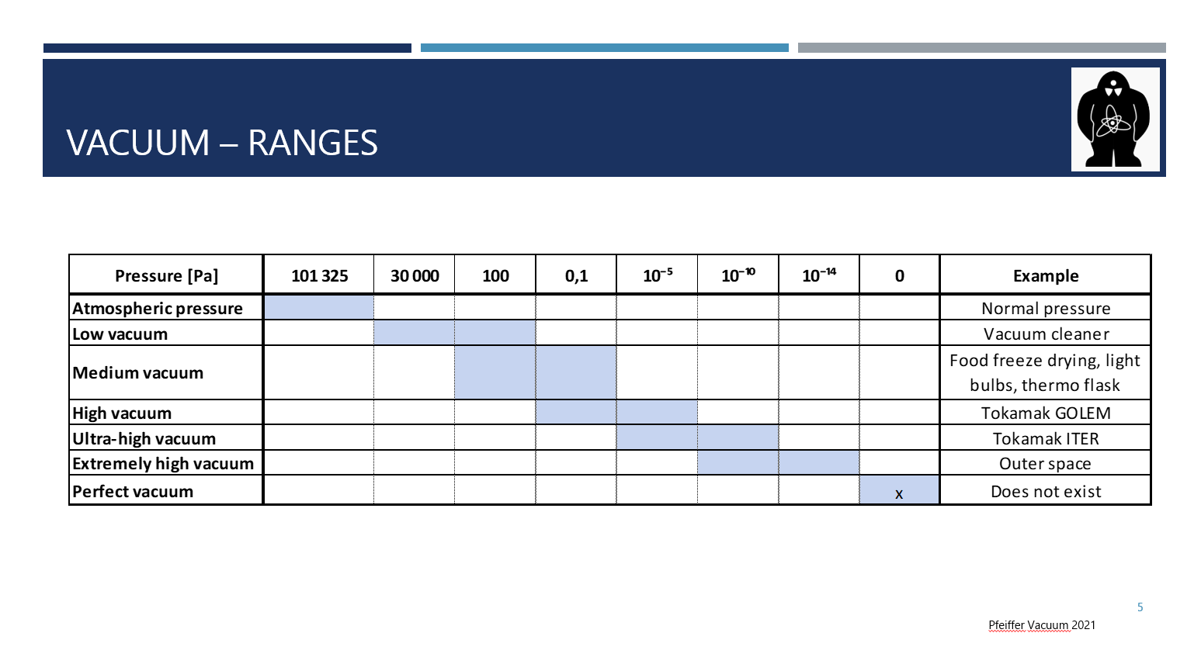 | Here you can see the overview of ranges or degrees of (under)pressure/vacuum. We differentiate between these ranges to, for example, choose the right vacuum pump for the purposes we need it.  The last row denotes a perfect vacuum, with zero pressure. This is a hypothetical concept because at least some particles, which create the pressure, are always present in a real world.  I listed some examples for each range in the last column.
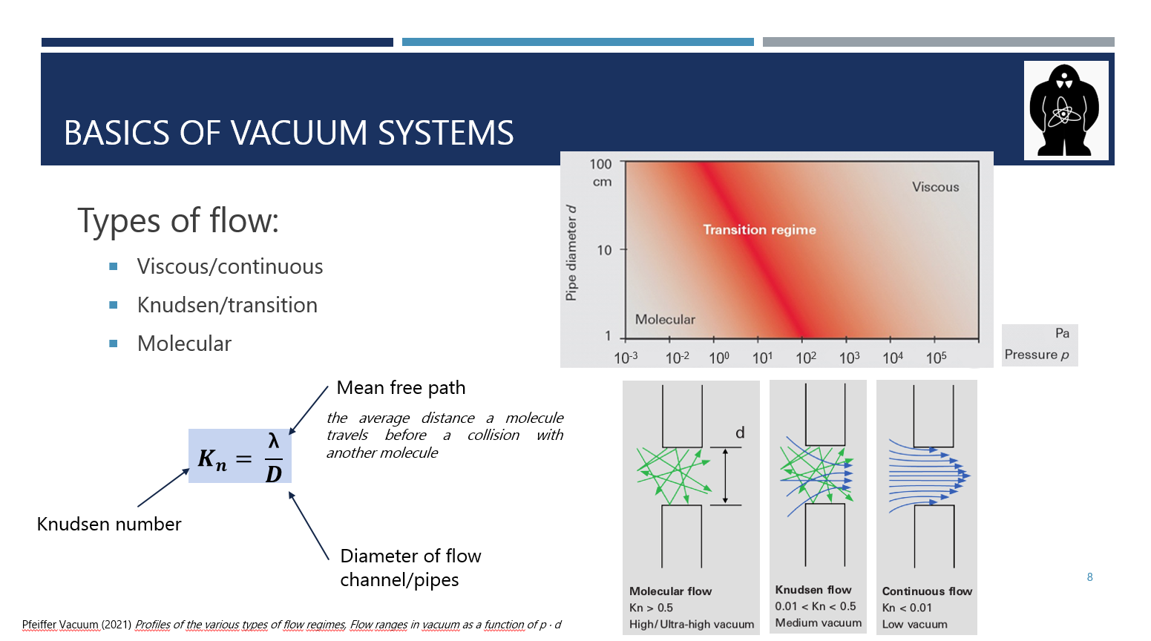 | To understand vacuum systems, we first need to understand how fluids, in our case gases, behave in closed spaces. There are three main types of flow of such gases. Viscous/continuous, Knudsen/transition and Molecular. We differentiate them based on the so-called Knudsen number.  You can see the formula on the slide, in a blue frame. Letter lambda is the mean free path. To refresh your memory, it is an average path a molecule travels before a collision with another molecule. Mean free path is closely linked to pressure since if there are more molecules in a certain volume, in other words, the pressure is higher, the collisions between molecules are very common, therefore the mean free path is short whereas with low pressure and a small number of molecules, the collisions are not nearly as common, so the molecules can travel longer distances.  Upper case “D” stands for the diameter of pipes, which is linked to the volume. Both those values are expressed in meters.  At the top right corner, you can see a graph linking the diameter and pressure of the gas. Notice that in a real life there are no strict barriers between the different types of flow.  At the bottom right corner, you can see the visual representation of the flows. In viscous flow, the molecules travel as a mass towards the inlet of the vacuum pump due to their frequent collisions.  In molecular flow, collisions with walls are much more common. When a molecule hits a wall, it resides there for a very short time and then it releases in a random direction. The movement is unpredictable.
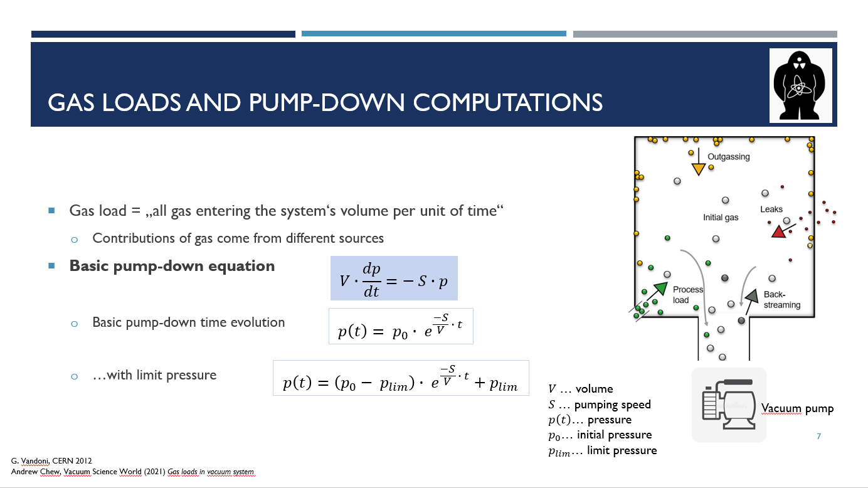 | Now we are getting to the pump-down time evolution. It may seem quite easy and straightforward to pump out all air from the chamber, but let me explain why it is not so. We have to deal with something called a gas load, which is the total amount of gas entering the system's volume in a given time. The gas load can come from a variety of different sources, as the picture on the right suggests.  One such a source is, for example, outgassing, which is caused by processes such as vaporisation or permeation. To put it simply, molecules from the walls are entering the vacuum chamber at the same time we are evacuating it.  In the blue frame, there is the basic pump-down equation, from which we can derive the two equations below. The first one represents an ideal vacuum system with no gas load. In this system, all that matters is the volume of the chamber, the pumping speed and the initial pressure.  However, the second equation is much closer to the reality of vacuum systems. This equation introduces limit pressure, which is minimum pressure level below which we can’t get.  If we wanted to be even more precise, we would have to count with leakage as well.
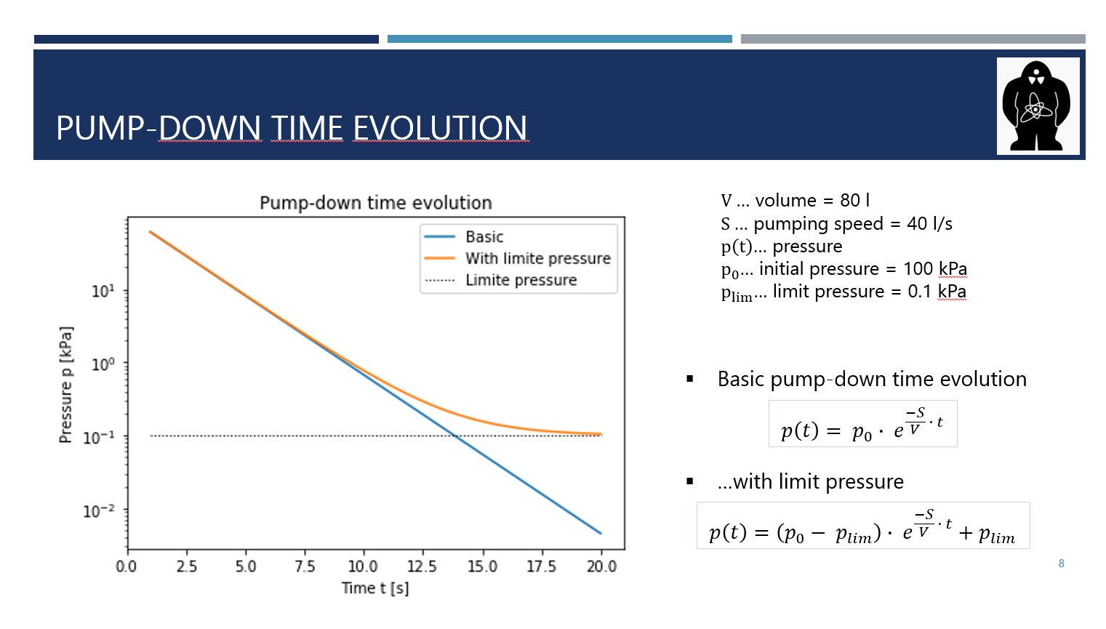 | This graph shows how a pump-down process may look. On the right side there are parameters entering the functions used to draw these curves.  Also, notice the logarithmic scale of the pressure.  The ideal evolution is shown in a blue colour whereas the orange colour represents the more realistic scenario with limit pressure.
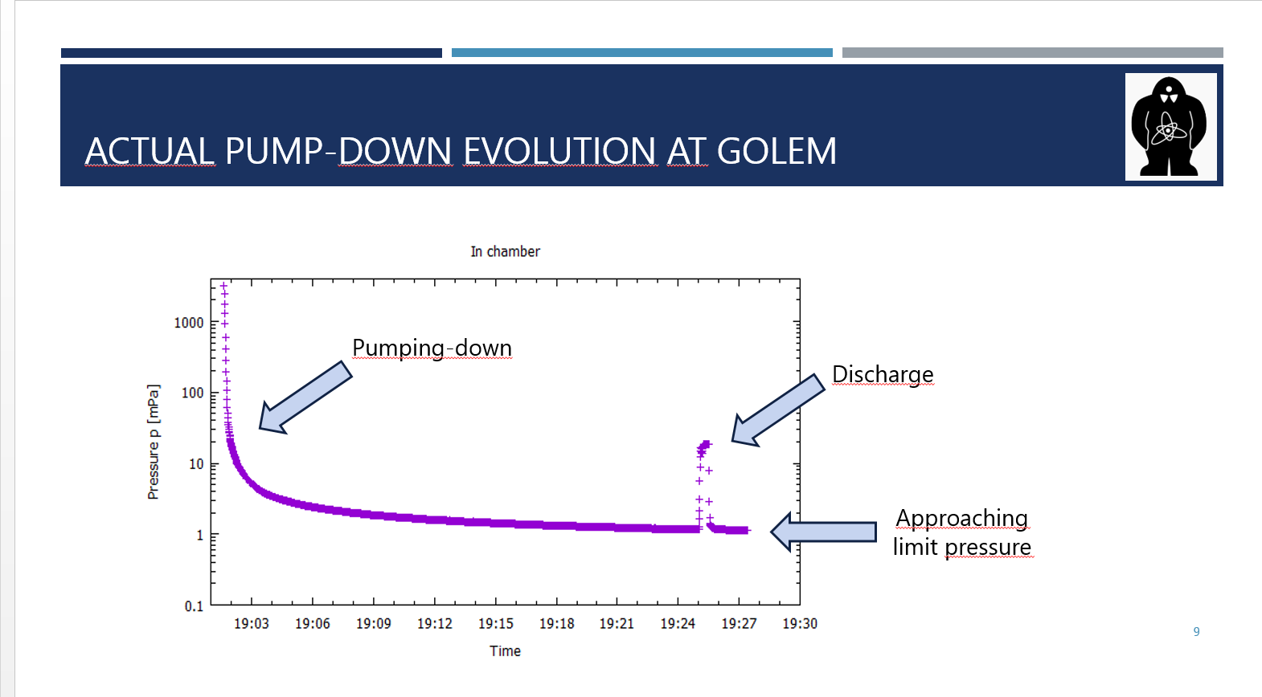 | This graph shows an actual pump-down process measured at tokamak GOLEM.  Just like before, logarithmic scale was used for the y-axis representing pressure. The graph shows gradual pump-down process done as a preparation for a session with discharges. Notice how the graph is getting less and less steep as we approach the limit pressure.  The peak on the right side of the graph was measured during a discharge. The working gas was injected in the chamber, the discharge happened and finally, the gas was exhausted from the chamber.
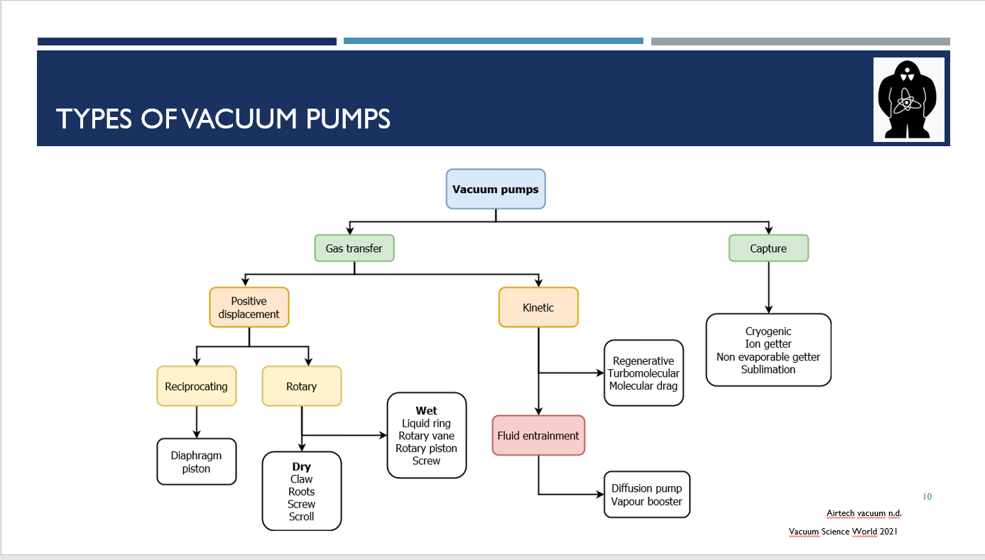 | On this scheme you can see the overview of vacuum pumps types. There are three basic strategies on how to evacuate a chamber. The first two are based on gas transfer:  The first one is called positive displacement. The gas is trapped, isolated, moved and compressed. It is then exhausted into the atmosphere or sent into another pump.  The second type of pumps are called kinetic pumps. They work by transferring momentum to the molecules of the gas. In order for them to work, they need a supporting primary pump since they are unable to exhaust the atmospheric pressure, i.e. they are unable to work with such a high pressure.  And finally, we have capture pumps. Unlike the previous two types, capture pumps immobilize gas molecules on special surfaces within the vacuum system.
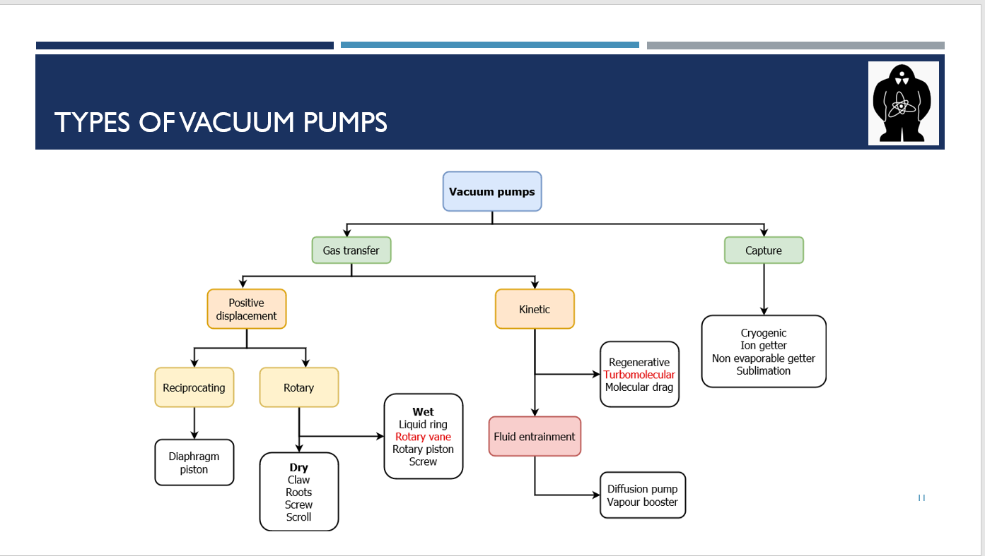 | Later on in this presentation, we will look in more detail at the rotary vane and turbomolecular pumps, which are used at tokamak GOLEM. Here, they are highlighted in red.
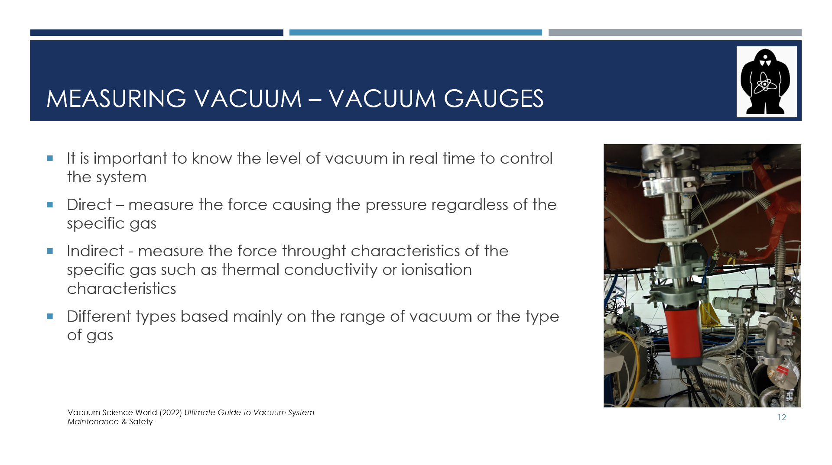 | Another vital part of every vacuum system is the measurement of vacuum, which is done with vacuum gauges. It is very important to know the level of vacuum in the system at all times to monitor the system and to react to the changes in pressure.  There are two main types of gauges – direct and indirect. Indirect gauges rely on specific characteristics of the working gas while direct gauges use other methods.  As with vacuum pumps, there are many options based on the exact requirements. I will talk in more detail about Pirani and Penning gauges later as they are used at tokamak GOLEM. Additionally, they are the most commonly used gauges because their combined range is from 10^5 - 10^-7 Pa.
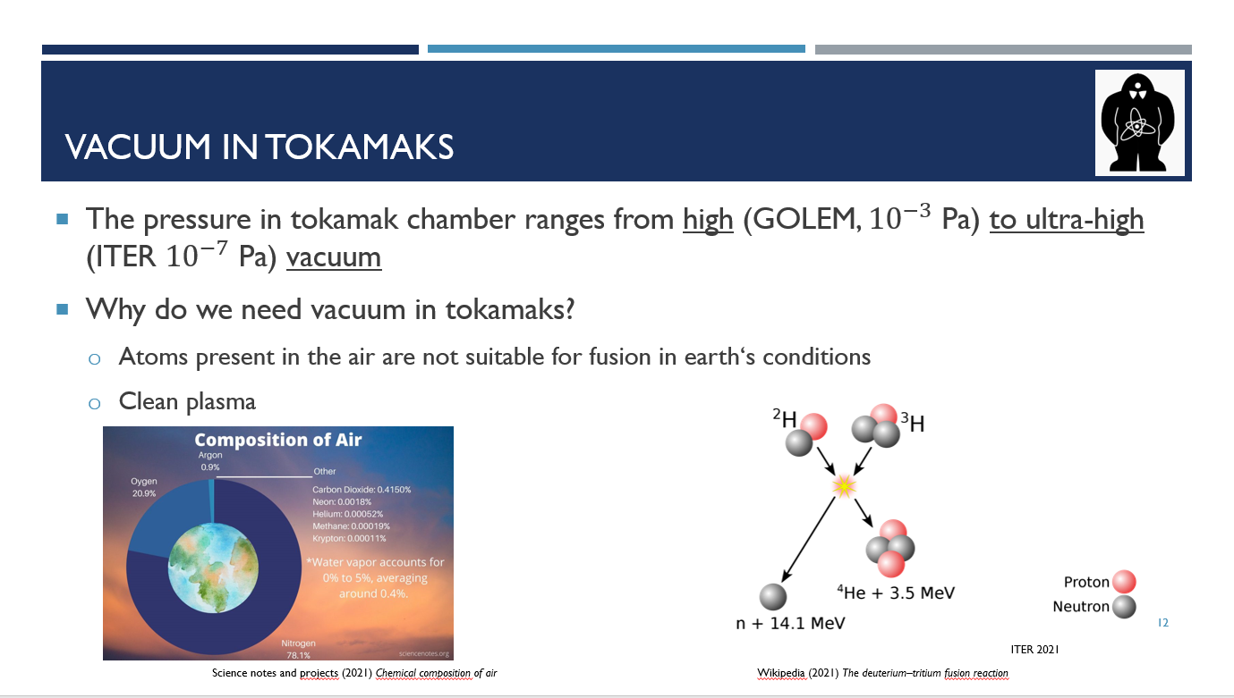 | In tokamaks, in general, the pressure ranges from 10⁻³ Pa, high vacuum (for example in tokamak GOLEM), to 10⁻⁷ Pa, which is considered to be ultra-high vacuum (can be found for example at tokamak ITER, which is being built in France).  Now let us ask: why do we need vacuum in tokamaks?  The main reason is that the atoms present in the air are not suitable for fusion in the Earth's conditions.  The composition of air is shown in the picture at the bottom left corner. Its two main components are nitrogen and oxygen, with seven and eight protons, respectively.  In fusion reactions, nuclei of lighter atoms fuse to form nuclei of heavier atoms. However, the atom nucleus consists of neutral neutrons and positively charged protons, which very strongly repel each other. The more protons an atom has, the stronger the repulsion.  Stars can overcome this repulsion with extreme temperatures and pressures but on the Earth, we try to fuse atoms with as few protons as possible, which is shown in the picture on the right. This picture represents the deuterium-tritium reaction, the most suitable for the conditions in the Earth. Both deuterium and tritium are heavier isotopes of hydrogen with one proton each. Also, the number of neutrons allow us to bypass some problems connected to using simple hydrogen.  Additionally, we want to keep the number of air molecules remaining in the chamber as low as possible because these molecules take away some of the energy. These energy loses result in cooling down of the plasma, which is an undesirable effect.
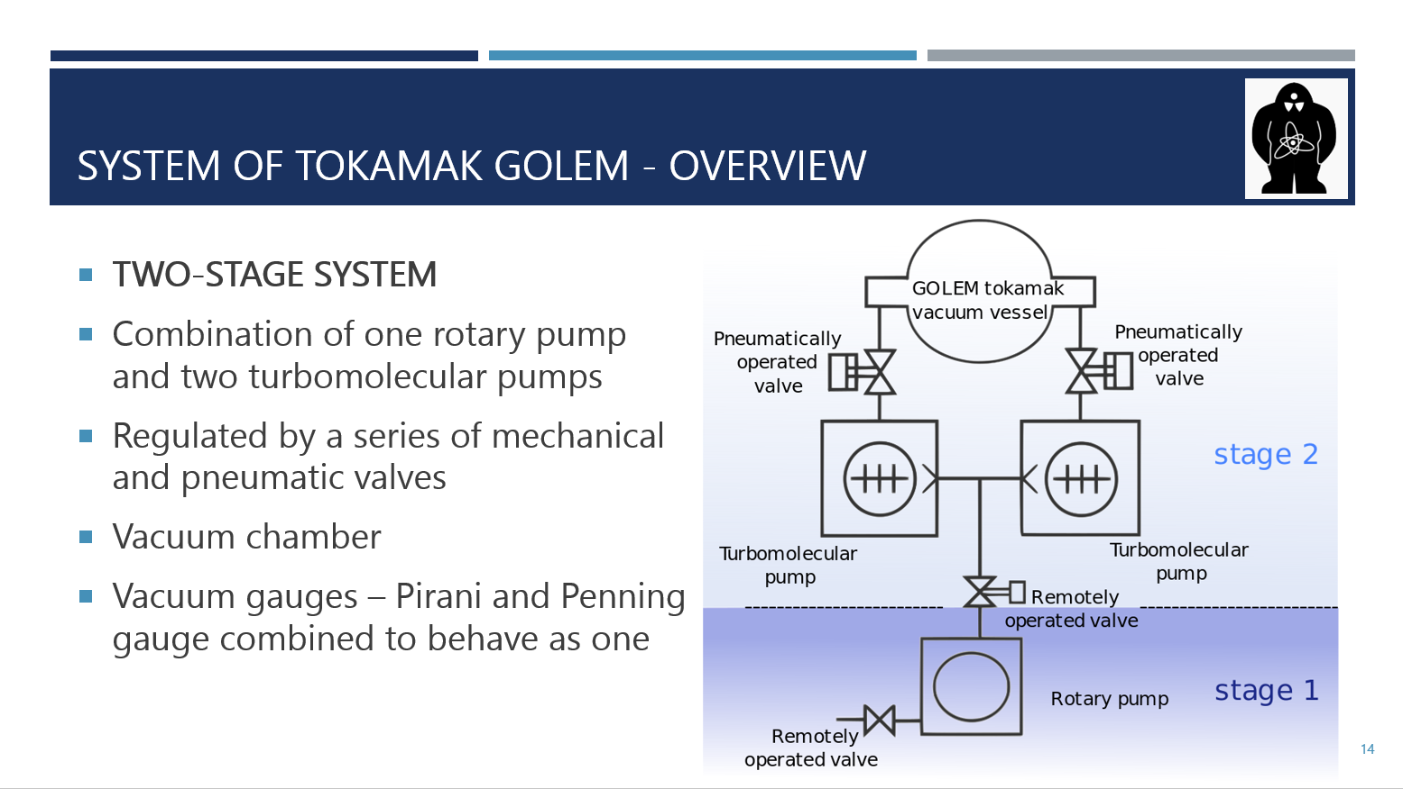 | Now let me present the overview of the vacuum system of tokamak GOLEM. It is a two-stage system consisting of a rotary vane pump and two turbomolecular pumps. It is regulated by a series of mechanical and pneumatic valves and then there is the vacuum chamber. We'll look at all these components in a detail.
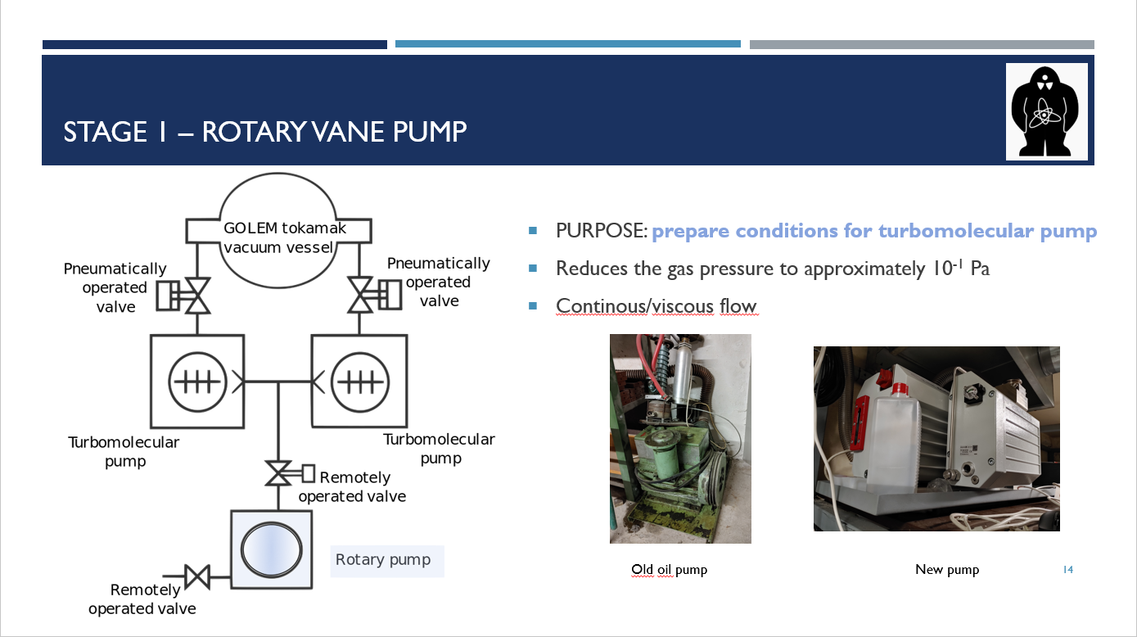 | The first stage of the system is created by the rotary vane pump. In contrast to the turbomolecular pumps, it can function in the continuous flow regime, therefore its purpose is to decrease the pressure, approximately to 10⁻¹ Pa, so the flow changes to molecular and the turbomolecular pumps can work.  At the bottom right corner, there are the photos of the rotary pumps. The left photo shows the old oil rotary pump and on the right photo there is a new one which is currently installed in GOLEM.
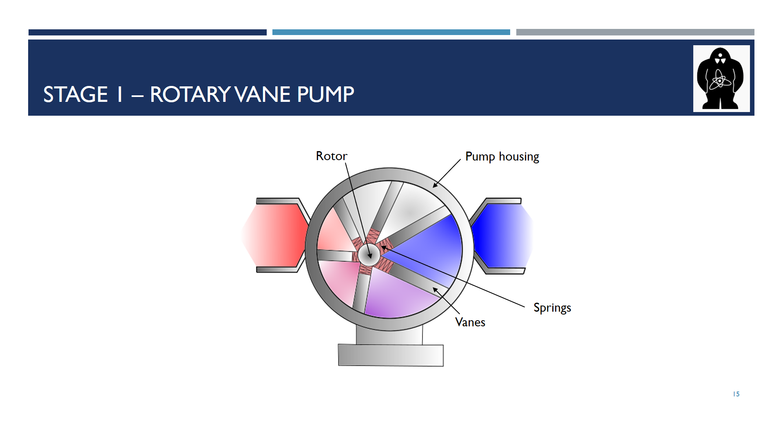 | Now, we’ll look at the scheme presenting how the rotary vane pump looks like from the inside. The main components are the off-centred rotor and vanes with springs. The vanes rotate and since the rotor is off-centred, the vanes shrink when they arrive to the left part where there is not much space and they extend when they arrive to the right part. The shrinking and extension is ensured by the springs.  Thanks to this mechanism, the space created by the vanes get smaller as the vanes shrink and later increase in size as the vanes extend.
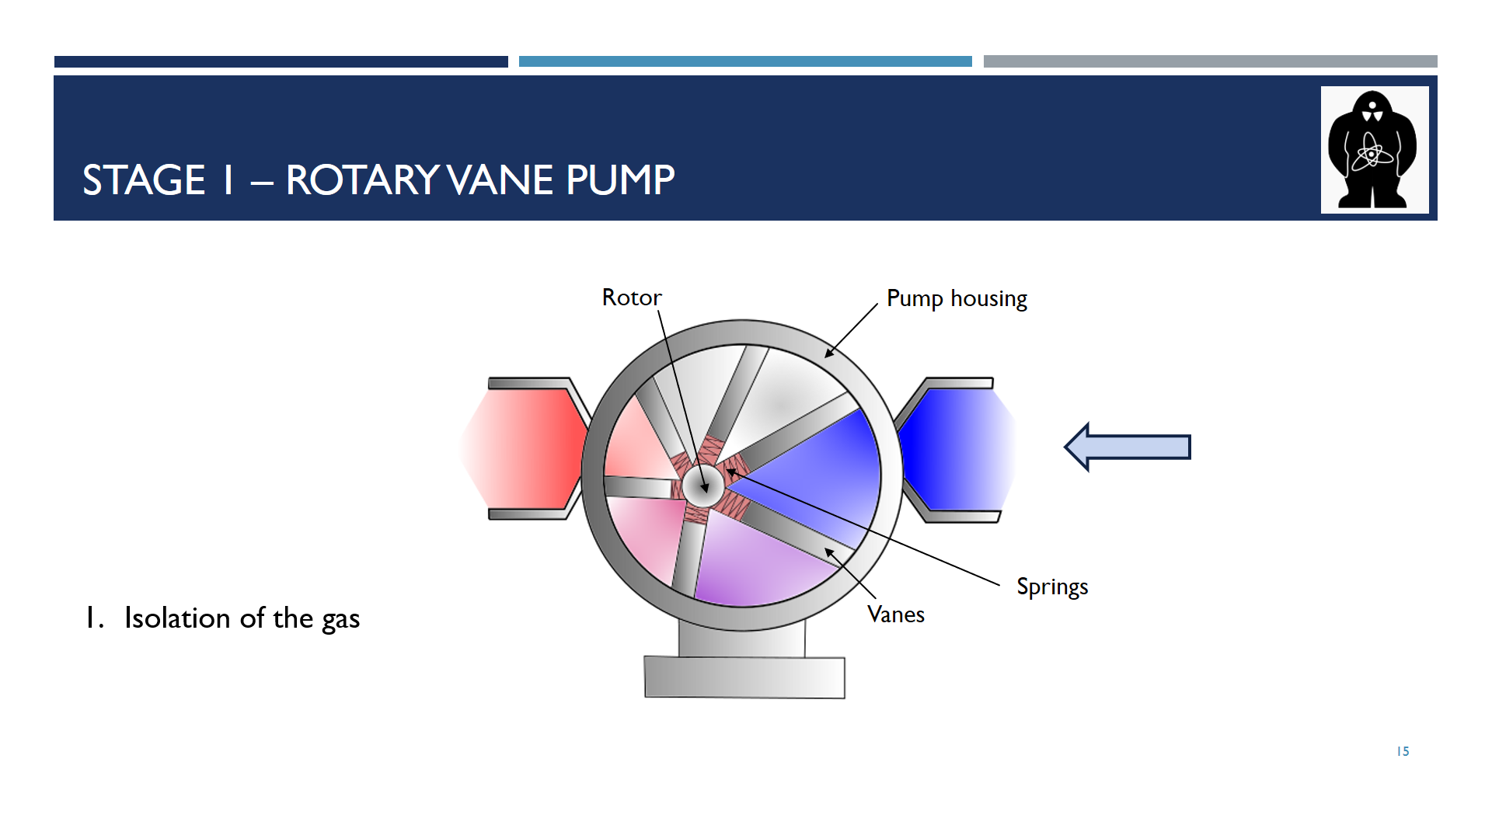 | Animation The gas enters the pump from the right side.
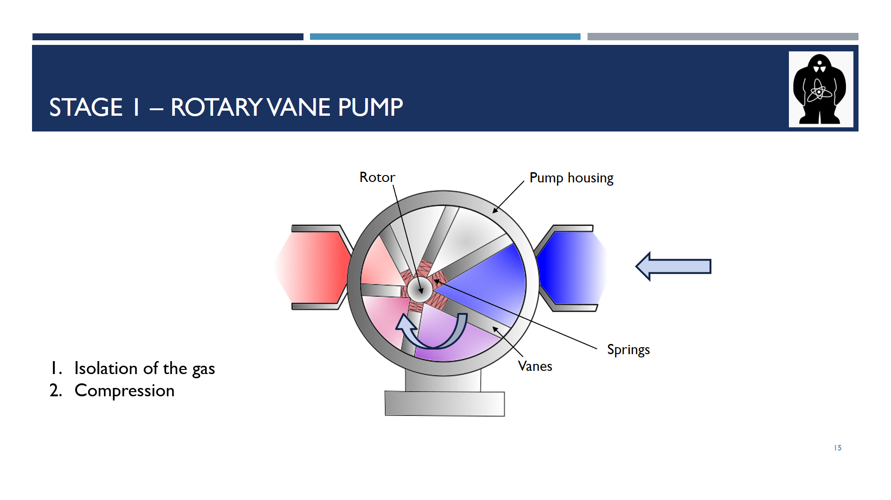 | Animation It is divided into the smaller spaces between the rotating vanes. As they move, the space is getting smaller, thus the gas is being compressed.
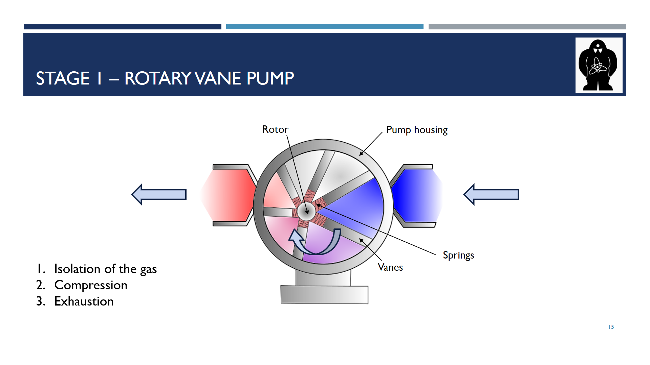 | Animation When compressed gas arrives to the left side, it leaves the pump through the exhaustion port.  At this point gas can be either exhausted to the atmosphere or, like in the case of the GOLEM tokamak, sent into the next pump.
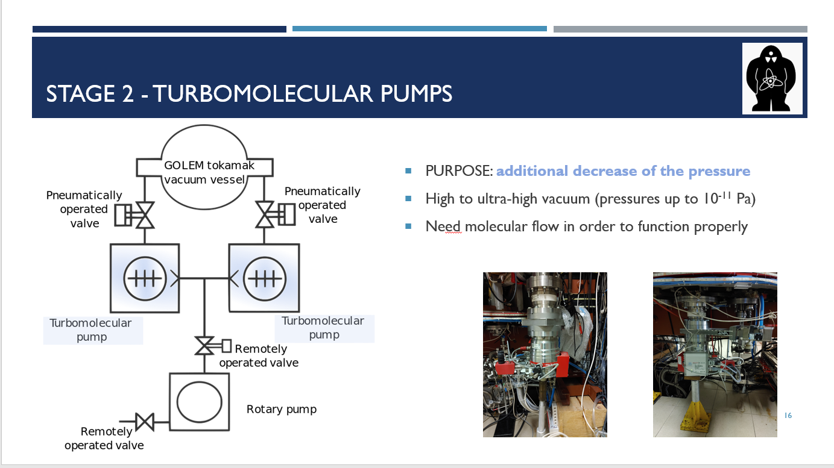 | The second stage of the system consists of two turbomolecular pumps. Their purpose is to decrease the pressure to the desired value. They can reach ultra-high vacuum, theoretically up to 10⁻¹¹Pa, but as I mentioned earlier, the pressure in tokamak GOLEM is much closer to 10⁻³ Pa. This difference may be caused by leakage through the diagnostic ports in the vacuum chamber.
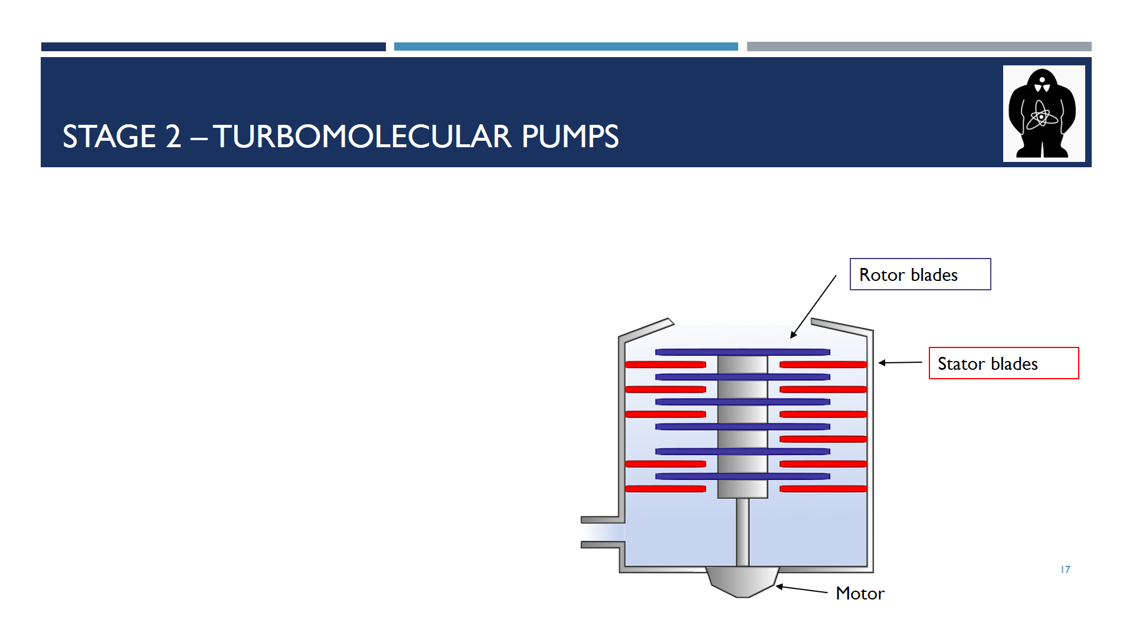 | On this slide you can see the inside of the turbomolecular pump. It consists of stationary stator blades (in red), and of rotor blades (in blue), which spin extremely fast.  Molecules of air, which we are trying to get rid of, travel at certain speeds. This speed is called the mean thermal velocity. For example, nitrogen, the main component of air, has a mean thermal velocity of about 470 m/s. To have some influence on the molecule, the rotor blades must rotate at speeds of the same order of magnitude as the molecules. So the rotor blades of a smaller turbomolecular pump can rotate at 300 m/s, which is very fast.
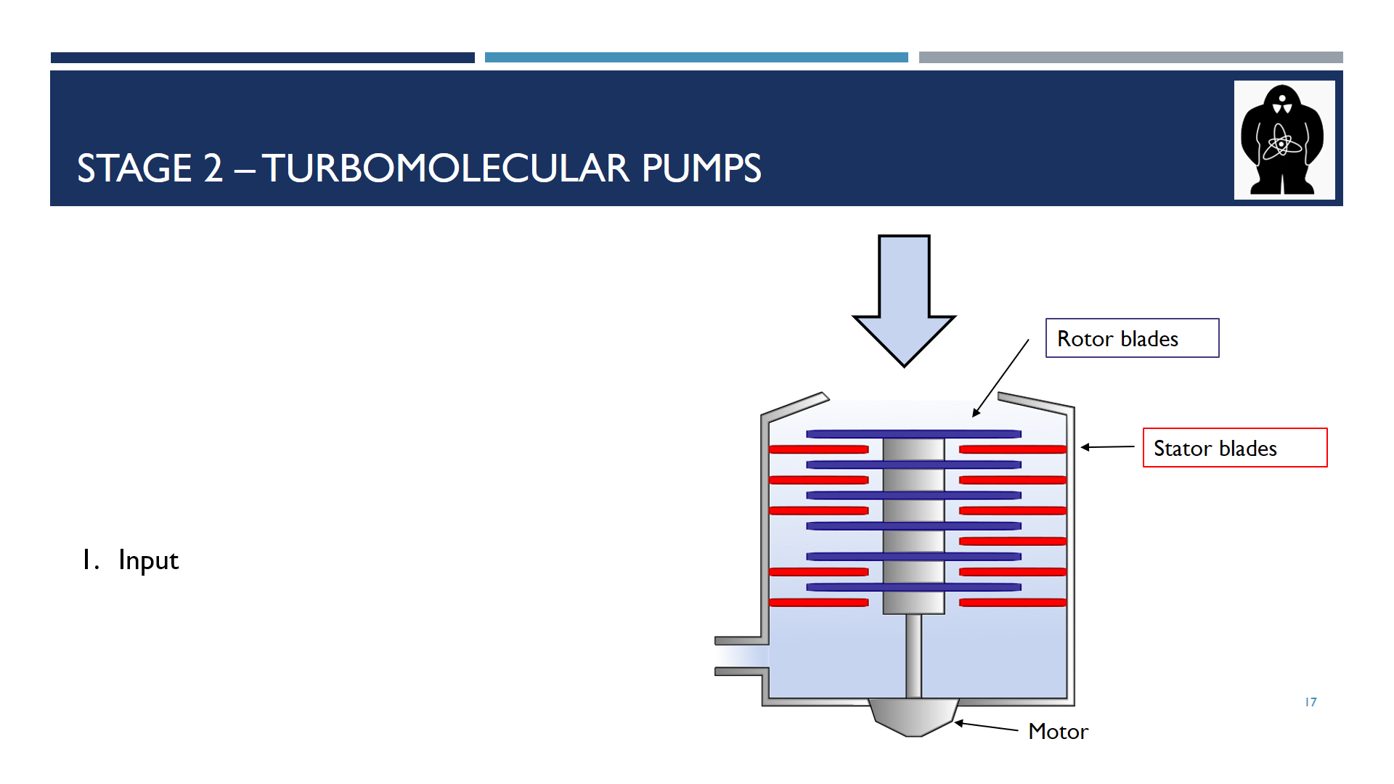 | When a molecule enters the turbomolecular pump Animation it is hit by the rotor blades.
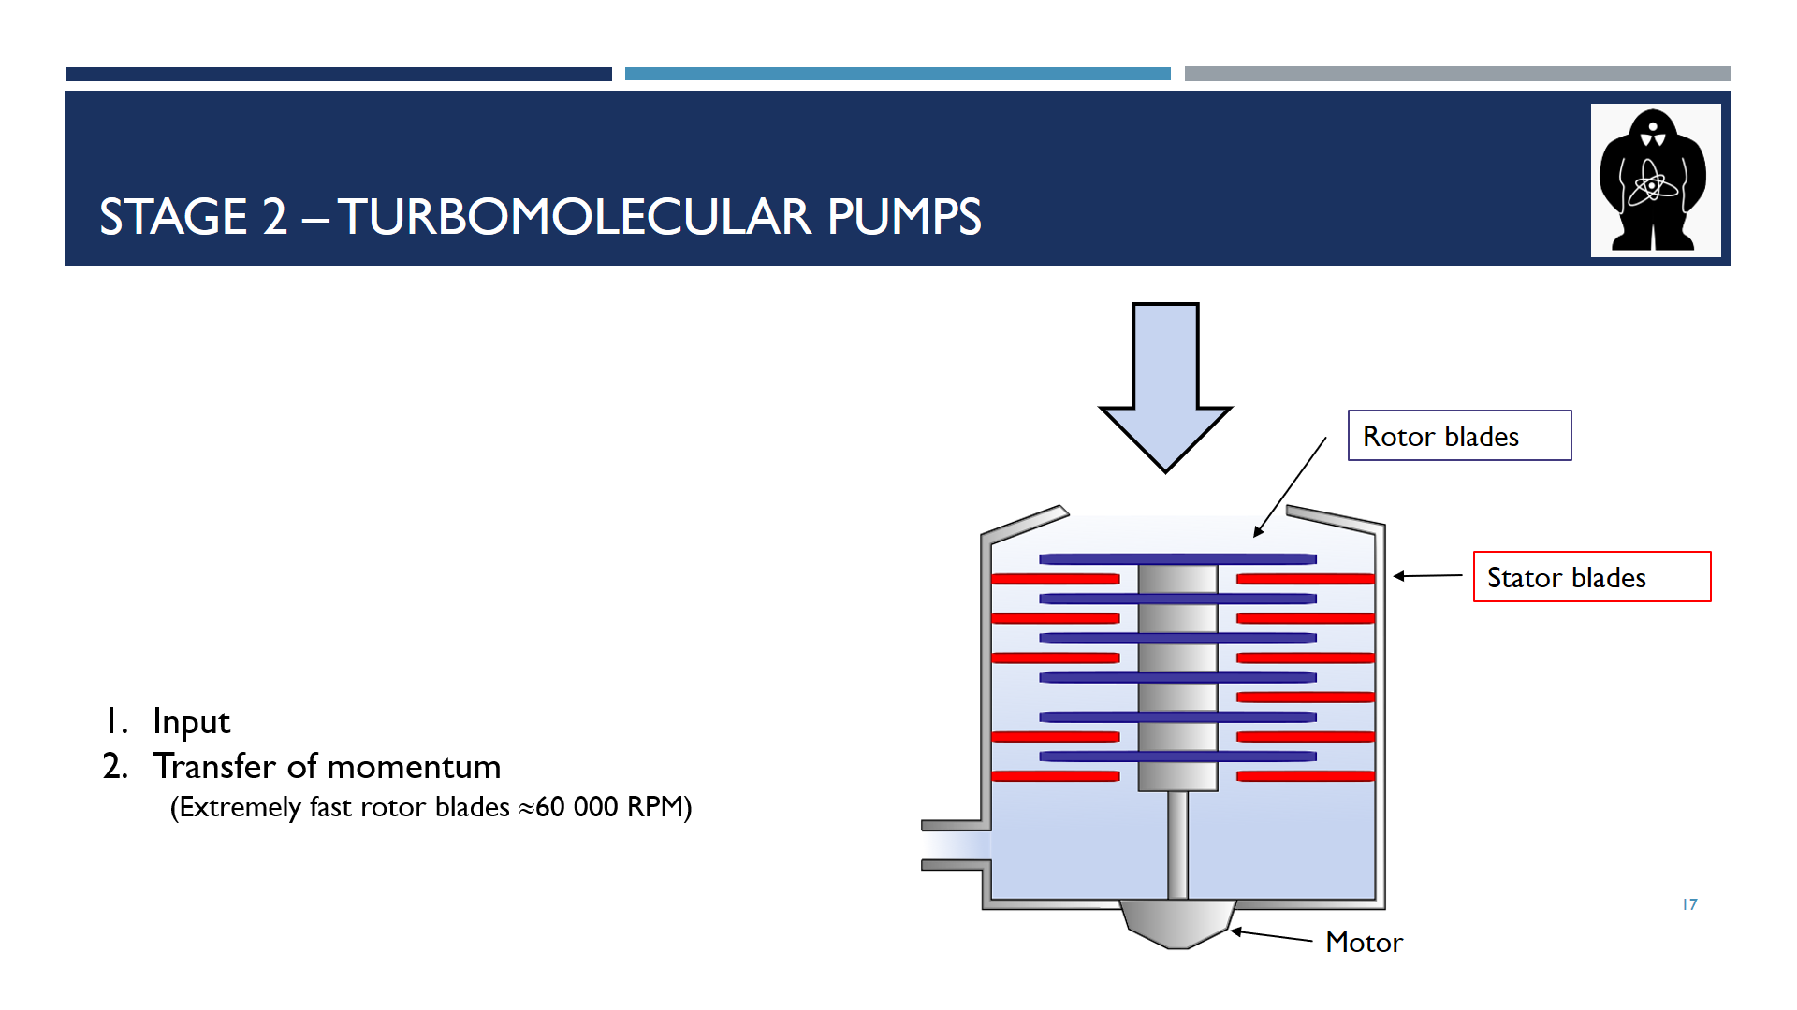 | The blades change the momentum and the trajectory of the molecule, which is sent to the stator blades. Animation This transfer continues until the molecule reaches the bottom of the pump…
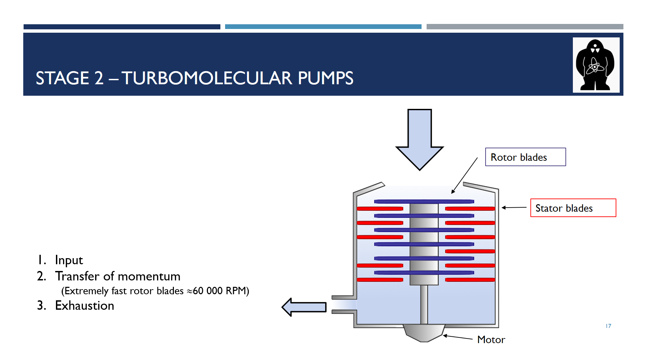 | …and leaves through the exhaustion port Animation.
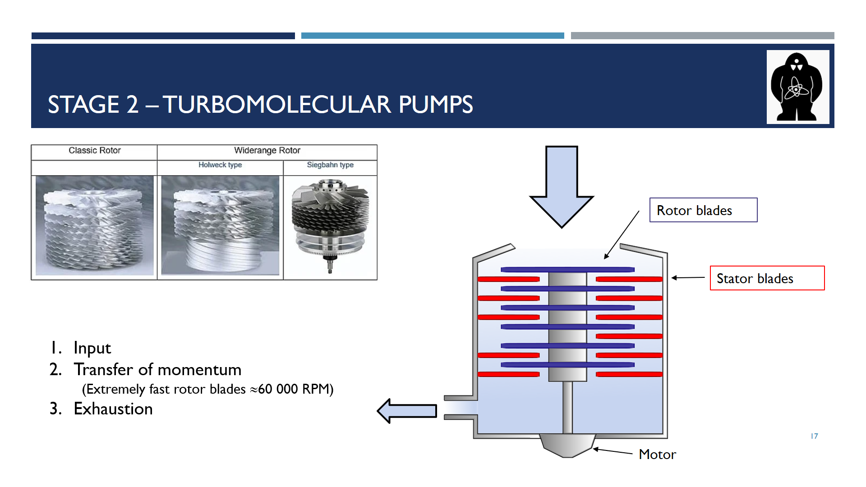 | There are different designs of the turbomolecular pumps, Animation some of which you can see at the upper left corner.
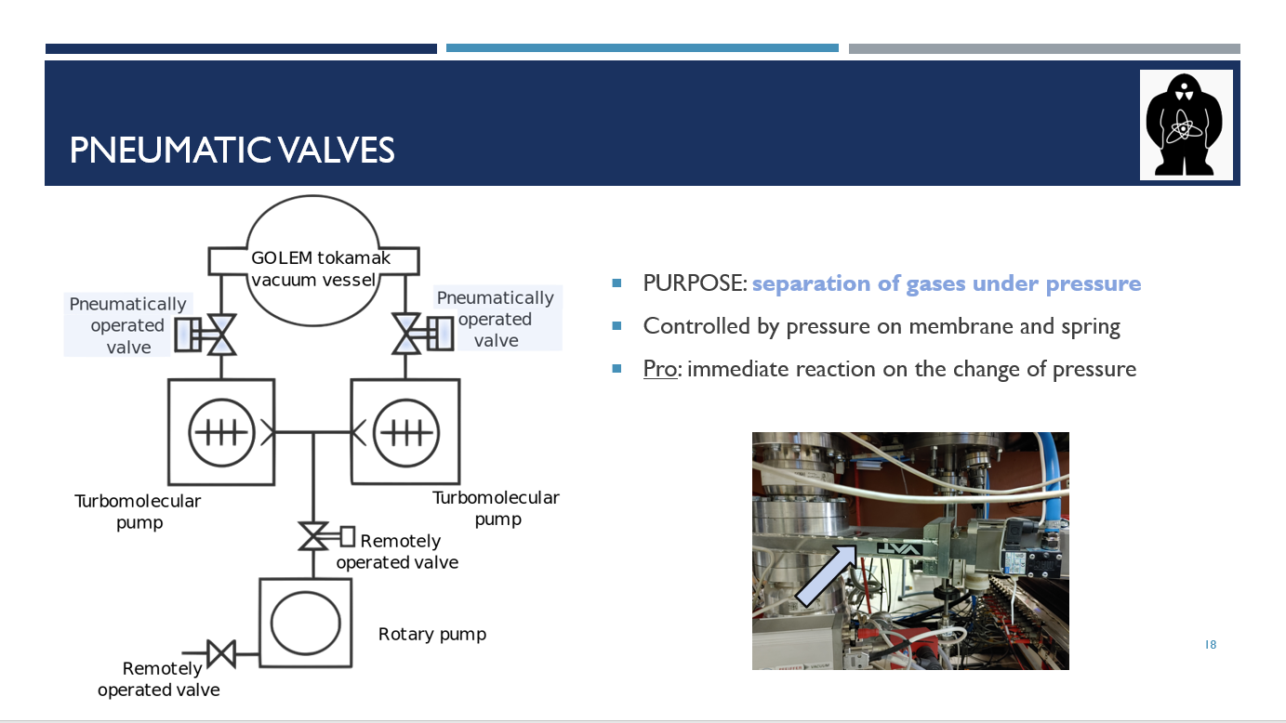 | Another crucial part of the vacuum system is pneumatic valves. Their purpose is to separate and to control gases under pressure. They are controlled by a diaphragm-spring mechanism, which I'll show in a second. This mechanism allows for a much quicker reaction of the valves than mechanical valves would allow.
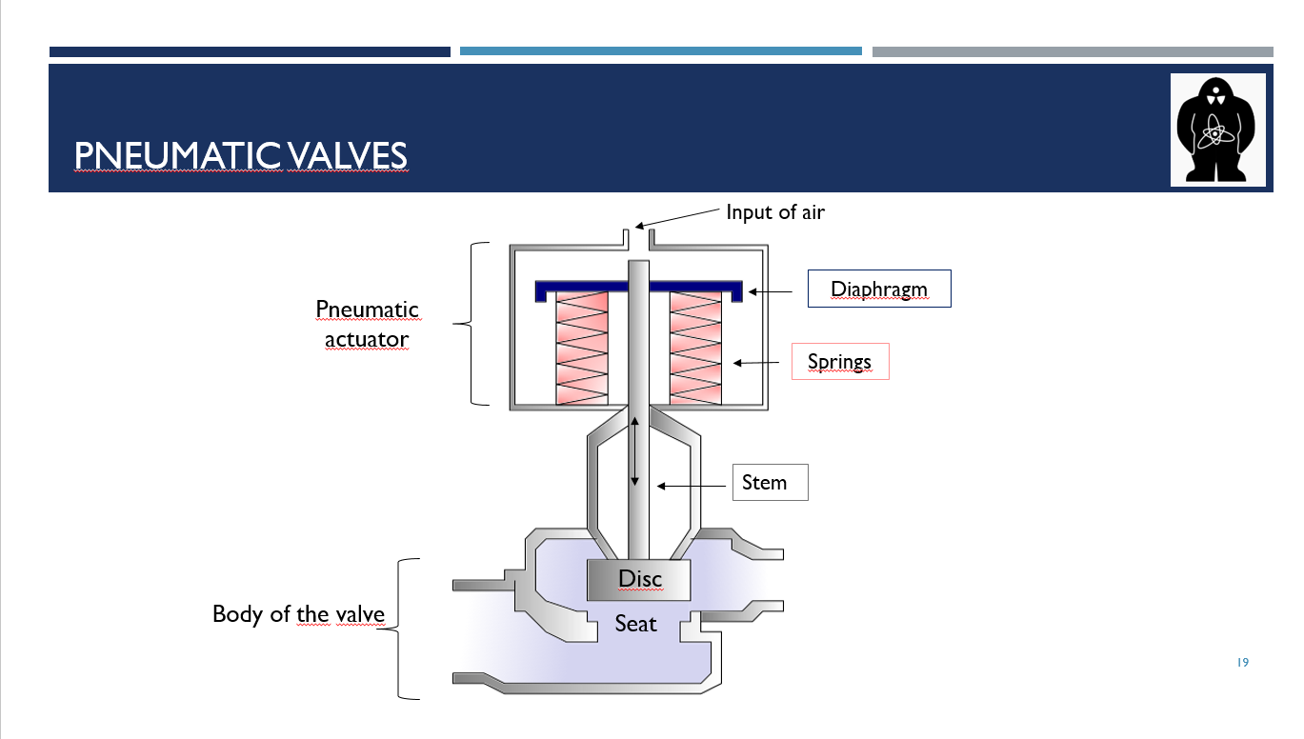 | This slide explains how a pneumatic valve looks like. The upper part, which houses the control mechanism, is called the actuator. The bottom part is known as the body of the valve.  At the top, the air controlling valve enters the actuator. The diaphragm reacts to this change in pressure. If there is no pressure on the diaphragm, the springs extend. As a result, the central rod called the stem travels up, therefore, the gas we are regulating can travel freely through the body of the valve.  If the pressure increases, the diaphragm makes the springs shrink. The stem is forced downwards and the disc linked to the stem then sits in the area called the seat and blocks the way of the gas we are trying to regulate. The valve is now closed.
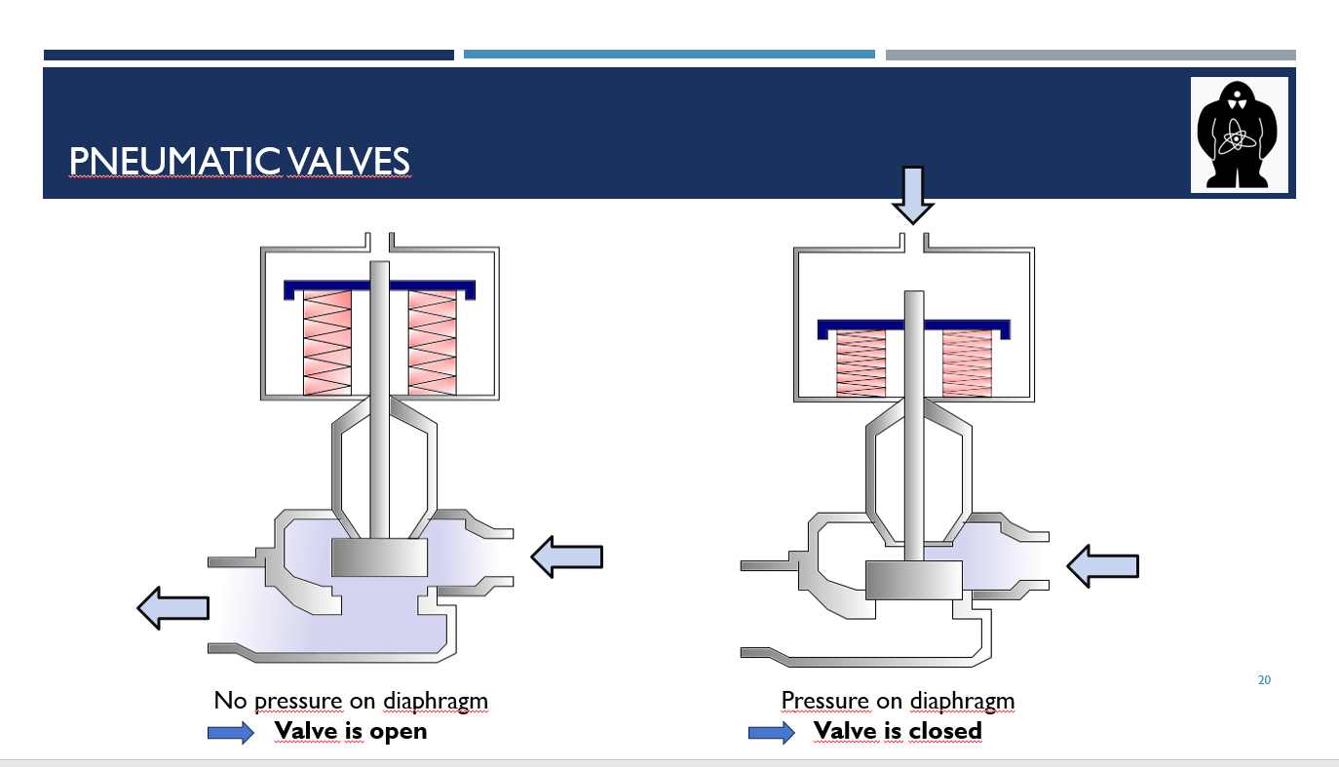 | These pictures visualize the scenarios I just described. On the left side, there is no pressure on the diaphragm, the springs are extended and both the stem and the disc stay up. The valve is open and gas is flowing through.  On the right side, the pressure on the diaphragm compresses the springs, which push down the stem and the disc blocking the way of the gas. The valve is closed.
Finally, we arrive to the vacuum chamber. This is the place we are evacuating the air from as well as the place where all the fusion reactions occur.
The chamber is a steel toroid, something like a big doughnut or a tire. It contains several ports for diagnostics, for example, the port for the electrostatic probe head. Even tough special flanges are used, the use of ports increases leakage.

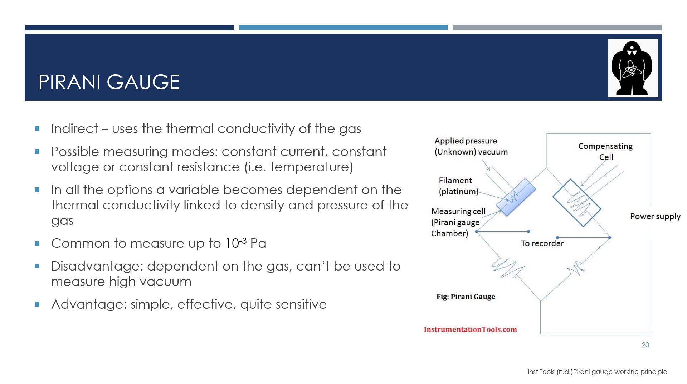 | Tokamak GOLEM uses two types of gauges to measure vacuum. The first one is called the Pirani gauge. It is an indirect gauge since it relies on thermal conductivity of gases.  The gauge has a metal wire, commonly platinum, tungsten or nickel, suspended in a tube and exposed to the gas. There are three possible operation modes: constant voltage is supplied, constant current is passing through the wire or the wire is kept at a constant temperature, which is linked to resistivity.  When the pressure of the gas changes, its density changes also. It causes the thermal conductivity, and hence the conditions to maintain the constant variable constant, change. This change is recorded and compared to calibration curve of the thermal conductivity of the specific gas. The current gas pressure can be obtained from the calibration curve.  This gauge is generally able to measure vacuum from 1000 to 0.1 Pa with reasonable uncertainty, therefore, it is not suitable for measuring high vacuum. On the other hand, it is simple and in its measuring range it is quite effective.
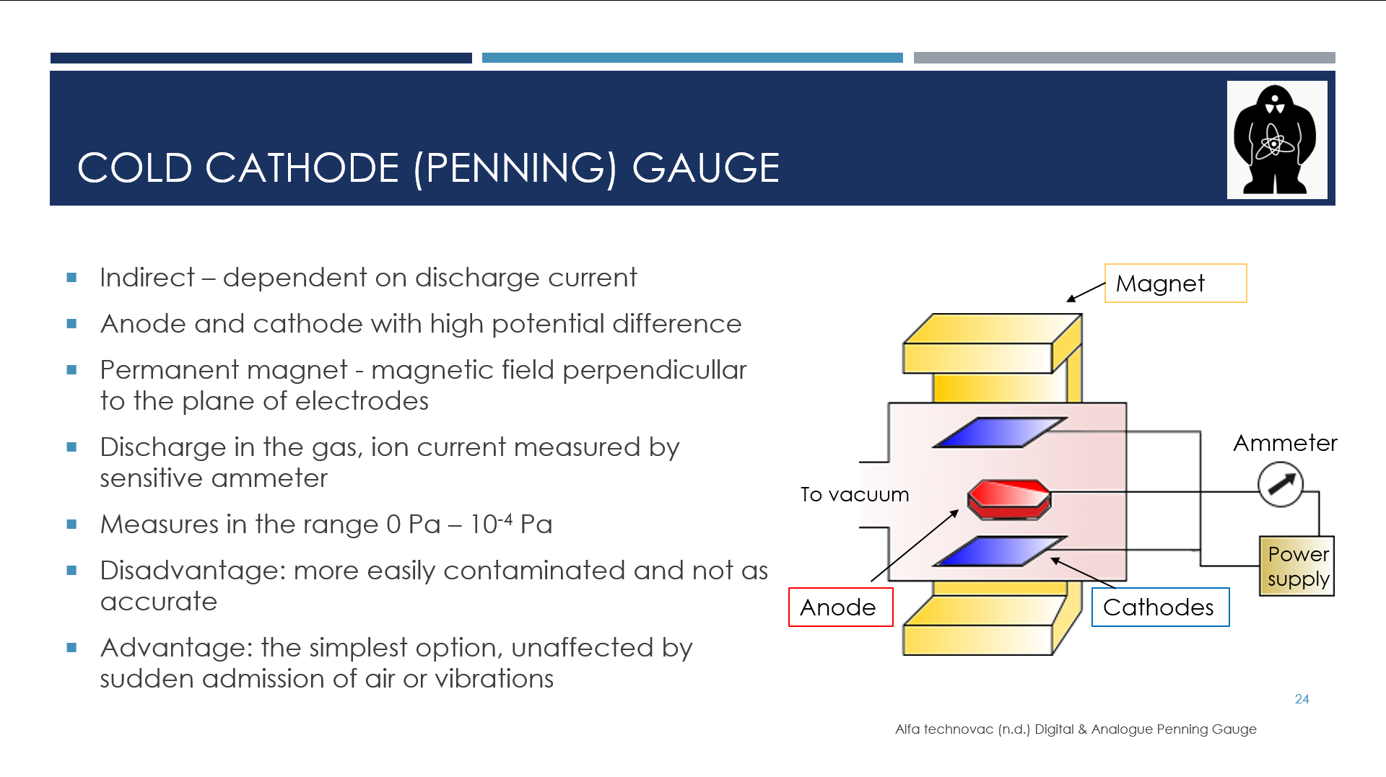 | The second method of measuring vacuum at tokamak GOLEM is the cold cathode gauge, also known as Penning gauge.  This gauge is also indirect because it relies on the specifics of gas discharge. The apparatus consists of cathode and anode with high potential difference, an ammeter and a permanent magnet, which introduces magnetic field perpendicular to the electrodes plane.  When the voltage is applied, the ions of the gas are accelerated towards the cathode. The so-called secondary electrons are emitted from the cathode. The magnetic field constraints them to move in helical path, therefore they spend more time in the space between the electrodes. Those electrons then have high chance of ionising any remaining gas molecules. The cycle is then repeated.  The very sensitive ammeter measures the ion current, which is translated into pressure.  This gauge measures from 10⁻² Pa to 10⁻⁷, which is higher vacuum than the Pirani gauge. The Penning gauge is again dependent on the gas, the gauge is more easily contaminated and it is not as accurate as other tools to measure higher vacuum.  However, it is the simplest and most affordable option used for measuring higher vacuum. Also, it is not affected by sudden air admission or vibrations.
 | Next to GOLEM: end of the presentation…
 | Without talking, something like end credits
 | Without talking, something like end credits

