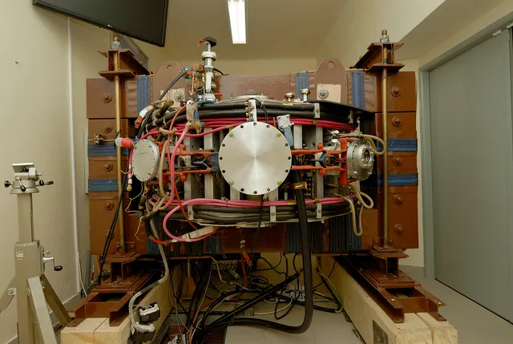 | Next to GOLEM: Hello, welcome, my name is Martina and I will be your guide in this video series about the systems and diagnostics of tokamak GOLEM.  ? + Svoboda ?
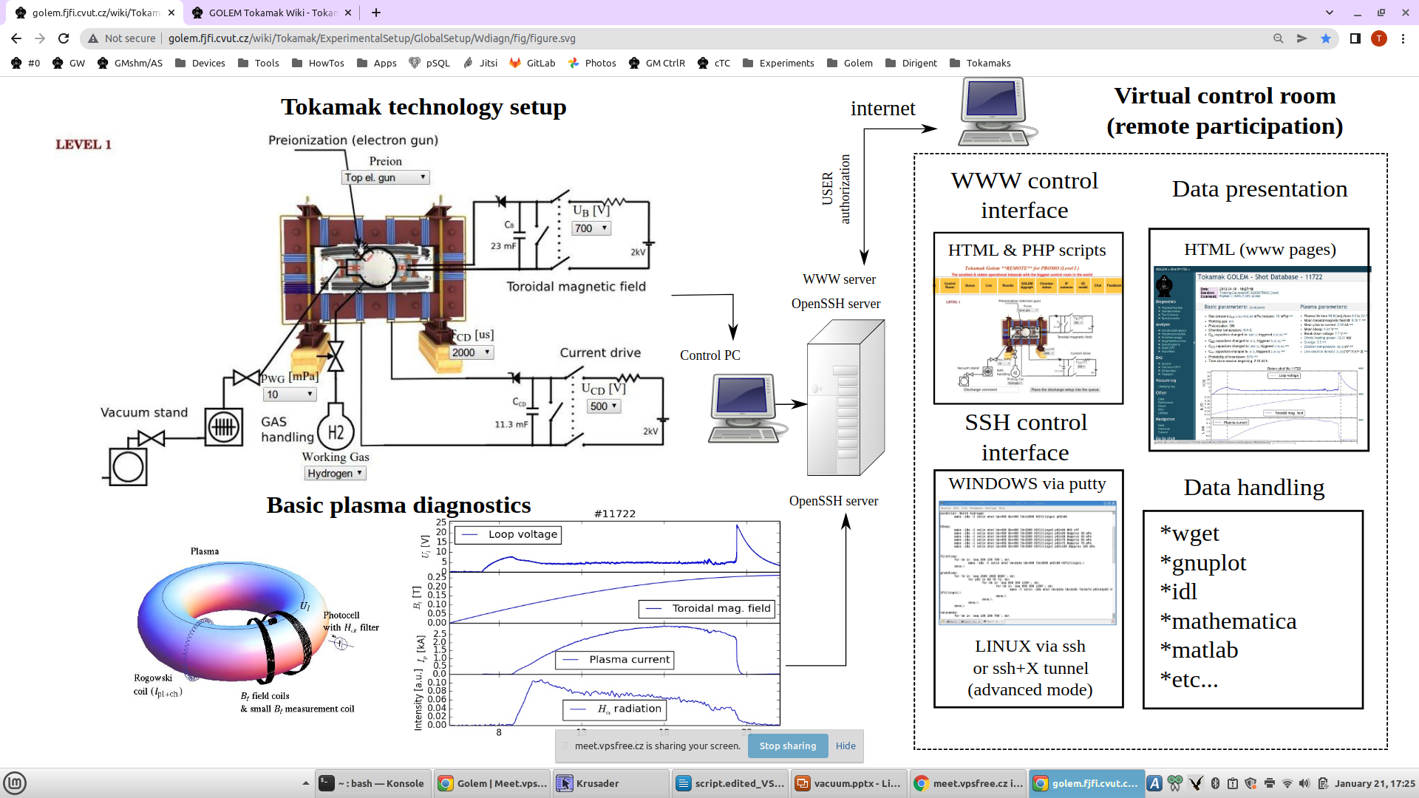
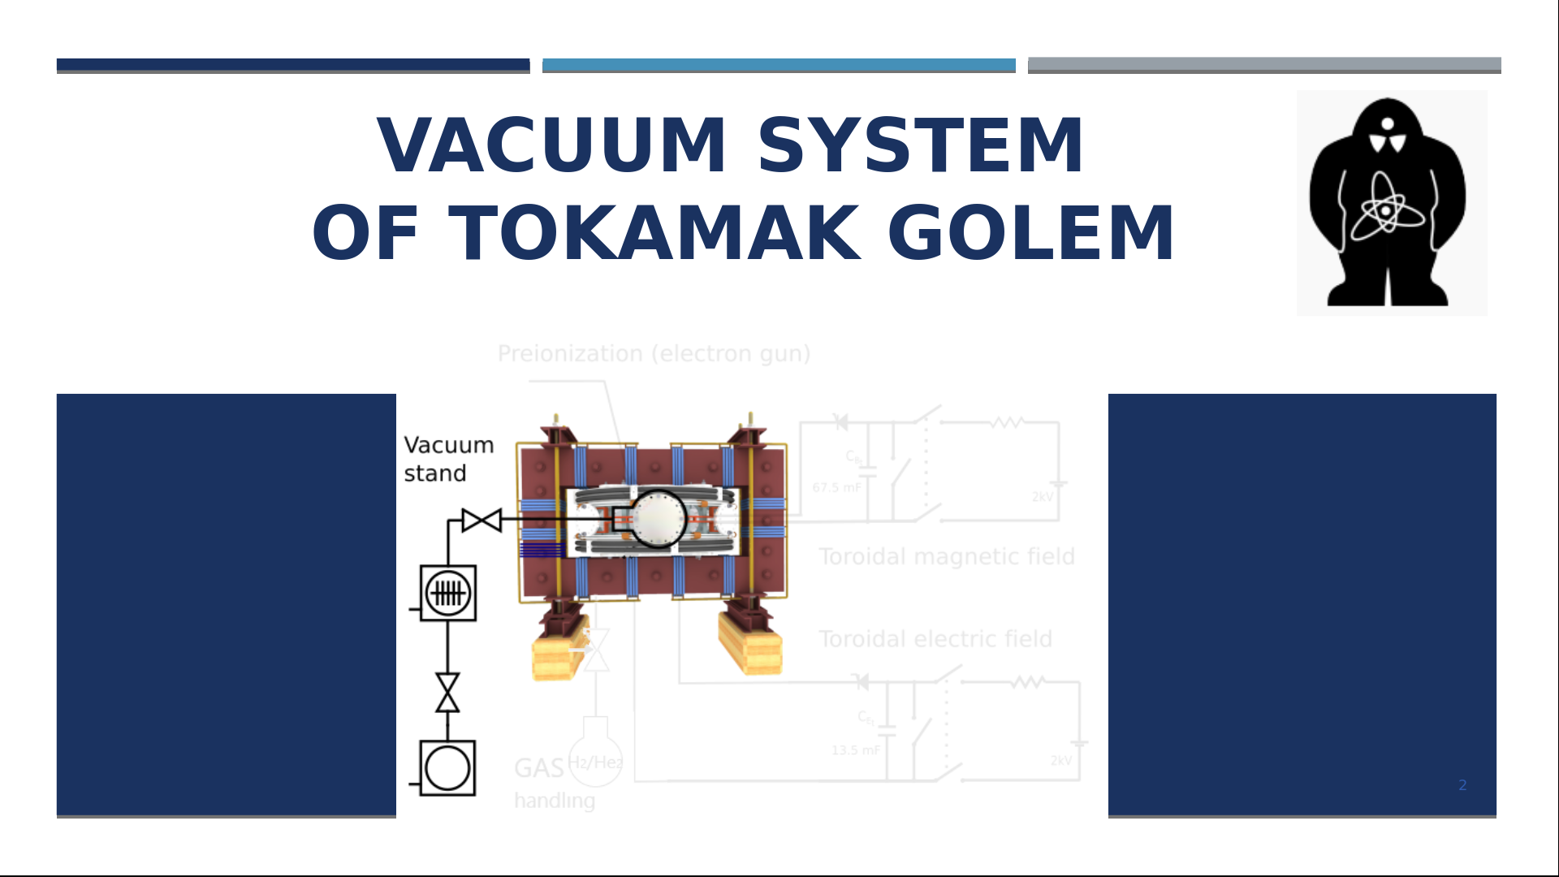 | In this presentation, we will look more closely at the vacuum system of tokamak GOLEM
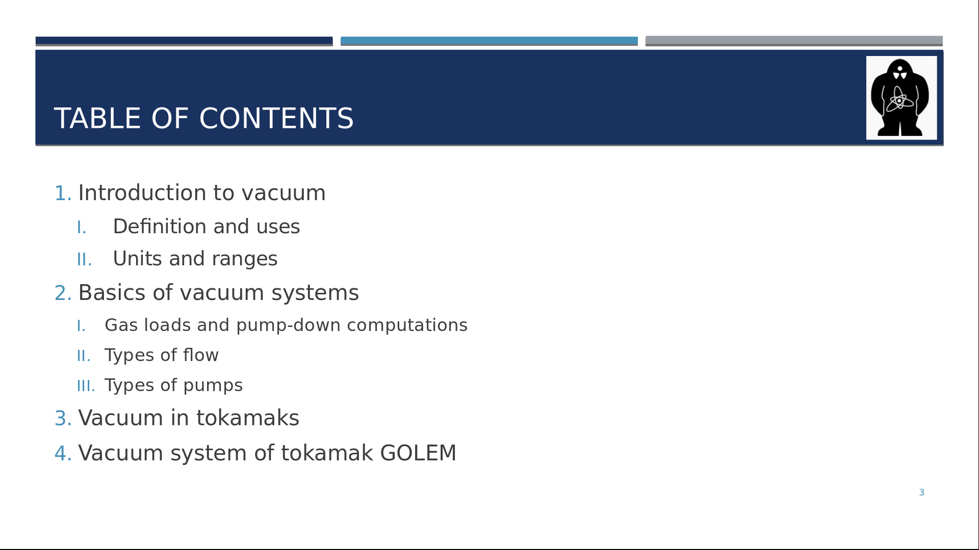 | Those are the topics we will cover?.  Firstly, we will take a look at what exactly vacuum is and where we can find it.  Then, we will talk about the basics of vacuum systems, the components and how do they work.  After that, we will move to tokamaks generally and finally, to the specifics of tokamak GOLEM.
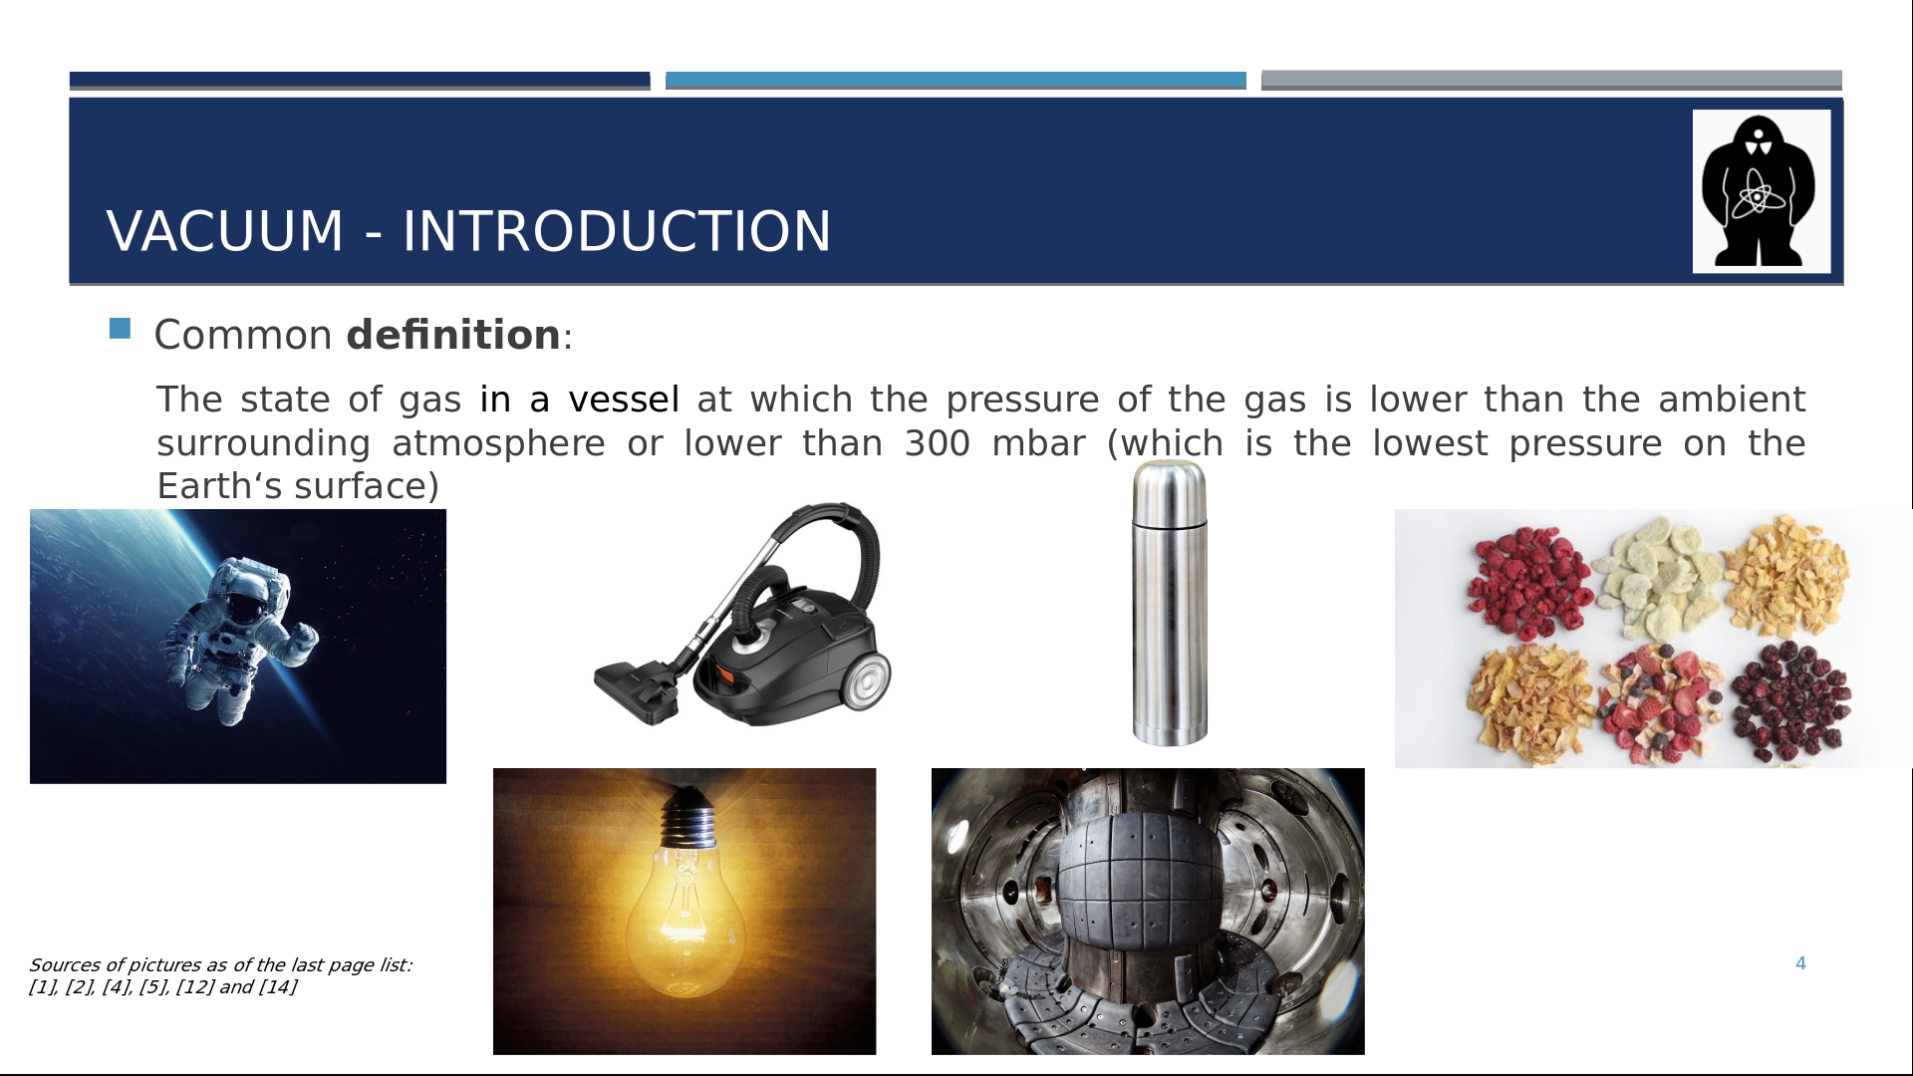 | There are several definitions of vacuum. Most commonly, vacuum is referred to as a state of gas at which the pressure of the gas is lower than the ambient surrounding atmosphere i.e. 100 kPa or lower than 30 kPa. This level, 30 kPa, is the pressure at the top of Mount Everest, making it the lowest pressure on the surface of the Earth.  And where can we encounter vacuum? Animation Free space is a prime example, one which would come to a mind of many of you at the first place. Also, vacuum is used for a protection layer. In a light bulb Animation there is a metal wire heated by the passing current. The vacuum inside the bulb protects it from an oxidation and a disintegration.  And of course, a vacuum can be used for a suction. Probably most of you have a machine using this principle at home, Animation a vacuum cleaner. Another example of using the system of creating vacuum is a straw you put into your drink to be able to get the fluid or some types of wells work by decreasing pressure to pump the liquid.  Since this is a presentation about tokamaks, it is no surprise that tokamaks also use vacuum Animation, let me tell you more about that later. But also other scientific machines rely on vacuum (free space), such as particle accelerators. You can encounter evacuated tubes even in a school laboratory, for example, tubes used to show cathode rays.  Another example from everyday life Animation is a thermos flask or, more generally, insulation.  And finally, Animation vacuum is widely used in the food industry for dry-freezing or persevering the food.  Vacuum has a lot more uses but they are not the focus of this presentation, so let's move on.
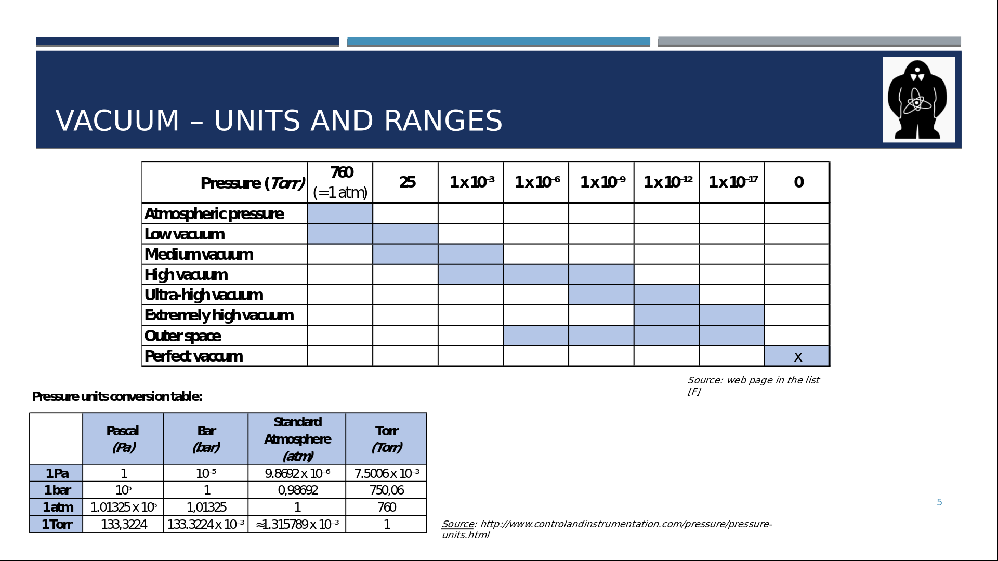 | Here you can see the overview of ranges or degrees of (under)pressure/vacuum. We differentiate between these ranges to, for example, choose the right vacuum pump for the purposes we need it. At the bottom of the table, you can notice outer space, as I mentioned earlier.  The last row denotes a perfect vacuum, with zero pressure. This is a hypothetical concept because at least some particles, which create the pressure, are always present in a real world.  Zde bych Martino vynechal převodní tabulku a do řádků tabulky přidal příklady, kde jsou tokamaky, kde GOLEM, kde vysavač, žárovka, apod. Ale celé do Pascalů.

