Task 13 Analysis for Test 12/21/2021
Governor’s School at Innovation Park
Kalea Wen
1/23/2022

Tasks 1 and 2 are not applicable since this was a virtual test. Figure one addresses the shot banks for Task 3 and 4. Chamber resistance was determined by the two vacuum shots. Four shots were taken to calculate the amplification constants on the Rogowski coil and toroidal magnetic field signal where 2 were isolated time traces of the U_B parameter and the remaining U_CD isolated time traces. Shot 37759 was the executed Tokamak discharge with all pre-set values. The time traces of the individual 3 main diagnostic signals for this shot are seen in figure 2. Per the directions of Task 13, no shift or amplification has been accounted for in these signals.
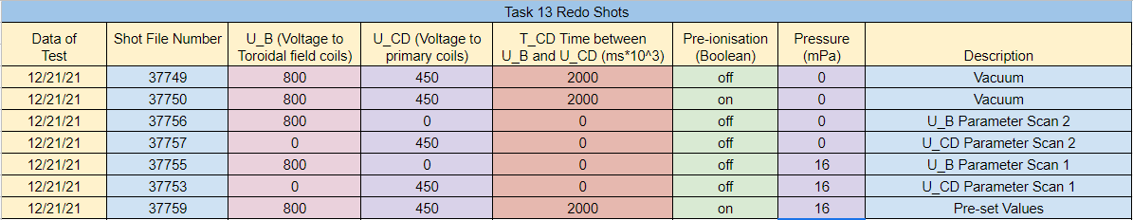
Figure 1: Shot bank for tasks 3 and 4.
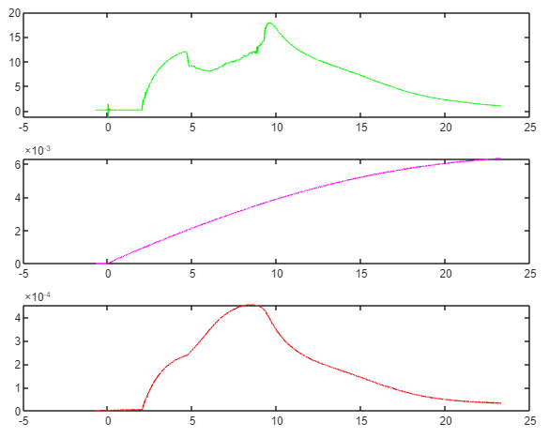
Figure 2: Top graph is the loop voltage, middle graph is the toroidal field or Bt signal, and the bottom graph is the Rogowski signal from shot 37759 (pre-set values).
From the designated vacuum shot, the chamber resistance was found to be 9.7e-3 ohms. GOLEM discharges experience ohmic heating, so this calculation was made according to Ohm’s Law. Figures 3 and 4 show the loop voltage and magnetic field for the toroidal magnetic field and toroidal electric field parameter scans. Notice that everything is given zero power except the signal of choice for these scans so the calibration constants can be correctly derived.
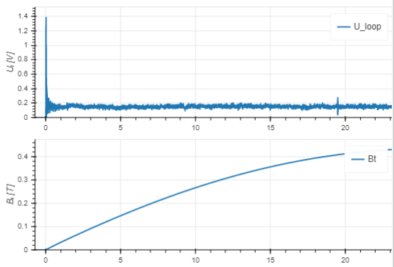
Figure 3: Isolated time trace for U_Bt parameter, time in ms. Calibration constant was calculated as C_{Bt} = 68.878624905151497.
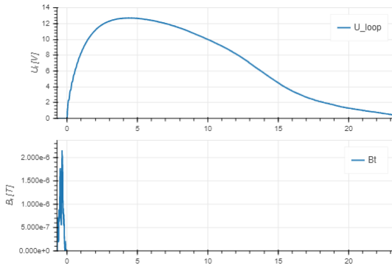
Figure 4: Isolated time trace for U_RC parameter, time in ms. Calibration constant was calculated as C_{RC} = 4.893788606161927e+06.
Concerning the calculation of the constants mentioned in figures 3 and 4, the signal in question is simply compared to the recorded values in the GOLEM database to solve for these constants. The first couple thousand values for each signal were not included when performing this calculation due to noise. The code for these calculations are shown in figure 5. This corresponds to tasks 4a and 4b.
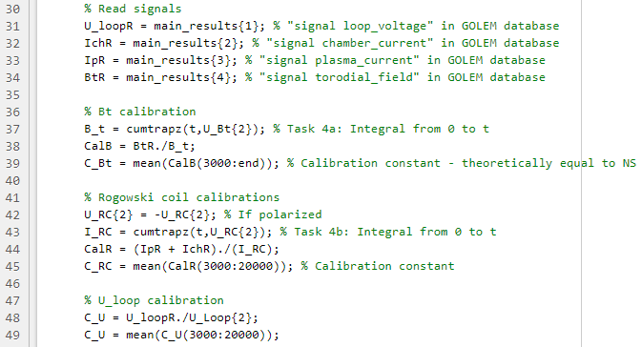
Figure 5: MATLAB code responsible for calculations of calibration constants for Bt coil, Rogowski coil, and Loop coil.
Using these calibration constants, a full plasma discharge was executed (shot 37759) and is shown in figures 6, 7, and 8. There is an idle shift present in the Rogowski coil that was accounted for through similar methods depicted in figure 5. There is an error in the shift elimination method used as shown in figures 9 and 10. For this reason, the plasma current stored in the GOLEM database for each shot was used for Task 5 analysis to increase accuracy.
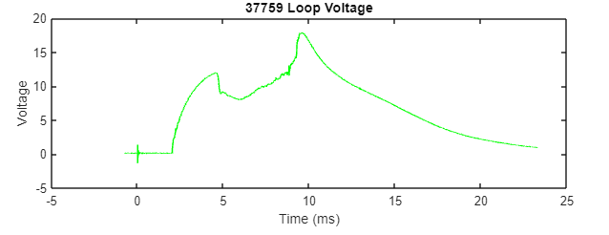
Figure 6: Temporal evolution of the Loop Voltage [V].
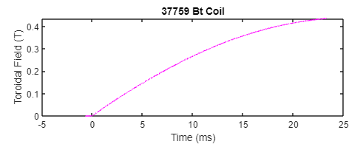
Figure 7: Temporal evolution of the Toroidal Field [T].
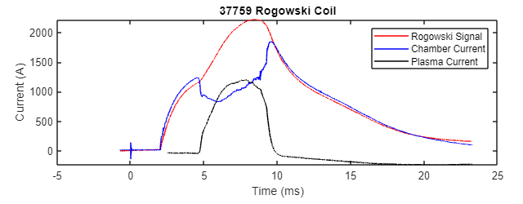
Figure 8: Reference color legend. Temporal evolution of Rogowski coil signal (proportional to poloidal field) and its two components, the Tokamak chamber current and plasma current [A].
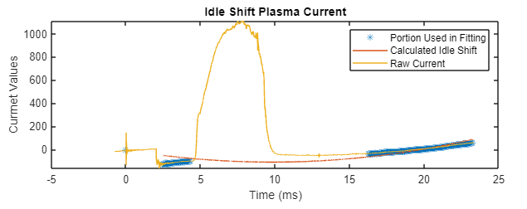
Figure 9: Calculated idle shift graph for shot 37759. The red line should perfectly match the blue highlights in the yellow line.
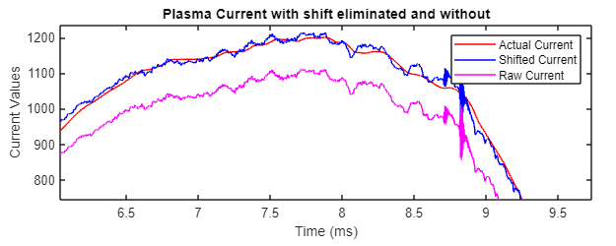
Figure 10: Reference the legend. Notice the red and blue lines are similar relative to the raw signal, or purple line.
The central electron temperature time trace is calculated from equation 4 in Task 13 during the quasi-stationary period of the discharge in figure 11. This fully addresses task 4c.
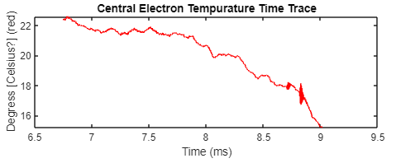
Figure 11: The temporal evolution of the central electron temperature shot 37759 during life of plasma.
For the fifth task, 12 shots are used for the time confinement analysis calculations shown in figure 12. They will be analyzed in groups of 5-6 or according to constant U_{RC} value as dictated in Task 13. There were 2 experimental shots between both groups that were expected to fail, only 37764 did. Fail shots include null plasma generation, null loop voltage, or discharges with a quasi-stationary phase occurring for less than 1 ms. All other shots contain a successful quasi-stationary phase that occurs for at least 4ms.
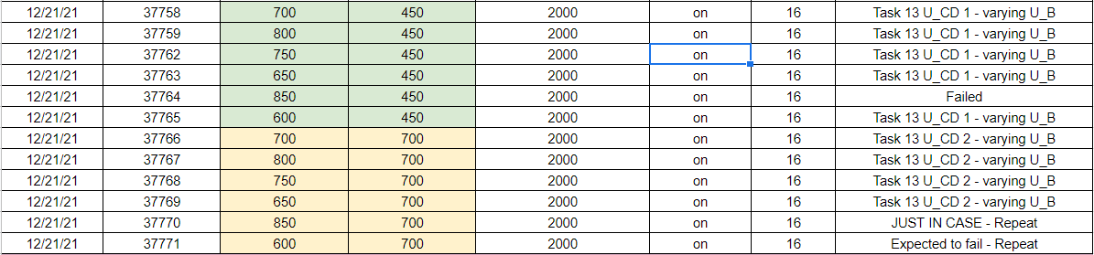
Figure 12: These are the selected shots for the time confinement analysis. The ones in green are a U_{Bt} scan with a constant U_{RC} value of 450 and the ones in yellow are the same except with a 700 value. These were the direction in Task 13.
The goal of this task is to compare the energy confinement time (a merit value of a good discharge) to the average toroidal magnetic field value during the quasi-stationary phase. Energy confinement time was calculated from equation 3 in Task 13 and from the flow chart of calculations on the last page of the document. Figures 12 and 13 show these equations. They produced very different values ultimately. The reason for this is unknown currently but interesting, nevertheless.
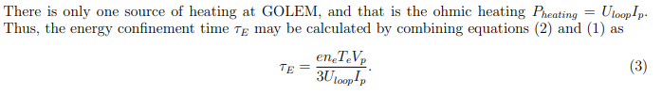
Figure 13: Equation 3 for energy time confinement with description.
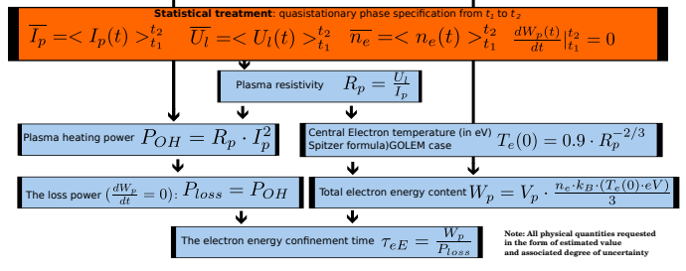
Figure 14: Flow chart of alternative equation for energy time confinement.
Both of the following equations are mathematically identical, so this discrepancy seen in the energy time confinement verse respective toroidal field for the data in figure 12 is attributed to a mistake in programming in MATLAB.

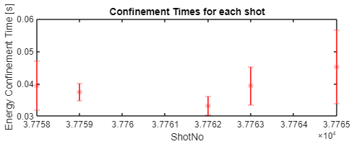
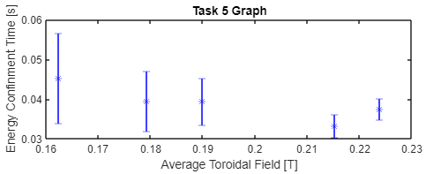
Figure 15: Energy confinement time verses the shot number (top) and average toroidal field (bottom) for the first U_RC value shots in figure 12 [37758 – 37765] using equation in figure 13.

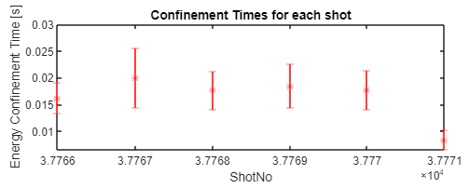
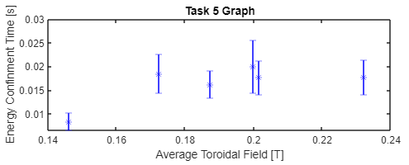
Figure 16: Energy confinement time verses the shot number (top) and average toroidal field (bottom) for the second U_RC value shots in figure 12 [37766 – 37771] using equation in figure 13.
However, we can see when we compare figures 15 and 17, and figures 16 and 18, that this mistake is just of amplification, for the trend/curve of these plots are identical but just of different values. Therefore this error was not pursued since the information asked in Task 5 is still successfully communicated: the relationship/dependence of energy time confinement on average toroidal magnetic fields.
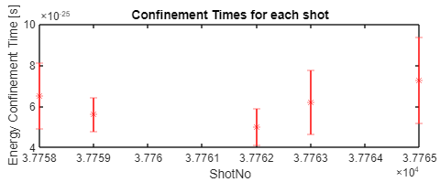
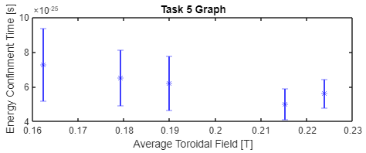
Figure 17: Energy confinement time verses the shot number (top) and average toroidal field (bottom) for the first U_RC value shots in figure 12 [37758 – 37765] using equation in figure 14.

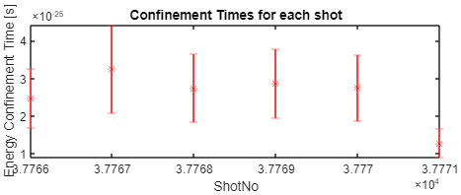
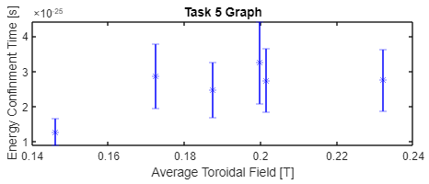
Figure 18: Energy confinement time verses the shot number (top) and average toroidal field (bottom) for the second U_RC value shots in figure 12 [37766 – 37771] using equation in figure 14.
All the graphs in blue for figures 15-18 address task 5 and show a toroidal field scan for the selected shots. We can see that the data requested from Task 13 is not enough to solidify a relationship at first glance. To statistically find a dependency, we would need more data points as well. However it appears the blue graphs are quadratic . There is possibly an optimal average toroidal field value to achieve the highest or lowest energy time confinement. Figures 15 and 17 imply a positive quadratic line of best fit while figures 16 and 18 imply a negative version. Therefore, we need more data point to make any conclusions.

