Radiometer report
- Technical aspects
The radiometer from COPASS has 16 channels in frequency range 1.5 – 15 GHz with 850 MHz channel width. For now, 12 of these 16 channels are able to make measurement, but 3 of them have problems with the shape of transfer characteristic and need to be repaired. Channels 2, 3, 4, 5, 6, 7, 8, 11 can be used in their current condition. The high-end of the radiometer has heterodynes with frequencies 25 GHz and 75 GHz.
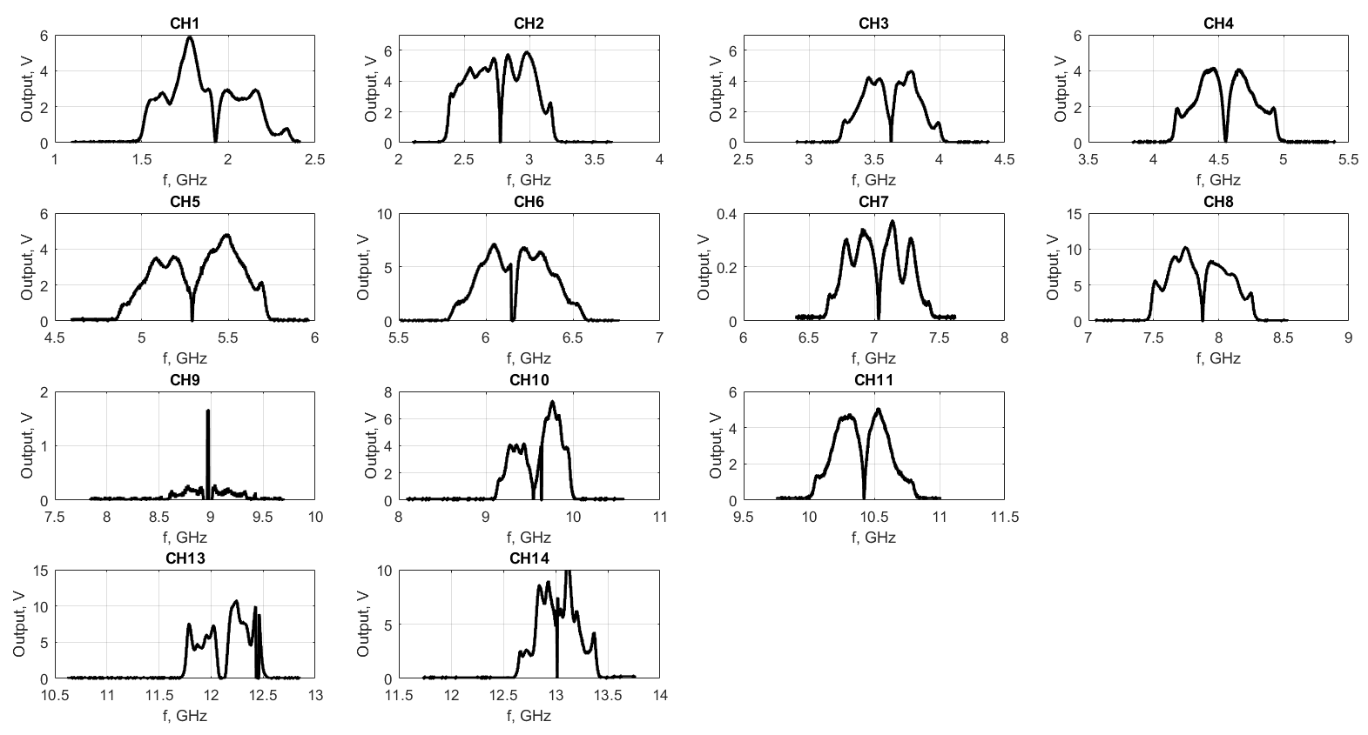
Fig. 1 Radiometer channels pattern without high frequency part
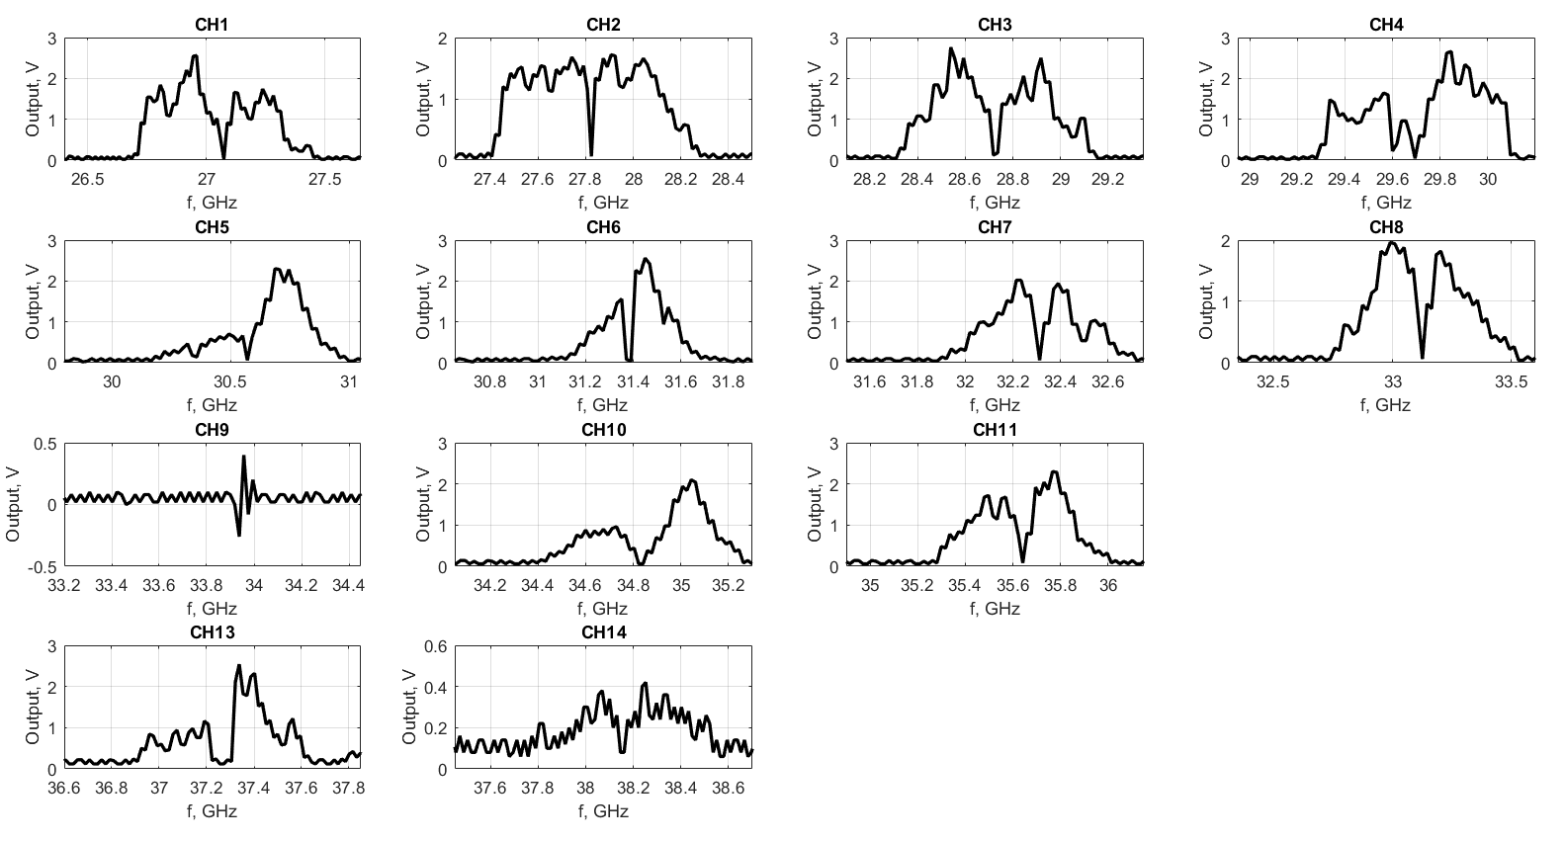
Fig. 2 Radiometer channels pattern with high frequency part

- Electron temperature profiles measurement estimation
The 25 GHz heterodyne allows to measure electron temperature profile on the 2nd ECE harmonic in the radial range from center to 0.9 of minor radius for magnetic field about 0.5 T and electron density not higher than 4.6x10¹⁸ m⁻³. Measurements on 1st ECE harmonic are possible without heterodyne only for very low density regimes with bad spatial resolution (about 1-6 points in dependence on magnetic field), but the 2nd ECE harmonic measurements look more perspective.
The table demonstrates density limits for ECE measurements and recommended heterodyne frequencies for different magnetic field.
B, T | n_{e}, 10¹⁸ m⁻³. | Heterodyne frequency, GHz
0.5 | 4.6 | 21
0.4 | 2.9 | 13 - 17
0.3 | 1.6 | 6 - 12
0.2 | 0.7 | 0 - 7
0.1 | 0.1 | 0 - 2

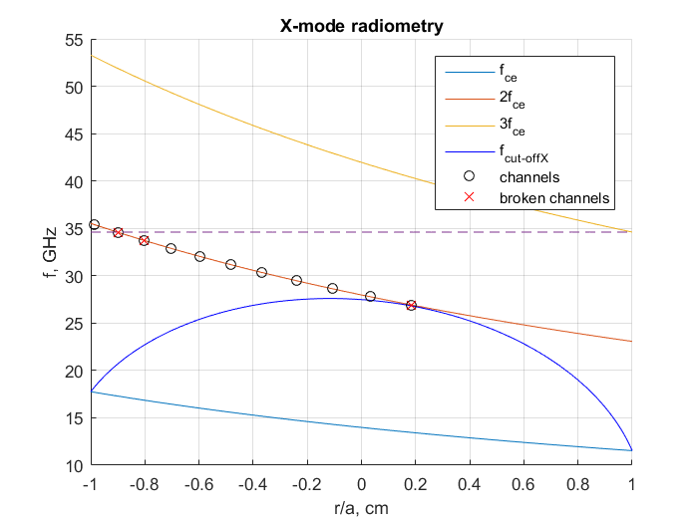
Fig. 3 Estimation of ECE observation for 2nd harmonic X-mode. 25 GHz heterodyne ,B = 0.5 T, n_{e} = 4.6x10¹⁸ m⁻³.
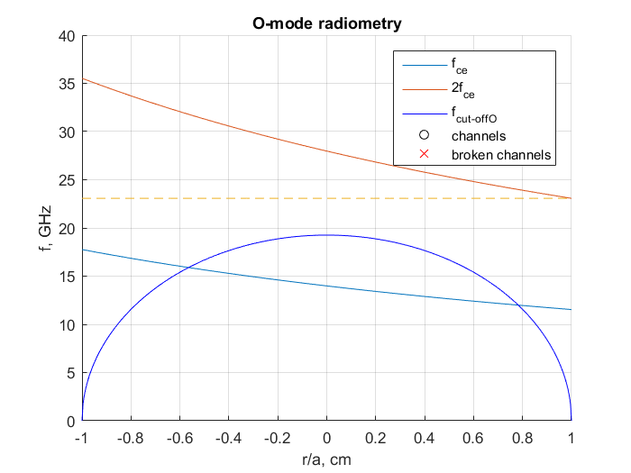
Fig. 3 Estimation of ECE observation for 1st harmonic O-mode. ,B = 0.5 T, n_{e} = 4.6x10¹⁸ m⁻³.

