The ECE radiometer from COMPASS tokamak was moved to GOLEM and installed. According to simulations GOLEM plasma is not optically thick (fig. 1), it means the emission of non-thermal electrons dominates in measured signal.
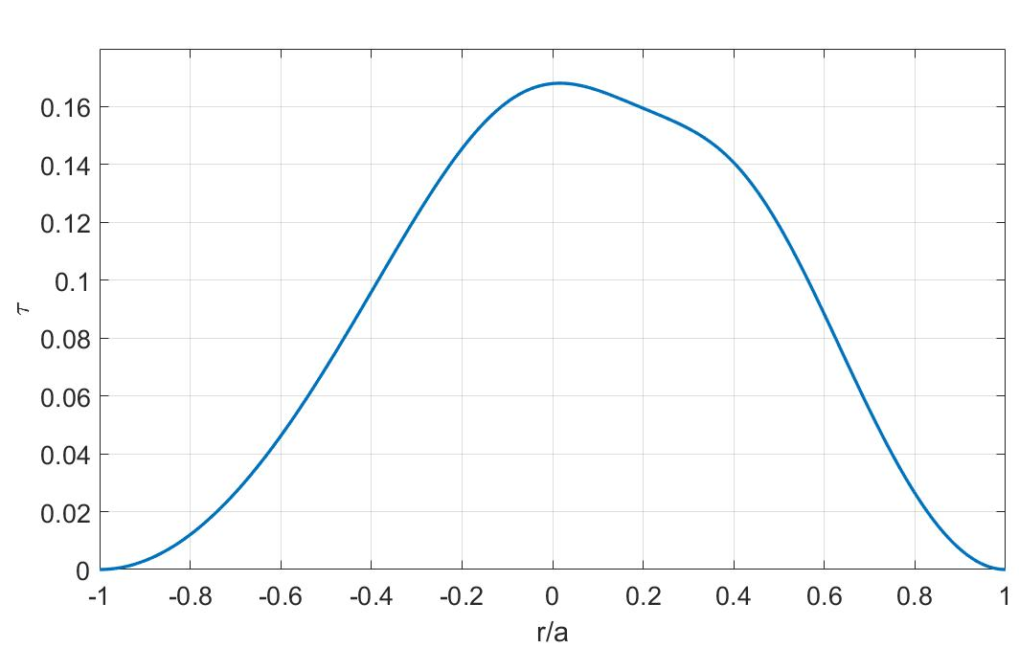
Figure 1: Simulation of optical thickness for 2nd ECE harmonic of GOLEM plasma for parabolic profiles of temperature and electron density (n_{e0} = 4.2x10¹⁸ m⁻³, T_{e0} = 100 eV, B₀ = 0.5 T)
The experiments on GOLEM have demonstrated possibility of non-thermal electron emission measurements by ECE radiometer. Figures 2, 3 shows the time dependence of measured signal for 2 discharges. The first one was made in plasma with high impurity level without additional cleaning of chamber. For the second one the full number of chamber conditioning actions was made and more pure plasma with significant level of RE was expected. Both of these shots demonstrated increasing of measured power after the moment of time, when cyclotron frequency is enough to be measured by ECE radiometer, however for the pure plasma a lot of high spikes were observed in the signal. These spikes can be associated with non-thermal electron beams and the substrate should be emission from thermal emission of the bulk plasma. The radiation temperature for this part of signal is about 50-100 eV. The radiation temperature of spikes is about 2 – 4 keV. Unfortunately low plasma thickness does not let to directly connect this temperature with temperature of plasma.

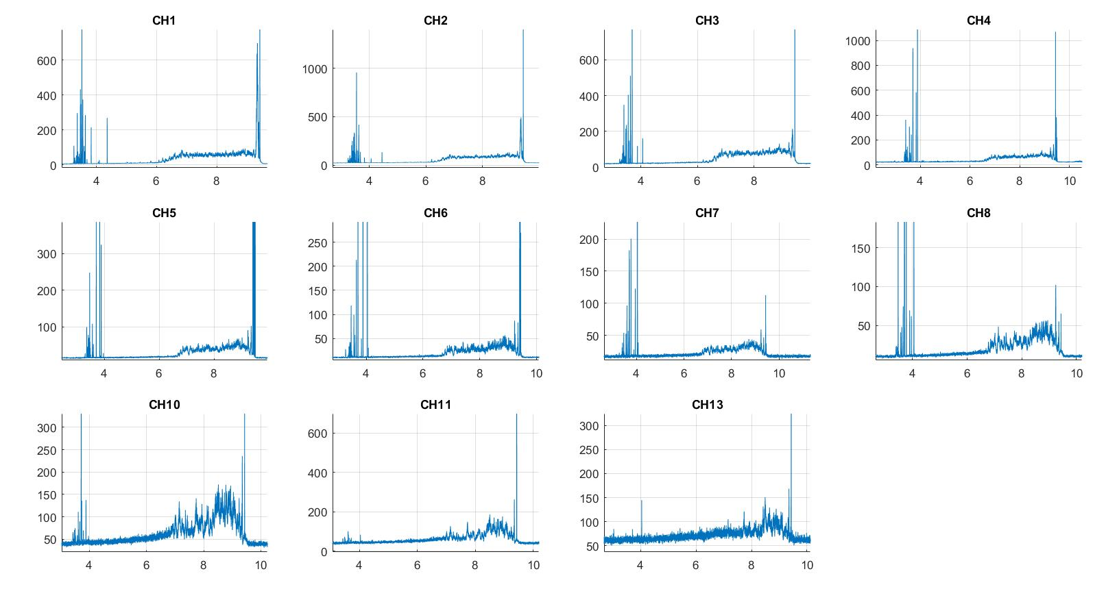
Figure 2: Radiometer measurements on time for dirty chamber discharge

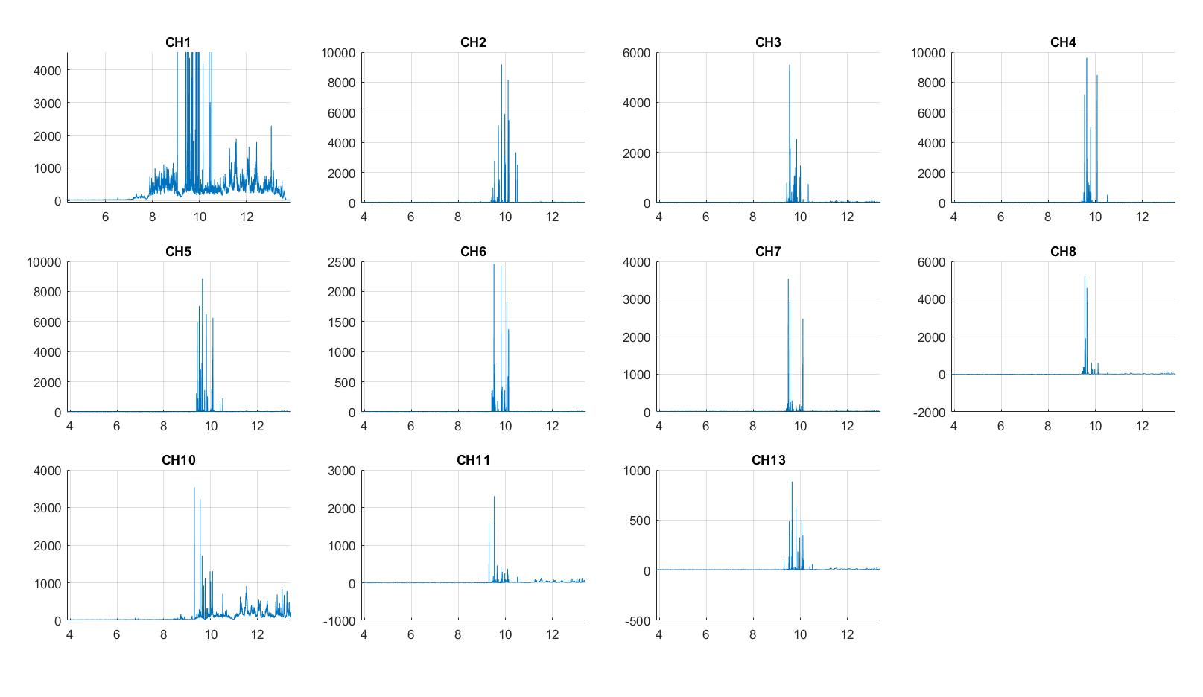
Figure 3: Radiometer measurements on time for clear chamber discharge (channel 1 is without attenuation and demonstrates the substrate in signal)

However the analysis of collected data has demonstrated that the moment of the signal growth is not matched with time when the second harmonic of ECE enters into the range of radiometer channels. The figure 4 demonstrates signal level for every frequency and lowest acceptable frequency for each channel (red line). This discrepancy can be connected with huge, about 30%, error in magnetic field measurements (which is linearly connected with electron cyclotron frequency) and with hardware problem. The tests have confirmed hardware defects in the amplifier of the front-end HF receiver. Replacement of this amplifier highlikely will fix the problem.

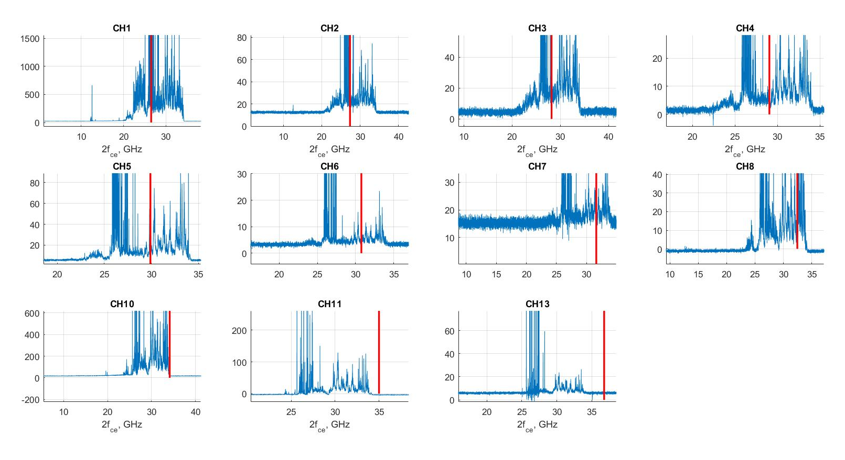
Figure 4: The radiometer signal on 2nd ECE harmonic frequency.

