The year report 2021/2022.
- The radiometer

  - Preliminary simulations
The GOLEM tokamak is a small device with low magnetic field, which is a problem for classic ECE measurements on 2nd ECE harmonic. The figure 1 demonstrates the available area for X-mode measurements for the typical reachable magnetic field in this tokamak. Mainly measurements are possible on the 3rd ECE harmonic, but rising of magnetic field during the discharge leads to change of harmonics for some channels. This fact creates a problem with understanding what harmonic is detected.
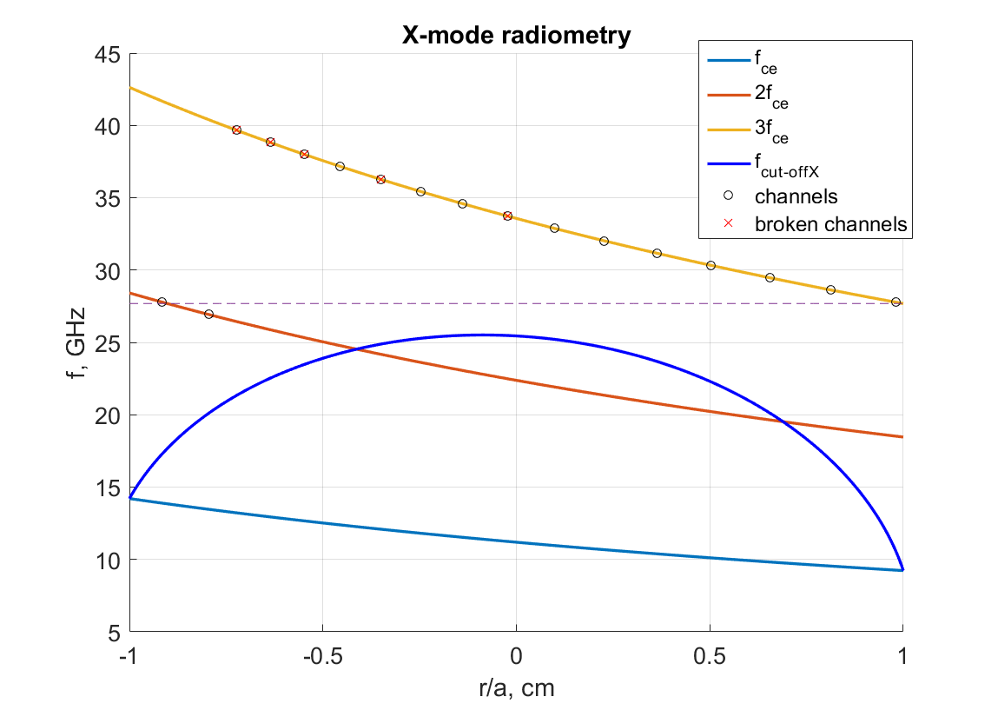
Figure 1: Estimation of ECE observations for 2nd harmonic X-mode. 25 GHz heterodyne, B = 0.4 T, n_{e} = 4.2x10¹⁸ m⁻³.

The simulations of optical thickness (fig. 2) demonstrate that GOLEM plasma is always optically thin (the highest $τ \sim 0.2)$. Direct measurements of electron temperature are impossible, but the same time for thin plasma non-thermal electrons has strong influence to the measured signal. This fact gives possibility to use ECE radiometer for RE measurements.
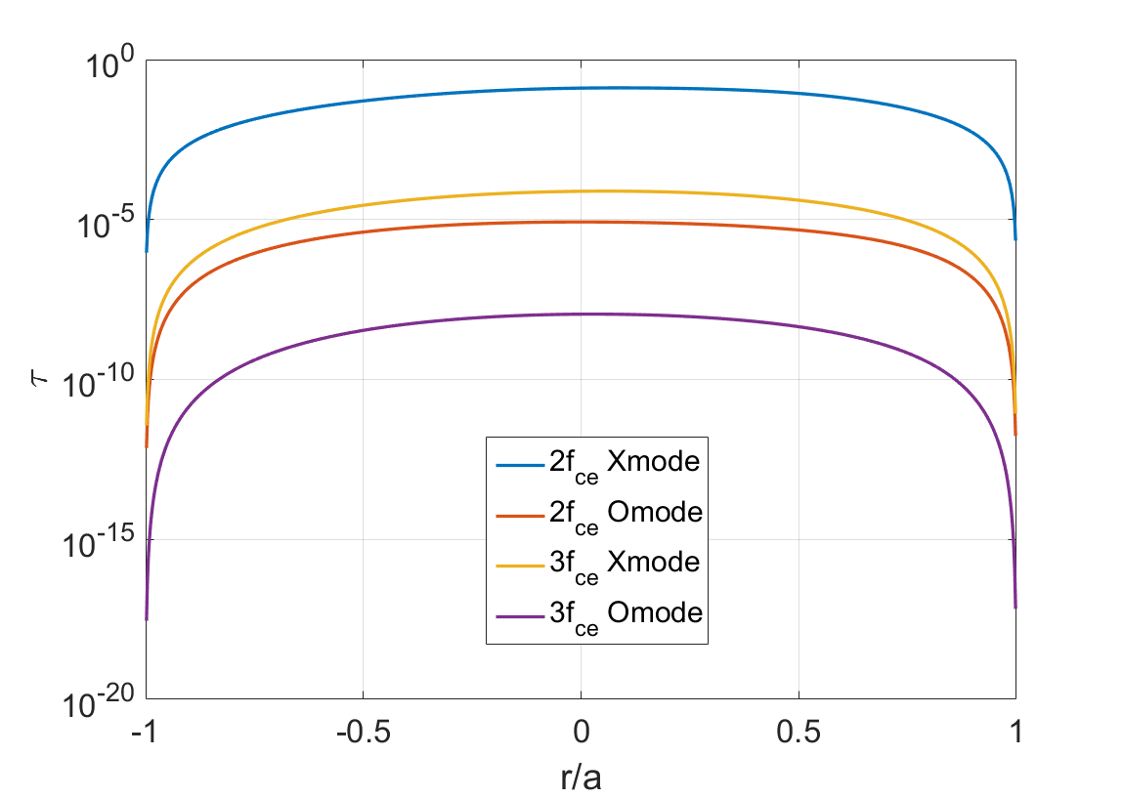
Figure 2: Optical thickness B = 0.5 T, n_{e} = 4e12 cm⁻³, T_{e} = 100 eV
  - Installation of the radiometer and RE detection.

The radiometer was installed at the GOLEM tokamak. The best position for REs measurements is the vertical view, unfortunately now there is no possibility on GOLEM to install the radiometer this way, so the antenna was placed radially from the LFS.

The first measurements demonstrated possibility to measure REs emission and to separate signals from the bulk plasma electrons and the non-thermal electrons.

The figures 3 and 4 demonstrate the difference between measured signals in pure plasma with the high rate of REs and dirty plasma without them.

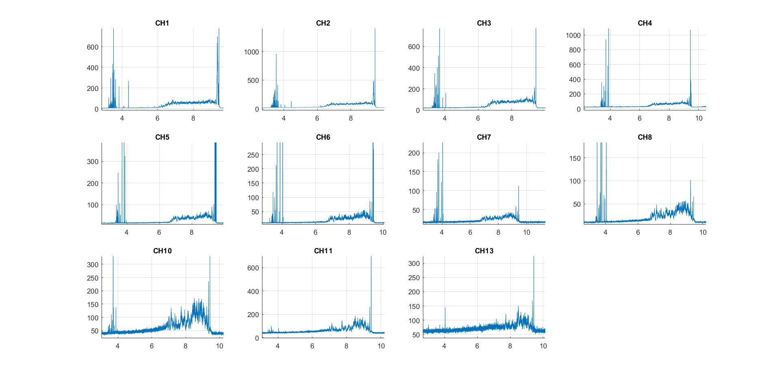
Figure 3: ECE radiometer measurements in dirty plasma

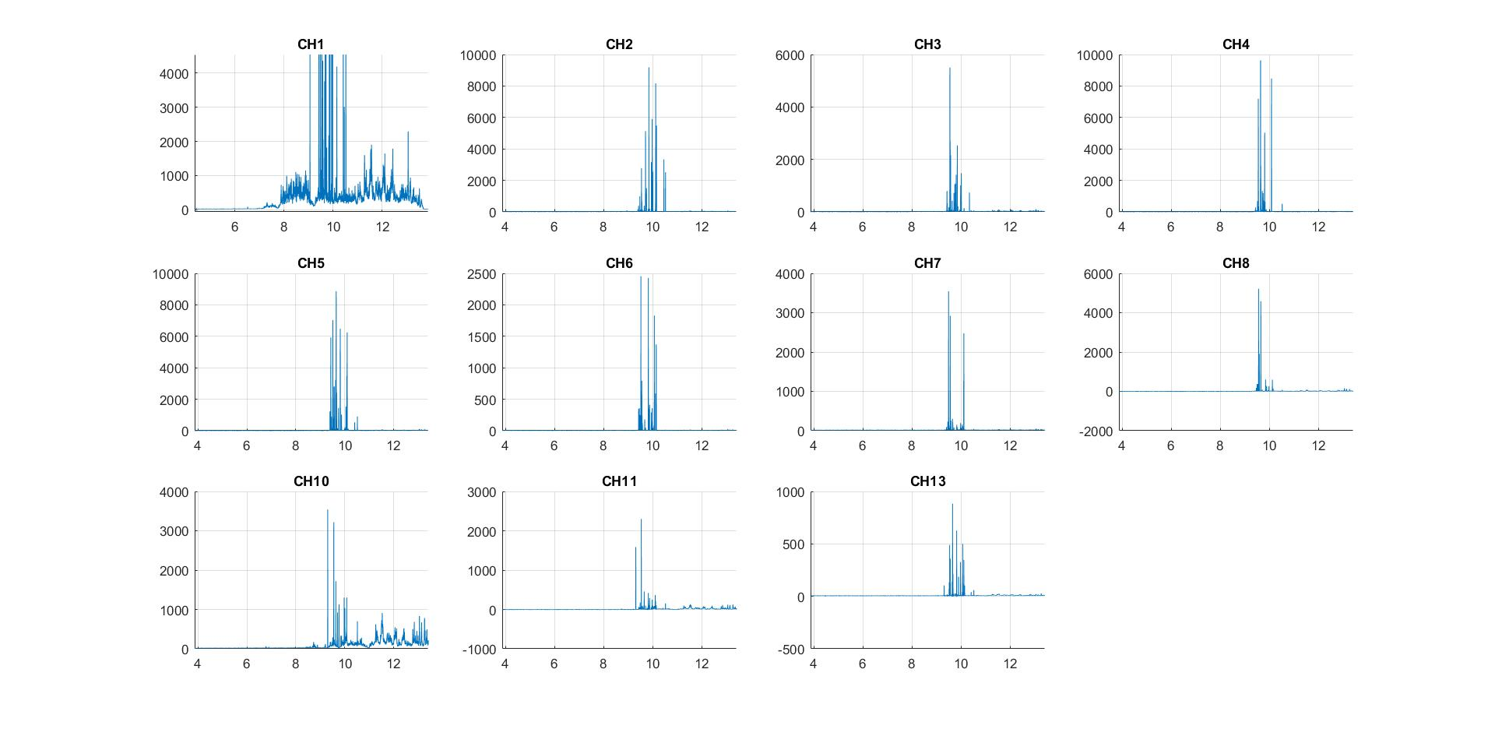

Figure 4: ECE radiometer measurements in pure plasma. The channel 1 is without attenuation

In pure plasma the measured signal is smoothed and forms a quasi-constant substrate, in dirty plasma this substrate still can be observed (fig.4 the first channel), however it is covered with high level spikes that may be associated with RE emission.
For the validation of these measurements the signal was compared with HXR detectors (fig. 5). The spectral sensitivity of these methods is different, but anyway comparison demonstrates the bursts of activity at the same time. This fact additionally compares that spikes on the radiometer signal are connected with REs.

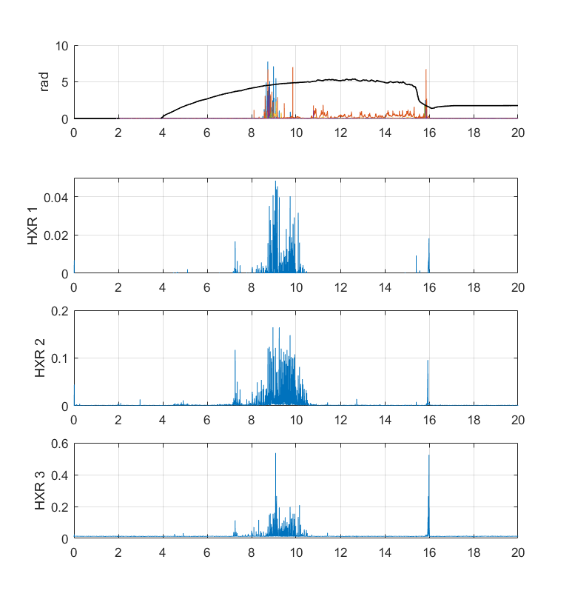
Figure 5: a) Radiometer measurements, b) YAP HXR detector, c) NaITl HXR detector, d) LYSO HXR detector. The black line is the plasma current

  - The ECE location

If the magnetic field evolution is known, the recovering of emission location is simple
$ω_{ce}\left(B\left(r,t\right)\right)→r(ω, B(t))$. The example is placed on the figure 6. The signal of the radiometer on this graph is mapped from time dependence to dependence on normalized radius (r/a) with 2 assumptions. Observation of 2nd and 3rd ECE harmonics is respectively the blue line and the red line.
According to my expectations, the signal should appear on the HFS, at the moment when the corresponding frequency appears there. However, the figure demonstrates the opposite situation.
Here are several possibilities to explain this:
- Technical defect (The radiometer detects lower frequency than expected)
- The detection of other plasma emissions (synchrotron radiation, bremsstrahlung)
- The third harmonic ECE appears in the center of the chamber (due to temperature, plasma position or relativistic effect??) and then it changes to the 2nd harmonic

- The first assumption was checked, the high frequency part of radiometer indeed has defect and even after replacement of the amplifier it can generates noises when observed frequencies is lower than 25 GHz of heterodyne frequency. But these noises level is about 10 dB lower than that main signal.

- The other radiation sources are not able to explain the level and the shape of the signal.

- Now, this way looks the most promising. In some discharges observation of signal intensity in the moment of “jump” between harmonic is possible (fig. 6). Also for higher frequency (ch8, ch10, ch11 from fig. 6), which appear later with higher temperature and density, the signal perfectly lies in r/a = [-1, 1].

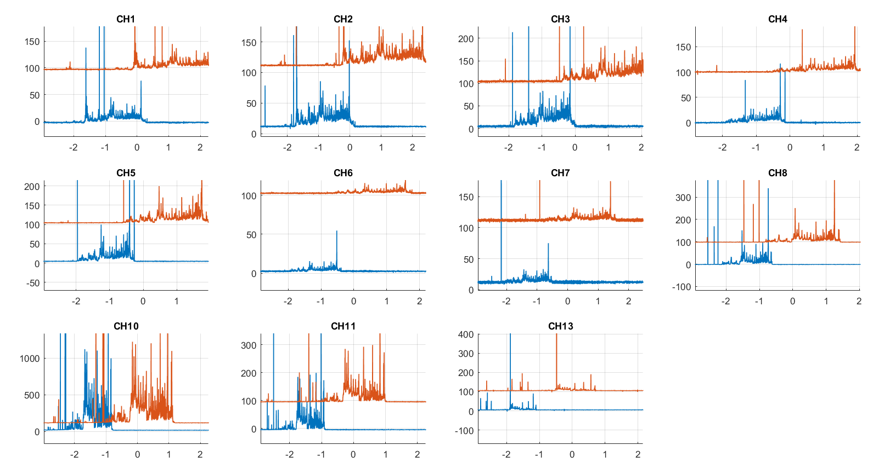
Figure 6: The radiometer signal is mapped on r/a. The blue line – assumption of 2nd ECE harmonic, the red line – assumption of 3rd ECE harmonic

  - The radiometer calibration
For the radiometer calibration the noise source is used. Unfortunately for optically thin plasma it does not let to estimate the electron temperature directly. The radiation temperature of the bulk plasma was estimated about 50-100 eV and radiation temperature of REs spikes about several keV.
Now, after the replacement of HF amplifier, the radiometer is not calibrated.

- MHD coils ring

Magnetic islands are able to significantly influence the REs behavior. For detection of islands the tokamak is equipped with 16 coils of poloidal magnetic field. Unfortunately clear observation of plasma structure requires quite low safety factor and relatively low magnetic field that is negatively affect radiometer measurements, which require high magnetic field to have observed frequency in plasma.
The figure 7 shows the spectrogram of the poloidal magnetic field perturbations measured by one of these coils. The spectrogram demonstrates a stable process with frequency about 20 kHz between 10 and 11.5 ms, when safety factor is low enough (evolution of the safety factor is shown on the figure 8)
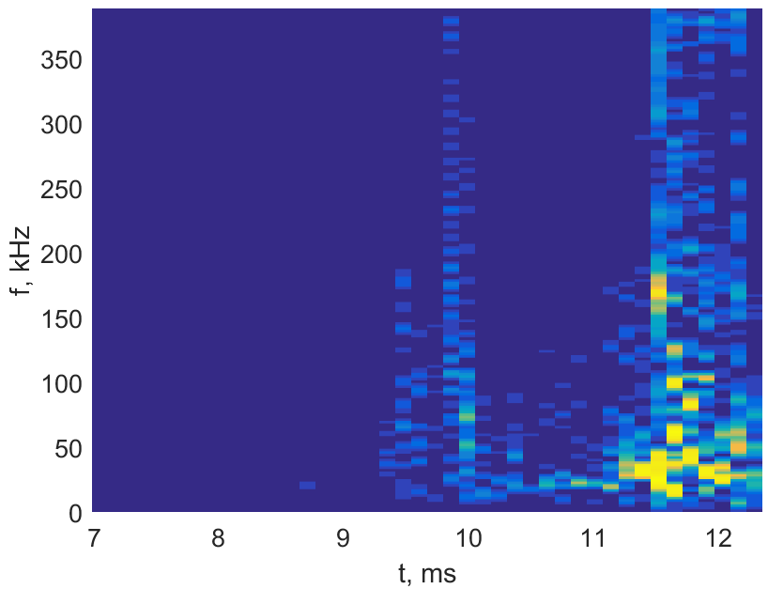
Figure 7: $B_{θ}perturbations spectrum$
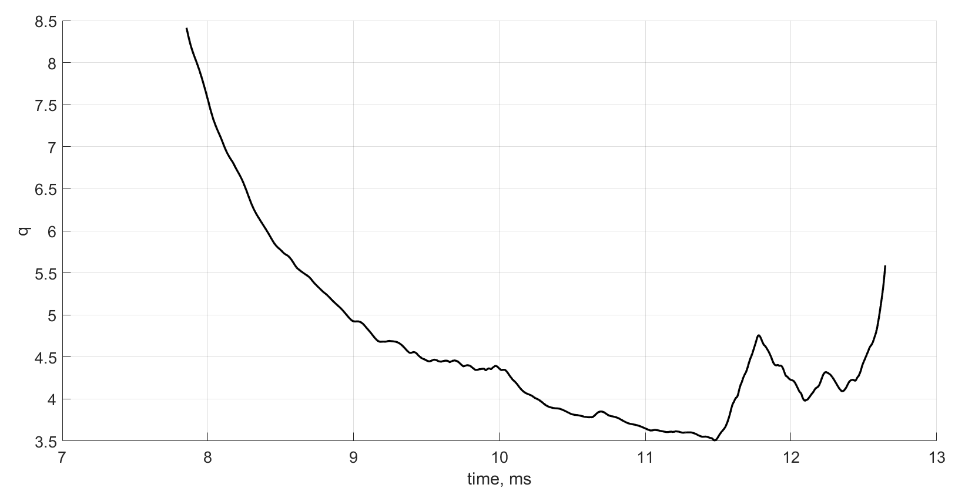
Figure 8: the safety factor evolution

The correlation analysis of these 16 coils set also shows stable poloidal configuration (fig. 9) in this period of time.

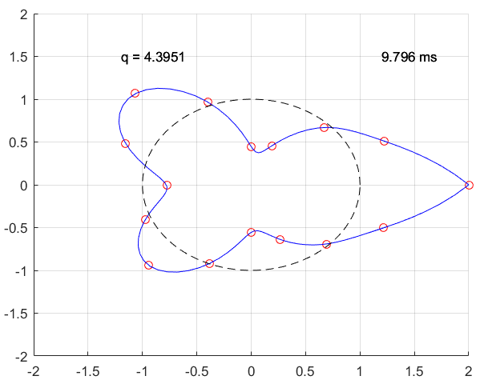
Figure 9: Cross correlation coefficients of MHD coils ring based on the first coil

The standard deviation of cross correlation coefficients can demonstrate the level of MHD activity in time (fig. 10). On this graph coefficients calculated for all possible combinations of coils, the black line is the standard deviation of the coefficients based on the first coil. The data plotted here also shows increasing of MHD activity in the same period of time, from 10 to 11.5 ms
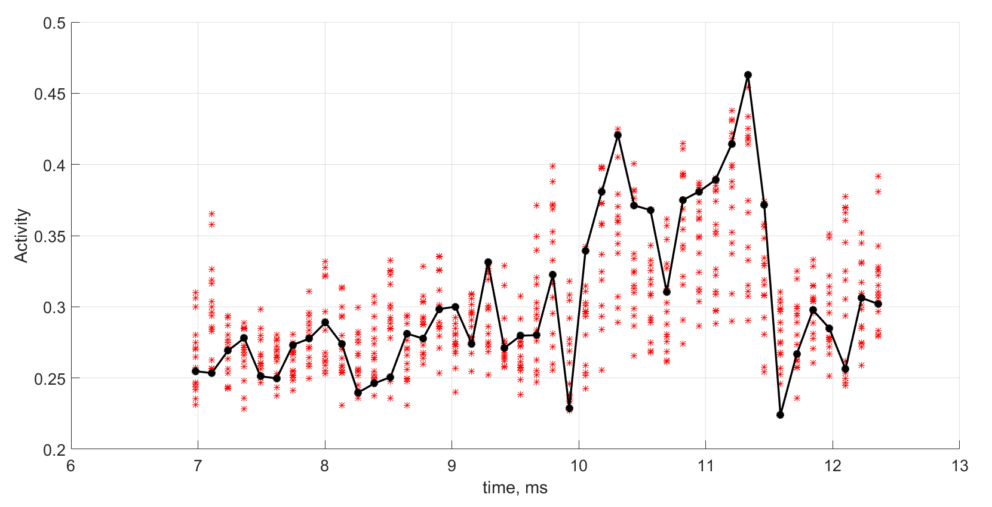
Figure 10: Standard deviation of cross correlation coefficients for all combinations of coils

