Tokamak Golem in Prague remotely operated during the lecture Introduction to Plasma Physics
An old legend tells that Rabbi Löwe (http://en.wikipedia.org/wiki/Judah_Loew_ben_Bezalel), an important Talmudic scholar, Jewish mystic, and philosopher in the 16th century Prague, created an animate being fashioned from clay: The Golem of Prague (http://en.wikipedia.org/wiki/Golem). This creature was unnaturally strong and followed blindly the orders of its master, whether they were good or not. And even if the intention of its master was good , it was very difficult to control Golem's powers.
The researchers from the Czech Technical University in Prague (CTU, http://www.cvut.cz/en) have, therefore, selected the name Golem for their experimental Tokamak reactor, where the first experience with magnetized plasmas for nuclear fusion and power generation can be made. In parallel to the legend of Golem, also the nuclear fusion can be utilized in a hydrogen bomb (as "successfully" demonstrated several times during the cold war) or for generation of fusion energy in a fusion power plant. This latter application is however quite difficult due to inherent instability of the hot fusion plasma and still large and more advanced devices has to be built to achieve an ultimate goal of save and environmental friendly power generation. Well known is currently running construction of the International Thermonuclear Experimental Reactor (ITER), a € 15 billion machine with the main diameter of 12.4 m.
The Golem Tokamak is, in contrast, with its main diameter of 0.8 m one of the smallest Tokamaks in the world. And also the oldest still functioning one. It was built in former Soviet Union as TM1-MH Tokamak at the beginning of sixties. It moved then to Institute of Plasma Physics in Prague in 1977 (being called CASTOR there) and is now for the last six years operated with name Golem at CTU. It has become an educational device for domestic as well as for foreign students. It is offered to the FUSENET (the 7th FWP European Fusion Education Network) as a remote practica experiment, since its operation can be fully maintained through an internet browser (http://golem.fjfi.cvut.cz/).
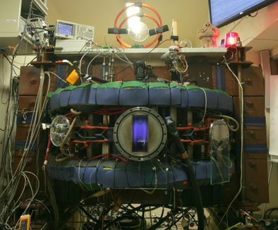
Fig. 1: Golem Tokamak in action. Photo: courtesy...
Additionally, the measurements of many experimental parameters are processed and analyzed automatically and are available online several seconds after the plasma operation, allowing very quickly to have a closer look to the plasma performance or even to perform a further analysis.
Ruhr-University Bochum is a well-known plasma center in Germany and in the world, where both low- and high-temperature (fusion) plasmas are discussed in the bachelor and master study courses and close cooperation exist with the Research Centrum Jülich, with its TEXTOR Tokamak (main diameter 3.5 m).
The participants of the "Introduction to Plasma Physics" in this summer semester had now the possibility to operate the GOLEM Tokamak remotely during the lecture and got familiar with its operation principle. The effect of different plasma parameters such as pressure, magnetic field and pre-conditioning of the reactor chamber were tested.
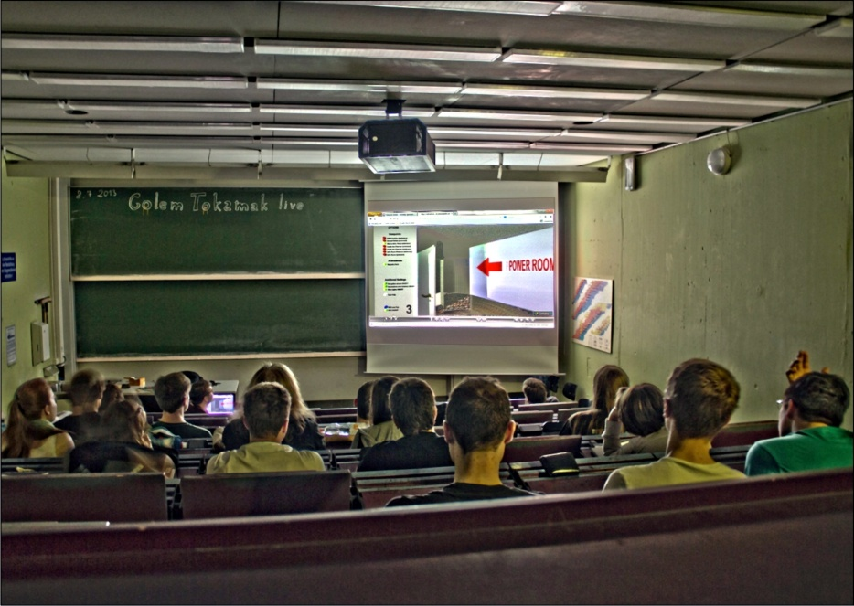
Fig. 2: Participants of the "Introduction to Plasma Physics" lecture during the introduction to the reactor. 08.07.2013, Photo: courtesy Hendrik Bahre.
Thanks to the GOLEM team, lead by Dr. Vojtěch Svoboda, the physic students at RUB will have now the opportunity to control the Tokamak also in the following years. Moreover, the organization of a remote practica, Bachelor theses or even short training visits in Prague is now being prepared.

