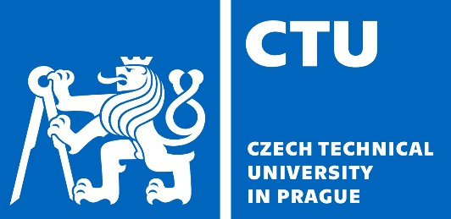
Czech Technical University in Prague
Faculty of Nuclear Sciences and Physical Engineering
Břehová 7, CZ 115 19 Prague 1

CERTIFICATE OF ATTENDANCE

This is to certify that the below-named person attended The GOleM TRAIning Course (GOMTRAIC-2019) held at Faculty of Nuclear Sciences and Physical Engineering at the Czech Technical University in Prague, Czech Republic during March 04-08, 2019. The training course has been organized in cooperation with Fusion Education Network (FUSENET) and International Atomic Energy Agency (IAEA).

Name in Full : PD
Affiliation : CVUT

Date: 08 March 2019

Vojtěch Svoboda, Ph.D. and Pravesh Dhyani, Ph.D.
on behalf of the GOMTRAIC organizers

