Hand on GOLEM experiment

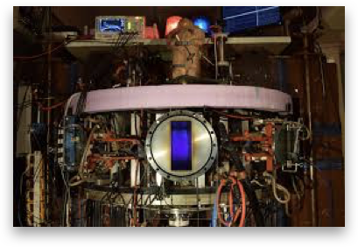
Figure1 GOLEM reactor

Figure2 GOLEM workshop

GOLEM is the oldest operation tokamak in the world. It serves as an educational device at the Faculty of Nuclear Science and Physical Engineering at CTU in Prague.

Objective
To study magnetic effect in plasma discharge
Theory
- U_{B} : Charging voltage of capacitors for toroidal magnetic field coil
:The total voltage measured by the flux coil (Rogowki coil)
: Unit Voltage [V]

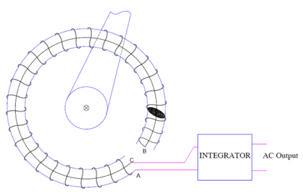
Figure3 magnetic measurement

https://electricalbaba.com/rogowski-coil-working/

The rogowki coil is put on around the plasma shape the calculate the magnetic flux and the data is transfer to the integrator and interpret as AC output.
To calculate charging voltage of capacitor for toroidal magnetic field coil, we start at

Ampere’s law
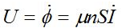
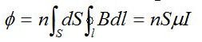
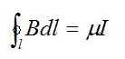
>> >>

- Plasma Breakdown : plasma has to start at some point in time after breakdown the plasma stabilizers into a steady-state mode and the plasma is used for its intended purpose.

Experiment Setup
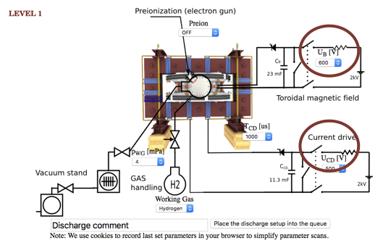

Figure4 Experiment Setup
The voltage for magnetic field in toroidal direction $U_{B}$ and voltage for current drive $U_{CD}$ are varied as the table below:

U_{CD} | U_{B} | ShortNo.
550 | 800 | 26118
 | 900 | 26103/26123
 | 1000 | 26119
700 | 600 | 26072
 | 800 | 26074
 | 900 | 26080
 | 1000 | 26077
 | 1100 | 26078

Table1 The parameters and shot number are used in this experiment

Method

- Check the plasma by looking at plasma current
- Look at the magnetic flux in different of charging voltage capacitor for B_{T}
- Look at the magnetic and voltage breakdown

Result
- Look at the plasma current at the condition $U_{CD}$ = 550 and $U_{B}$ =800 which is the minimum value from the table.
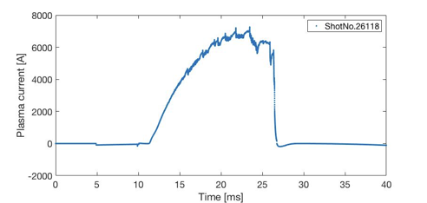
Figure5 Plasma current (A)

The result shows there is plasma in that condition, the peak of plasma current is around 7000 A in 20-25 ms of time range.
- Look at the magnetic flux in plasma discharge in the different voltage of magnetic field.

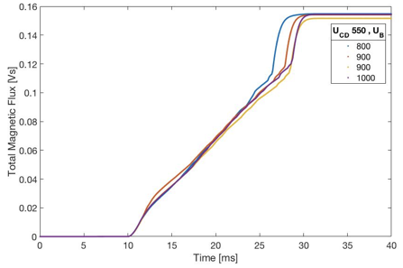
Figure6 the magnetic profile vs time in different $U_{B}$ at $U_{CD}=550$
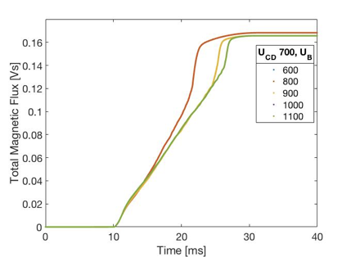
Figure7 the magnetic profile vs time in different $U_{B}$ at $U_{CD}=700$

From figure6 and figure7 , The different of voltage to drive current is not effect to magnetic flux and the magnetic is still remain the same flux in various of time.

- Measure toroidal magnetic field during breakdown discharge

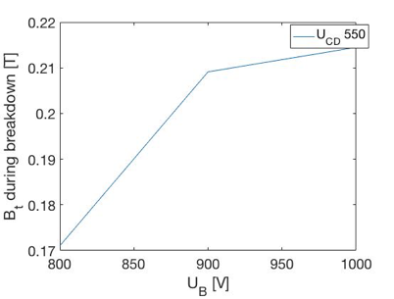
Figure8 the toroidal magnetic field during breakdown in different $U_{B}$ at $U_{CD}=550$

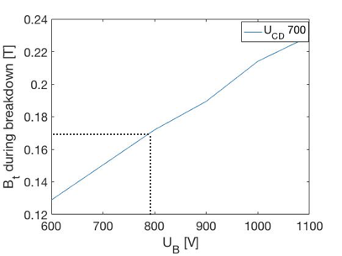
Figure9 the toroidal magnetic field during breakdown in different $U_{B}$ at $U_{CD}=700$

The toroidal magnetic field during breakdown discharge is the same at different $U_{CD}$
- Measure breakdown voltage during breakdown discharge
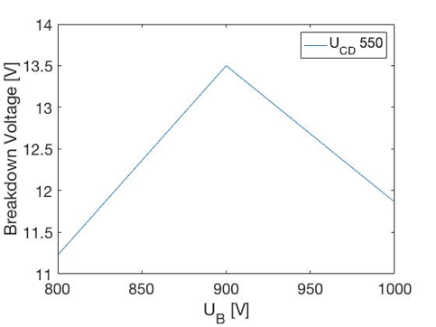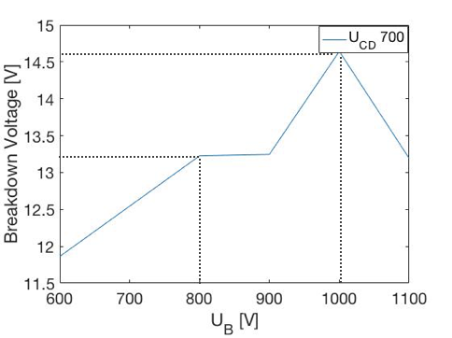

It seem like fluctuation of breakdown voltage because of the scale, the result can’t conclude.

