8 GOLEM experiments
(supervised by Vojtech Svoboda, Michael Gryaznevich)
Experiments with High Temperature Superconductor winding on the GOLEM tokamak - testing of the quench protection system designed by Tokamak Energy, UK.

“Comparison of the quench characteristics of HTS with and without plasma”.
The quench protection is very important for safe operations of HTS magnets in Fusion devices. Under the neutron irradiation, local heating of superconductor may cause loss of superconductivity and creation of hot spots. Cu and silver layers of the HTS tape play stabilising role that helps to prevent or smooth local overheating and reduce the increment of a quench. However, the plasma itself may also play a similar stabilising/smoothing role. Tests of quench properties and quench protection could be done on test beds, but the only way to investigate the role of the plasma (as a possible stabiliser) is to perform tests on a tokamak or on other plasma device.
The goal of the experiment is to characterise quench properties with and without plasma. Only one cryostat will be needed with one or two (for better statistics) independent coils. One turn in each coil will be sufficient. Measurements should include tokamak parameters, HTS tape current, voltages and temperatures. Measurements should also be done over feeds.
If the quench protection system will be available, it also can be tested.
The current in the HTS tape should be close, but not exceeding the critical level. During previous experiments on Golem, this current was about 300A, Fig.1, but the value needs to be checked again.
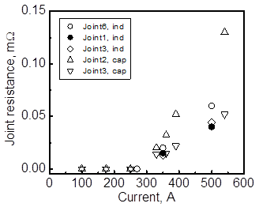
Fig.1. Critical current in different turns of the HTS coil
The quench will be induced by tokamak dischargers, with and without plasma, and time dependences of resistivity and temperature will be measured.

