One of unsolved threat for large fusion experimental devices is a phenomenon of runaway electrons. Runaway electrons are high energetic particles with velocities comparable with speed of light and their impact on the first wall of tokamak could cause a serious damage or even put the machine out of operation. The experimental investigation of runaway electrons brings new challenges and motivates new diagnostics development. At GOLEM tokamak one of diagnostic technique was under investigation. Possibility of development of scintillation probe for detection of runaway electrons was studied. For simulation of an interaction of runaway electrons with the probe the FLUKA code was used and preliminary design based on results was proposed. The visualization of interaction of energetic electrons can be seen in Fig. 1.

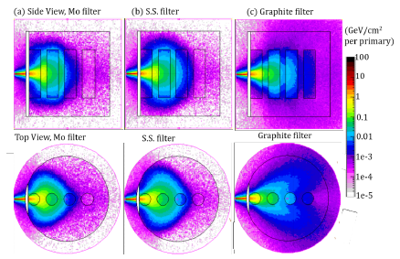

Fig. 1: Side view (top) and top view (bottom) of energy deposition (GeV/cm² per primary) on the probe using YSO crystal by 10 MeV electron beam with (a) Mo, (b) SS, (c) Graphite filters.

